
MINISTRY OF EDUCATION, CULTURE AND RESEARCH
OF THE REPUBLIC OF MOLDOVA
Technical University of Moldova
Faculty of Computers, Informatics and Microelectronics
Department of Software Engineering and Automation
Teodor Strulea FAF-242
Report
Laboratory Work No. 2
Operating Systems
Topic: Meet the OS You Will Build
Checked by:
Reițman Patricia, university assistant
Chișinău – 2026

CONTENTS
Introduction 4
1 Theoretical Background 5
1.1 xv6 and the Unix Lineage 5
1.2 Kernel Space, User Space, and System Calls 5
1.3 Cross-Compilation and Emulation 5
2 Environment Preparation 7
2.1 Installing the Toolchain 7
2.2 Verifying the Tools 7
2.3 Obtaining the xv6 Source 8
3 Build and Boot 10
3.1 First Build Attempt 10
3.2 Installing the RISC-V QEMU Target 10
3.3 Booting xv6 in QEMU 11
4 Using xv6 as the Unix It Is 12
4.1 Listing the File System 12
4.2 Reading a File 13
4.3 Echo, Pipes, and Word Count 13
4.4 Answers to the Observe Questions 14
5 Reading the Source 15
5.1 Structure of the Source Tree 15
5.2 A User Program: ls.c 15
5.3 A User Program: cat.c 17
5.4 System-Call Declarations in user.h 18
5.5 Locating sys_read and sys_write 19
5.6 Answers to the Observe Questions 19
6 Writing the First xv6 Program 21
6.1 Creating user/sleep.c 21
6.2 Registering the Program in the Makefile 21
6.3 Building and Fixing the System-Call Name 22
6.4 Testing Inside xv6 23
6.5 Final State of the Work Tree 24
Conclusion 26
References 27

Introduction
This laboratory work introduces xv6, the small teaching operating system on which the rest of the semester is built. xv6 is a modern re-implementation of Unix Version 6 written in about 9,000 lines of C for the RISC-V architecture and executed under the QEMU emulator. Whereas Laboratory Work No. 1 observed the Linux kernel only from the outside, this work compiles a complete kernel from source, boots it on emulated hardware, uses it as a tiny Unix, reads both the user-level and the kernel-level side of a system call, and finally adds a new user program to the system.
The report is organized around the commands executed in the terminal and the observations derived from their output. Each exercise contains its own terminal figure, followed immediately by a comment that answers the corresponding questions from the handout. The two "Observe" boxes of the handout (Part 2 and Part 3) are answered in dedicated subsections so that the material intended for notes.md is fully contained in this report.
The objectives of the work are to prepare the RISC-V cross-compiler and QEMU; obtain and build the xv6 source tree; boot xv6 and use its built-in programs, including a pipe; read user/ls.c, user/cat.c, user/user.h, and locate sys_read and sys_write in kernel/sysfile.c; and write, register, build, and test the program user/sleep.c, which calls the kernel's sleep system call.
The laboratory was completed on Ubuntu 26.04 LTS (resolute), 64-bit, under the user account teos, instead of the course Linux virtual machine. The xv6 source tree was cloned to /home/teos/xv6-riscv. Each figure in this report reproduces the terminal output of the corresponding exercise.

1 Theoretical Background

1.1 xv6 and the Unix Lineage
xv6 is a teaching operating system developed at MIT for the course 6.1810. It follows the structure and style of Unix Version 6 (1975) but is implemented in ANSI C for a modern RISC-V multiprocessor. The source is deliberately small: a kernel with a scheduler, virtual memory, a log-structured file system and system-call handlers, plus a handful of user programs such as sh, ls, cat, echo, grep, and wc.
Because the entire system fits in a few thousand lines, every mechanism that was only observable from the outside in Linux (processes, file descriptors, pipes, system calls) can here be followed from the user program that asks to the kernel code that answers. This is why xv6 is used as the vehicle for the rest of the course: the whole OS can be held in one's head.

1.2 Kernel Space, User Space, and System Calls
The source tree is divided into two folders, and this division mirrors the two privilege levels of the processor. The code in kernel/ runs in RISC-V supervisor mode: it owns the hardware, manages memory and processes, and implements the file system. The code in user/ runs in user mode: it cannot touch the hardware directly and must request every service from the kernel.
A system call is the controlled transition between the two. A user program calls an ordinary-looking function such as read() or write(), declared in user/user.h. The stub for that function (generated into user/usys.S) places a system-call number in a register and executes the ecall instruction, which traps into the kernel. The kernel dispatches on the number (kernel/syscall.c) and runs the matching handler, for example sys_read() or sys_write() in kernel/sysfile.c, before returning the result to the user program.
A pipe illustrates how several kernel services combine. The shell creates two processes with fork(), connects them through a kernel-managed buffer created with pipe(), redirects their standard output and input with dup() and close(), and finally replaces each process image with exec(). Processes and inter-process communication are therefore the two OS features that must exist for ls | grep c to work.

1.3 Cross-Compilation and Emulation
The host machine is an x86-64 computer, while xv6 targets RISC-V. The kernel and the user programs are therefore built with a cross-compiler, riscv64-linux-gnu-gcc, together with the matching binutils (riscv64-linux-gnu-ld, objdump, objcopy). The Makefile compiles the kernel, builds every user program listed in the UPROGS variable, and packs them with README into the disk image fs.img using the host tool mkfs/mkfs.
The resulting kernel is executed by qemu-system-riscv64, which emulates a virt machine with 128 MiB of RAM and three harts (hardware threads). The -nographic option connects the emulated console to the terminal, so the xv6 shell appears directly in the host terminal; the QEMU exit sequence Ctrl-A followed by X terminates the emulator.

2 Environment Preparation
Before xv6 can be built, the cross-compiler, the debugger, and the emulator must be present. The work was done on a personal Ubuntu 26.04 installation rather than on the course virtual machine, so the toolchain had to be installed as described in the handout.

2.1 Installing the Toolchain
sudo apt update
sudo apt install -y git build-essential gdb-multiarch qemu-system-misc \
gcc-riscv64-linux-gnu binutils-riscv64-linux-gnu
The evidence for this exercise is shown in Figure 2.1.
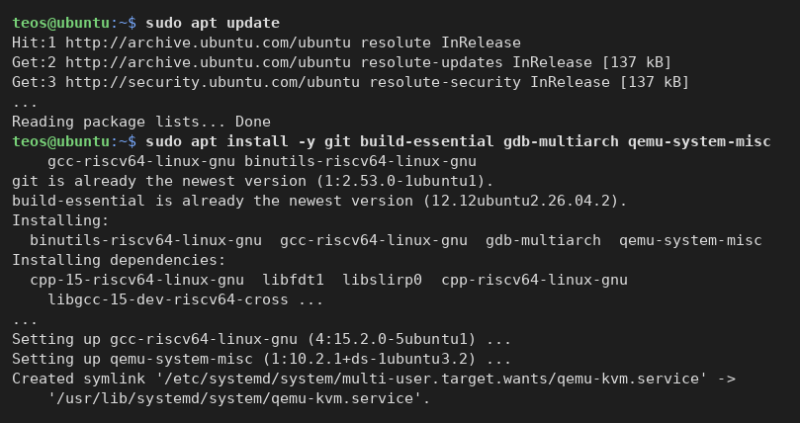
Figure 2.1: Package installation of the RISC-V toolchain, GDB, and QEMU on Ubuntu
Comment and observation
apt update refreshed the package lists of the resolute (26.04) release. git and build-essential were already installed; the command from the handout added the cross-compiler gcc-riscv64-linux-gnu, the matching binutils-riscv64-linux-gnu, the debugger gdb-multiarch, and qemu-system-misc, together with their dependencies (cross versions of libc and libgcc, libfdt, libslirp, and so on). A qemu-kvm.service unit was also registered by the QEMU package.

2.2 Verifying the Tools
git --version
make --version
riscv64-linux-gnu-gcc --version
qemu-system-riscv64 --version
The evidence for this exercise is shown in Figure 2.2.
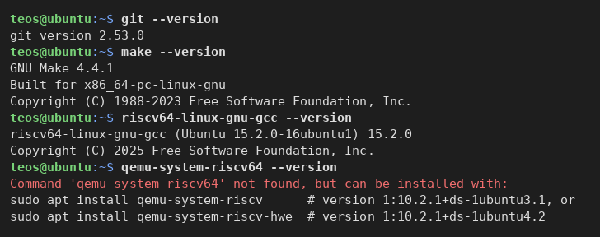
Figure 2.2: Versions of git, make, and the RISC-V cross-compiler; the RISC-V QEMU binary is still missing
Comment and observation
The host provides git 2.53.0, GNU Make 4.4.1, and the cross-compiler riscv64-linux-gnu-gcc 15.2.0. However, qemu-system-riscv64 was not found: on this Ubuntu release the package qemu-system-misc no longer contains the RISC-V system emulator, which has been moved into a separate package qemu-system-riscv. The shell's command-not-found helper reported exactly this package, and it was installed in Section 3.2 after the first build attempt made the problem visible.

2.3 Obtaining the xv6 Source
cd ~
git clone https://github.com/mit-pdos/xv6-riscv.git ~/xv6-riscv
cd ~/xv6-riscv
ls # kernel/ user/ Makefile README ...
The evidence for this exercise is shown in Figure 2.3.
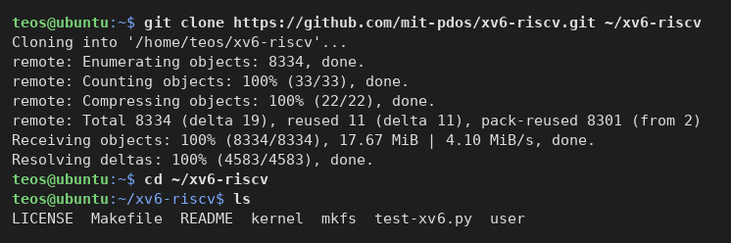
Figure 2.3: Cloning the xv6-riscv repository and listing the top of the source tree
Comment and observation
The repository was cloned from GitHub into /home/teos/xv6-riscv (8,334 objects, 17.67 MiB). The top of the tree contains exactly the parts described in the handout: kernel/ (the operating system), user/ (the programs that run on it), mkfs/ (the host tool that builds the disk image), the Makefile, README, LICENSE, and a test script test-xv6.py.

3 Build and Boot
This chapter corresponds to Part 1 of the handout. The kernel and the user programs are compiled with a single make qemu, which then launches the emulator and boots xv6.

3.1 First Build Attempt
cd ~/xv6-riscv
make qemu
The evidence for this exercise is shown in Figure 3.1.
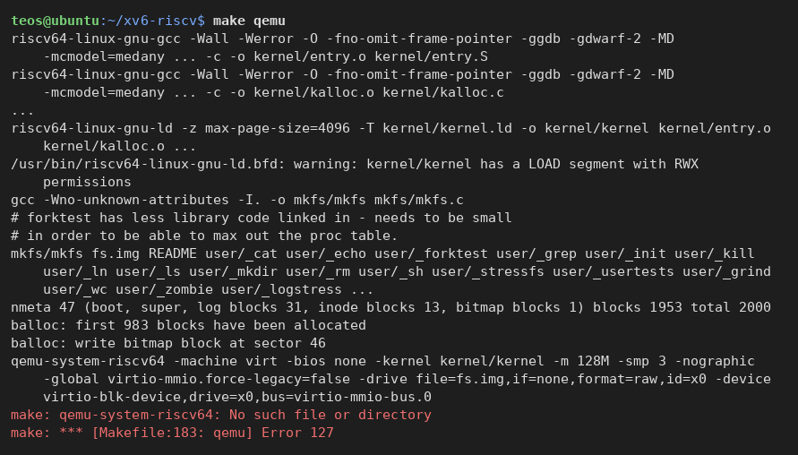
Figure 3.1: First make qemu: the kernel, the user programs, and fs.img are built, but QEMU cannot be started
Comment and observation
The build itself succeeded. The cross-compiler compiled every file in kernel/ and linked them into kernel/kernel; the host gcc built mkfs/mkfs; every user program was linked into user/_cat, user/_echo, and so on; and mkfs wrote the disk image fs.img (2,000 blocks, 47 of them metadata, 983 blocks allocated). The only warnings concern ELF segments with RWX permissions, which is expected for a bare-metal kernel. The final step, however, failed with make: qemu-system-riscv64: No such file or directory (exit code 127), confirming the observation of Section 2.2 that the RISC-V emulator was not installed.

3.2 Installing the RISC-V QEMU Target
sudo apt install -y qemu-system-riscv
command -v qemu-system-riscv64
qemu-system-riscv64 --version
The evidence for this exercise is shown in Figure 3.2.
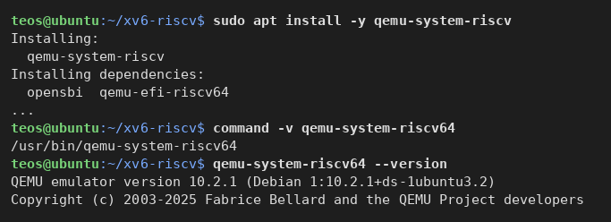
Figure 3.2: Installation of qemu-system-riscv and verification of the emulator binary
Comment and observation
On Ubuntu 26.04 the binary is simply not part of qemu-system-misc. Installing qemu-system-riscv (together with its dependencies opensbi and qemu-efi-riscv64) placed the emulator at /usr/bin/qemu-system-riscv64. The installed version is QEMU 10.2.1. Only this package differed from the handout's list of tools; everything else matched.

3.3 Booting xv6 in QEMU
make qemu
# to leave xv6: press Ctrl-A, release, then X
The evidence for this exercise is shown in Figure 3.3.
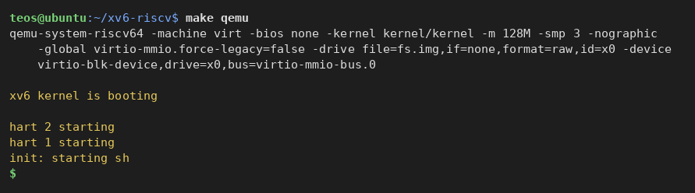
Figure 3.3: xv6 booting under QEMU and starting the shell
Comment and observation
Because the kernel and the disk image were already up to date, make went straight to the qemu target. QEMU was started with -machine virt -bios none -kernel kernel/kernel -m 128M -smp 3 -nographic and the virtio block device backed by fs.img. The kernel printed xv6 kernel is booting, the two secondary harts reported hart 2 starting and hart 1 starting, and the first user process init started the shell, which displayed the $ prompt. The system was later left with the QEMU sequence Ctrl-A X, which printed QEMU: Terminated.

4 Using xv6 as the Unix It Is
This chapter corresponds to Part 2 of the handout. At the xv6 $ prompt the built-in programs were run to show how familiar this ancestor of Linux feels.

4.1 Listing the File System
$ ls
The evidence for this exercise is shown in Figure 4.1.
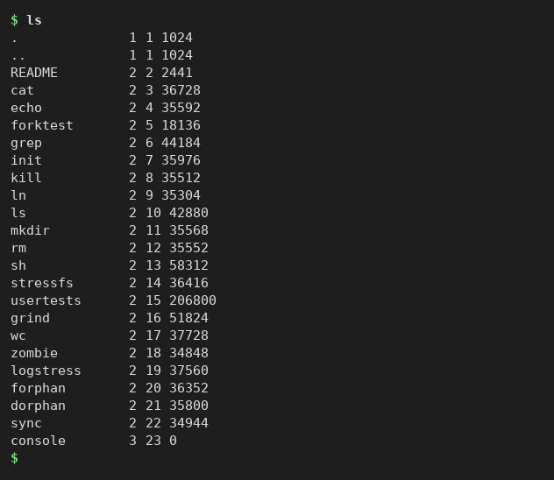
Figure 4.1: Contents of the xv6 root directory
Comment and observation
The xv6 ls prints four columns: name, type, inode number, and size in bytes. Type 1 is a directory (. and ..), type 2 a regular file, and type 3 a device (console). The root directory holds README and 21 executable programs: cat, echo, forktest, grep, init, kill, ln, ls, mkdir, rm, sh, stressfs, usertests, grind, wc, zombie, logstress, forphan, dorphan, and sync. The whole file system occupies one 2,000-block image, and even the largest program, usertests, is only 206,800 bytes.

4.2 Reading a File
$ cat README
The evidence for this exercise is shown in Figure 4.2.
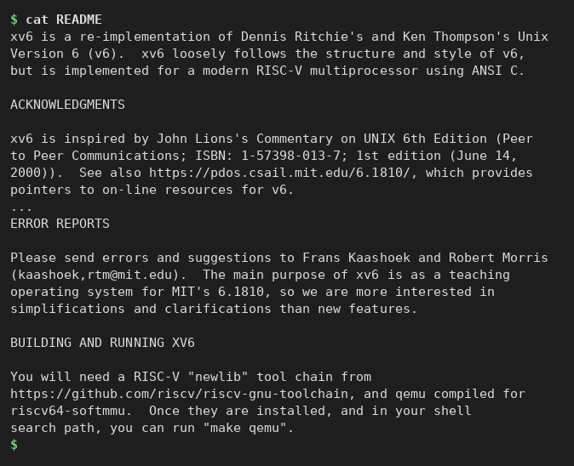
Figure 4.2: The README file printed by the xv6 cat program (middle part shortened)
Comment and observation
cat printed the 48-line README, which states that xv6 is a re-implementation of Unix Version 6 for a modern RISC-V multiprocessor, written in ANSI C and inspired by John Lions's commentary on Unix 6th Edition. The file also documents how to build and run the system (make qemu) and names the course for which it is maintained, MIT 6.1810. The output shows that the xv6 file system, the open/read system calls, and the console device all work together exactly as on Linux.

4.3 Echo, Pipes, and Word Count
$ echo hello xv6
$ ls | grep c # pipes work here too
$ wc README
The evidence for this exercise is shown in Figure 4.3.
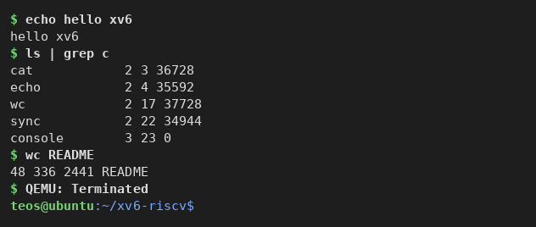
Figure 4.3: echo, a pipeline between ls and grep, and wc inside xv6
Comment and observation
echo hello xv6 printed its arguments back, showing argument passing through exec. The pipeline ls | grep c printed only the five entries whose names contain the letter c (cat, echo, wc, sync, console): the shell created two processes and connected the output of ls to the input of grep through a pipe. wc README reported 48 lines, 336 words, and 2,441 bytes, which matches the size shown by ls. The optional usertests -q was not run during the session.

4.4 Answers to the Observe Questions
(1) Three programs xv6 ships with. ls, cat, and echo (the session also used grep, wc, and sh; the full list is in Figure 4.1).
(2) OS features needed for a pipe. Two features must exist: (a) processes — the kernel must be able to create and schedule several processes at once (fork and exec), so that ls and grep run concurrently; and (b) inter-process communication through the kernel — the pipe system call creates a kernel buffer with a read end and a write end exposed as file descriptors, and dup/close let the shell redirect one process's standard output and the other's standard input into it. Without processes there would be nothing to connect; without a kernel-managed channel the two processes could not exchange data.
(3) xv6 shell versus the Linux shell. The xv6 shell understands the same basic syntax as bash from Lab 1 — commands with arguments, pipes |, redirection < and >, and & for background jobs — but it is a minimal implementation with no command history, tab completion, variables, scripting, or job control, and it has only about twenty programs available instead of thousands.

5 Reading the Source
This chapter corresponds to Part 3 of the handout. After leaving QEMU, the source tree was inspected from the Ubuntu shell to see both sides of a system call.

5.1 Structure of the Source Tree
The listing in Figure 2.3 shows the two folders into which the whole operating system splits. kernel/ is the operating system itself and runs in privileged (supervisor) mode: it contains the scheduler and process table (proc.c), the memory allocator and page tables (kalloc.c, vm.c), the file system (fs.c, log.c, bio.c), the trap and system-call dispatch (trap.c, syscall.c), and the system-call handlers (sysfile.c, sysproc.c).
user/ holds the ordinary programs that run on top of the kernel in user mode: ls.c, cat.c, echo.c, sh.c, and so on, together with the small C library (ulib.c, printf.c, umalloc.c) and the header user.h that declares the system calls available to programs.

5.2 A User Program: ls.c
sed -n '1,40p' user/ls.c
The evidence for this exercise is shown in Figure 5.1.
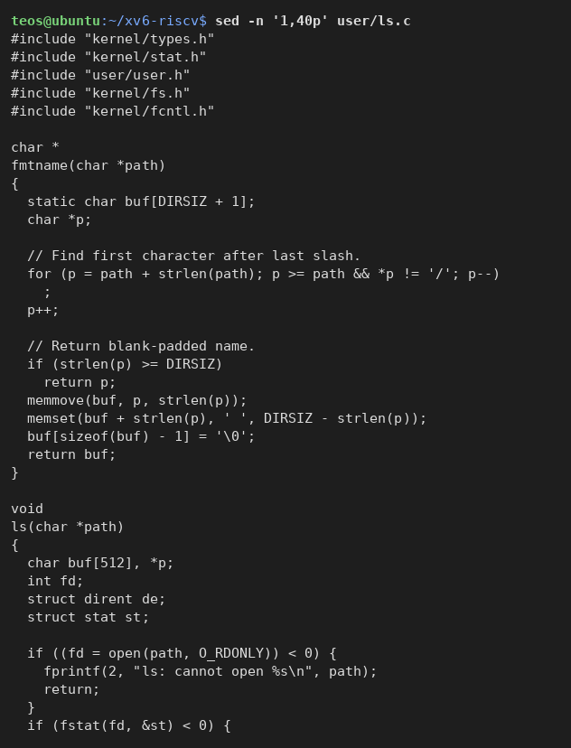
Figure 5.1: The first 40 lines of user/ls.c
Comment and observation
ls.c includes kernel/types.h, kernel/stat.h, kernel/fs.h, and kernel/fcntl.h for shared definitions, and user/user.h for the system-call and library prototypes. The helper fmtname() returns the last path component padded to DIRSIZ characters, which produces the aligned columns seen in Figure 4.1. The function ls() opens the path with open(path, O_RDONLY), queries it with fstat(), and then (beyond line 40) reads the directory entries with read(). The shape is exactly that of a C program from the programming labs: includes, helper functions, and main.

5.3 A User Program: cat.c
sed -n '1,30p' user/cat.c
The evidence for this exercise is shown in Figure 5.2.
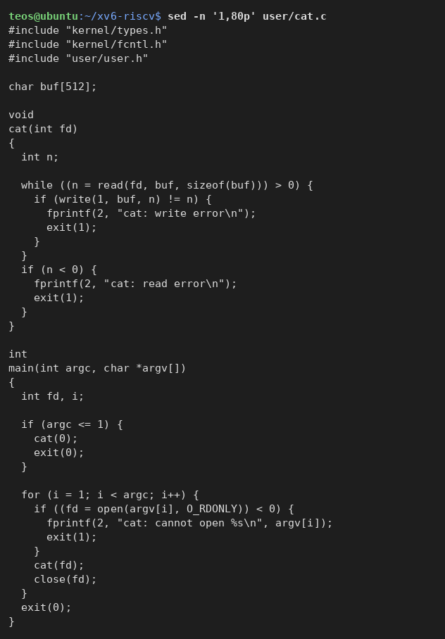
Figure 5.2: The complete user/cat.c
Comment and observation
cat.c is only 43 lines long. The function cat(fd) loops on read(fd, buf, sizeof(buf)), copying each chunk of up to 512 bytes to file descriptor 1 (standard output) with write(1, buf, n), and reports errors on file descriptor 2 with fprintf. main either cats standard input (descriptor 0) when no argument is given, or opens each argument with open(argv[i], O_RDONLY), cats it, and closes it. Every interaction with files and the console goes through system calls; the program itself contains no I/O logic.

5.4 System-Call Declarations in user.h
cat user/user.h # the list of system calls available to programs
The evidence for this exercise is shown in Figure 5.3.
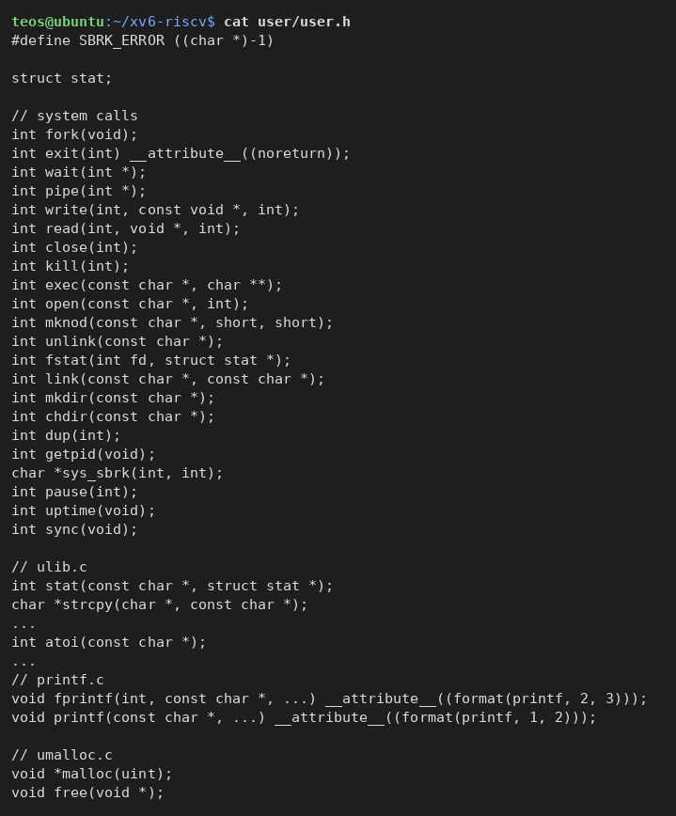
Figure 5.3: user/user.h: system-call prototypes followed by the user-level library
Comment and observation
The header is divided by comments. The block // system calls declares the 22 entry points a program may request from the kernel: fork, exit, wait, pipe, write, read, close, kill, exec, open, mknod, unlink, fstat, link, mkdir, chdir, dup, getpid, sys_sbrk, pause, uptime, and sync. The blocks // ulib.c, // printf.c, and // umalloc.c declare ordinary library functions (strlen, atoi, printf, malloc, ...) that are implemented in user space on top of those calls. An important detail for Chapter 6 is that, in the current upstream repository, the system call that pauses a process for a number of ticks is declared as int pause(int); on line 25, not as sleep.

5.5 Locating sys_read and sys_write
grep -n "sys_read\|sys_write" kernel/sysfile.c | head
grep -n "open\|read\|write\|close\|exit" user/cat.c
The evidence for this exercise is shown in Figure 5.4.
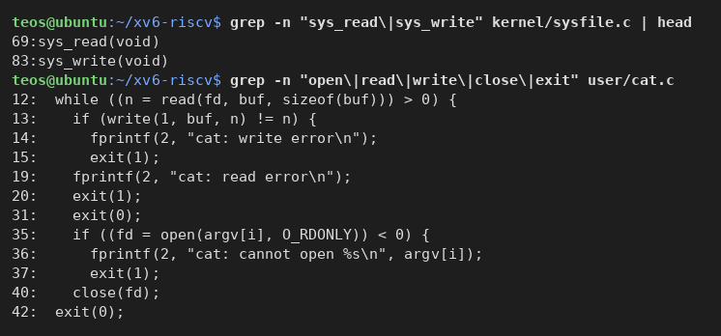
Figure 5.4: Kernel-side handlers sys_read and sys_write, and the system calls used by cat.c
Comment and observation
grep -n shows that `sys_read` is implemented in `kernel/sysfile.c` at line 69 and sys_write at line 83. These are the kernel functions that run after the ecall issued by the user-level stubs for read() and write(). The second grep lists every line of cat.c that uses a system call: read (line 12), write (line 13), exit (lines 15, 20, 31, 37, 42), open (line 35), and close (line 40); the fprintf calls on lines 14, 19, and 36 are library functions that ultimately call write on descriptor 2.

5.6 Answers to the Observe Questions
(1) System calls used by user/cat.c. open(path, O_RDONLY) asks the kernel to look up the file and return a file descriptor; read(fd, buf, n) asks it to copy up to n bytes from the file into the program's buffer; write(1, buf, n) asks it to send n bytes from the buffer to standard output (the console); close(fd) asks it to release the descriptor; and exit(status) asks it to terminate the process with the given status. The error messages go through fprintf(2, ...), which is a library function that calls write on standard error.
(2) Where sys_read is implemented. In kernel/sysfile.c, line 69 (sys_write follows on line 83).
(3) kernel/ versus user/. The code in kernel/ runs with full hardware privileges and implements the services (scheduling, memory, files, devices), while the code in user/ runs unprivileged and can only ask for those services through system calls; the kernel answers the requests that user programs make.

6 Writing the First xv6 Program
This chapter corresponds to Part 4 of the handout: a new user program sleep that pauses for a number of clock ticks by calling the kernel's sleep system call, registered in the build and tested inside xv6.

6.1 Creating user/sleep.c
nano user/sleep.c
sed -n '1,80p' user/sleep.c
The evidence for this exercise is shown in Figure 6.1.
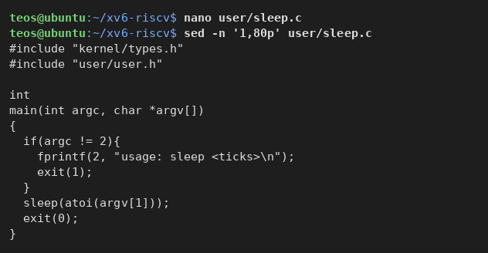
Figure 6.1: The program user/sleep.c as written from the handout
Comment and observation
The file was created with nano exactly as given in the handout. It includes kernel/types.h and user/user.h, checks that exactly one argument was supplied (argc != 2), prints usage: sleep <ticks> to descriptor 2 and exits with status 1 otherwise, converts the argument with atoi, calls the sleep system call, and exits with status 0. The file is 200 bytes long.

6.2 Registering the Program in the Makefile
nano Makefile # add $U/_sleep\ to the UPROGS list
grep -n '$U/_sleep' Makefile
nl -ba Makefile | sed -n '130,142p'
The evidence for this exercise is shown in Figure 6.2.
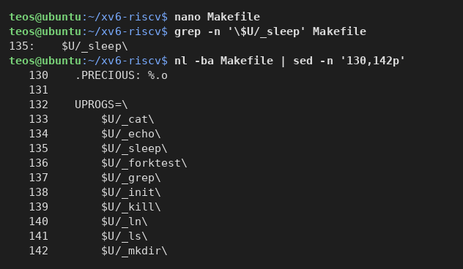
Figure 6.2: The UPROGS list in the Makefile after adding $U/_sleep
Comment and observation
The line $U/_sleep\ was added after $U/_echo\ on line 135, copying the indentation of the neighbouring lines (a tab, not spaces) and keeping the trailing backslash. The numbered listing shows why both details matter: UPROGS=\ on line 132 starts a single logical line that is continued by the backslash at the end of every entry, and make treats the tab-indented entries as part of that variable only while the continuation is unbroken. An empty line or a missing backslash inside the list would end the variable early and make the remaining entries look like a recipe without a target.

6.3 Building and Fixing the System-Call Name
make clean
make qemu
sed -i 's/sleep(atoi(argv\[1\]));/pause(atoi(argv[1]));/' user/sleep.c
grep -n 'pause' user/user.h user/sleep.c
The evidence for this exercise is shown in Figure 6.3.
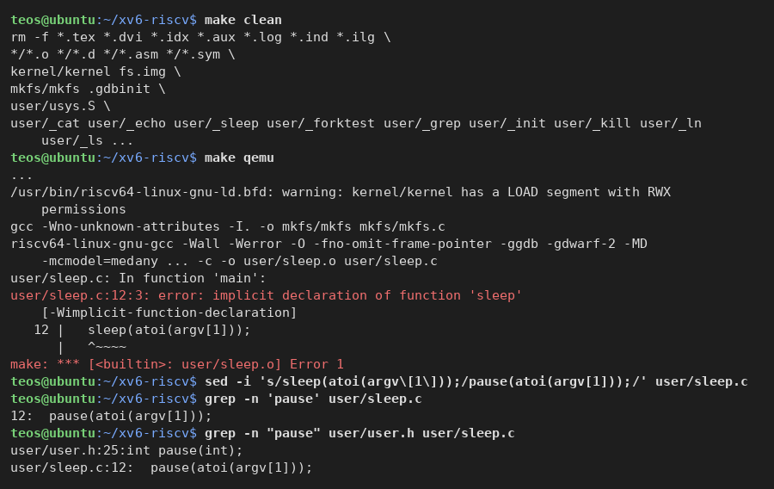
Figure 6.3: The implicit-declaration error for sleep and the change to the pause wrapper
Comment and observation
After make clean, the rebuild compiled the kernel and mkfs and then failed on the new program: user/sleep.c:12:3: error: implicit declaration of function 'sleep'. Because xv6 is built with -Werror, an undeclared function is fatal. As noted in Section 5.4, the current upstream user/user.h declares the sleeping system call as int pause(int); (line 25); the name sleep used in the handout belongs to older versions of the repository. The call was therefore changed to pause(atoi(argv[1])) with sed, and grep confirms that the program now calls exactly the wrapper declared in user.h. The program still makes the same system call into the kernel that the handout describes; only the user-level name differs.

6.4 Testing Inside xv6
make qemu
$ ls | grep sleep
$ sleep 10 # should pause, then return to the prompt
$ sleep # should print the usage message
The evidence for this exercise is shown in Figure 6.4.
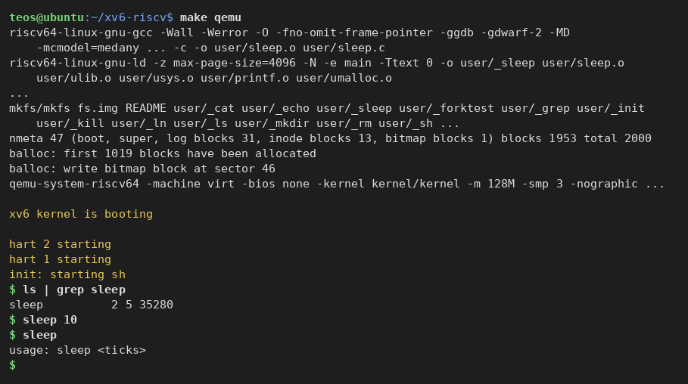
Figure 6.4: Successful build with sleep, boot, and the two test runs inside xv6
Comment and observation
The build now completed: sleep.c was compiled and linked into user/_sleep, which mkfs packed into fs.img (1,019 blocks allocated instead of 983). After boot, ls | grep sleep showed the new program as a regular file (type 2, inode 5, 35,280 bytes). sleep 10 paused for ten clock ticks and then returned silently to the prompt, and sleep without an argument printed usage: sleep <ticks>, as required. Both the usage check and the system call therefore work. The full ls after the rebuild also showed that every other program had been renumbered by one inode because sleep was inserted after echo.

6.5 Final State of the Work Tree
git status --short
sed -n '1,80p' user/sleep.c
grep -n '$U/_sleep' Makefile
ls user/_sleep kernel/kernel fs.img
The evidence for this exercise is shown in Figure 6.5.
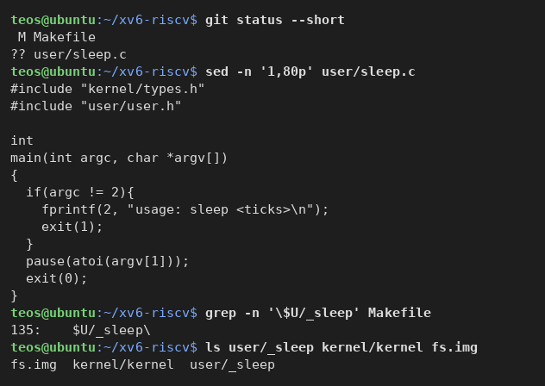
Figure 6.5: Modified files, the final sleep.c, and the build artifacts
Comment and observation
git status shows exactly two changes relative to the upstream repository: the modified Makefile and the new, untracked user/sleep.c. The final program is listed below. The build produced the three artifacts needed to run the system: the kernel kernel/kernel, the disk image fs.img, and the user/_sleep executable (35,280 bytes, as shown by ls inside xv6 in Figure 6.4). user/sleep.c and this report are the files pushed to the course repository.
Final user/sleep.c
#include "kernel/types.h"
#include "user/user.h"

int
main(int argc, char *argv[])
{
if(argc != 2){
fprintf(2, "usage: sleep <ticks>\n");
exit(1);
}
pause(atoi(argv[1])); // system call into the kernel (sleep for N ticks)
exit(0);
}

Conclusion
In this laboratory work a complete operating system was built from source and booted on emulated hardware. The RISC-V cross-compiler, GDB, and QEMU were installed on Ubuntu 26.04; the only deviation from the handout was that the RISC-V emulator had to be installed from the separate package qemu-system-riscv. The Makefile compiled the kernel, every user program, and the disk image, and QEMU booted xv6 to the shell prompt.
Used as a Unix, xv6 behaved like the ancestor of the Linux system from Laboratory Work No. 1: ls, cat, echo, grep, and wc worked as expected, and a pipeline demonstrated that the kernel already provides both processes and inter-process communication. Reading the source made both sides of a system call visible: cat.c asks through open, read, write, close, and exit, and the kernel answers in kernel/sysfile.c, where sys_read begins at line 69 and sys_write at line 83.
Finally, the program user/sleep.c was written, registered in UPROGS, built, and tested. One practical obstacle was solved on the way: the current xv6 declares the sleeping system call as pause() rather than sleep(), so the handout's call had to be renamed. The resulting program validates its argument, prints a usage message when called incorrectly, and makes a real system call into a kernel compiled by hand — the starting point for modifying the kernel side in the following laboratories.

References
[1] Operating Systems Lab 2 handout. Meet the OS You Will Build – Track B: build your own small OS (xv6). FCIM / FAF / UTM, 2026–2027.
[2] MIT PDOS. xv6-riscv source repository. https://github.com/mit-pdos/xv6-riscv (cloned in September 2026).
[3] R. Cox, M. F. Kaashoek, R. Morris. xv6: a simple, Unix-like teaching operating system. MIT 6.1810, https://pdos.csail.mit.edu/6.1810/.
[4] QEMU Project. QEMU documentation – RISC-V System emulator. https://www.qemu.org/docs/master/system/target-riscv.html.
[5] GNU Make Manual, section Splitting Long Lines and Chained Rules. https://www.gnu.org/software/make/manual/.

