
MINISTRY OF EDUCATION, CULTURE AND RESEARCH
OF THE REPUBLIC OF MOLDOVA
Technical University of Moldova
Faculty of Computers, Informatics and Microelectronics
Department of Software Engineering and Automation
Teodor Strulea FAF-242
Report
Laboratory Work No. 3
Operating Systems
Topic: The Command Line: Shell, Pipes and Text Filters
Checked by:
Reițman Patricia, university assistant
Chișinău – 2026

CONTENTS
Introduction 3
1 Moving Fast and Finding Help 4
1.1 Tab Completion and Command History 4
1.2 Built-in and External Commands 4
1.3 The PATH Variable 5
1.4 Exit Codes 6
1.5 Finding Help Without a Browser 6
1.6 Answers to the Observe Questions 7
2 What the Shell Does to Your Line 8
2.1 Preparing the Test Directory 8
2.2 Globbing 8
2.3 Spaces in File Names 9
2.4 Quoting 9
2.5 Brace Expansion, Arithmetic and Command Substitution 10
2.6 Predictions and Real Output 10
2.7 Answers to the Observe Questions 11
3 Redirection, Chaining and Jobs 12
3.1 Separate Files for stdout and stderr 12
3.2 The Order of Redirections 12
3.3 The Operators ; && || 13
3.4 Background Jobs 13
3.5 Append and Input Redirection 14
3.6 Answers to the Observe Questions 14
4 One-Liners over the Access Log 15
4.1 Q1. How many requests failed? 15
4.2 Q2. How many different pages were requested, and which? 15
4.3 Q3. How many requests did each page get? 15
4.4 Q4. Which user or users have the most failed requests? 16
4.5 Q5. How many requests did user3 make, and how many of them failed? 16
4.6 Q6. The last 3 failed requests, only time and user 17
4.7 Q7. Login shells in /etc/passwd 17
4.8 Q8. ls /etc | wc -l versus ls -l /etc | wc -l 17
4.9 The Complete oneliners.sh 18
4.10 Bonus: Failed Requests Whose Minute Ends in 0 19
5 Your First Script 20
5.1 Contents of report.sh 20
5.2 Making the Script Executable and Running It 20
5.3 Error Handling 21
5.4 Why ./ Is Needed 21
5.5 Answers to the Observe Questions 22
Conclusion 23
References 24

Introduction
This laboratory work is about the command line, the most direct way of talking to a Unix-like operating system. Whereas Laboratory Work No. 2 built a tiny Unix (xv6) and used its minimal shell, this work uses the shell of a real Linux system, bash, from the outside: it moves quickly with Tab completion and history, shows what the shell does to a command line before the command runs (globbing, quoting, expansions), redirects the standard streams, chains commands and jobs, and finally answers questions about data with one-line pipelines of small text filters and a first shell script.
The purpose of the work is to move fast in bash, to predict how the shell rewrites a line before it is executed, to redirect output where it is needed, and to answer real questions about a data set with small filters joined by pipes.
The report follows the five parts of the handout. Each exercise shows the commands, a terminal figure with the real output and a comment. The predictions of Part 2, the answers to every Observe box and the answers to questions Q1–Q8 are given in dedicated subsections (1.6, 2.6, 2.7, 3.6, 4.1–4.8 and 5.5). The first number of every figure is the number of the part, the second is the figure number within that part.
All commands were executed in GNU bash 5.2.21 on Ubuntu 24.04.4 LTS (64-bit) under the user account teos; the working directory of the lab is /home/teos/os-lab3. The deliverables oneliners.sh and report.sh are stored in the lab3/ folder of the course repository together with this report.
The data set of Part 4, an artificial web access log of 500 requests, was generated with the block given in the handout:
mkdir -p ~/os-lab3 && cd ~/os-lab3
for i in $(seq 1 500); do
echo "2026-10-05 10:$(printf %02d $((i % 60))) user$((i % 7)) $([ $((i % 5)) -eq 0 ] && echo FAIL || echo OK) /page$((i % 4))"
done > access.log
head -3 access.log ; wc -l access.log
The check passed: the last command printed the required 500 access.log. Each line of the file has five fields separated by single spaces: date, time, user (user0 … user6), result (OK or FAIL) and page (/page0 … /page3). The output of the check was:
2026-10-05 10:01 user1 OK /page1
2026-10-05 10:02 user2 OK /page2
2026-10-05 10:03 user3 OK /page3
500 access.log

1 Moving Fast and Finding Help
This chapter corresponds to Part 1 of the handout. A terminal was opened and the exercises on completion, history, command lookup, PATH, exit codes and built-in help were performed one by one.

1.1 Tab Completion and Command History
ls /usr/sh<Tab><Tab>
cd /et<Tab>
# three commands, then Ctrl+R and a few letters of the first one
The evidence for this exercise is shown in Figure 1.1.
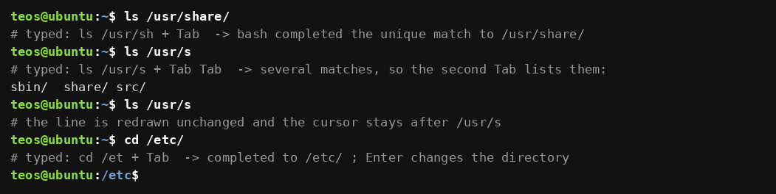
Figure 1.1 – Tab completion
Comment and observation
Typing ls /usr/sh and pressing Tab once completed the only match to ls /usr/share/; a second Tab right after it left the line unchanged (the shell only rang the terminal bell). To see what happens when several names match, the shorter prefix /usr/s was used: two presses of Tab printed the candidates sbin/ share/ src/ and redrew the prompt with the unchanged text. cd /et followed by Tab was completed to cd /etc/, and Enter changed the directory (the prompt in the last line of the figure shows /etc).
For the history exercise three commands were run (echo one, date +%Y, whoami). Ctrl+R switched the prompt to (reverse-i-search); after typing the letters ech bash displayed the most recent command containing them, echo one, and Enter executed it again. Tab therefore saves typing and avoids typing errors, and Ctrl+R finds an old command by any fragment instead of retyping it.

1.2 Built-in and External Commands
type cd ; type ls ; type echo ; which ls
The evidence for this exercise is shown in Figure 1.2.
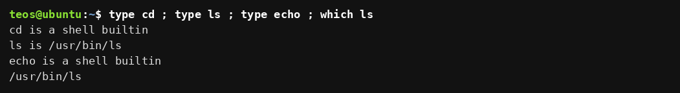
Figure 1.2 – Output of type and which
Comment and observation
type reports cd and echo as shell builtins, while ls is an external program, the file /usr/bin/ls; which ls finds the same file by searching the directories of PATH. A builtin is executed by the shell process itself, an external command needs a new process that loads a file from disk.

1.3 The PATH Variable
echo $PATH
echo $PATH | tr ':' '\n' # one directory per line
echo $PATH | tr ':' '\n' | wc -l
type -a ls
The evidence for this exercise is shown in Figure 1.3.
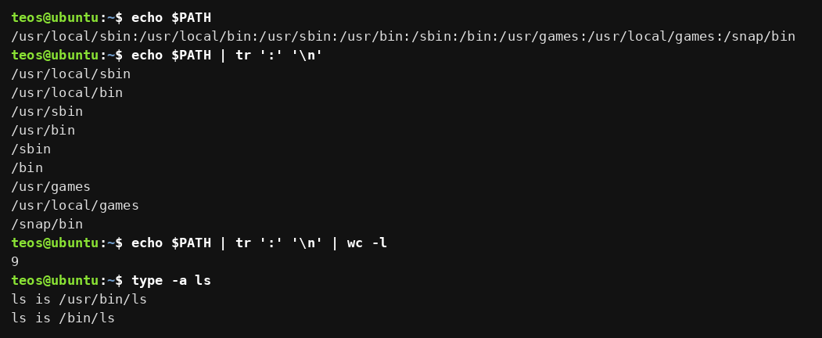
Figure 1.3 – The directories in PATH
Comment and observation
PATH is a colon-separated list of directories. When a command name contains no slash, the shell looks for an executable file with that name in these directories from left to right and runs the first one it finds. After tr replaced every colon with a newline the list is shown one directory per line: /usr/local/sbin, /usr/local/bin, /usr/sbin, /usr/bin, /sbin, /bin, /usr/games, /usr/local/games and /snap/bin, that is 9 directories (wc -l confirms it). type -a ls lists /usr/bin/ls and /bin/ls; both names lead to the same program because on this Ubuntu release /bin is a symbolic link to /usr/bin.

1.4 Exit Codes
nosuchprog ; echo "exit code: $?"
ls /nope ; echo "exit code: $?"
ls / > /dev/null ; echo "exit code: $?"
The evidence for this exercise is shown in Figure 1.4.
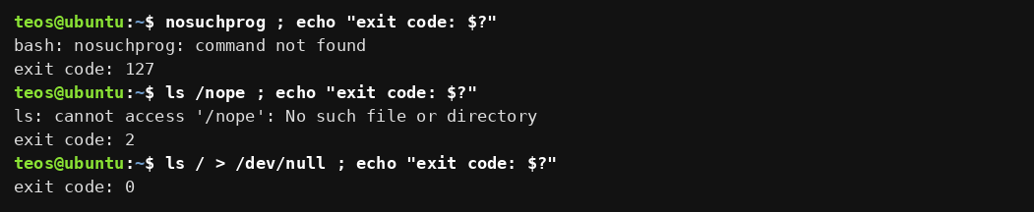
Figure 1.4 – Exit code of a missing command
Comment and observation
$? holds the exit code of the last command. A command that cannot be found returns 127 and the shell prints command not found. For comparison, ls /nope (an existing program that fails) returned 2, and a successful ls / returned 0. By convention 0 means success and every non-zero value means some kind of failure; the && and || operators of Part 3 are built on this convention.

1.5 Finding Help Without a Browser
ls --help | head -5
ls --help | grep -n "sort by time"
help cd | head -3
type help
man ls # inside: /sort, n for next, q to quit
man -k "list directory"
The evidence for this exercise is shown in Figure 1.5.
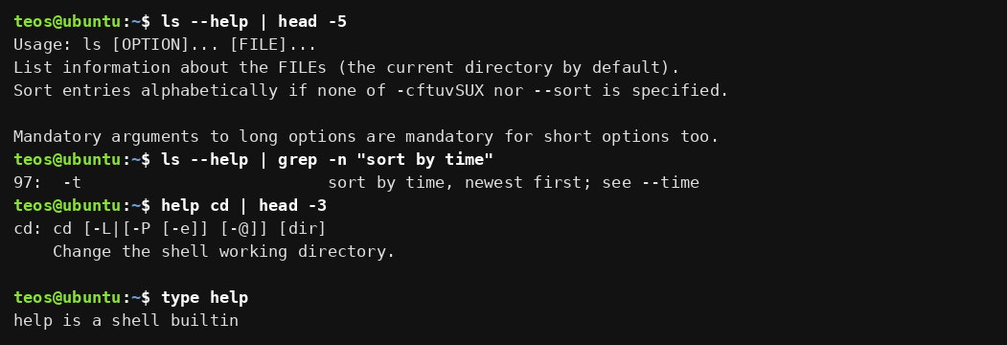
Figure 1.5 – Help from the command itself: --help and help
Comment and observation
Three sources of help were used. External programs describe themselves with --help (ls --help prints the usage line, the description and every option), builtins have no manual page of their own and are described by the builtin help (type help confirms that help is itself a builtin), and man shows the full manual page, where /sort searches for a word, n jumps to the next match and q quits; man -k searches the one-line descriptions of all manual pages for a keyword. The option that sorts ls output by modification time was found with grep -n in the help text: line 97 reads -t sort by time, newest first; see --time.

1.6 Answers to the Observe Questions
(1) Built-ins. cd and echo are built-ins; ls is external (/usr/bin/ls). cd MUST be a built-in because the current working directory is a property of a process. An external program runs in a child process, so a cd executed there would change the directory of the child only, and the child disappears when it finishes; the directory of the shell that started it would stay unchanged. Only the shell itself can change its own working directory.
(2) PATH. The PATH contains 9 directories (Figure 1.3). ls is found in /usr/bin (the name /bin/ls is the same file through the symbolic link /bin → usr/bin).
(3) Exit code. A command that is not found returns 127 (Figure 1.4).
(4) Sorting by time. The option is `-t`: sort by modification time, newest first (ls --help and man ls).

2 What the Shell Does to Your Line
This chapter corresponds to Part 2 of the handout. For every line the prediction was written down first, then the line was executed; the comparison is given in Table 2.1 in Section 2.6.

2.1 Preparing the Test Directory
mkdir -p ~/os-lab3/play && cd ~/os-lab3/play
touch a.c b.c file1.txt file2.txt notes.txt "alfa beta.txt"
ls
The evidence for this exercise is shown in Figure 2.1.
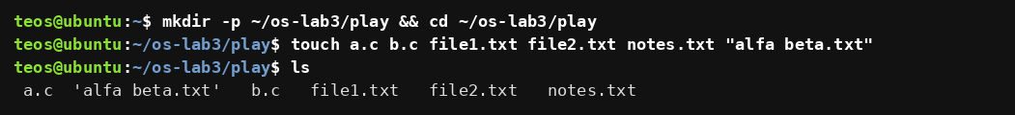
Figure 2.1 – Files created in the play directory
Comment and observation
The directory ~/os-lab3/play contains six files: a.c, b.c, file1.txt, file2.txt, notes.txt and one whose name contains a space, alfa beta.txt. Because the output goes to a terminal, ls shows the name with the space inside single quotes.

2.2 Globbing
echo *.c
echo file?.txt
echo [a-b]*
echo *.xyz
The evidence for this exercise is shown in Figure 2.2.
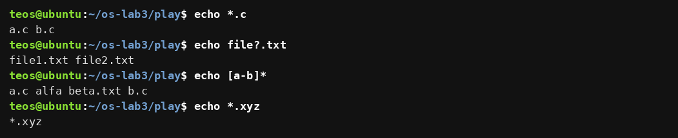
Figure 2.2 – Globbing results
Comment and observation
*.c was replaced by the two names ending in .c; file?.txt matched exactly one character in place of ? (file1.txt, file2.txt); [a-b]* matched every name that begins with a or b, so besides a.c and b.c it also produced alfa beta.txt. The pattern *.xyz matches nothing, and in that case bash leaves the pattern unchanged, so echo printed the text *.xyz itself.

2.3 Spaces in File Names
ls alfa beta.txt
ls "alfa beta.txt"
ls alfa\ beta.txt
ls
The evidence for this exercise is shown in Figure 2.3.
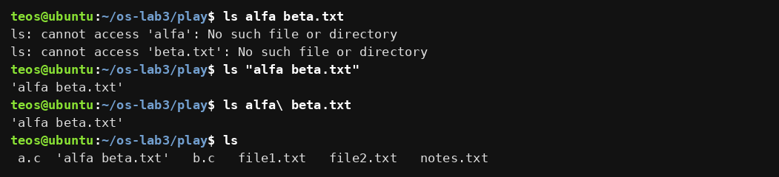
Figure 2.3 – The ls error on a name with a space, and the fix
Comment and observation
The first line failed with two errors, cannot access 'alfa' and cannot access 'beta.txt': the shell split the line at the space into two separate arguments and ls looked for two files that do not exist. Putting the name in double quotes, or escaping the space with a backslash, makes it a single argument and ls prints 'alfa beta.txt' (the quotes in the output are added by ls, see Section 2.7).

2.4 Quoting
echo '$HOME' "$HOME" \$HOME
The evidence for this exercise is shown in Figure 2.4.
Figure 2.4 – Single quotes, double quotes and backslash
Comment and observation
The three forms of the same word gave different results: inside single quotes $HOME stayed literal, inside double quotes it was replaced by the home directory /home/teos, and with a backslash in front of the dollar sign the shell treated it as an ordinary character and printed $HOME.

2.5 Brace Expansion, Arithmetic and Command Substitution
echo {1..5} ; echo $((7 * 6))
echo "today is $(date +%A), I am $(whoami)"
touch log{1..3}.txt && ls log*
The evidence for this exercise is shown in Figure 2.5.
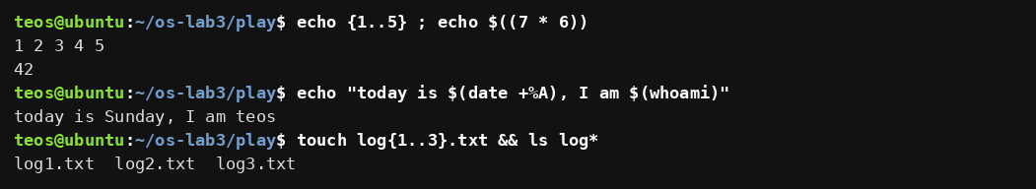
Figure 2.5 – Brace expansion, arithmetic and command substitution
Comment and observation
{1..5} was expanded to the five words 1 2 3 4 5, and $((7 * 6)) was replaced by the result 42. In the second line the shell first ran date +%A and whoami, put their output into the line, and only then started echo. In the third line log{1..3}.txt became log1.txt log2.txt log3.txt, so one touch created three files, which the pattern log* then listed.

2.6 Predictions and Real Output
Table 2.1 – Predictions compared with the real output
Command | My prediction | Real output | Explanation (if different)
echo *.c | a.c b.c | a.c b.c | –
echo file?.txt | file1.txt file2.txt | file1.txt file2.txt | –
echo [a-b]* | a.c b.c | a.c alfa beta.txt b.c | I forgot that alfa beta.txt also begins with a; the range matches the first letter of every name.
echo *.xyz | an empty line | *.xyz | No file matches, so bash does not remove the pattern; echo receives it as an ordinary word.
ls alfa beta.txt | the file name | two errors: cannot access 'alfa' and 'beta.txt' | Word splitting: the shell passes two arguments, not one.
ls "alfa beta.txt" | the file name | 'alfa beta.txt' | Same file; ls itself adds the quotes because the name contains a space.
echo '$HOME' "$HOME" \$HOME | $HOME /home/teos $HOME | $HOME /home/teos $HOME | –
echo {1..5} ; echo $((7 * 6)) | 1 2 3 4 5 and 42 | 1 2 3 4 5 and 42 | –
echo "today is $(date +%A), I am $(whoami)" | today is (weekday), I am teos | today is Sunday, I am teos | – (the weekday is the day of the machine clock)
touch log{1..3}.txt && ls log* | log1.txt log2.txt log3.txt | log1.txt log2.txt log3.txt | – (ls puts the names in columns on a terminal)

2.7 Answers to the Observe Questions
(1) Predictions. The table in Section 2.6 contains, for every line, the prediction, the real output and an explanation where they differ (three lines differed: [a-b]*, *.xyz and ls alfa beta.txt).
(2) Who produced the file names? The shell. echo knows nothing about files: before starting it, bash expands the pattern *.c into the list of matching names (globbing) and passes a.c b.c to echo as two ordinary arguments. echo simply prints its arguments.
(3) Why did ls alfa beta.txt fail? The shell splits the line into words at spaces, so ls received two arguments, alfa and beta.txt, and neither file exists. Two fixes: quote the name, ls "alfa beta.txt", or escape the space with a backslash, ls alfa\ beta.txt (single quotes work as well).
(4) Single versus double quotes. Single quotes keep everything literal: no variable, command, arithmetic or glob expansion takes place inside them. Double quotes still protect spaces and wildcards from splitting and globbing, but allow $variable, $(command), $((expression)) and backslash escapes to be expanded. A backslash outside quotes removes the special meaning of the one character that follows it.
Why does ls show 'alfa beta.txt' in quotes? Because the name contains a character that is special for the shell. When its output is a terminal, GNU ls prints such names in shell-quoted form, so that the line can be copied and pasted back into a command and still mean the same file. When the output goes into a pipe or a file, the name is printed without quotes.

3 Redirection, Chaining and Jobs
This chapter corresponds to Part 3 of the handout. All commands were run in ~/os-lab3, where access.log is stored.

3.1 Separate Files for stdout and stderr
ls /etc /nope > out.txt 2> err.txt
wc -l out.txt ; cat err.txt
The evidence for this exercise is shown in Figure 3.1.
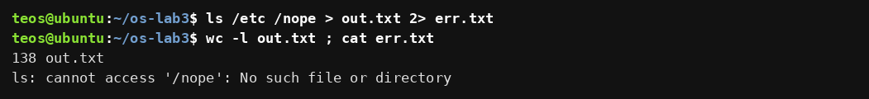
Figure 3.1 – stdout and stderr in separate files
Comment and observation
The first command printed nothing on the screen: its standard output (descriptor 1) was redirected to out.txt and its standard error (descriptor 2) to err.txt. out.txt holds 138 lines, the heading /etc: followed by the 137 names of the directory, and err.txt contains the single message ls: cannot access '/nope': No such file or directory.

3.2 The Order of Redirections
ls /etc /nope > all.txt 2>&1 ; tail -2 all.txt ; grep -c nope all.txt
ls /etc /nope 2>&1 > all.txt ; tail -2 all.txt ; grep -c nope all.txt
The evidence for this exercise is shown in Figure 3.2.
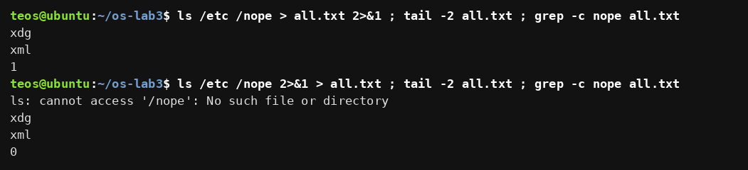
Figure 3.2 – Comparing the order of redirections
Comment and observation
With > all.txt 2>&1 nothing appeared on the screen and grep -c nope all.txt found the error message in the file (count 1): both streams ended up in all.txt. With 2>&1 > all.txt the error message appeared on the screen, and the file contained only the listing (the count of lines with nope is 0). The same two commands, with the redirections in the opposite order, therefore give different results.

3.3 The Operators ; && ||
ls /nope 2> /dev/null || echo "failed with code $?"
mkdir -p tmp && cd tmp && echo "I am in $(pwd)" ; cd ~/os-lab3
false ; echo "after ; (always runs)"
false && echo "after && (skipped)"
true || echo "after || (skipped)"
The evidence for this exercise is shown in Figure 3.3.
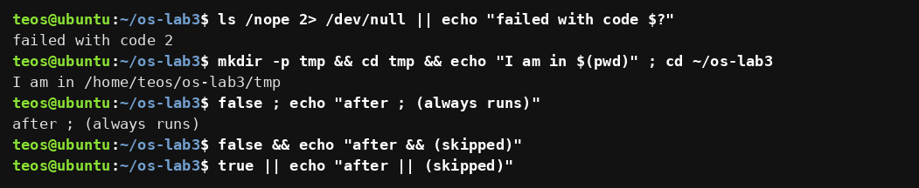
Figure 3.3 – The ; && || operators
Comment and observation
The error message of ls /nope was thrown away into /dev/null, and because ls failed, the part after || ran and reported the exit code 2. In the second line mkdir, cd and echo ran one after another because each one succeeded; the echo showed the new directory /home/teos/os-lab3/tmp, and the final cd ~/os-lab3 after ; ran in any case and returned to the lab directory (the prompt in the figure confirms it). The three extra lines with false and true show the rules directly: the command after ; always runs, the command after && was skipped because false fails, and the command after || was skipped because true succeeds.

3.4 Background Jobs
sleep 100 &
jobs
kill %1
jobs
The evidence for this exercise is shown in Figure 3.4.
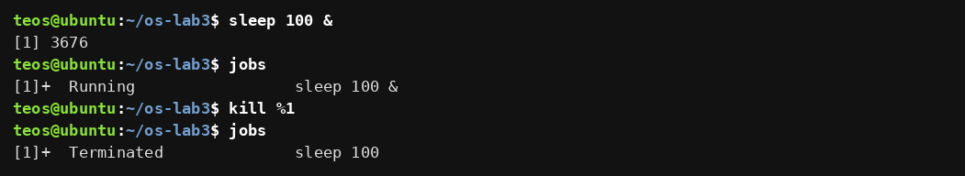
Figure 3.4 – Running a background job and stopping it
Comment and observation
The & at the end of the line started sleep 100 in the background; the shell printed the job number and the process number ([1] 3676) and returned the prompt immediately. jobs listed the job as Running. kill %1 sent the default termination signal to job number 1, and the next jobs reported it as Terminated.

3.5 Append and Input Redirection
echo first > notes.md ; echo second >> notes.md ; cat notes.md
wc -l < access.log
wc -l access.log
The evidence for this exercise is shown in Figure 3.5.
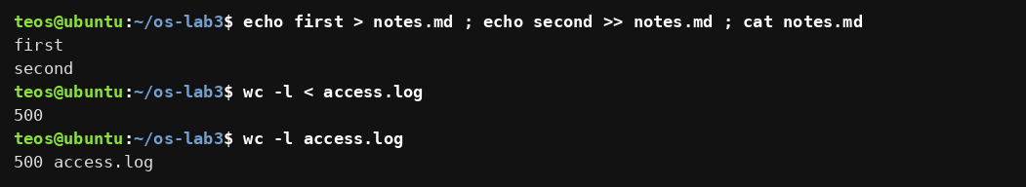
Figure 3.5 – Append (>>) and input redirection (<)
Comment and observation
> creates the file (or empties an existing one), >> appends to it: after echo first > notes.md and echo second >> notes.md the file contains both lines. wc -l < access.log printed only 500, while wc -l access.log printed 500 access.log.

3.6 Answers to the Observe Questions
(1) Which file got what? In Figure 3.1 the listing went to out.txt and the error message ls: cannot access '/nope'… went to err.txt.
(2) > all.txt 2>&1 versus 2>&1 > all.txt. The shell processes redirections from left to right, and 2>&1 means "make descriptor 2 point to the place where descriptor 1 points now". In > all.txt 2>&1, descriptor 1 is first connected to the file and then descriptor 2 is made a copy of it, so both streams go to all.txt. In 2>&1 > all.txt, descriptor 2 is first made a copy of descriptor 1 while it still points at the terminal, and only afterwards descriptor 1 is moved to the file; so the errors stay on the screen and only the listing reaches the file (Figure 3.2: count 1 versus count 0).
(3) wc -l < access.log versus wc -l access.log. With < the shell opens the file and gives it to wc as standard input; wc only sees a stream of bytes and does not know a file name, so it prints just the number. With the file name as an argument wc opens the file itself, knows its name and prints it after the count.
(4) The operators. ; runs the next command after the previous one has finished, whatever its result; && runs the next command only if the previous one succeeded (exit code 0); || runs the next command only if the previous one failed (non-zero exit code).

4 One-Liners over the Access Log
This chapter corresponds to Part 4 of the handout. Every question was answered with a single command line (pipes allowed) over access.log; the lines were saved in oneliners.sh, each preceded by the question as a comment. Fields of the log are separated by a space: 1 date, 2 time, 3 user, 4 result, 5 page.

4.1 Q1. How many requests failed?
grep -c FAIL access.log
The evidence for this exercise is shown in Figure 4.1.
Figure 4.1 – Number of failed requests
Comment and observation
grep -c counts the matching lines instead of printing them. 100 requests failed, which is exactly every fifth request of the 500 (the generator marks the request as FAIL when the counter is divisible by 5).

4.2 Q2. How many different pages were requested, and which?
echo "$(cut -d' ' -f5 access.log | sort -u | wc -l) different pages:" $(cut -d' ' -f5 access.log | sort -u)
The evidence for this exercise is shown in Figure 4.2.
Figure 4.2 – Number and names of the requested pages
Comment and observation
cut -d' ' -f5 keeps only the fifth field (the page), sort -u sorts it and removes duplicates, and wc -l counts the remaining lines. The command substitutions put the count and the list into one line: 4 different pages, /page0, /page1, /page2 and /page3.

4.3 Q3. How many requests did each page get?
cut -d' ' -f5 access.log | sort | uniq -c
The evidence for this exercise is shown in Figure 4.3.
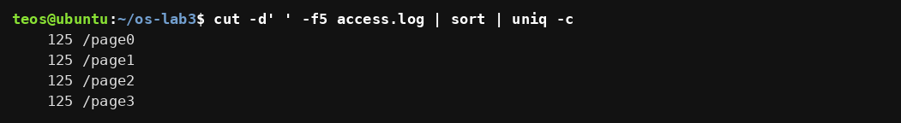
Figure 4.3 – Requests per page
Comment and observation
uniq -c counts runs of identical neighbouring lines, which is why sort must come before it. Every page received 125 requests. Self-check: 4 × 125 = 500, the number of lines of the log.

4.4 Q4. Which user or users have the most failed requests?
grep FAIL access.log | cut -d' ' -f3 | sort | uniq -c | sort -rn
grep FAIL access.log | cut -d' ' -f3 | sort | uniq -c | sort -rn | awk 'NR==1{m=$1} $1==m'
The evidence for this exercise is shown in Figure 4.4.
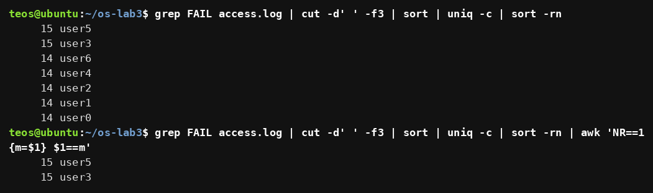
Figure 4.4 – Failed requests per user and the users with the maximum
Comment and observation
The first pipeline counts the failed requests per user and sorts the counts in descending order: user5 and user3 have 15 failures each, the other five users have 14. Because the maximum is shared, head -1 would hide one of the two users; the awk filter in the second line prints every line whose count equals the count of the first line. The answer is therefore user5 and user3, 15 failed requests each. Self-check: 15 + 15 + 5 × 14 = 100, which equals the result of Q1.

4.5 Q5. How many requests did user3 make, and how many of them failed?
echo "$(grep -c user3 access.log) requests, $(grep user3 access.log | grep -c FAIL) failed"
The evidence for this exercise is shown in Figure 4.5.
Figure 4.5 – Requests and failures of user3
Comment and observation
The first grep -c counts all lines of user3; the second pipeline keeps only those lines that also contain FAIL. user3 made 72 requests and 15 of them failed.

4.6 Q6. The last 3 failed requests, only time and user
grep FAIL access.log | tail -3 | cut -d' ' -f2,3
The evidence for this exercise is shown in Figure 4.6.
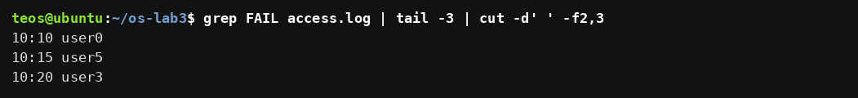
Figure 4.6 – The last three failed requests (time and user)
Comment and observation
grep FAIL selects the failed requests, tail -3 keeps the last three of them, and cut -f2,3 prints only the time and the user. The result is 10:10 user0, 10:15 user5 and 10:20 user3.

4.7 Q7. Login shells in /etc/passwd
cut -d: -f7 /etc/passwd | sort | uniq -c | sort -rn
The evidence for this exercise is shown in Figure 4.7.
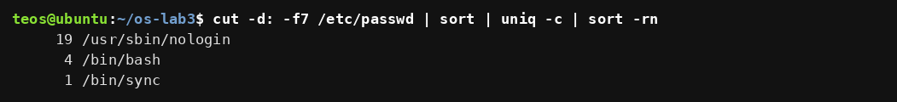
Figure 4.7 – Login shells and the number of accounts using each
Comment and observation
The seventh field of every line of /etc/passwd is the login shell. On this system /usr/sbin/nologin is used by 19 accounts (system accounts that must not log in), /bin/bash by 4 accounts and /bin/sync by 1 account. The numbers depend on the accounts of the machine on which the command is run.

4.8 Q8. ls /etc | wc -l versus ls -l /etc | wc -l
ls /etc | wc -l
ls -l /etc | wc -l
ls -l /etc 2>&1 | grep total
The evidence for this exercise is shown in Figure 4.8.
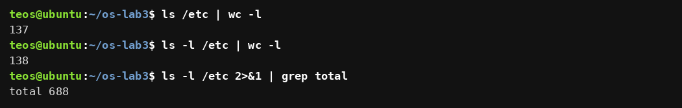
Figure 4.8 – The two counts and the extra line of the long listing
Comment and observation
Prediction: ls -l prints one extra line before the entries, so its count will be exactly one larger. Real output: 137 for ls /etc | wc -l and 138 for ls -l /etc | wc -l. The third command confirms the prediction: the long format starts with a summary line total 688 (the number of disk blocks used by the listed files), which is not a directory entry but is counted by wc -l as a line. wc -l counts lines, and ls prints one entry per line when its output goes into a pipe, so the difference is that single total line.

4.9 The Complete oneliners.sh
# Q1. How many requests failed?
grep -c FAIL access.log
# Q2. How many different pages were requested, and which?
echo "$(cut -d' ' -f5 access.log | sort -u | wc -l) different pages:" $(cut -d' ' -f5 access.log | sort -u)
# Q3. How many requests did each page get?
cut -d' ' -f5 access.log | sort | uniq -c
# Q4. Which user or users have the most failed requests, and how many?
grep FAIL access.log | cut -d' ' -f3 | sort | uniq -c | sort -rn | awk 'NR==1{m=$1} $1==m'
# Q5. How many requests did user3 make, and how many of them failed?
echo "$(grep -c user3 access.log) requests, $(grep user3 access.log | grep -c FAIL) failed"
# Q6. Print the last 3 failed requests, showing only time and user.
grep FAIL access.log | tail -3 | cut -d' ' -f2,3
# Q7. Which login shells appear in /etc/passwd, and how many accounts use each?
cut -d: -f7 /etc/passwd | sort | uniq -c | sort -rn
# Q8. Why do ls /etc | wc -l and ls -l /etc | wc -l differ by exactly one?
ls /etc | wc -l ; ls -l /etc | wc -l
The evidence for this exercise is shown in Figure 4.9.
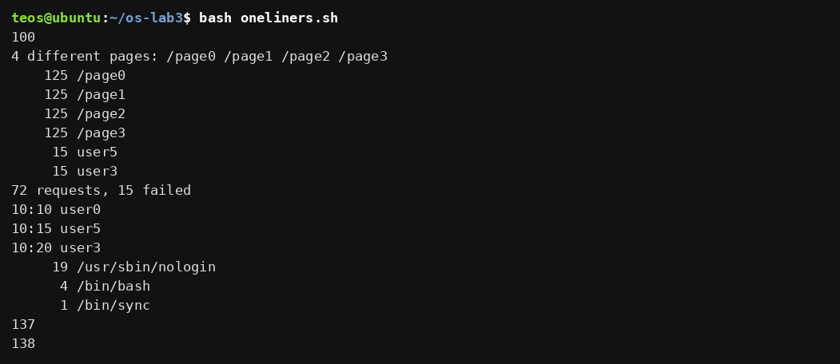
Figure 4.9 – Full run of oneliners.sh
Comment and observation
bash oneliners.sh inside ~/os-lab3 ran all eight lines in order: 100; the four pages; four times 125; the two users with 15 failures; 72 requests, 15 failed; the three last failures; the three login shells; and the numbers 137 and 138. Both self-checks of the handout hold: the page counts of Q3 add up to 500, and the per-user failure counts behind Q4 add up to 100, the result of Q1.

4.10 Bonus: Failed Requests Whose Minute Ends in 0
grep -E ' 10:[0-5]0 .*FAIL' access.log | wc -l
grep -E ' 10:[0-5]0 .*FAIL' access.log | head -3
The evidence for this exercise is shown in Figure 4.10.
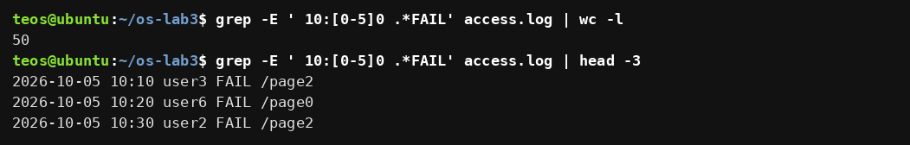
Figure 4.10 – Failed requests whose minute ends in 0
Comment and observation
The extended regular expression 10:[0-5]0 .*FAIL matches the time field with a minute from 00 to 50 in steps of ten (10:00, 10:10, …, 10:50) followed later in the line by FAIL. There are 50 such lines. Every request whose minute ends in 0 fails: the minute is the request counter modulo 60, so a minute ending in 0 means that the counter is divisible by 10, hence by 5, and the generator marks it FAIL; the pattern therefore matches all 50 requests with such a minute.

5 Your First Script
This chapter corresponds to Part 5 of the handout. The best one-liners were turned into the program report.sh, which prints the numbers of requests and failures and the number of failures of every user from user0 to user6.

5.1 Contents of report.sh
cat report.sh
The evidence for this exercise is shown in Figure 5.1.
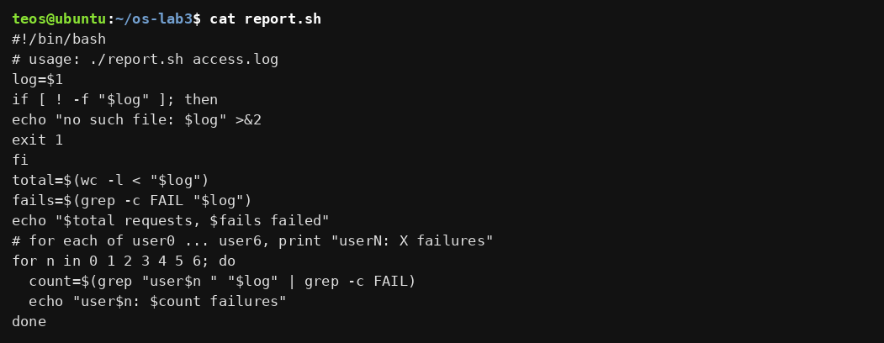
Figure 5.1 – Contents of report.sh
Comment and observation
The script is the template of the handout with the TODO completed: a for loop runs over the numbers 0 to 6; for each n it selects the lines of userN (the trailing space in the pattern "user$n " prevents a match on longer names), counts those with FAIL and prints userN: X failures.

5.2 Making the Script Executable and Running It
chmod +x report.sh
./report.sh access.log
The evidence for this exercise is shown in Figure 5.2.
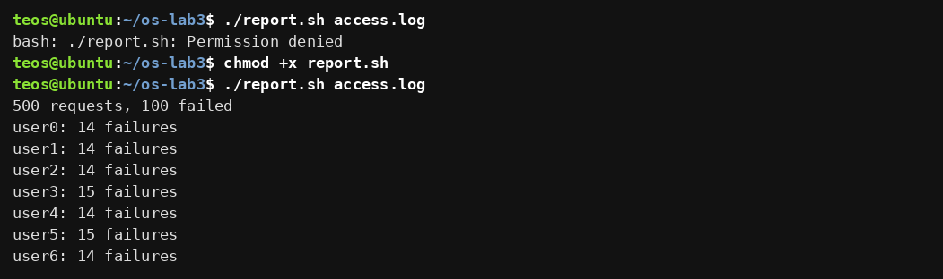
Figure 5.2 – Running the script on access.log (before and after chmod +x)
Comment and observation
The first attempt, before chmod +x, failed with Permission denied: the file has no execute permission. After chmod +x report.sh the script ran and printed 500 requests, 100 failed followed by one line per user: 14 failures for user0, user1, user2, user4 and user6, and 15 for user3 and user5. The numbers agree with Q1 and Q4 of Part 4.

5.3 Error Handling
./report.sh nope.log ; echo "exit code: $?"
./report.sh nope.log > /dev/null ; echo "exit code: $?"
The evidence for this exercise is shown in Figure 5.3.
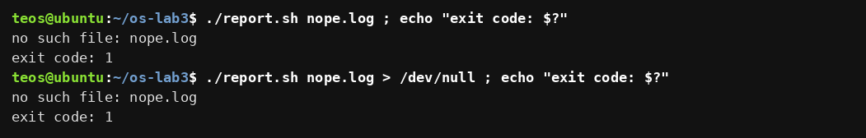
Figure 5.3 – Error handling for a missing file
Comment and observation
For a file that does not exist the script printed no such file: nope.log and ended with exit code 1. In the second command the standard output was thrown away into /dev/null, and the error message was still shown, which proves that it was written to standard error.

5.4 Why ./ Is Needed
report.sh access.log
bash report.sh access.log
The evidence for this exercise is shown in Figure 5.4.
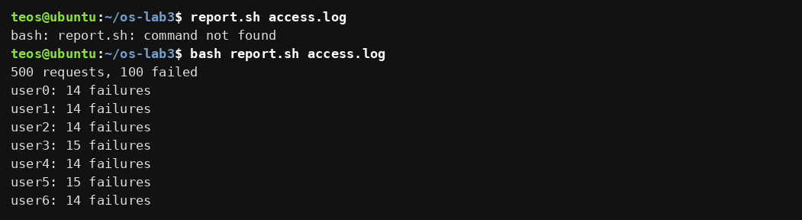
Figure 5.4 – Calling the script without ./ and through bash explicitly
Comment and observation
report.sh access.log failed with command not found, although the file is in the current directory. bash report.sh access.log worked because the program being started is bash, which is found in PATH, and the script is only its argument.

5.5 Answers to the Observe Questions
(1) The first line. #!/bin/bash (the "shebang") tells the kernel which interpreter must run the file: when a file starting with #! is executed, the kernel starts /bin/bash and gives it the script as its argument. Without chmod +x the execute permission is missing, so the shell refuses to run the file: bash: ./report.sh: Permission denied (Figure 5.2).
(2) Why ./report.sh? A command name without a slash is searched only in the directories of PATH, and the current directory is not among them (Figure 1.3); this is deliberate, so that a program placed in a directory cannot silently replace a standard command. A name that contains a slash, such as ./report.sh, is taken as a path and no search is made. Figure 5.4 shows the failure of the form without ./.
(3) Why >&2 and exit 1? >&2 sends the error message to standard error, so that it is not mixed with the normal results when the output is redirected or piped (Figure 5.3: the message stayed visible when stdout went to /dev/null). exit 1 stops the script immediately and gives it a non-zero exit code, so that the caller (the shell with $?, && and ||, or a scheduler such as cron) can detect the failure; without it the script would go on working with a missing file and could end with exit code 0.

Conclusion
In this laboratory work the real Linux command line was explored from the outside. Tab completion and Ctrl+R shortened the work at the prompt; type, which and PATH showed how the shell decides between built-in and external commands and why cd has to be built in; exit codes (127 for a missing command, 0 for success) turned out to be the basis of && and ||.
The predictions of Part 2 showed what the shell does with a line before the command runs: it expands patterns, variables, braces, arithmetic and command substitutions, splits words at spaces, and removes quotes, so the program only receives the finished list of arguments. The three mismatches ([a-b]*, the unmatched pattern *.xyz and the unquoted name with a space) all came from this rewriting. In Part 3 the order of > file 2>&1 was shown to matter, and jobs were started in the background and stopped.
In Part 4 eight questions about a 500-line access log were answered with pipelines of grep, cut, sort, uniq, wc, head and tail; the results are consistent (100 failures, 4 × 125 requests, 15 + 15 + 5 × 14 failures per user). Finally, report.sh combined the same tools with a variable, a test, a loop and exit codes into a first script that checks its argument, reports errors on standard error and ends with a meaningful exit code. The files report.sh and oneliners.sh are delivered together with the report.

References
[1] Operating Systems Lab 3 handout. Lab 3 – The Command Line: Shell, Pipes and Text Filters (Track A). FCIM / FAF / UTM, 2026–2027.
[2] Free Software Foundation. GNU Bash Reference Manual. https://www.gnu.org/software/bash/manual/.
[3] Free Software Foundation. GNU Coreutils Manual (ls, wc, cut, sort, uniq, tail, head, tr). https://www.gnu.org/software/coreutils/manual/.
[4] GNU grep Manual. https://www.gnu.org/software/grep/manual/.
[5] The Open Group. POSIX Shell Command Language (redirection, pipelines, exit status). https://pubs.opengroup.org/onlinepubs/9699919799/utilities/V3_chap02.html.

