Here will have more information in the future 0.0  
But now only file name :D

Therefore, this document is not the final version, and its contents may change :-P

Cockpit:  
(Format:Titan_Cockpit_col.dds)

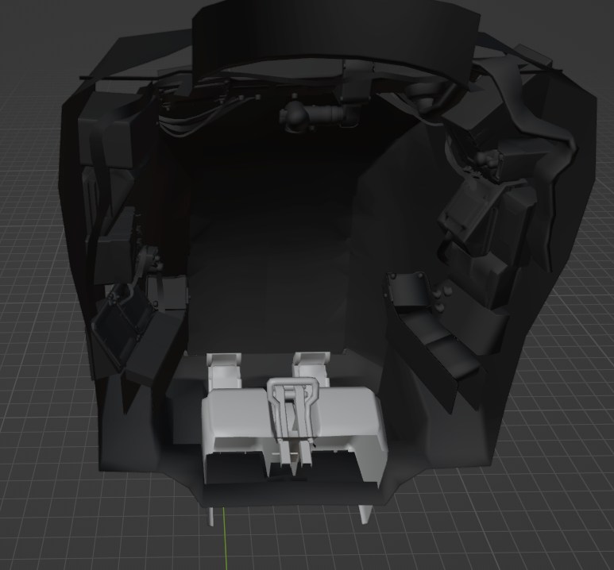

Console:  
(Format:Titan_Console_col.dds)

