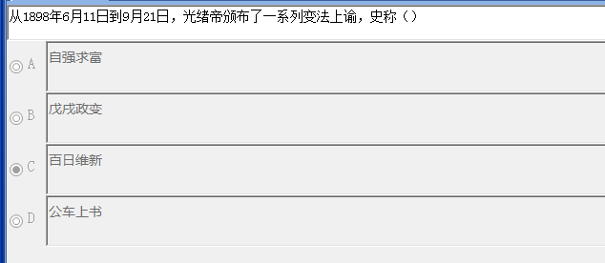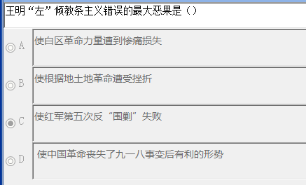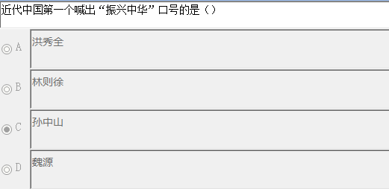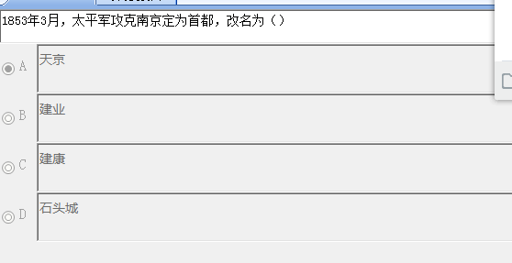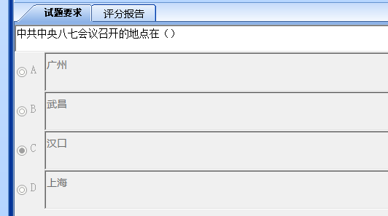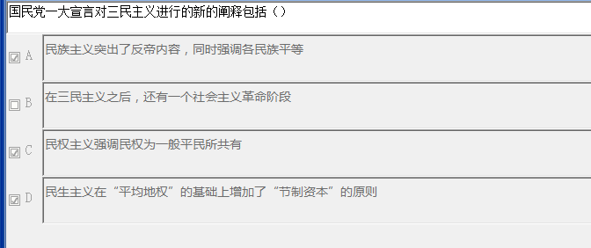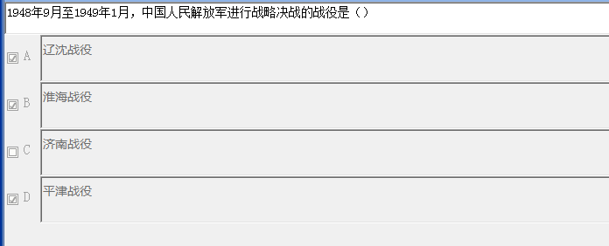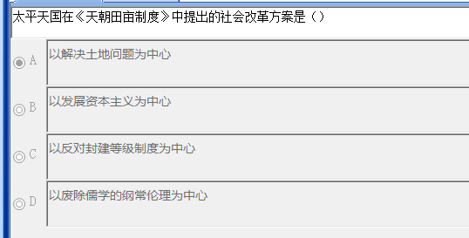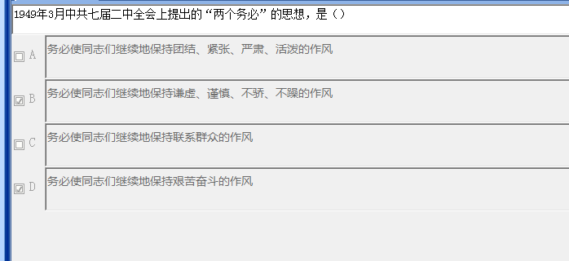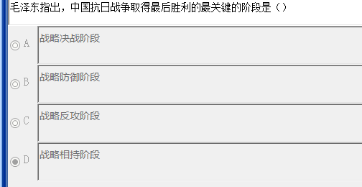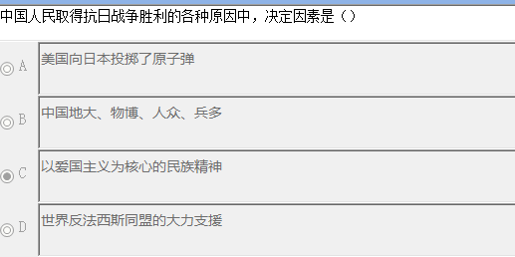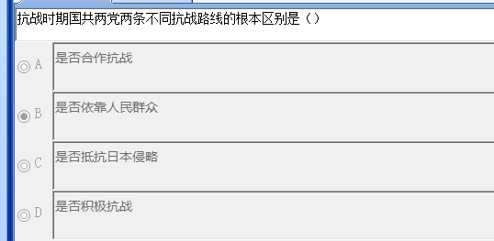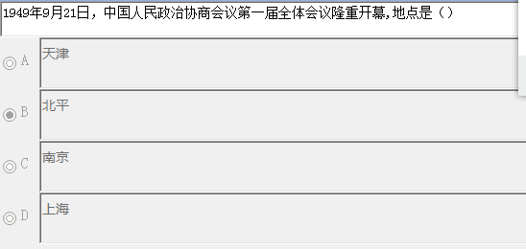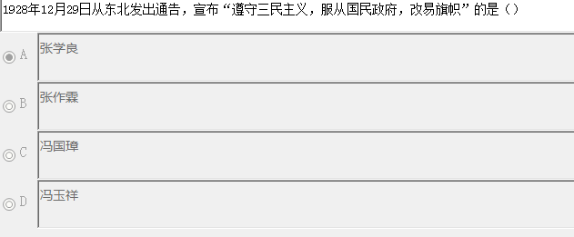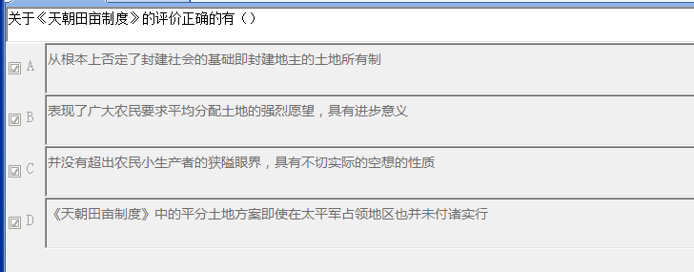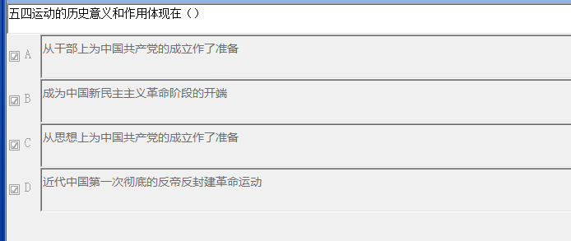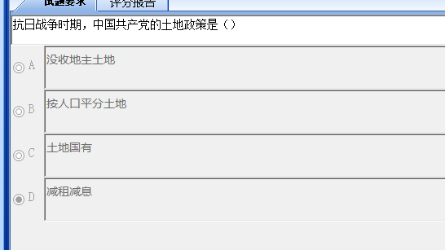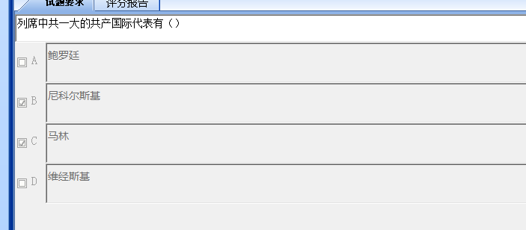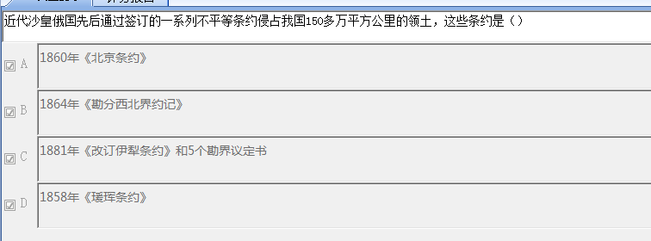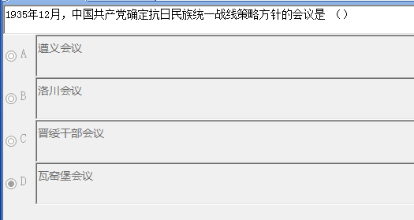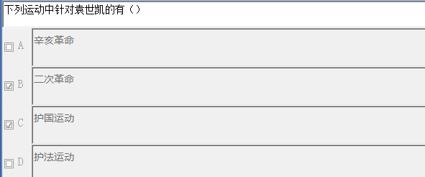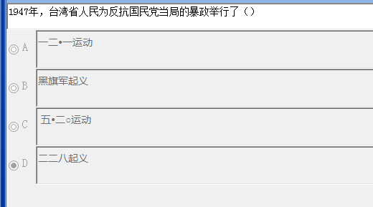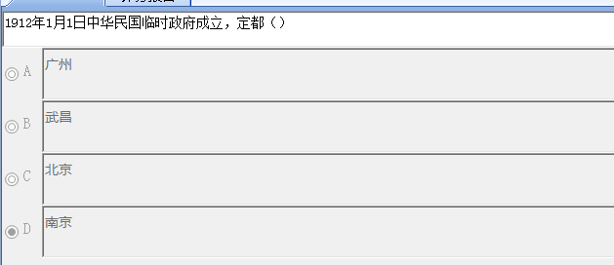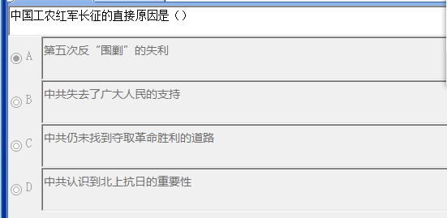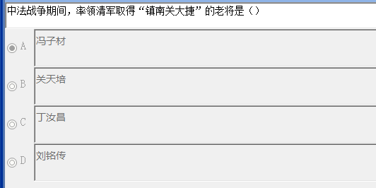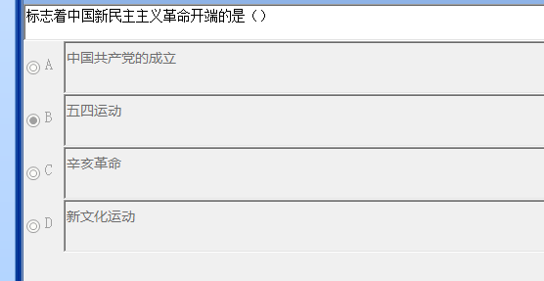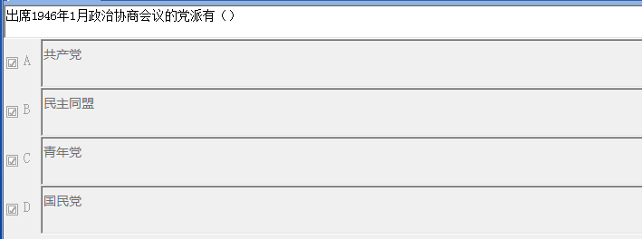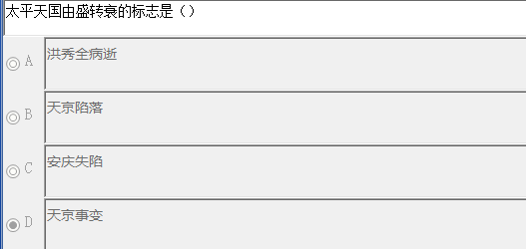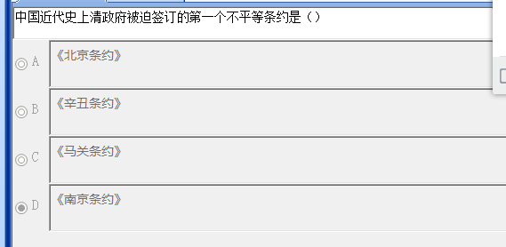

多选

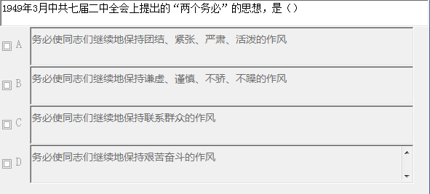

BD

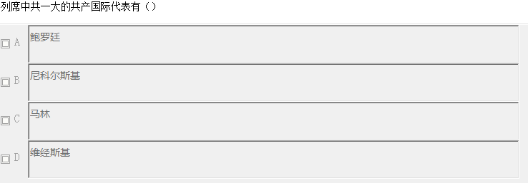

BC

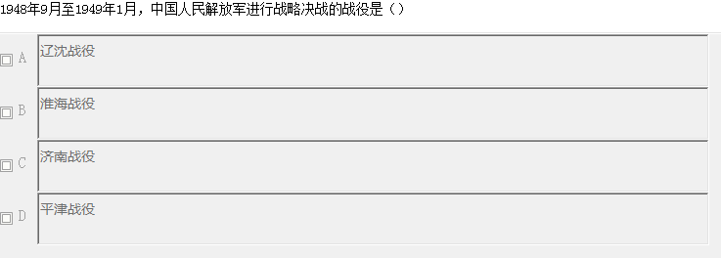

ABD

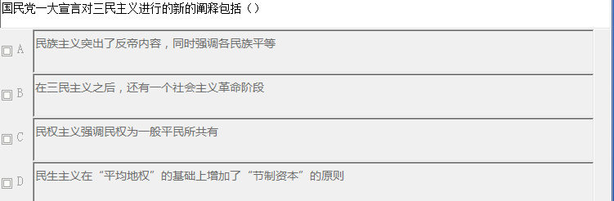

ACD

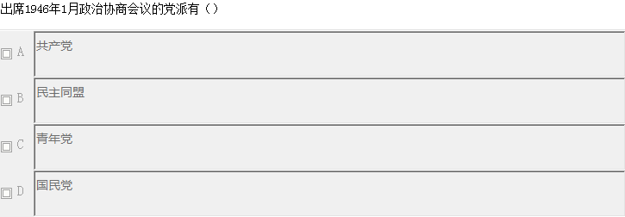

ABCD

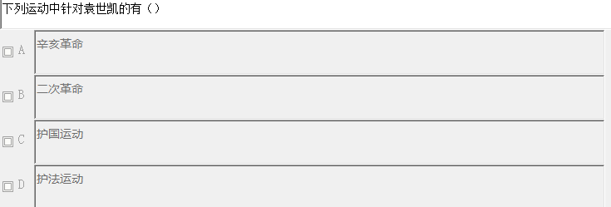

BC

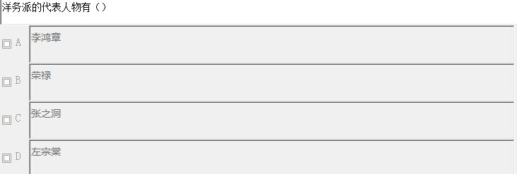

ACD

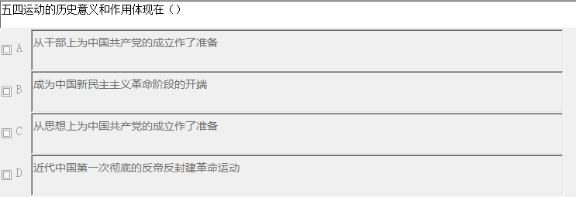

ABCD

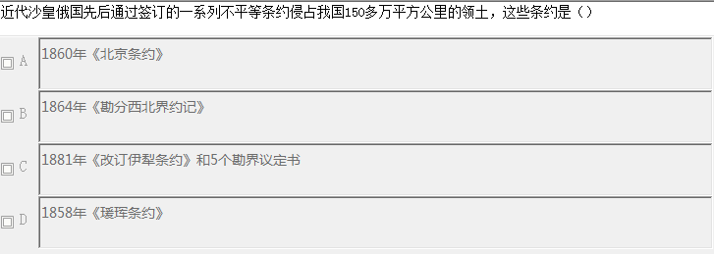

ABCD

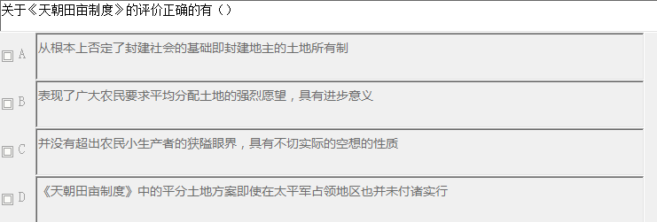

ABCD

C:\Users\Administrator\AppData\Roaming\Tencent\Users\619648193\QQ\WinTemp\RichOle\[N_O%G_LUMSRPJ[%MZY6C`M.png

错误

C:\Users\Administrator\AppData\Roaming\Tencent\Users\619648193\QQ\WinTemp\RichOle\5X[%%4@JDP(ZL9W0GT2OO)G.png

错误

C:\Users\Administrator\AppData\Roaming\Tencent\Users\619648193\QQ\WinTemp\RichOle\YC(7ELF2(R`7[RUXAH[G`IK.png

正确

C:\Users\Administrator\AppData\Roaming\Tencent\Users\619648193\QQ\WinTemp\RichOle\G22X3FZWD8SF01)%1I5(FHY.png

错误

C:\Users\Administrator\AppData\Roaming\Tencent\Users\619648193\QQ\WinTemp\RichOle\3{@VOQZZ21JOV%2)1Z4YV50.png

错误

C:\Users\Administrator\AppData\Roaming\Tencent\Users\619648193\QQ\WinTemp\RichOle\6%I3{8{DFBHR])IA2_@){E5.png

错误

C:\Users\Administrator\AppData\Roaming\Tencent\Users\619648193\QQ\WinTemp\RichOle\TC{LOBV)F]JN@ARN(PHCWZ2.png

正确

C:\Users\Administrator\AppData\Roaming\Tencent\Users\619648193\QQ\WinTemp\RichOle\%[6SYHL)TX(AVSK6J{8IEZQ.png

错误

C:\Users\Administrator\AppData\Roaming\Tencent\Users\619648193\QQ\WinTemp\RichOle\B@4P[4PT1EUM@O`K9L5Q%X1.png

错误

C:\Users\Administrator\AppData\Roaming\Tencent\Users\619648193\QQ\WinTemp\RichOle\}3APZA0{LO[UY09XC5~MT80.png

正确

C:\Users\Administrator\AppData\Roaming\Tencent\Users\619648193\QQ\WinTemp\RichOle\88[EP5E]0Y}LQ6E5M678YNN.png

正确

C:\Users\Administrator\AppData\Roaming\Tencent\Users\619648193\QQ\WinTemp\RichOle\%3J@N@5~1A(1U9EZ3ZEB`77.png

错误

C:\Users\Administrator\AppData\Roaming\Tencent\Users\619648193\QQ\WinTemp\RichOle\9NPC~Y@58JQG%TVDP{O_RMA.png

错误

C:\Users\Administrator\AppData\Roaming\Tencent\Users\619648193\QQ\WinTemp\RichOle\VI`EQT3HM~BXCVY{1GZZS7V.png

《论人民民主专政》



江西



邓世昌



平型关



宋教仁



重庆



工农联盟