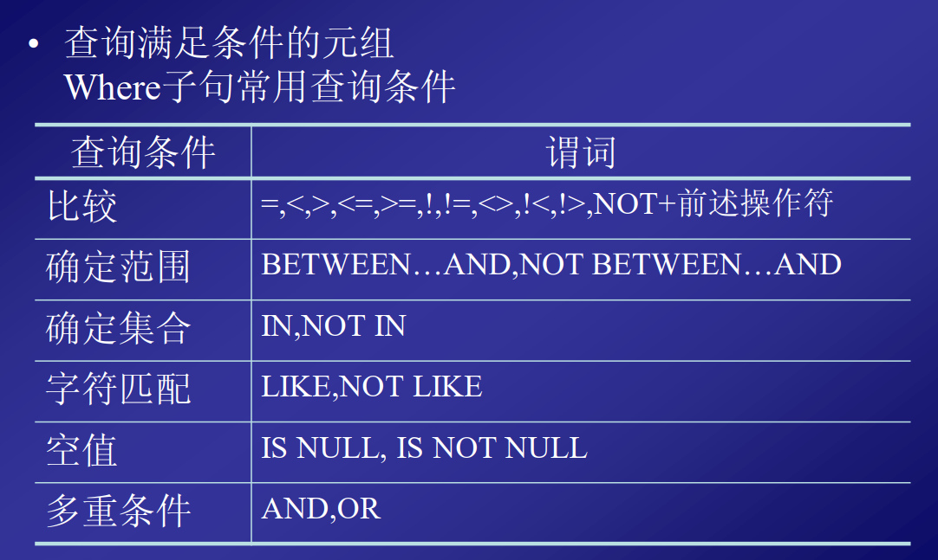

1. 日期

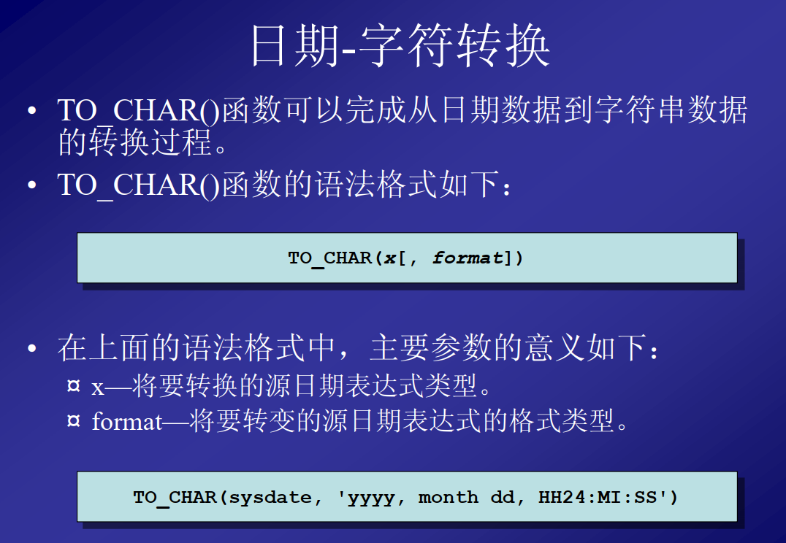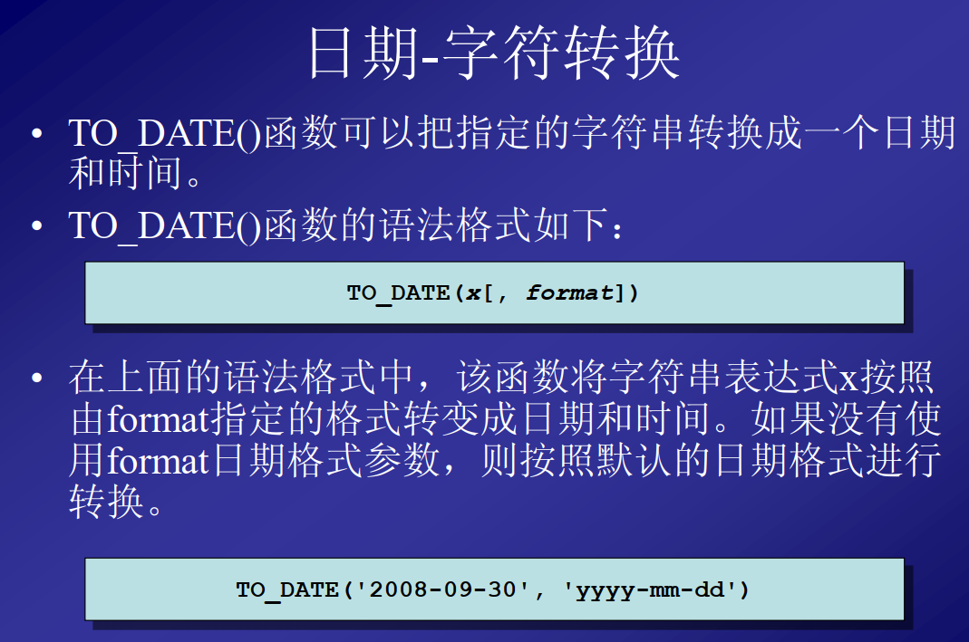

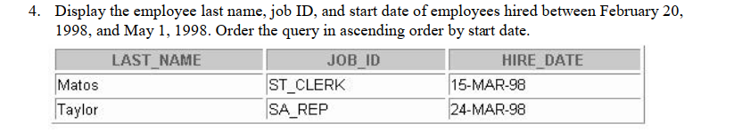

select last_name,job_id,hire_date from employees

where hire_date between to_date('1998-02-20','yyyy-mm-dd') and to_date('1998-05-01','yyyy-mm-dd');

2.



select last_name,job_id from employees

where employees.manager_id is null;

此处is用 = 是无法得到正确答案的

3.

select last_name,job_id,salary from employees

where job_id in ('SA_REP','ST_CLERK') and salary not in (2500,3500,7000);

4.decode+sum+group by

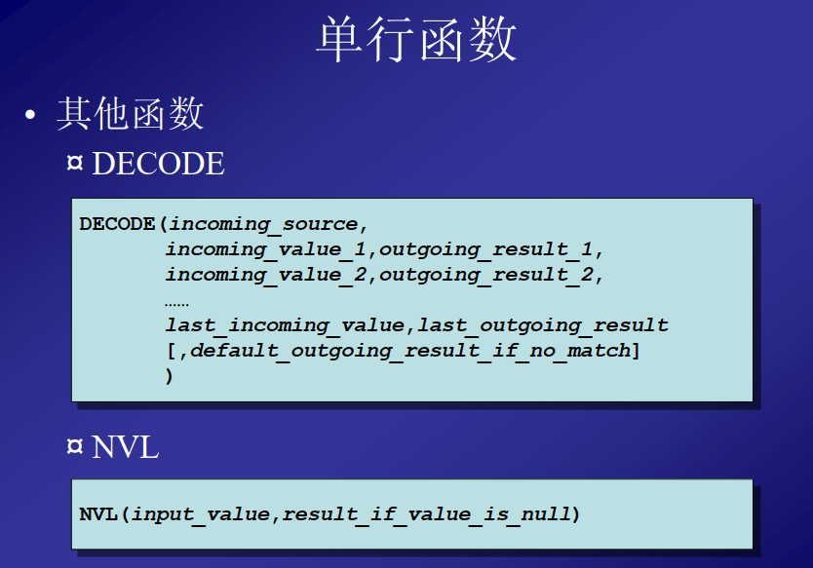

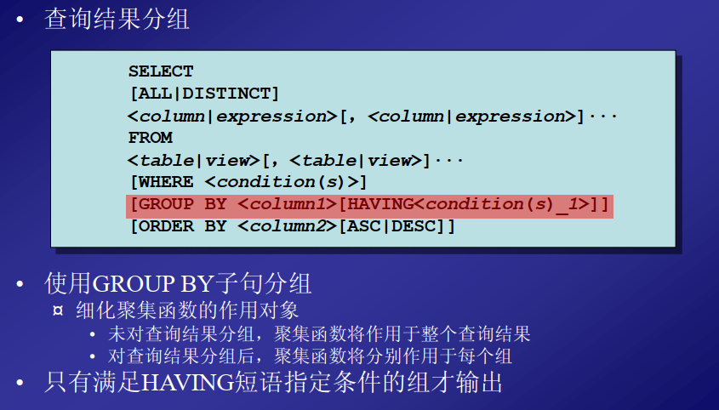

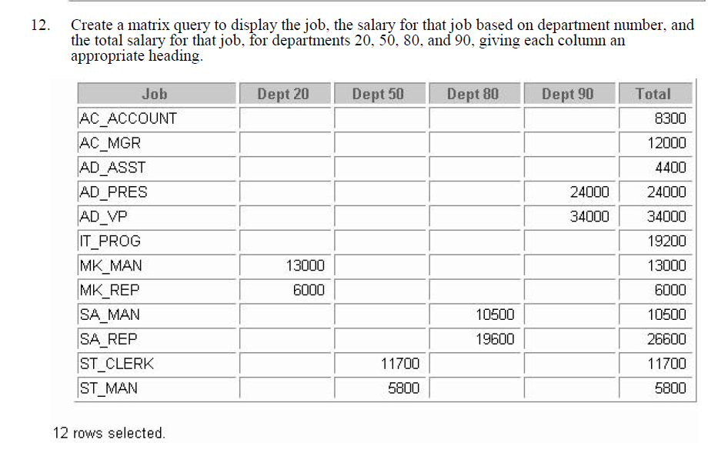

SELECT job_id "Job",

SUM(decode(department_id,20,salary)) "Dept 20",

SUM(decode(department_id,50,salary)) "Dept 50",

SUM(decode(department_id,80,salary)) "Dept 80",

SUM(decode(department_id,90,salary)) "Dept 90",

SUM(salary) "Total"

from employees

group by job_id