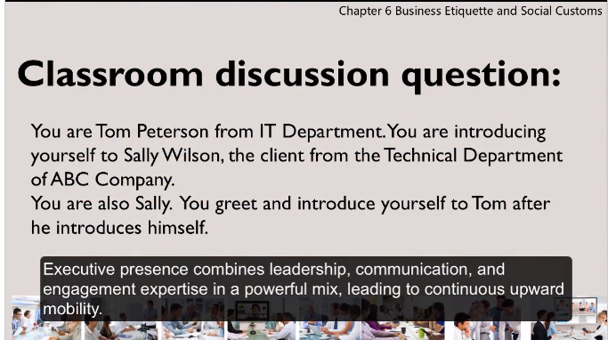

Hi, I am Tom Peterston from the IT department. If you need any tech assistance I am glad to be calling.

That was great, Tom. I’m Sally Wilson from the Technical Department of ABC Company. It is nice to cooperate with you.

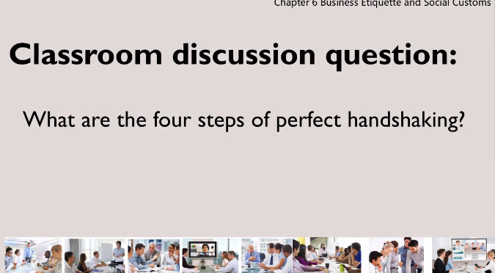

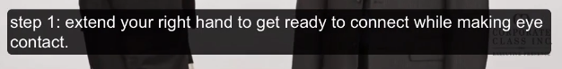







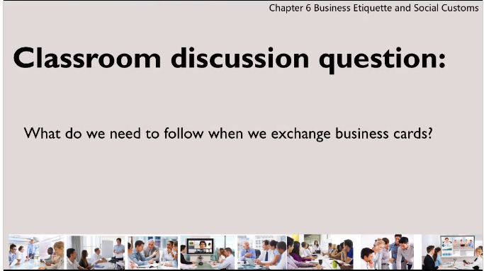  


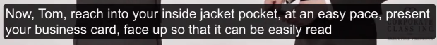





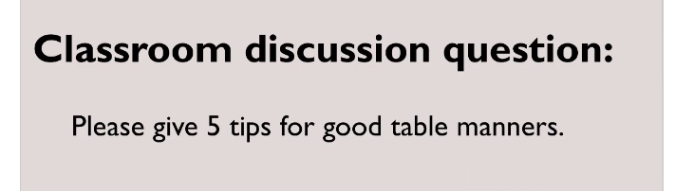

1.





2.



3.







4.





5.





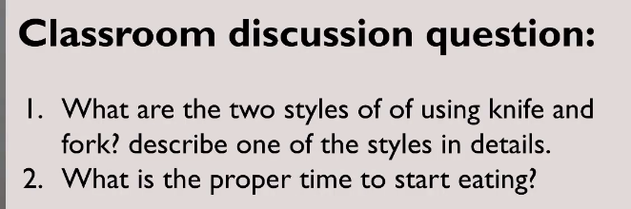

1.







2.

