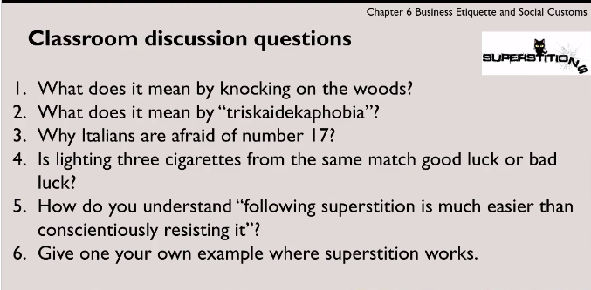

1. touching something made of wood to ensure good luck and get rid of bad luck







1. Fear of the number thirteen







4.





5.













6. Chinese like number 8 because it can make us feel lucky.



We are in a collectivism culture so sometimes people will not follow the time schedule but solving problems with relationship.

Case Study

1. Different ideas to face local superstition.

2. For Ned and his U.S staff, the best way to solve the problem is that respecting the local superstition which includes evil spirits and warding off them. Although there is no scientific basis to the superstition but it can make the local supervisors feel more comfortable and it is benefit to whole company.

Taboos







       