1

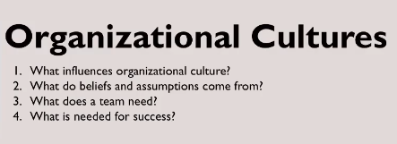





2

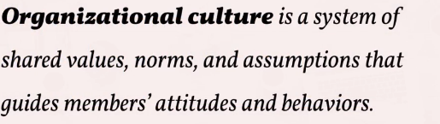

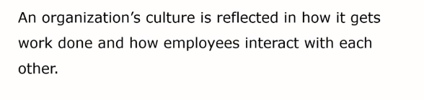

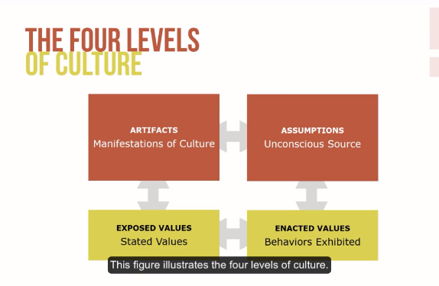

3











4 golden rules for building a great team







5

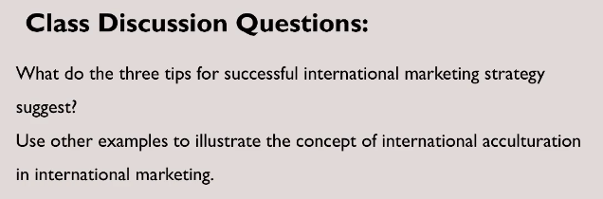





For example, many foreign companies like Intel and AMD has Weibo accounts to adapt the environment of Chinese social media since they cannot use twitter or Facebook in China.

6.

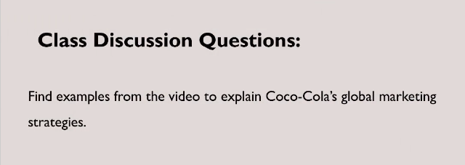





7.

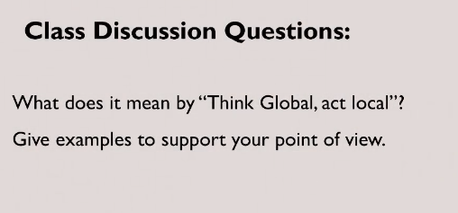

 

Exercise

The video tells a story that how a group of small animals align to recapture a fruit from an eagle. In the process of recaptruing, the animals almost found a organization which everyone share a same goal that get back the fruit. And after a series of efforts and team works, they finally get the fruit from the eagle.