# Module 3 - Assignment 2

## Broach, Stuart

### Introduction to R Markdown

My name is Stuart Broach. This is my first R Markdown doucment. In this document, we will go over some previous topics covered in class including atomic vectors, data frams and data types.

Next I will write the code which will be a basic plot showing sales over the past six months.

library("tidyverse")

## -- Attaching packages --------------------------------------------------------------------------------- tidyverse 1.2.1 --

## v ggplot2 3.1.0 v purrr 0.2.5  
## v tibble 1.4.2 v dplyr 0.7.7  
## v tidyr 0.8.2 v stringr 1.3.1  
## v readr 1.1.1 v forcats 0.3.0

## -- Conflicts ------------------------------------------------------------------------------------ tidyverse_conflicts() --  
## x dplyr::filter() masks stats::filter()  
## x dplyr::lag() masks stats::lag()

sales <- c(50,150,200,100,300,250)  
   
month <- c(1,2,3,4,5,6)  
  
qplot(month,sales)

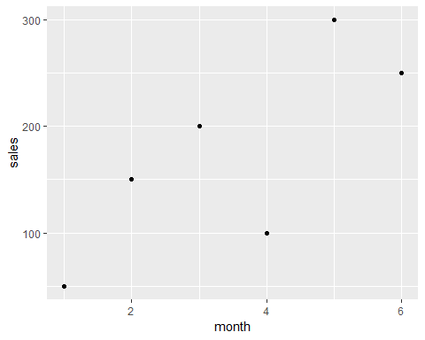 What month had the largest sales? What was the amount? Month 5 with 300 in sales.

Yearly_Sales <- data.frame(month = c("Jan", "Feb", "Mar", "Apr", "May", "Jun", "Jul", "Aug", "Sep", "Oct", "Nov", "Dec"),  
 sales = c(150.25, 258.54, 268.55, 122.52, 987, 458.82, 667.23, 845.54, 586.78, 888.58, 756.12, 456.84))

Which month had the most sales? May  
Which month had the least sales? April