# Exploratory Data Analysis

library("tidyverse")

## -- Attaching packages ----------------------------------------------------------- tidyverse 1.2.1 --

## v ggplot2 3.1.0 v purrr 0.2.5  
## v tibble 1.4.2 v dplyr 0.7.7  
## v tidyr 0.8.2 v stringr 1.3.1  
## v readr 1.1.1 v forcats 0.3.0

## -- Conflicts -------------------------------------------------------------- tidyverse_conflicts() --  
## x dplyr::filter() masks stats::filter()  
## x dplyr::lag() masks stats::lag()

diamonds

## # A tibble: 53,940 x 10  
## carat cut color clarity depth table price x y z  
## <dbl> <ord> <ord> <ord> <dbl> <dbl> <int> <dbl> <dbl> <dbl>  
## 1 0.23 Ideal E SI2 61.5 55 326 3.95 3.98 2.43  
## 2 0.21 Premium E SI1 59.8 61 326 3.89 3.84 2.31  
## 3 0.23 Good E VS1 56.9 65 327 4.05 4.07 2.31  
## 4 0.290 Premium I VS2 62.4 58 334 4.2 4.23 2.63  
## 5 0.31 Good J SI2 63.3 58 335 4.34 4.35 2.75  
## 6 0.24 Very Good J VVS2 62.8 57 336 3.94 3.96 2.48  
## 7 0.24 Very Good I VVS1 62.3 57 336 3.95 3.98 2.47  
## 8 0.26 Very Good H SI1 61.9 55 337 4.07 4.11 2.53  
## 9 0.22 Fair E VS2 65.1 61 337 3.87 3.78 2.49  
## 10 0.23 Very Good H VS1 59.4 61 338 4 4.05 2.39  
## # ... with 53,930 more rows

ggplot(diamonds,aes(cut))+  
 geom_bar()

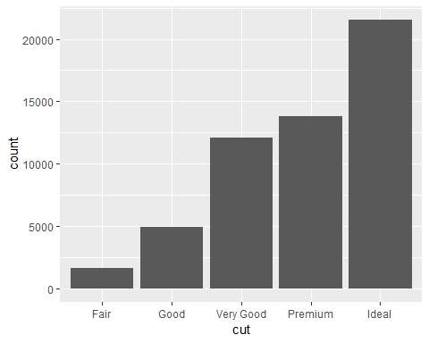

ggplot(diamonds,aes(clarity))+  
 geom_bar()

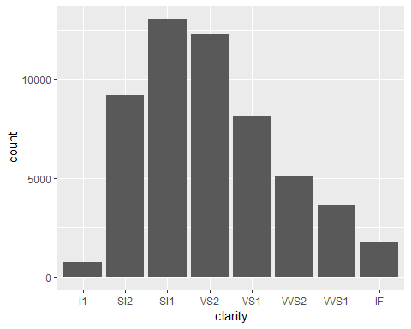

ggplot(diamonds,aes(carat))+  
geom_histogram(binwidth=0.5)

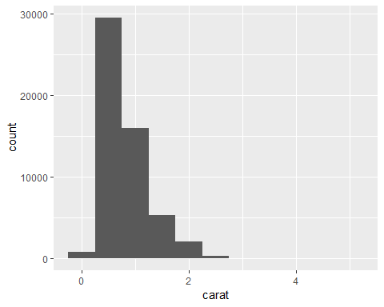

ggplot(diamonds,aes(depth))+  
 geom_histogram(binwidth = 0.5)

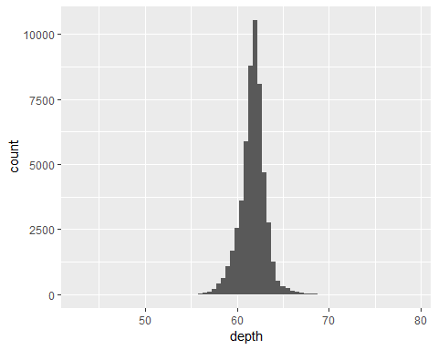

ggplot(diamonds,aes(price,fill=color))+  
 geom_histogram(binwidth = 500)

