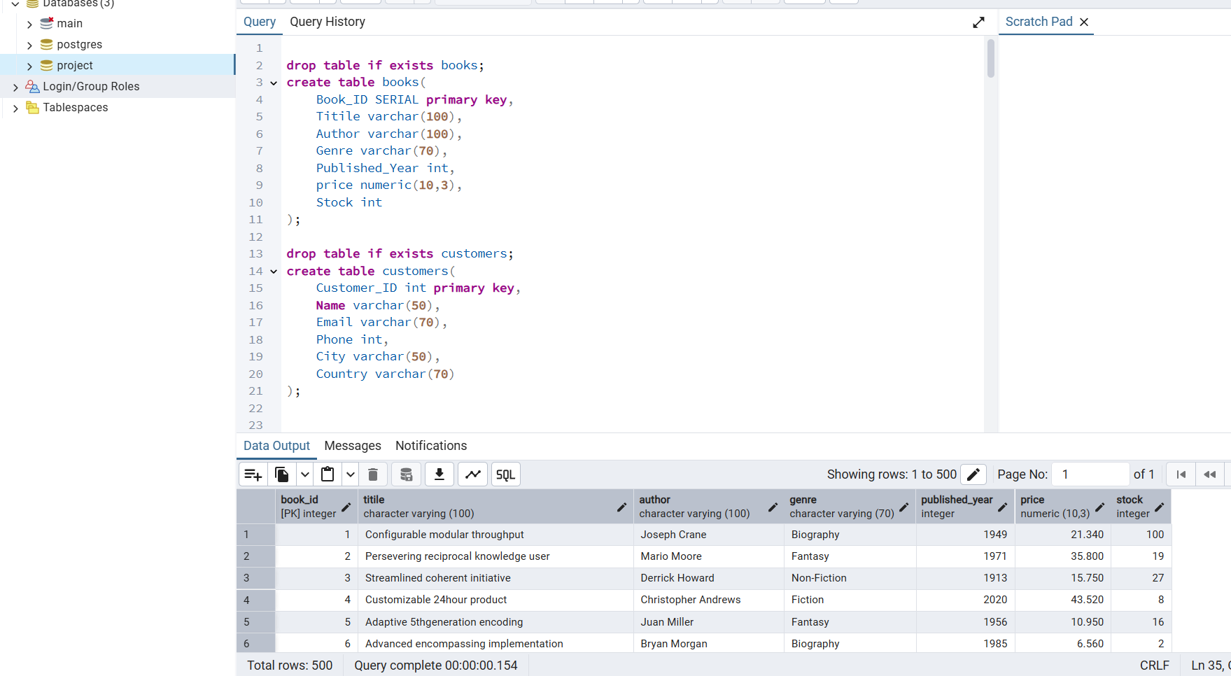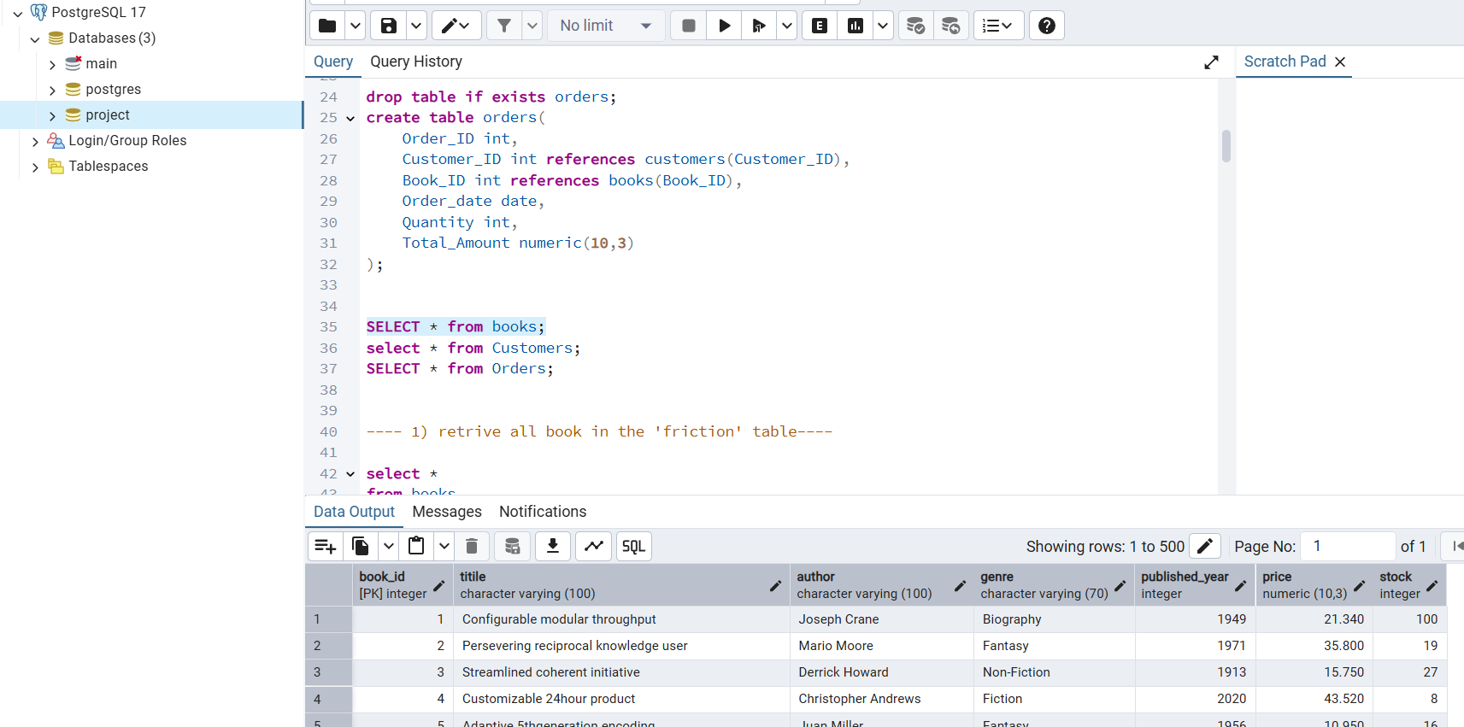

*In this SQL-based project, I worked with a relational database consisting of three interconnected tables:* ***Books****,* ***Customers****, and* ***Orders****.*

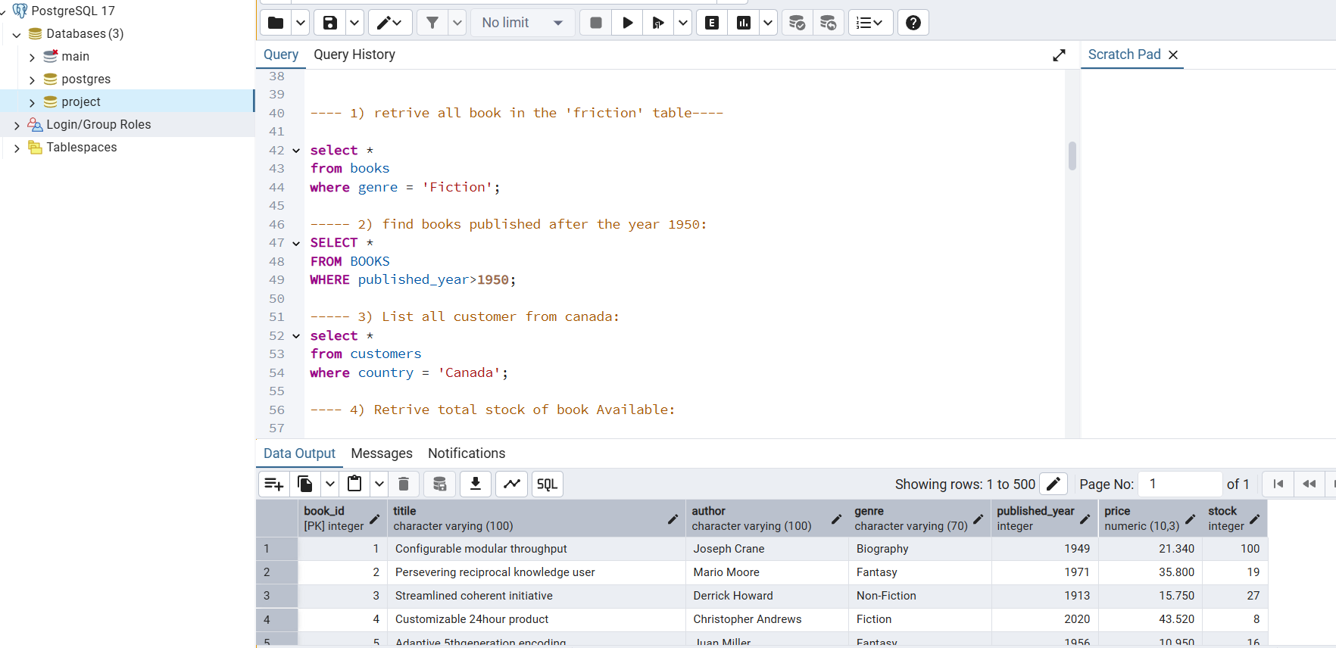

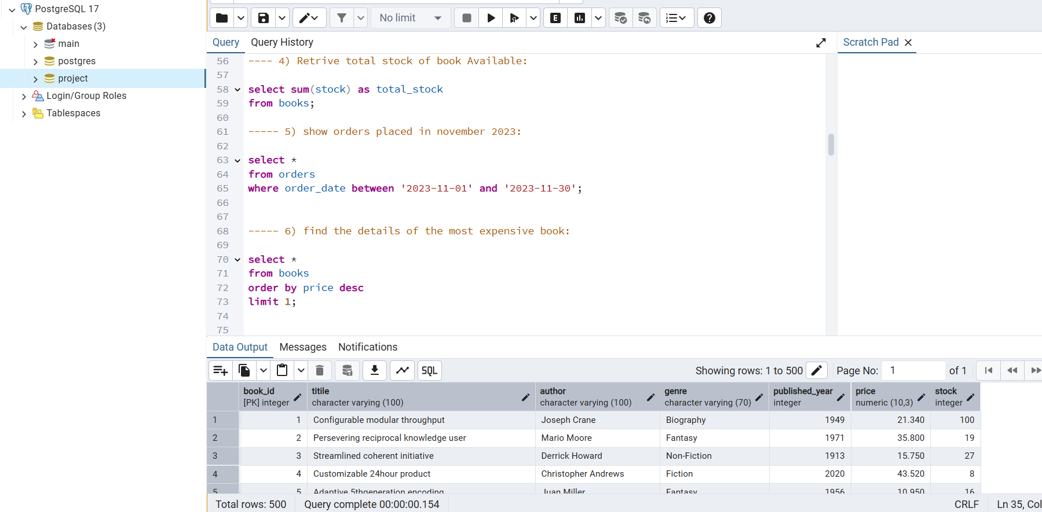

The goal was to extract meaningful insights and perform in-depth data analysis by writing and optimizing SQL queries.

Over the course of the project, I answered **19 business-relevant questions**, which helped deepen my understanding of database relationships, query structuring, and data manipulation.

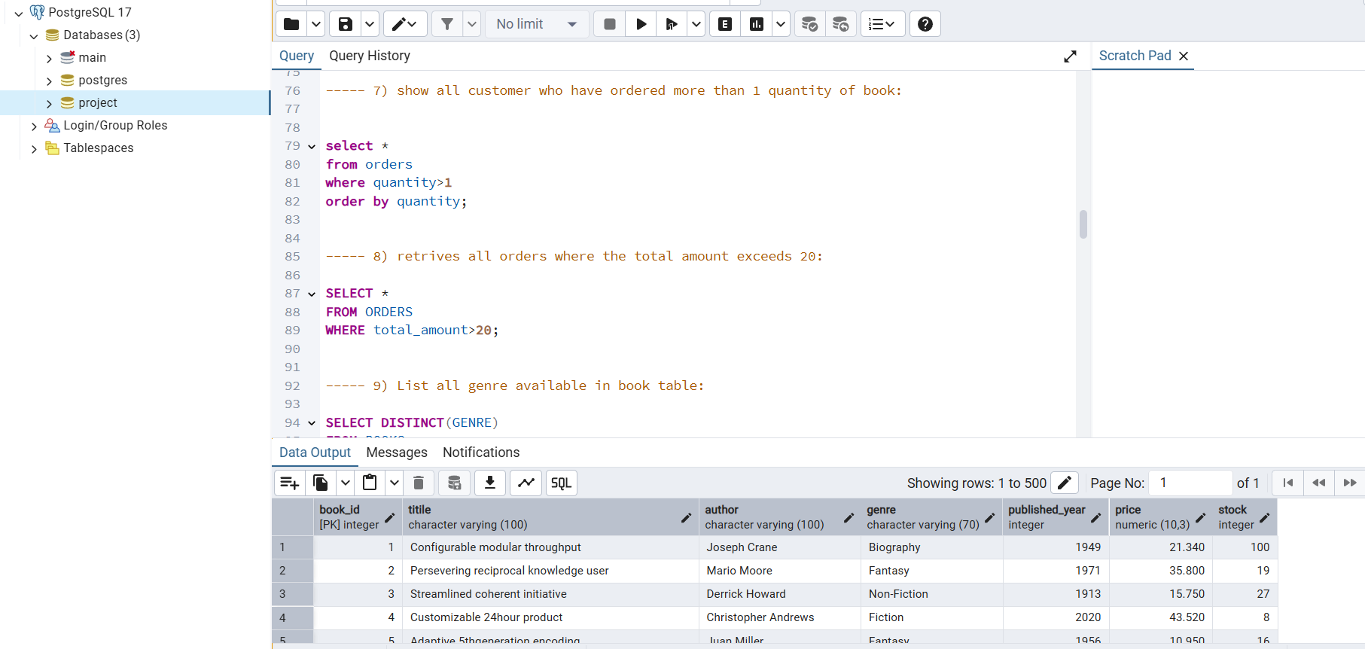

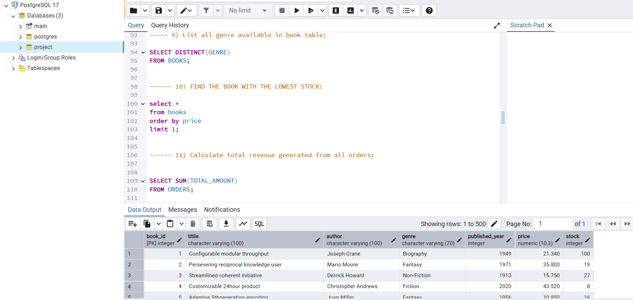

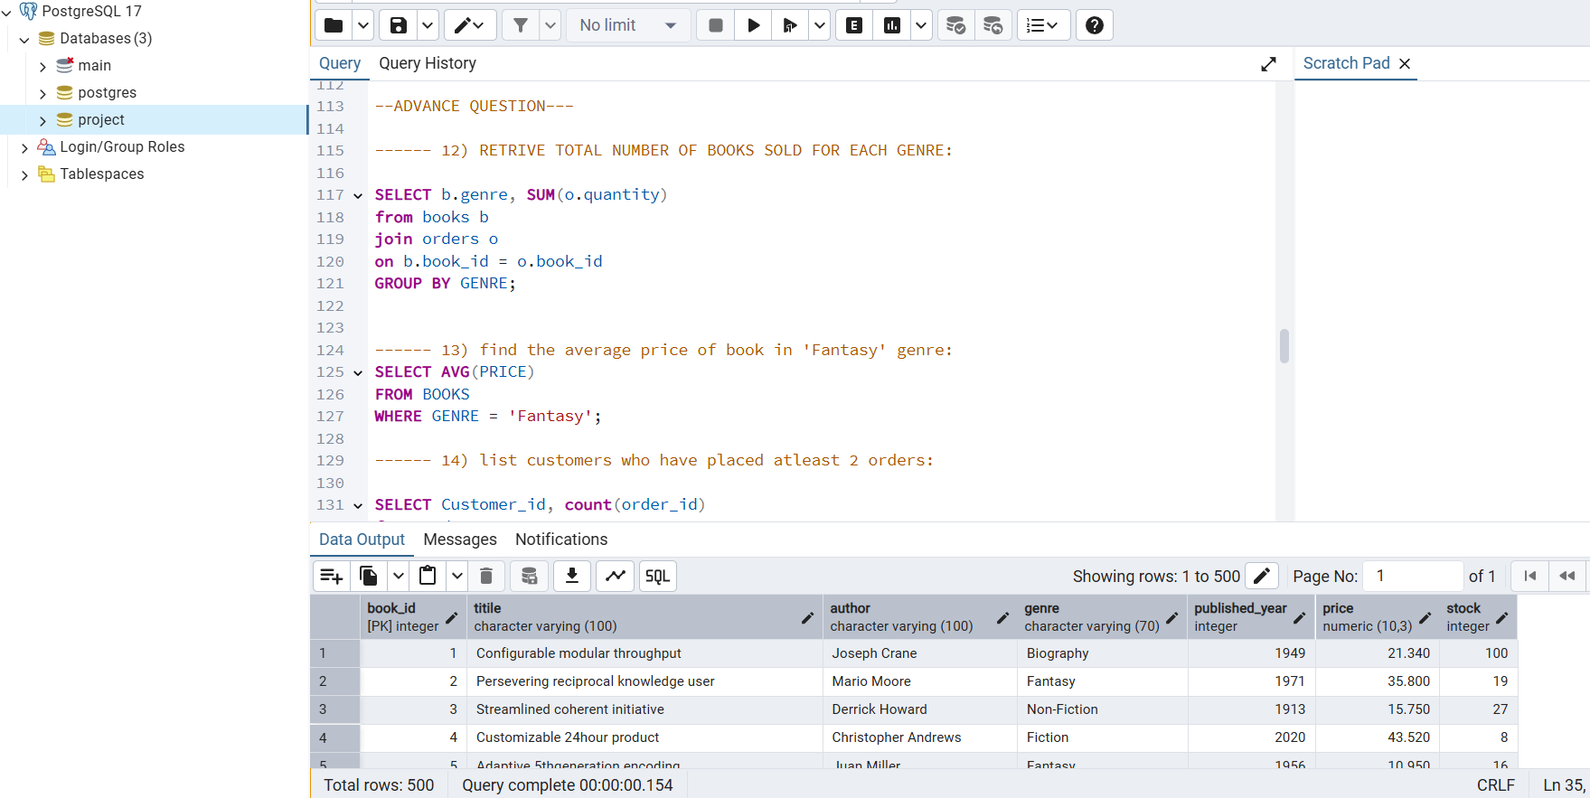

**Highlights:**

* - Identified top-selling books and most active customers
* - Analyzed customer purchase patterns and frequency
* - Calculated total revenue, average order value, and sales trends over time
* - Cleaned and filtered data to answer business questions efficiently

**Key skills and concepts applied:**

* - JOINs (INNER, LEFT, RIGHT) to combine data across multiple tables
* - Filtering with WHERE, IN, BETWEEN, and LIKE clauses
* - Aggregate functions (COUNT(), SUM(), AVG(), MAX(), MIN())

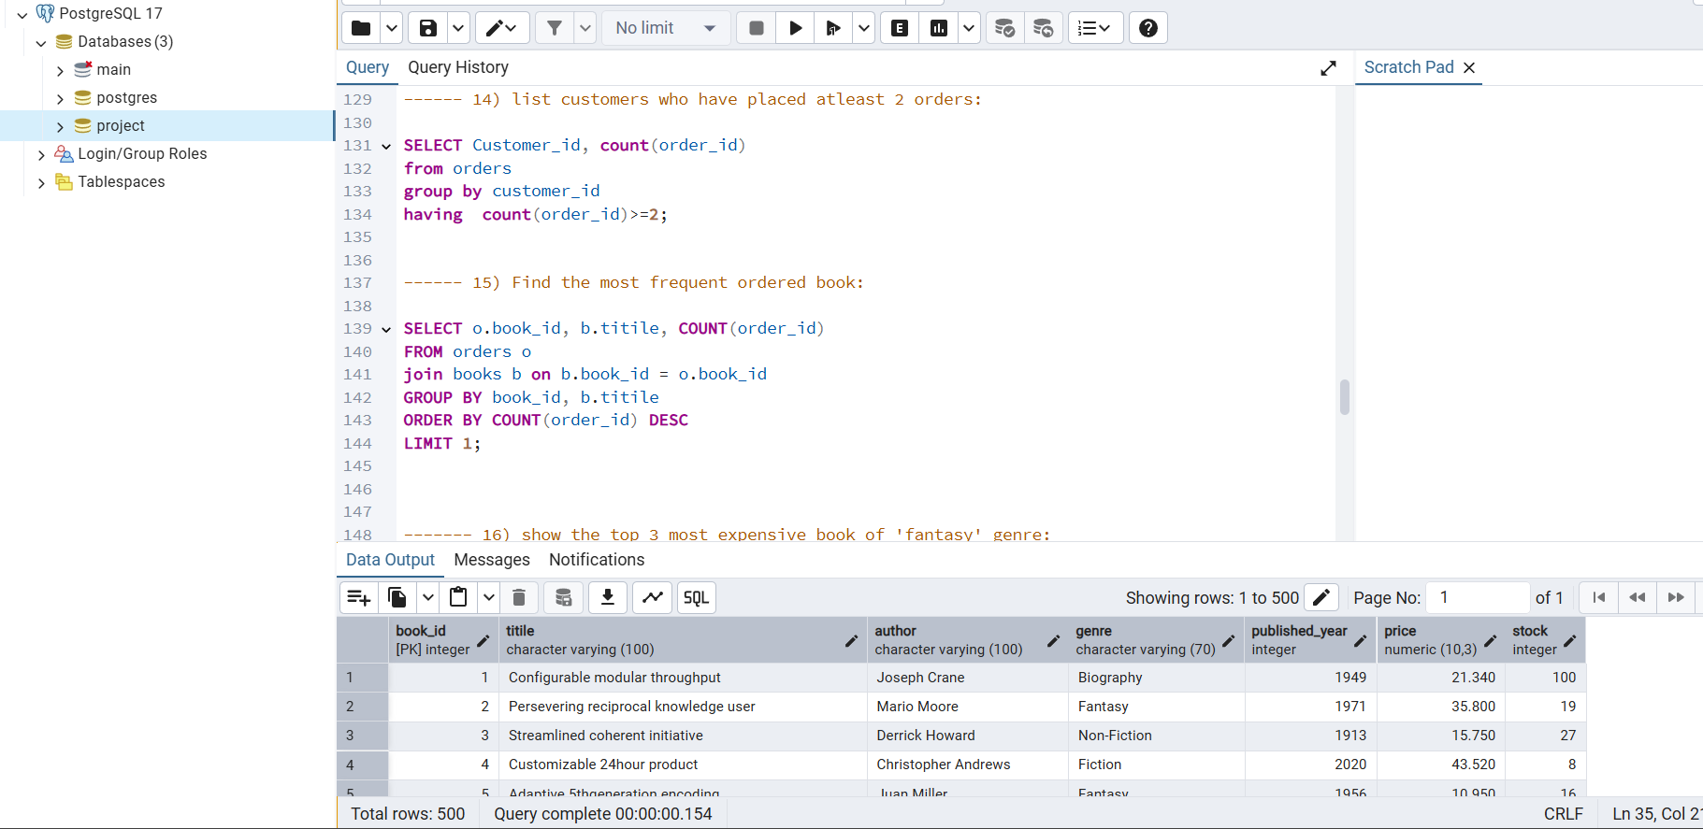

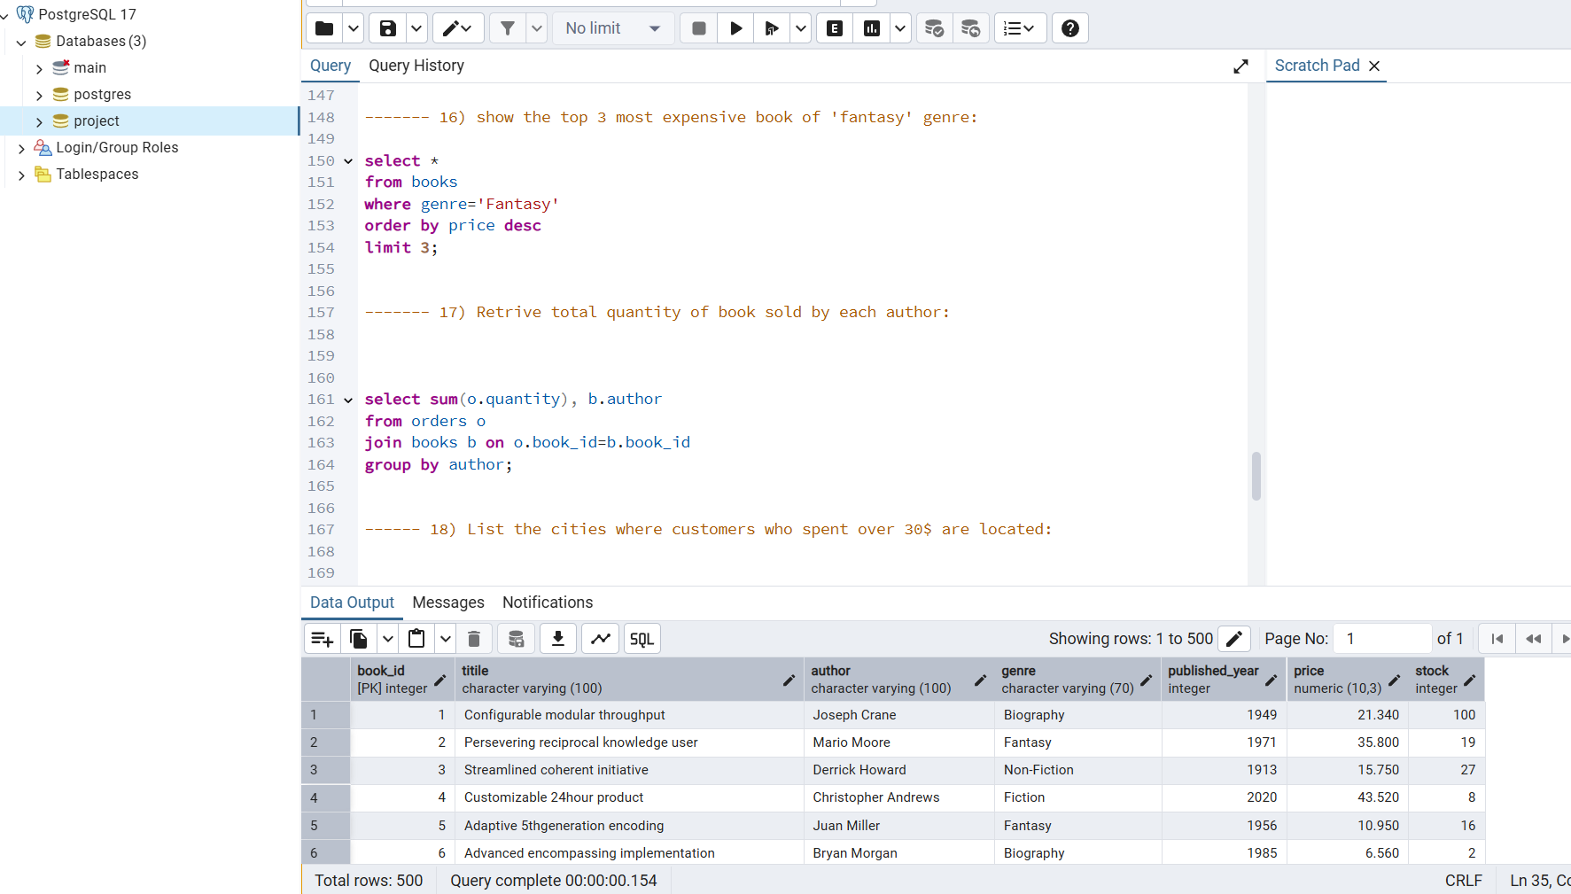

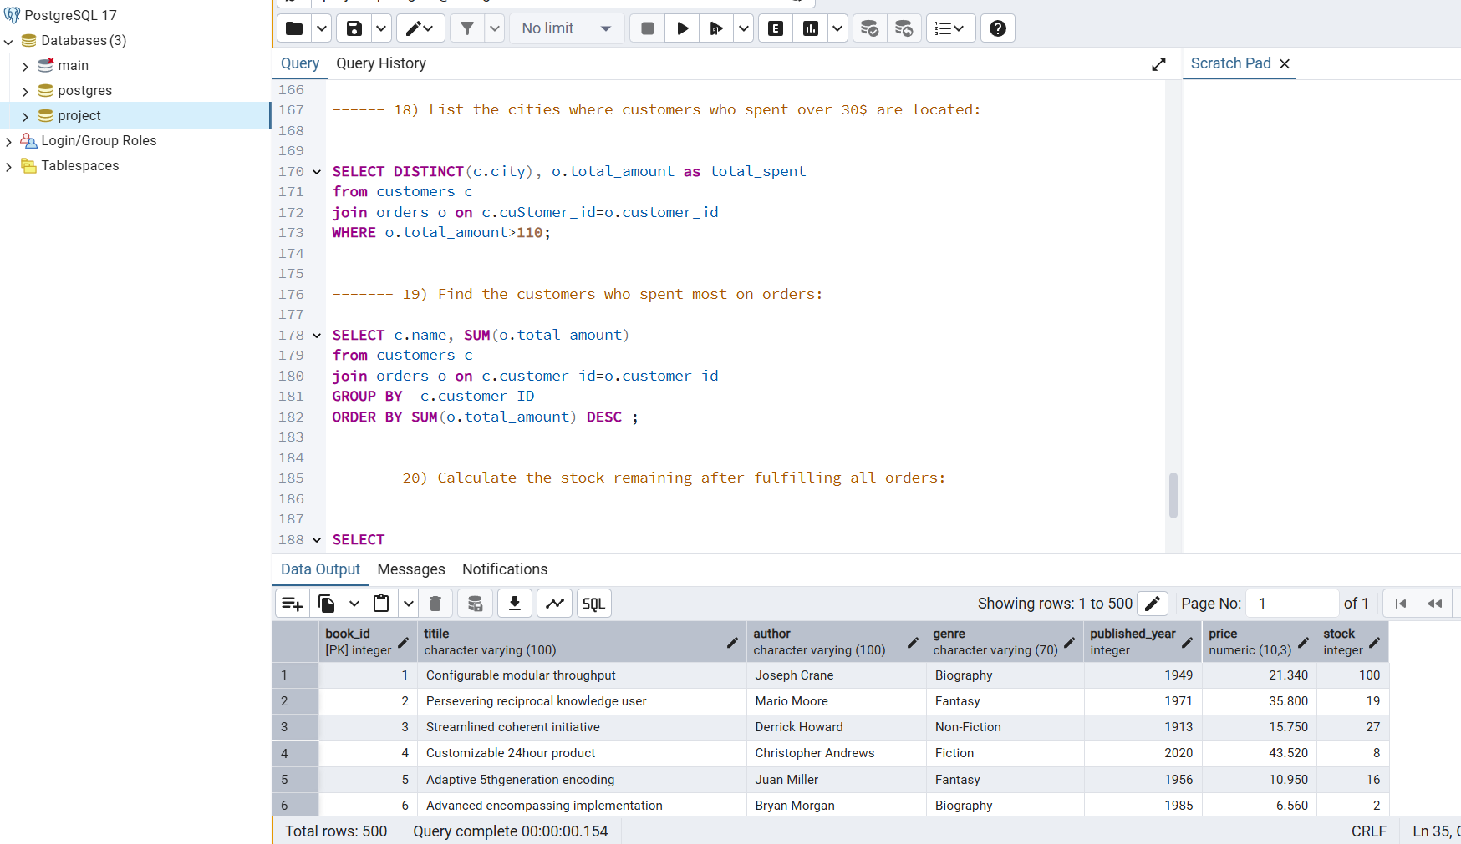

**Conclusion:**

This SQL project provided me with hands-on experience in working with relational databases and performing in-depth data analysis using real-world scenarios. By solving 19 diverse and practical queries, I not only improved my technical command over SQL but also developed a structured approach to analyzing business data and drawing meaningful insights.

The project enhanced my confidence in writing efficient queries, understanding table relationships, and using SQL as a powerful tool for decision-making support. It reinforced the importance of data accuracy, logic building, and performance optimization in analytics.