A few SELECT methods for SQL:

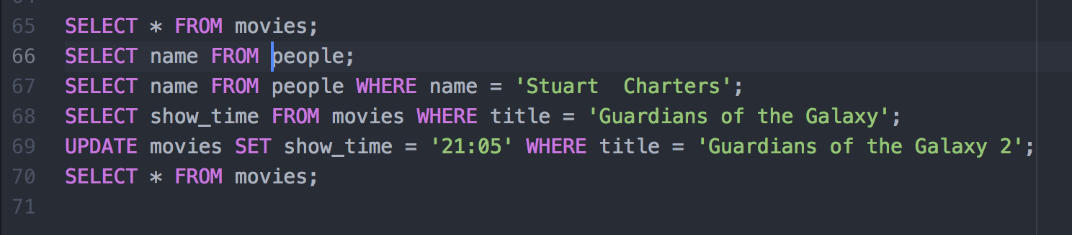

Result for SELECT * FROM movies:



Result from SELECT show_time FROM movies WHERE title = 'Guardians of the Galaxy' :

