A hash in Ruby, updating a value using the key to find it, and printing the new hash value:

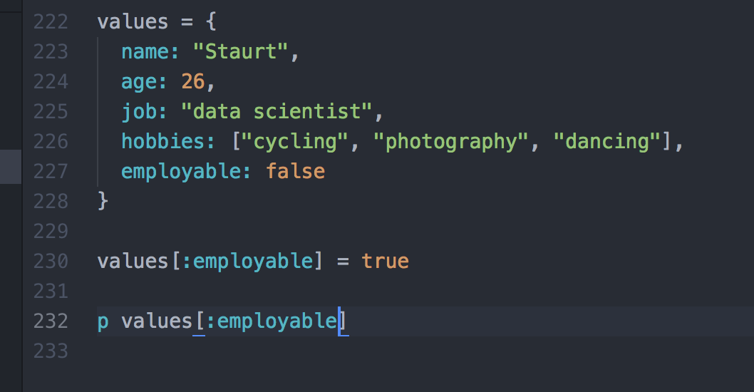

Result:

