Dimensions of PRS10 are 2x3x4”

Half-width 2U enclosure might be a good size: <https://www.hammfg.com/part/RM2U0808VBK?referer=733>

LS75-24 PSU is 129x38x98mm

RS232 VCP drivers are available here

<http://www.ftdichip.com/Drivers/VCP.htm>

RS-232 data is sent to the host on pin 4, received from the host on pin 7. The baud rate is  
fixed at 9600 baud, 8 bits, no parity, with 1 start and 1 stop bit. No DTR or CTS controls are  
used; rather, the XON/XOFF protocol has been implemented. The transmit drive level is 0  
and 5 V, not the +/-12 V normally associated with RS-232. These levels are compatible with  
most RS-232 line receivers, but does not require their use (a TTL inverter may be used  
instead), hence simplifies the interface when used inside an instrument at the sacrifice of  
degraded noise immunity over long lines.

The RS-232 interface uses CMOS logic levels (0V and +5V) which will work with standard RS-232 line drivers and receivers. The }12V of the standard RS-232 line driver will not harm the logic input, and the 0/+5V RS-232 output from the rubidium standard will work with virtually all computers, provided the cable is less than 25 feet long. The RS-232 control lines, CD, DSR and CTS are all pulled high via 10kÙ resistors. An XON/XOFF protocol is used to pause communications as needed. The LOCK/1PPS function may be configured via RS-232. The factory default is a low level to indicate lock, with a 10ìs pulse to +5V at 1PPS, with the leading edge being defined as the 1PPS timing reference. This BNC output is a CMOS logic output via a 1kÙ resistor. LEDs are used to indicate +24 power (electronics and heaters), lock status, and RS-232 data received and RS-232 data transmitted.

The RX and TX data lines need inverted – hence the use of a TI Hex Inverter on the breakout board!

|  |  |
| --- | --- |
| Signal | Pin |
| CD | 1 |
| DSR | 6 |
| CTS | 8 |
| Ground | 5 |

Termite is a free console port for RS232

<https://www.compuphase.com/software_termite.htm>

Resistors are 0.25W, 1206 1% devices

Transformer is MCTA080/15 and dimensions are 87.5dia + 5mm clearance, 39mm h

LM723 is rated at 40V peak input. That corresponds to the peak voltage of a 28.3V RMS waveform

Cap is 4700u, 100V

Mounting holes are 2x2mm at 10mm centres

Dia is 35mm x 50mm tall, ripple current of 3.8A

24V demand:

Heater & lamp, startup – 1.85A

Electronics – 0.14A

LED has a forward voltage of 2.2V therefore the 5V

FT231X output voltage is typically 0V (max 0.4V) so current through the LED is typically 10.4mA (min 8.9mA)

24V line status is therefore aiming for 10mA current so a drop across a 2.2k resistor

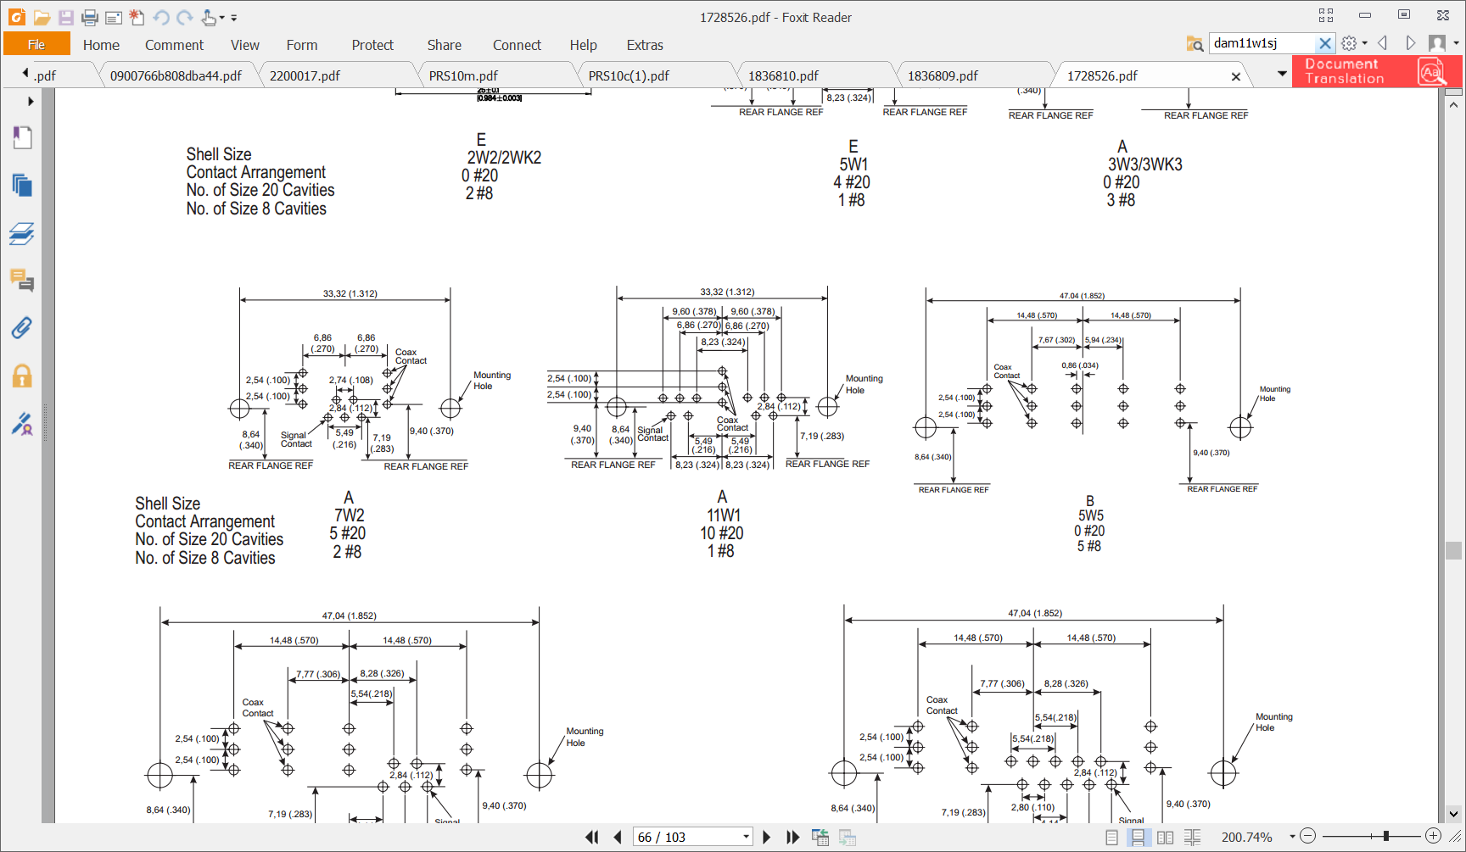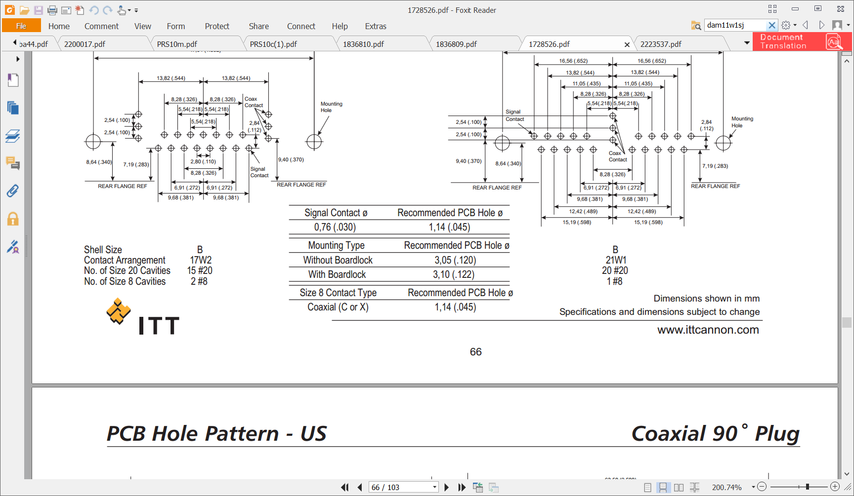

Connector part number

Receptacle

Case - A11W1

90 degrees – C

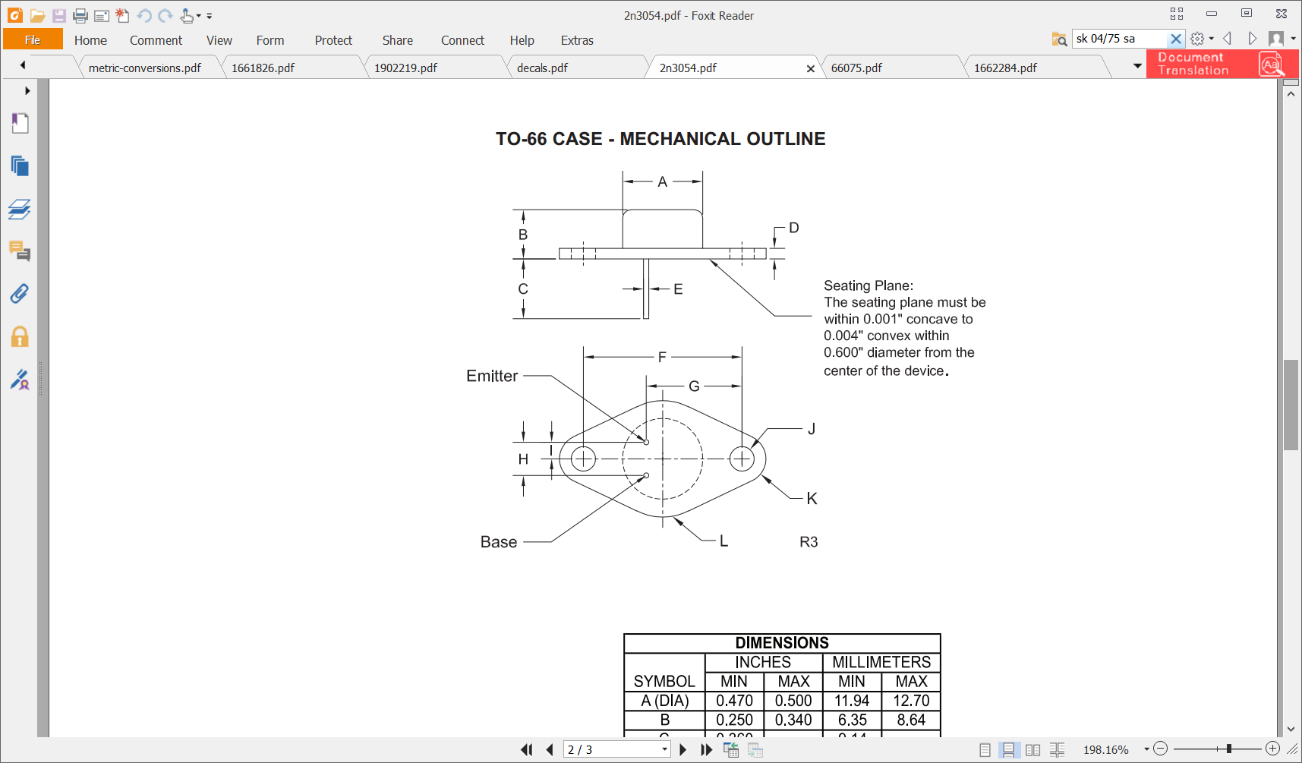

Questions

1. Earth loops – are they a problem?
2. The PRS10 output shield isn’t connected to ground by default. Is there a problem if I do so?

Considering alternative to LM723

Looking at TI’s LM338:

* Comes in a 4A TO3 package (or TO-220)
* 75dB ripple rejection is 3dB down on LM723
* Voltage is the same

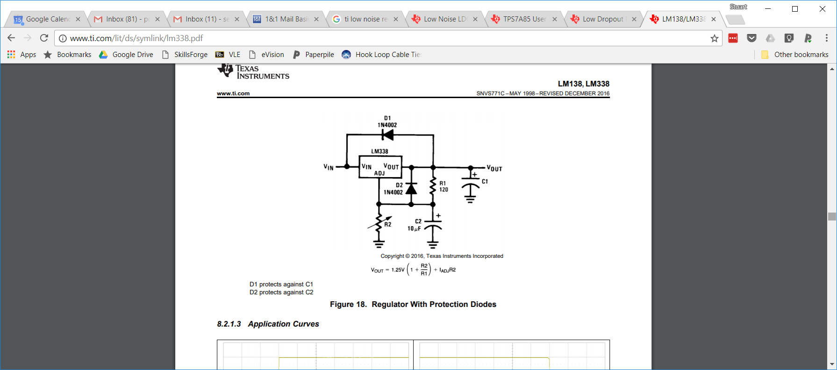

Iadj = 45uA typ and 100uA max

Inlet cutout is 28.1mm x 59.2mm

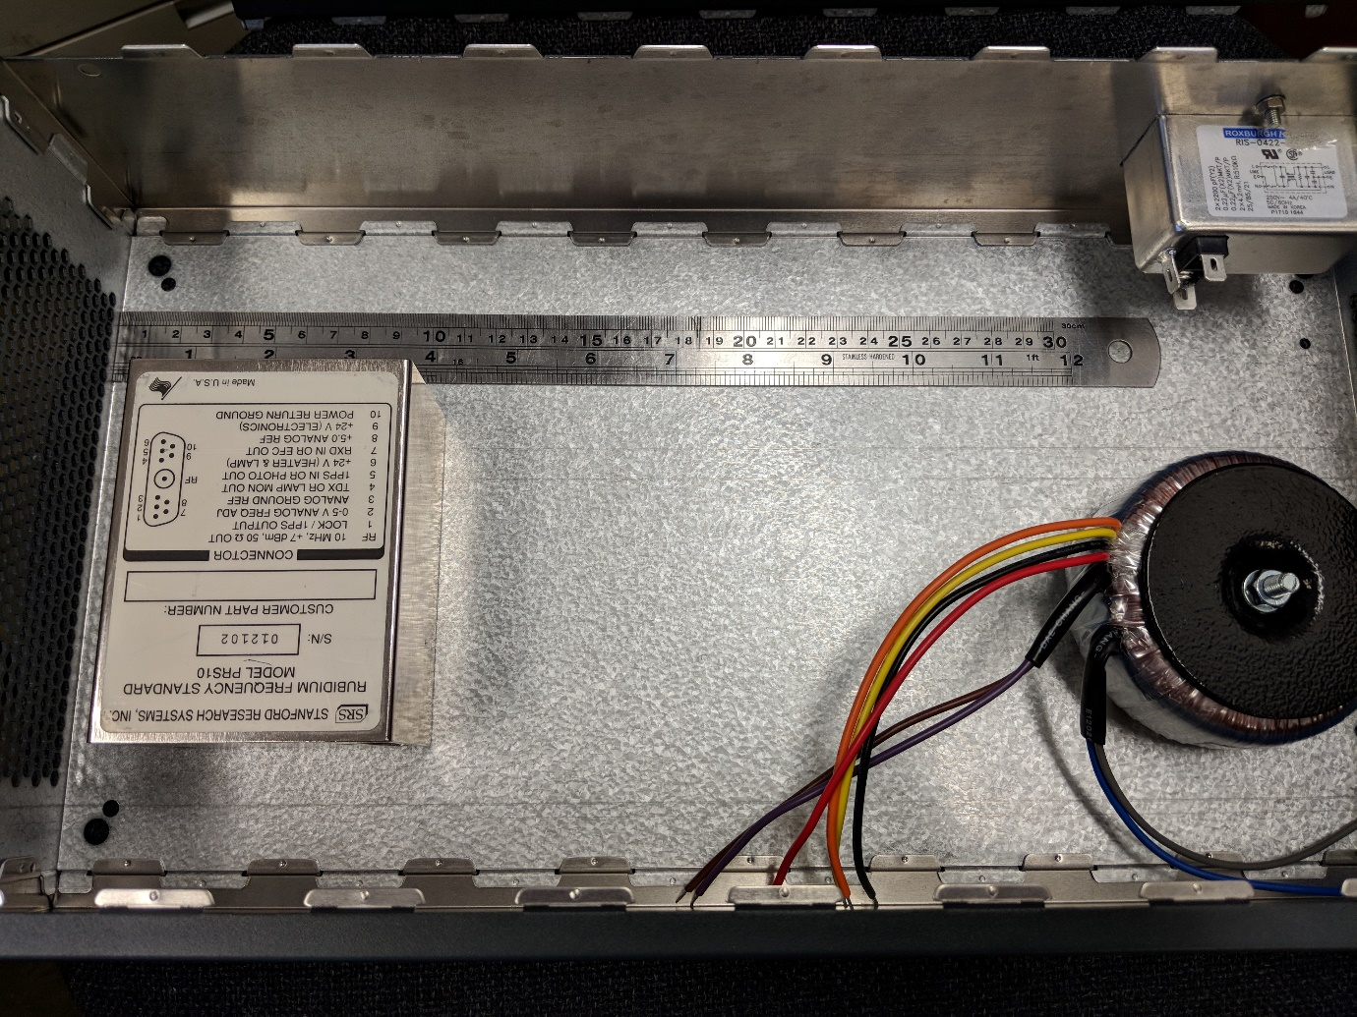

J1

J8

J23

J22

J9

J6

J15

J16

J5