**CS 330 Homework 2 – Key**

Give solutions to the problems listed below. Your automata diagram should be legible with clearly labeled paths and states. preferrable created by using software tools such FSMD by Evan Wallace. **Use software to complete this HW, save as PDF, and submit on Moodle. by 10 PM Monday (2/5). The cutoff time is 10 PM Wednesday.**

1. The following is a state diagram for a Finite Automata. Answer the following questions:

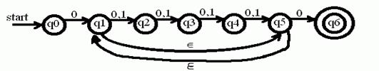

1. What is the start state and the set of accept states? (4)

Q0, {q6}

1. Draw the computing tree for the string 011011. Is it accepted and why? (10)

Not accepted as computation ends at q2

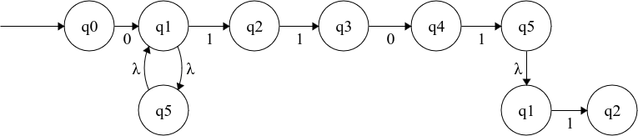

Grading:

need to draw a tree, -7 if there is only a path

// no deduction if tree is only off a bit.

1. For each of the following languages on alphabet ∑ = {0, 1}, give two strings that are member and two that are NOT. (8X2=16)
2. 0*1+0*

There could be many, ex.,

Member: 010, 0110, 10, 1111,

Not member: 101, 0101, … // anything that has >1 1s separated by 0

1. ∑*00∑* // R -> 0R | 1R | ε

Member: 00, 100, anything with 2 consecutive 0s

Not member: 1, 11, 10, 01 …

1. Give regular expressions for each of the following languages where ∑={0, 1}. (3x10=30)
2. Words where every 1 is followed by one or more 0s.

0*(10+)*

1. Words that contain exactly two 0s and two 1s.

0011 | 0101 | 0110 | 1001 | 1010 | 1100

// or by using intersect ∩ - anything with 2 0s intersect anything with 2 1s

1*01*01* ∩ 0*10*10*

1. Words where the first digit is different from the last one.

1∑*0 | 0∑*1

1. Give FA (either DFA or NFA) on alphabet {0, 1} that represents/recognizes for the following languages. **Do any 5 of the 6.** (5X8 = 40 points)
2. The language containing words where every 1 is followed by one or more 0s.

M1 – NFA: with only one accept state, this M is ideal for creating reverse of A

M2 – DFA: has 2 accept states and a deadend state (Qd), this M can be used to create its complement language

1. The language containing words where the first digit is different from the last one.

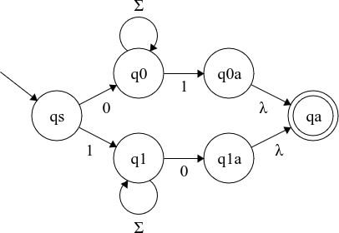

1. The complement of A

Created from M2 of A by flipping states: accept to non and vice versa.

1. Reverse of A – created from M1 of A

1. Union of A and B

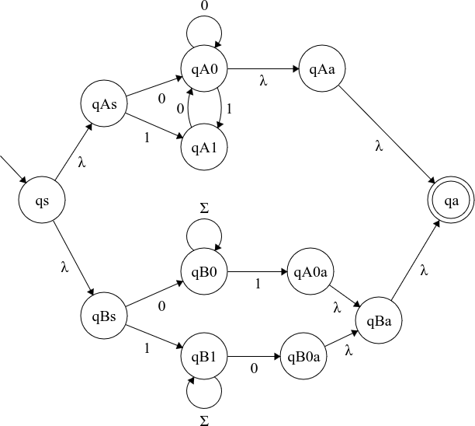

1. Intersect of A and B

Available upon request