

Design Document for:

Adventures of The Lost Boy

Re-live (and Re-invent) the old-school top-down classics

“Totally not a ‘Legend of Zelda’ clone”

All work Copyright © 2015 by StuMac

Written by Stuart McIntosh

Version # 1.00

Name of Game 1
Design History 5
Version 1.10 5
Version 2.00 5
Version 2.10 5
Game Overview 6
Philosophy 6
Philosophical point #1 6
Philosophical point #2 6
Philosophical point #3 6
Common Questions 6
What is the game? 6
Why create this game? 6
Where does the game take place? 6
What do I control? 6
How many characters do I control? 6
What is the main focus? 6
What’s different? 7
Feature Set 8
General Features 8
Multi-player Features 8
Editor 8
Game play 8
The Game World 9
Overview 9
World Feature #1 9
World Feature #2 9
The Physical World 9
Overview 9
Key Locations 9
Objects 9
Rendering System 10
Overview 10
2D Rendering 10
Camera 10
Overview 10
Camera Detail #1 10
Game Engine 10
Overview 10
Game Engine Detail #1 10
Collision Detection 10
Lighting Models 11
Overview 11
Lighting Model Detail #1 11
The World Layout 12
Overview 12
World Layout Detail #1 12
World Layout Detail #2 12
Game Characters 13
Overview 13
Creating a Character 13
Enemies and Monsters 13
User Interface 14
Overview 14
User Interface Detail #1 14
User Interface Detail #2 14
Weapons 15
Overview 15
Weapons Details #1 15
Weapons Details #2 15
Musical Scores and Sound Effects 16
Overview 16
Red Book Audio 16
3D Sound 16
Sound Design 16
Single Player Game 17
Overview 17
Single Player Game Detail #1 17
Single Player Game Detail #2 17
Story 17
Hours of Game-play 17
Victory Conditions 17
Multi-player Game 18
Overview 18
Max Players 18
Servers 18
Customization 18
Internet 18
Gaming Sites 18
Persistence 18
Saving and Loading 18
Character Rendering 19
Overview 19
Character Rendering Detail #1 19
Character Rendering Detail #2 19
World Editing 20
Overview 20
World Editing Detail #1 20
World Editing Detail #2 20
Extra Miscellaneous Stuff 21
Overview 21
Junk I am working on… 21
“XYZ Appendix” 22
“Objects Appendix” 22
“User Interface Appendix” 22
“Networking Appendix” 22
“Character Rendering and Animation Appendix” 22
“Story Appendix” 22

Design History

Version 1.00 of this document is written with only a basic shell of the game built.
The current game build features a playable character and simple, 2 tile world generation from a text file.

The Design Document will grow and evolve as the game continues development.

Game Overview

Philosophy

The original Console games featured simple graphics and controls but provided hours of challenging puzzle and adventure.
This game aims to pay tribute to those games amongst the barrage of HD graphics.
One big feature of modern games is the large amount of community interactivity through game modification and User level design, and my game aims to provide a way for users to create their own levels in a game style like those games which set the trend for home gaming.

Common Questions

What is the game?

This Game is my take on the old school top down genre, similar to the original Legend of Zelda.
The game will be a series of mazes through which the player must navigate to find the end, avoiding obstacles on the way such as Enemies. Because of the way the game loads levels there is also the ability for players to create their own levels for the game through ASCII text files.

Why create this game?

I am making this game as I have a strong love for this genre, top down puzzle adventures, and want to make a game in this style which also allows heavy user interaction.

Where does the game take place?

The world and levels of this game range from barren deserts to damp caves to lush forests. They are also fully open to the users through level creation.

What do I control?

The player is a small person lost in a vast world, trying to find an escape. Through simple keyboard controls the user will control the player through the world defending themselves from enemy attacks.

What is the main focus?

The aim of this game is to guide the character out of the levels they find themselves trapped in.

What’s different?

This game is different to others in the genre as it allows for easy user level creation to expand the gameplay as much as the user wants and can imagine.

Feature Set

General Features

Multiple Levels
‘Old-school’ 2D graphics
User level creation

Editor

Levels are edited through simple text files

Gameplay

Just a small boy lost in a large world

- Help him escape -

The Game World

Overview

The game world is comprised of numerous maze-like levels featuring various environments and enemies.

Sprawling Environments

The Levels of this game feature many environments which the player must navigate, Caves, deserts, forests and more.

These environments are inhabited by vicious enemies looking to stop the player in his tracks.
- Don’t let that happen -

The Physical World

Overview

Describe an overview of the physical world. Then start talking about the components of the physical world below in each paragraph.

The following describes the key components of the physical world.

Key Locations

Barren Desert
Vibrant Forest
Daunting Caves

Travel

The player navigates with basic keyboard controls, avoiding (or attacking) enemies that stand in their way, and attempting to reach the end of each level.

Objects

The levels will feature different obstacles, including enemies and multi-pathed mazes.

See the “Objects Appendix” for a full sheet of world sprites

Rendering System

Overview

The Game’s graphics will be simple low detail sprites of the player, enemies and environments. This is to better capture the ‘old school’ vibe that this game is aiming for.

2D Rendering

The graphics of this game are rendered using Unity’s Sprite Renderer and Animator.

Camera

Overview

The Camera provides a simple top down view of the world, focused on the Player.
The camera follows the player’s movement in the world, so only small section of the world is visible to user at any time.

Game Engine

Overview

Unity is a simple to use game engine which allows 2D and 3D game and animation creation.

Game Engine Detail #1

Unity provides many components to simplify 2D game creation, including collision detectors and animation controllers.

Collision Detection

The main aspect of collision in this game will occur between the player and enemies in order to judge whether the player or enemy is hit.
Collision will also control the player reaching the exit, and not walking through walls.

The World Layout

Overview

The world layout will be changing as the user creates their own levels to play through.
Several levels will come included but it is also expected the user will create their own mind bending levels to challenge themselves and friends with.

There will be different tiles in the world to create different environments, see the “Objects Appendix” for tile options that the game will feature.

Game Characters

Overview

Characters will include the main Player and several types of enemy characters.

Creating a Character

The Player Character is rendered from a sprite sheet which contains all sprites for animation, including walking, attacking and being hit by enemies.

Enemies and Monsters

The enemies will be rendered in the same way as the player, through a sprite sheet, and upon being killed by the player will be removed from the screen allowing player to pass by them.

User Interface

Overview

A basic interface will be created to display controls to the User and allow options for them to load their own levels into the game.

Weapons

Overview

The game will feature only one weapon for the User to utilize in their adventure in the form of a sword, which will allow defense from enemies.

Musical Scores and Sound Effects

Overview

Keeping with the minimal graphics, this game will feature limited sound effects, including, player movement, and player and enemy attacks.
Sounds will most likely be utilized from the wide selections of sounds effects available online, as noises are not the biggest feature of the game.

Single-Player Game

Overview

The game only contains small single-player experience as most gameplay is based on user interaction with level creation.

Story

The game features a simple story of a small, lost boy looking to find his way home and the adventures he faces on the way.

Victory Conditions

The player is victorious if they successfully navigate through all the levels in the game.
Each level is completed by reaching the end goal.

World Editing

Overview

The World Editor for this game is through the creation and editing of levels, in the form of text files contain a characters representing the level to be loaded.

World Editing Detail #1

As all the levels in the game are loaded from text files filled with characters configured within the game to represent different tiles.
As seen in the image below, the text file shows a basic maze with ‘+’ representing walls, ‘-‘ for floor, ‘P’ for Player start position and ‘E’ for Exit.
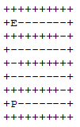

Therefore if a player is to modify a pre-existing file or add their own to the game then they are able to play their own levels, and these can be shared with others to play as well.

Extra Miscellaneous Stuff

I would for this game to end up feature a level designer option within the game, via a drag and drop tile placement, so that the game can be played on multiple platforms.
This is inspired by the new Nintendo game ‘Super Mario Maker’, which takes a well-known classic and allows users to create and share their own levels.

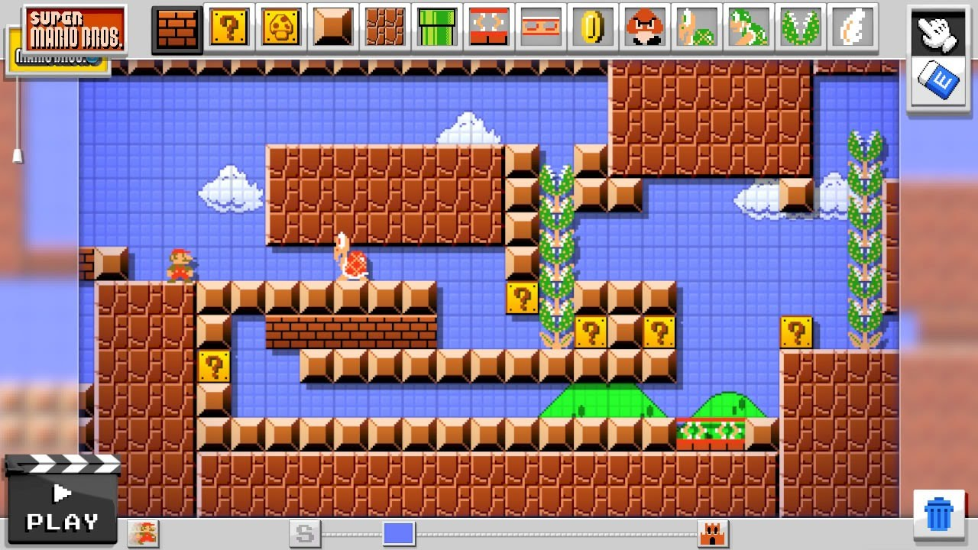

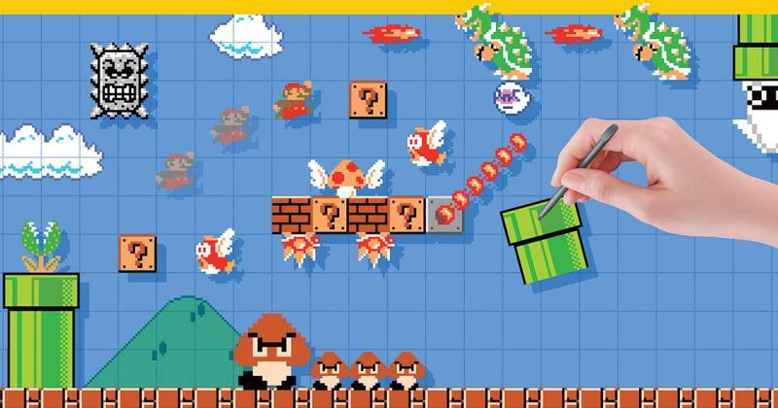

By using simple touch screen controls, users draw what the level would be and then can test and redesign their levels with the press of a button.

Many people online also wondered if Nintendo would make a version for ‘The Legend of Zelda’ and so part of my game design is based on this idea.

“Objects Appendix”

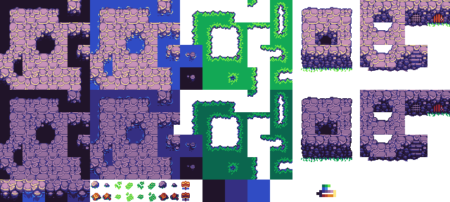
Sprite Sheet featuring the tiles used for creating the Level screens

