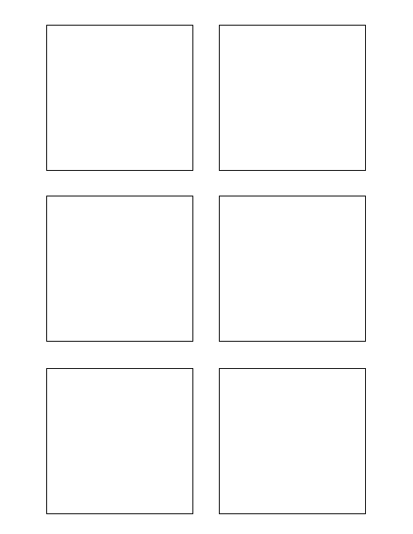

**Research**

Research different word document manipulation python libraries

0

8

3

5

1

2

**Software Design & Development**

Extract data from wiki format

**Software Design & Development**

Populate each stickie box with the story category

TWSSAFE-001

TWSSAFE-001

TWSSAFE-001

TWSSAFE-001

TWSSAFE-001

TWSSAFE-001

**Software Design & Development**

Populate each stickie box with the correct story points

**Software Design & Development**

Populate each stickie box with each story title

**Software Design & Development**

Populate stickie box title with the feature number

The box title color should change per feature!

Another bullet added for test