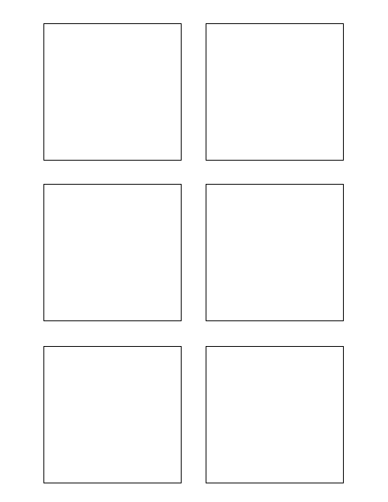

**Testing**

Develop Unit Test for Trixie Stickies

* Test

1

2

1

0

8

**Testing**

Test

**Software Design & Development**

Extract data from wiki format

TWSSAFE-002

TWSSAFE-002

TWSSAFE-002

TWSSAFE-002

TWSSAFE-001

TWSSAFE-001

**Software Design & Development**

Populate each Trixie box with the story category

**Software Design & Development**

The box title color should change per feature! (1)

Another bullet added for test (1)

Populate stickie box title with the feature number

**Research**

Research different word document manipulation python libraries