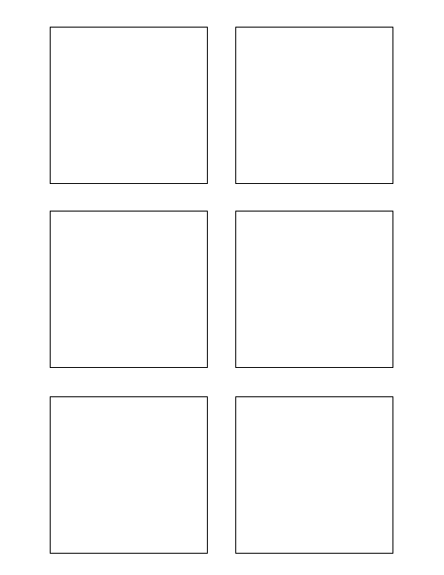

**Software Design & Development**

Populate each Trixie box with the correct story points

1

5

**Testing**

Develop Unit Test for Trixie Stickies

TWSSAFE-002

TWSSAFE-002