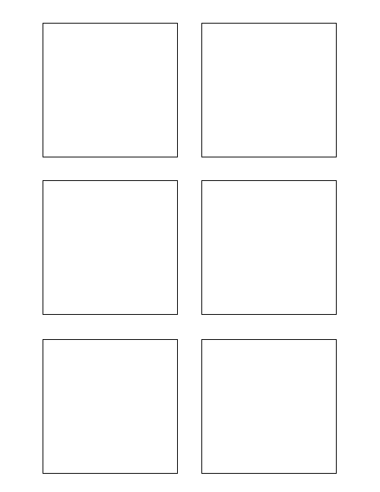

**8Research**

The box title color should change per feature! (1)

Another bullet added for test (1)

Research different word document manipulation python libraries 8

1

8

1

5

3

**Software Design & Development 1**

Populate each Trixie box with the story category 1

**Software Design & Development 5**

Populate each Trixie box with the correct story points 5

TWSSAFE-004

TWSSAFE-004

TWSSAFE-004

TWSSAFE-004

TWSSAFE-004

**1Testing**

Develop Unit Test for Trixie Stickies 1

**3Software Design & Development**

Populate each Trixie box with each story title 3