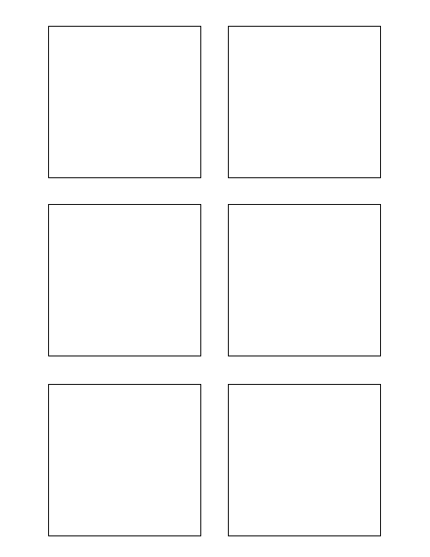

**0Software Design & Development**

Extract data from wiki format 0

2

0

5

1

3

1

**Software Design & Development 2**

The box title color should change per feature!

Another bullet added for test

Populate stickie box title with the feature number 2

**Software Design & Development 3**

Populate each stickie box with each story title 3

TWSSAFE-003

TWSSAFE-003

TWSSAFE-003

TWSSAFE-003

TWSSAFE-003

TWSSAFE-003

**Testing ===1**

Develop Unit Test for Trixie Stickies 1

**5Software Design & Development**

Populate each stickie box with the correct story points 5

**1Software Design & Development**

Populate each stickie box with the story category 1