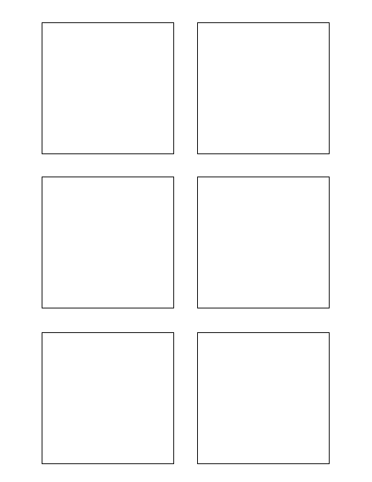

**3Software Design & Development (13)===**

Populate each stickie box with each story title 3

5

3

* Stickie Template Word Document will be populated from wiki data

* Wiki data has already been downloaded to hosting machine

* Tes

1

**Software Design & Development (13)===5**

Populate each stickie box with the correct story points 5

**Testing===* Tes**

Tes* Tes

TWSSAFE-003

TWSSAFE-003

TWSSAFE-003

TWSSAFE-003

TWSSAFE-003

TWSSAFE-003

**Assumptions===* Wiki data has already been downloaded to hosting machine**

Wiki data has already been downloaded to hosting machine* Wiki data has already been downloaded to hosting machine

**\* Stickie Template Word Document will be populated from wiki data**

Stickie Template Word Document will be populated from wiki data* Stickie Template Word Document will be populated from wiki data

**1 Testing ===**

Develop Unit Test for Trixie Stickies 1