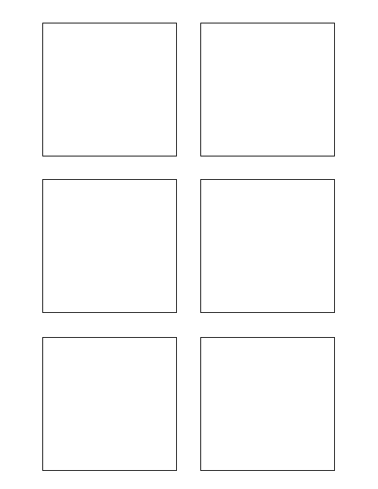

**8Research**

Research different word document manipulation python libraries 8

0

8

3

5

1

2

**Software Design & Development 0**

Extract data from wiki format 0

**Software Design & Development 1**

Populate each stickie box with the story category 1

TWSSAFE-003

TWSSAFE-003

TWSSAFE-003

TWSSAFE-003

TWSSAFE-003

TWSSAFE-003

**Software Design & Development 5**

Populate each stickie box with the correct story points 5

**3Software Design & Development**

Populate each stickie box with each story title 3

**2Software Design & Development**

Populate stickie box title with the feature number 2

The box title color should change per feature!

Another bullet added for test