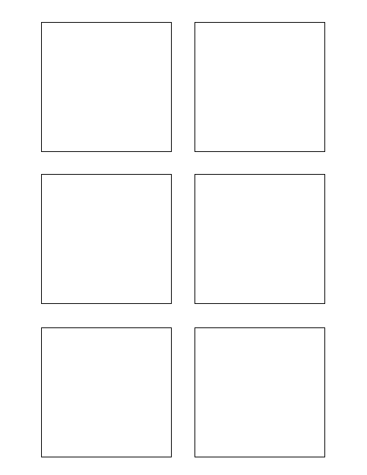

**Software Design & Development**

Populate each Trixie box with each story title

5

3

1

**Software Design & Development**

Populate each Trixie box with the correct story points

TWSSAFE-002

TWSSAFE-002

TWSSAFE-002

**Testing**

Develop Unit Test for Trixie Stickies