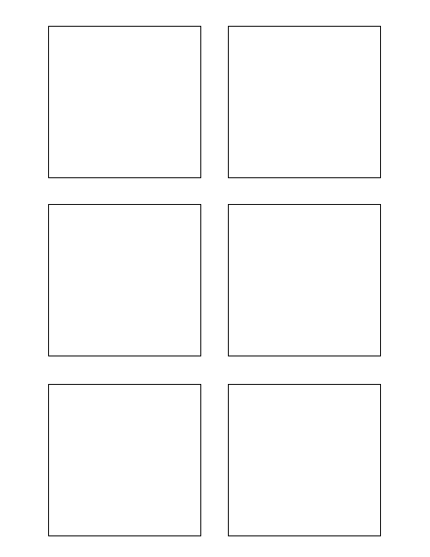

**Software Design & Development**

Populate each stickie box with the story category

3

1

8

0

1

5

**Software Design & Development**

Populate each stickie box with each story title

**Testing**

Develop Unit Test for Trixie Stickies

TWSSAFE-004

TWSSAFE-004

TWSSAFE-003

TWSSAFE-003

TWSSAFE-003

TWSSAFE-003

**Software Design & Development**

Extract data from wiki format

**Research**

Story Point 1 Test

Story Point 2 Test

Research different word document manipulation python libraries

**Software Design & Development**

Populate each stickie box with the correct story points