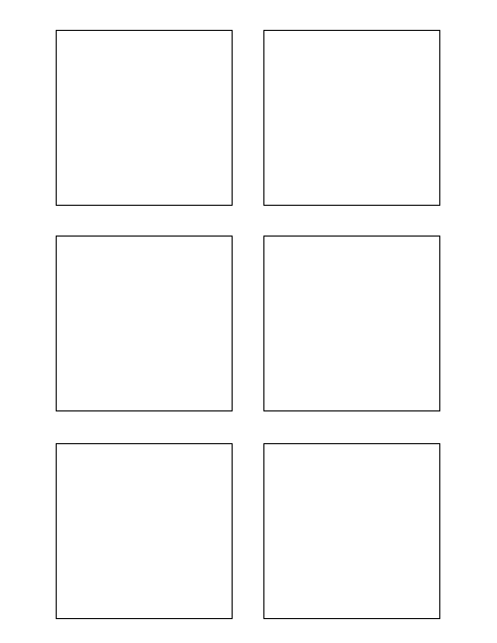

**\* Stickie Template Word Document will be populated from wiki data**

Stickie Template Word Document will be populated from wiki data* Stickie Template Word Document will be populated from wiki data

* Wiki data has already been downloaded to hosting machine

* Stickie Template Word Document will be populated from wiki data

2

1

0

8

**Assumptions===* Wiki data has already been downloaded to hosting machine**

Wiki data has already been downloaded to hosting machine* Wiki data has already been downloaded to hosting machine

**Software Design & Development (8) ===0**

Extract data from wiki format 0

TWSSAFE-002

TWSSAFE-002

TWSSAFE-002

TWSSAFE-002

TWSSAFE-002

TWSSAFE-002

**Software Design & Development (8) ===1**

Populate each Trixie box with the story category 1

**2Software Design & Development (8) ===**

The box title color should change per feature! (1)

Another bullet added for test (1)

Populate stickie box title with the feature number 2

**8Research (2)===**

Research different word document manipulation python libraries 8