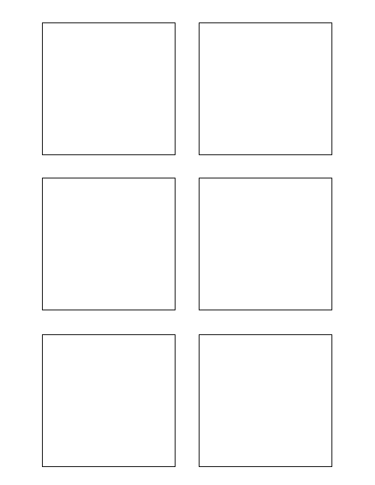

**3Software Design & Development (8) ===**

Populate each Trixie box with each story title 3

5

3

* Wiki data has already been downloaded to hosting machine

8

* Stickie Template Word Document will be populated from wiki data

* Develop Unit Test for Trixie Stickies

**Software Design & Development (8) ===5**

Populate each Trixie box with the correct story points 5

**\* Stickie Template Word Document will be populated from wiki data**

Stickie Template Word Document will be populated from wiki data* Stickie Template Word Document will be populated from wiki data

TWSSAFE-002

TWSSAFE-002

TWSSAFE-002

TWSSAFE-002

TWSSAFE-002

TWSSAFE-002

**Research 8**

Research different word document manipulation python libraries 8

**\* Wiki data has already been downloaded to hosting machineAssumptions===**

Wiki data has already been downloaded to hosting machine* Wiki data has already been downloaded to hosting machine

**\* Develop Unit Test for Trixie Stickies Testing (1)===**

Develop Unit Test for Trixie Stickies * Develop Unit Test for Trixie Stickies