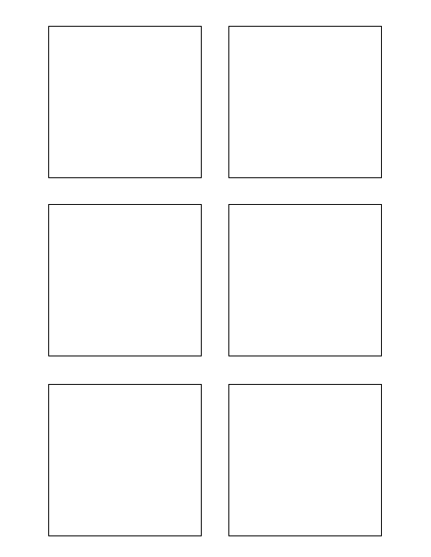

**0Software Design & Development**

Extract data from wiki format 0

2

0

5

* Develop Unit Test for Trixie Stickies

3

1

**Software Design & Development 2**

The box title color should change per feature! (1)

Another bullet added for test (1)

Populate stickie box title with the feature number 2

**Software Design & Development 3**

Populate each Trixie box with each story title 3

TWSSAFE-002

TWSSAFE-002

TWSSAFE-002

TWSSAFE-002

TWSSAFE-002

TWSSAFE-002

**Testing * Develop Unit Test for Trixie Stickies**

Develop Unit Test for Trixie Stickies * Develop Unit Test for Trixie Stickies

**5Software Design & Development**

Populate each Trixie box with the correct story points 5

**1Software Design & Development**

Populate each Trixie box with the story category 1