***STUBBS’ EDUCATIONAL FOUNDATION, Inc.***

|  |
| --- |
| **VARIETY EXTRAVAGANZA 2018 – “The Great Gatsby”** |
|  |

**TREBLE CLEF SPONSOR $1000 $800**

**GRAND PIANO SPONSOR $8000 $800**

**Three Reserved tables for ten at event**

**Full Page Back Cover Colored Ad**

**Recognized at Gala by MC**

**Business Logo in publicity**

**Recognized with signage at event**

**Recognized on SEF Website and Facebook**

**GRAND STAFF SPONSOR $4000 $800**

**Two Reserved Tables for ten at event**

**Full Page Inside Cover Color Ad**

**Recognized at Gala by MC**

**Business Logo in publicity**

**Recognized with signage at event**

**Recognized on SEF Website and Facebook**

**PIANO CLUB SPONSOR $1500 $800**

**One Reserved Table for ten at event**

**Full Page colored ad in program**

**Recognized at Gala by MC**

**Business Logo in publicity**

**Recognized on SEF Website and Facebook**

**COME and ENJOY a Roaring Twenties Evening!!**

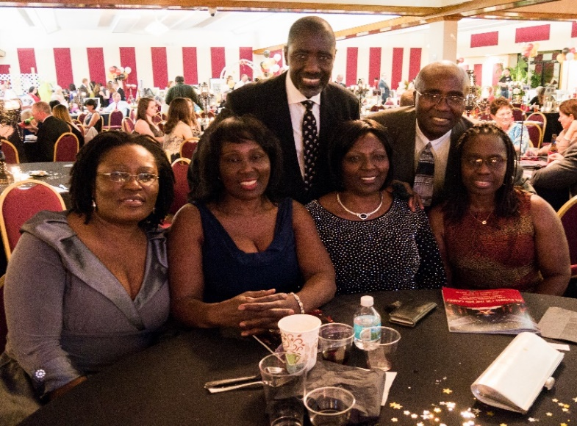

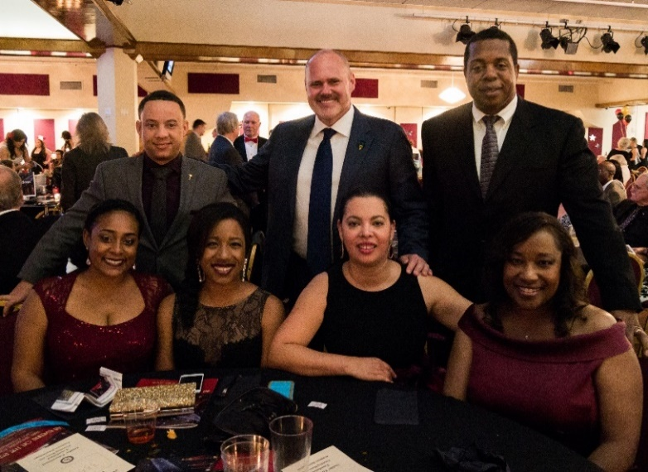

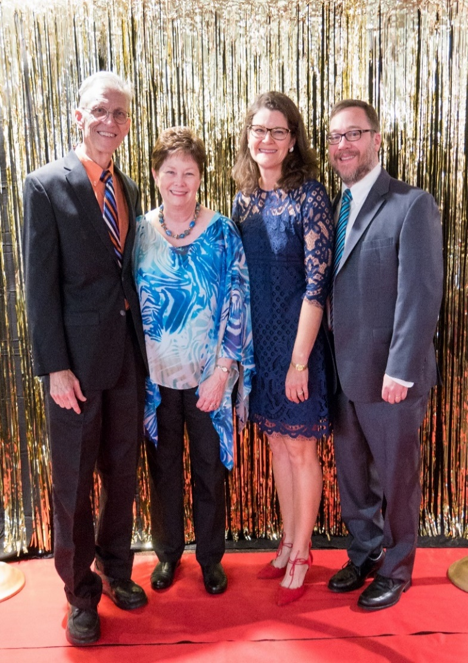

**One Reserved Table for ten at event**

**Half Page colored ad in program**

**Recognized at Gala by MC**

**Business Logo in publicity**

**Recognized on SEF Website and Facebook**

**BASS CLEF SPONSOR $500 $800**

**Four tickets for event**

**¼ page colored ad in program**

**Recognized on SEF Website and Facebook**

**NOTE CLUB SPONSOR $250 $800**

**Two tickets for event**

**Business Card colored ad in program**

**Recognized on SEF Website and Facebook**

**FORTE CLUB SPONSOR $50 - $249 $800**

**Recognized on SEF Website**

**+PLUS A WORTHY CAUSE**

**SOUTHERN SATISFACTION BAND**

**Hors d'oEuvReS, Dinner & DESSERT**

**Complimentary Beer & Wine**

**Cash Bar**

**Dancing & Silent Auction**

**50/50 raffle & Door Prizes**

