Cute-YOLO Studio
User Manual
Train, adapt, quantize, package, and deploy a fixed single-class detector over BLE

Fixed architecture: cute_yolo_fixed_dualcore_hybrid_8_24
Input: 128 x 128 grayscale
Detection head: 16 x 16 x 5 [objectness, dx, dy, w, h]
Trainable parameters: 23,925 | Convolution MACs: 6,995,968

August 2026

1. Quick Start
Cute-YOLO Studio organizes the complete workflow into four tabs. A typical project moves from source-domain training to optional real-domain adaptation, then packages the INT8 detector as a .cute file and uploads it to an ESP32 over BLE.
TRAIN -> ADAPT TO REAL DATA -> DEPLOY VIA BLE -> VERIFY IN LOG
First-time users: start with one of the ready-to-use ZIPs or download notes in dataset_examples/.
- Prepare a single-class YOLO-format ZIP for base training.
- Train the fixed Cute-YOLO model and optionally create the base .cute package.
- If camera-domain performance needs improvement, collect and label real ESP32 images with collect_cute_dataset.py and cute_label_gui.py, then run domain adaptation.
- Deploy the base or adapted .cute package over BLE.
- Confirm transfer, validation, and activation in the Log tab.
Paths: All paths shown in the screenshots are examples. Your dataset, output, and model paths can be different.

Recommended starting recipes
Object type | Preset | Min. size | Overlap loss
Faces / vehicles / animals | Complex / distinctive | 8 px is a useful starting point | CIoU
Circles / blobs / repeated shapes | Primitive / repetitive | 0 px or task-dependent | CIoU
Loss profiles: The Complex preset emphasizes hard-negative mining. The Primitive preset can add box-footprint, halo, and crowd-aware negative weighting to suppress geometric pseudo-objects.

2. Repository Layout and Example Datasets
The repository is organized so a new user can move from example data to training, adaptation, firmware, and documentation without searching through a monolithic folder. The dataset_examples/ folder should demonstrate the exact ZIP formats accepted by Cute-YOLO Studio.
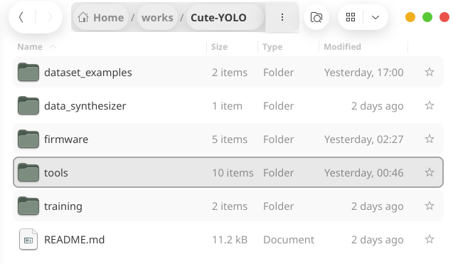
Repository view. A docs/ folder is recommended for the manual and project documentation.

Recommended top-level roles
Folder / file | Role in the Cute-YOLO workflow
dataset_examples/ | Ready-to-use example ZIPs and dataset download notes for base training and domain adaptation.
data_synthesizer/ | Synthetic-data generators, including the round-object generator used for primitive/repetitive experiments.
firmware/ | ESP32 Cute-YOLO firmware, fixed INT8 inference runtime, BLE model receiver, camera/TFT integration, and device-side deployment support. See Section 4 for the current ST7735 wiring.
tools/ | Cute-YOLO Studio and supporting utilities for real-domain collection, label verification, .cute packaging, and BLE upload. When the tools are run from this directory, several generated output folders also appear here.
training/ | Standalone or reference training material, notebooks/scripts, and experiment-specific training support.
docs/ | Recommended folder for this user manual, figures, and other project documentation.
README.md | Repository entry point: installation, quick start, hardware notes, and links to examples/documentation.

Example datasets
Use source dataset for the data used in base training, and real deployment-domain dataset for the smaller data collected from the target ESP32 camera setup and used during domain adaptation.

Round-object example
- round_synthetic.zip -> base training with the Primitive / repetitive preset.
- round_real.zip -> domain adaptation using real camera images of the same target class.
Face example
- WIDER FACE YOLO-format source dataset -> base training with the Complex / distinctive preset. Prefer a README/download note instead of committing the entire third-party dataset when redistribution or repository size is a concern.
- esp32_face_real.zip -> real deployment-domain data exported by the Cute-YOLO labeling workflow and used for adaptation.

Expected single-class YOLO ZIP organization
dataset.zip
images/
image001.jpg
image002.jpg
labels/
image001.txt
image002.txt
classes.txt (optional; otherwise the Studio uses class "X")
Each label row: 0 x_center y_center width height
Coordinates are normalized to [0, 1].

Workflow rule: source ZIP -> Tab 1 Base Training; real deployment-domain ZIP -> Tab 2 Domain Adaptation.

3. Tools Directory and Generated Folders
The tools/ directory contains both source utilities and working/output folders. Some folders are created automatically when a tool is run from tools/, so they should not be confused with hand-written source code.
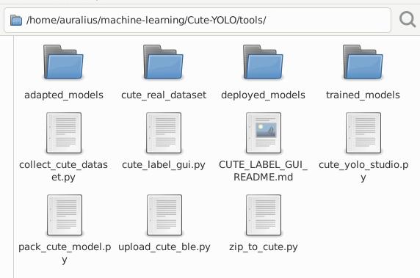
Figure 1a. tools/ directory showing source utilities together with generated training, adaptation, and collection folders.

Source utilities
The table below summarizes the current utilities and the files or folders they create.
Tool | Purpose | Creates / writes
cute_yolo_studio.py | Main four-tab desktop application for base training, domain adaptation, direct BLE deployment, and logging. | By default, Train writes to trained_models/ and Adapt writes to adapted_models/ when the Studio is launched from tools/. Each run also creates the corresponding export ZIP, debug folder, and optional .cute package. The current Deploy tab uploads an existing .cute directly and does not create a deployment folder.
collect_cute_dataset.py | Collects the exact 128 x 128 GRAY8 detector input and current ESP32 detections over USB serial for real-domain data acquisition. | Default output: cute_real_dataset/. It creates images/ (clean detector inputs), labeled/ (preview images), pseudo_labels/ (model-predicted YOLO boxes), and metadata/ (JSON confidence/timing/model information). Pseudo-labels are not verified ground truth.
cute_label_gui.py | Reviews and corrects the collector pseudo-labels, or labels images from scratch, for the single Cute-YOLO class. | Inside the selected dataset it creates/updates classes.txt, labels/, and reviewed/. Export ZIP writes a standard single-class YOLO ZIP containing classes.txt, images/, and labels/.
zip_to_cute.py | User-facing converter from a Cute-YOLO TensorFlow export ZIP to a memory-mappable .cute package. Supports optional deployment-setting overrides. | Writes one .cute file. Train/Adapt in Cute-YOLO Studio use this converter when "Also create <class>_base.cute" or "..._adapted.cute" is enabled.
pack_cute_model.py | Lower-level fixed-format packer for the same 8+24 architecture. Useful for scripted/explicit packaging and format validation. | Writes the explicitly requested --out .cute file. It does not create a fixed working directory.
upload_cute_ble.py | Standalone BLE uploader for an already-built .cute package. It scans for Cute-YOLO unless --address is supplied, uploads the blob, then waits for firmware validation/activation. | No model-output folder. The file is transmitted to the ESP32 A/B model partitions; progress and status are printed to the terminal.
CUTE_LABEL_GUI_README.md | Short usage notes for the labeling GUI. | Documentation only; it does not create data.

Generated folder lifecycle
tools/
collect_cute_dataset.py
cute_label_gui.py
cute_yolo_studio.py
zip_to_cute.py
pack_cute_model.py
upload_cute_ble.py
CUTE_LABEL_GUI_README.md
cute_real_dataset/ <- generated by collect_cute_dataset.py
trained_models/ <- default Studio Train output
adapted_models/ <- default Studio Adapt output
deployed_models/ <- legacy/optional folder from an older Studio flow

Important: in the current four-tab Studio, Deploy via BLE consumes an existing .cute file directly. Therefore deployed_models/ is not required by the current deployment tab and can be treated as a legacy or user-managed folder if it remains in the repository working tree. Generated folders such as trained_models/, adapted_models/, and cute_real_dataset/ are normally working artifacts; keep curated public samples under dataset_examples/ and consider excluding generated working folders from version control.

Real-domain data workflow
The collection and labeling utilities form a small pipeline before domain adaptation:
ESP32 camera + active .cute
-> collect_cute_dataset.py
-> cute_real_dataset/
images/ + pseudo_labels/ + metadata/
-> cute_label_gui.py
verify/correct boxes -> labels/
-> Export ZIP
-> Cute-YOLO Studio: Adapt to Real Data

4. ESP32-S3 Hardware Wiring
The current fixed 8+24 Cute-YOLO firmware uses an ST7735 128 x 160 SPI TFT. The display is initialized in landscape orientation, giving a 160 x 128 screen. The camera wiring is defined separately by camera_pins.h; the table below covers the TFT interface used by the detector firmware.
TFT label | ESP32-S3 pin | Function / note
SCK / SCL / CLK | GPIO39 | SPI clock
SDA / MOSI / DIN | GPIO40 | SPI MOSI (display data). On many ST7735 modules this pin is labeled SDA even though the interface is SPI.
CS | GPIO38 | SPI chip select
DC / A0 / RS | GPIO41 | Data / command select
RST / RES | GPIO42 | Display reset
MISO | Not connected | The firmware sets TFT_MISO = -1; the display is write-only in this configuration.
GND | GND | Common ground
VCC / LED / BL | Module-dependent | Use the supply/backlight voltage specified for the particular ST7735 breakout. Do not infer the power voltage from the GPIO mapping.
Current control button: the fixed 8+24 firmware uses the ESP32-S3 DevKitC-1 built-in BOOT button on GPIO0. No extra button is required for the current firmware when that board is used.

Relevant firmware definitions:
#define TFT_SCLK 39
#define TFT_MOSI 40
#define TFT_CS 38
#define TFT_DC 41
#define TFT_RST 42
#define TFT_MISO -1
#define BUTTON_PIN 0

Display initialization:
SPI.begin(TFT_SCLK, TFT_MISO, TFT_MOSI, TFT_CS);
tft.initR(INITR_BLACKTAB);
tft.setRotation(1);

5. Tab 1 - Train
Use the Train tab to learn the complete fixed network from a source dataset. All layers are trainable during base training: the three stems, Hybrid A, Hybrid B, and the detection head.
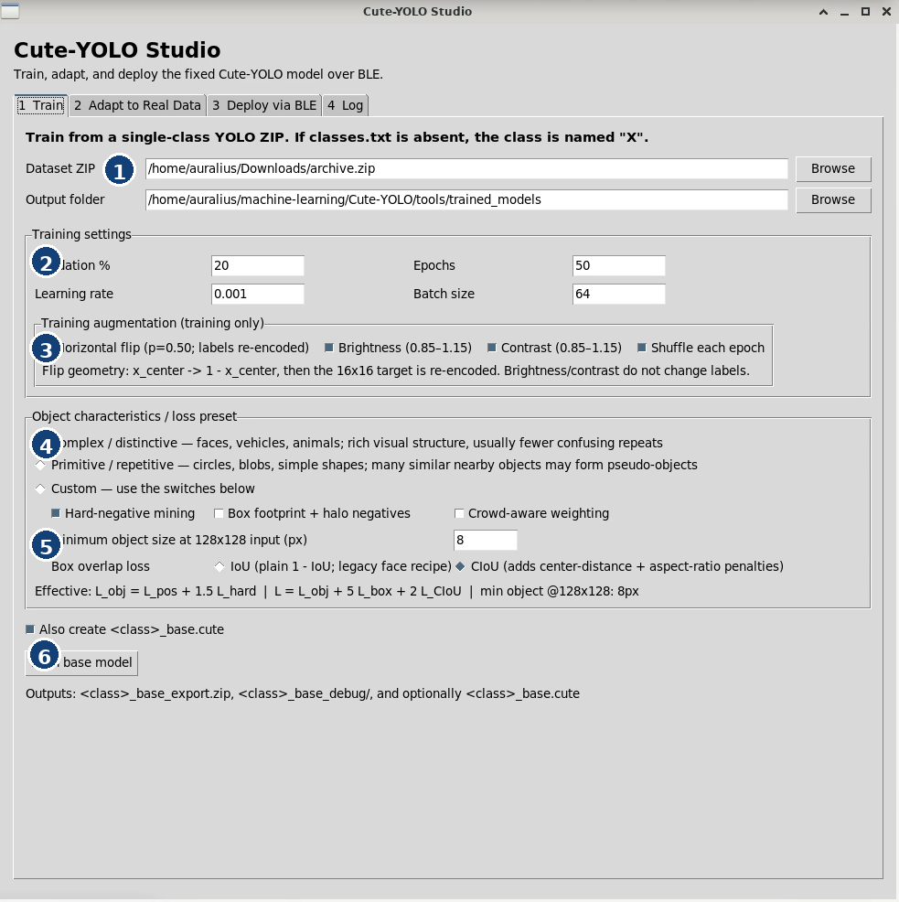
Figure 1. Train tab. Numbered markers correspond to the explanations below.
1 | Dataset ZIP and output folder. The ZIP must contain a single-class YOLO dataset. If classes.txt is absent, the Studio names the class "X".
2 | Core training settings. Validation % controls the hold-out split; epochs, learning rate, and batch size control optimization.
3 | Training-only augmentation. Horizontal flip is label-safe: x_center is transformed to 1 - x_center and the 16 x 16 target is re-encoded. Brightness and contrast alter only image appearance. Shuffle changes sample order each epoch.
4 | Object characteristics / loss preset. Choose Complex / distinctive for rich objects such as faces, or Primitive / repetitive for repeated simple geometry. Custom exposes the individual switches.
5 | Detection-loss details. Hard-negative mining focuses on confusing background cells. Minimum object size filters tiny boxes at 128 x 128. Box overlap can use IoU or CIoU.
6 | Package/output controls. Enable "Also create <class>_base.cute" for a deployment-ready package, then press Train base model.

6. Understanding the Training Loss
The detector predicts a 16 x 16 grid. Each cell has five outputs: objectness plus four bounding-box quantities [dx, dy, w, h]. Only the cell containing an object center receives objectness target 1; background cells have target 0.
L = L_obj + 5 L_box + 2 L_overlap
Complex / distinctive: L_obj = L_pos + 1.5 L_hard
Primitive / repetitive: task-dependent footprint / halo / crowd terms may be added

What the terms mean
- L_pos: binary-cross-entropy objectness loss at true object-center cells.
- L_hard: binary-cross-entropy loss over the hardest background cells - the cells most strongly mistaken for objects.
- L_box: coordinate regression loss for [dx, dy, w, h] at positive cells.
- L_overlap: IoU or CIoU loss on decoded predicted and ground-truth boxes.
- Footprint / halo negatives: specially weighted background cells around a ground-truth box. Their objectness target is still 0.
- Crowd-aware weighting: increases supervision where several nearby primitive-object footprints overlap or interact.
Grid resolution: The loss is evaluated on the 16 x 16 detection representation. Box geometry is decoded back into normalized image coordinates for IoU/CIoU. One detector cell corresponds to approximately 8 x 8 input pixels.

Training outputs
- <class>_base_export.zip - model/export data used by the Studio pipeline.
- <class>_base_debug/ - debug images and training diagnostics.
- <class>_base.cute - deployment package when the option is enabled.
Deployment calibration: After INT8 conversion, Cute-YOLO Studio selects the deployment confidence and NMS operating point on INT8 validation outputs rather than blindly copying the FP32 threshold.

7. Tab 2 - Adapt to Real Data
Domain adaptation fine-tunes a trained base detector using a mixture of the original source data and verified real deployment-domain samples. This is intended for cases where the source-validation model is good but the physical ESP32 camera domain differs in lighting, optics, scale, or background statistics.
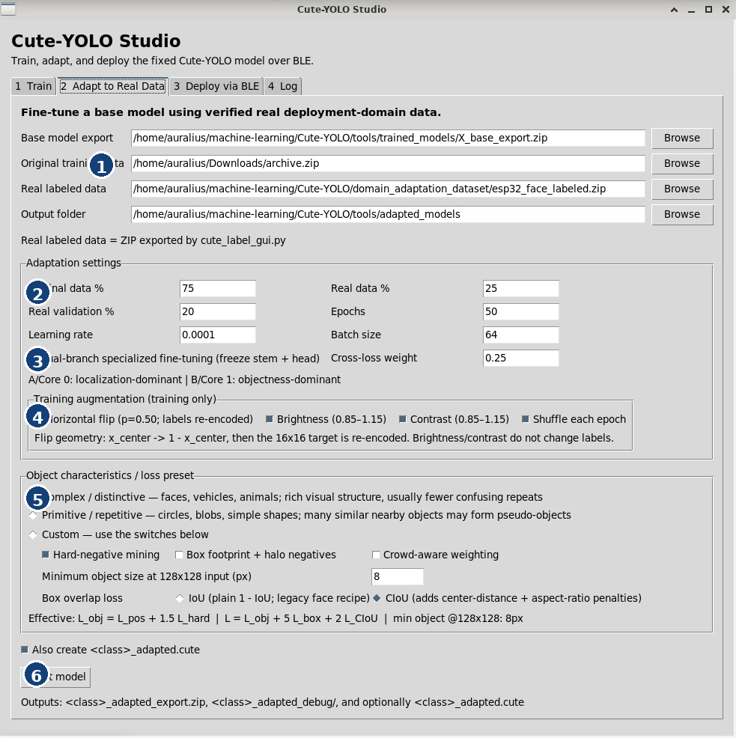
Figure 2. Adapt to Real Data tab.
1 | Input files. Select the base model export, the original source training ZIP, the real labeled ZIP, and an output folder. The real labeled ZIP is produced by the Cute-YOLO labeling workflow.
2 | Mixture and optimizer settings. Original data % and Real data % control the source/target mix. Real validation % reserves target-domain samples for evaluation. Adaptation normally uses a smaller learning rate than base training.
3 | Dual-branch specialized fine-tuning. When enabled, Stem 1/2/3 and the head are frozen. Hybrid A is localization-dominant; Hybrid B is objectness-dominant. The cross-loss weight keeps each branch aware of the complementary objective.
4 | Training-only augmentation is available again during adaptation. Flip labels are re-encoded exactly as in base training.
5 | Use the same task-appropriate loss preset and overlap loss unless you are intentionally running an ablation.
6 | Enable "Also create <class>_adapted.cute" and press Adapt model to produce the target-domain package.

8. Tab 3 - Deploy via BLE
The Deploy via BLE tab sends an existing .cute model package directly to the ESP32. The package is uploaded byte-for-byte; no conversion is performed in this tab.
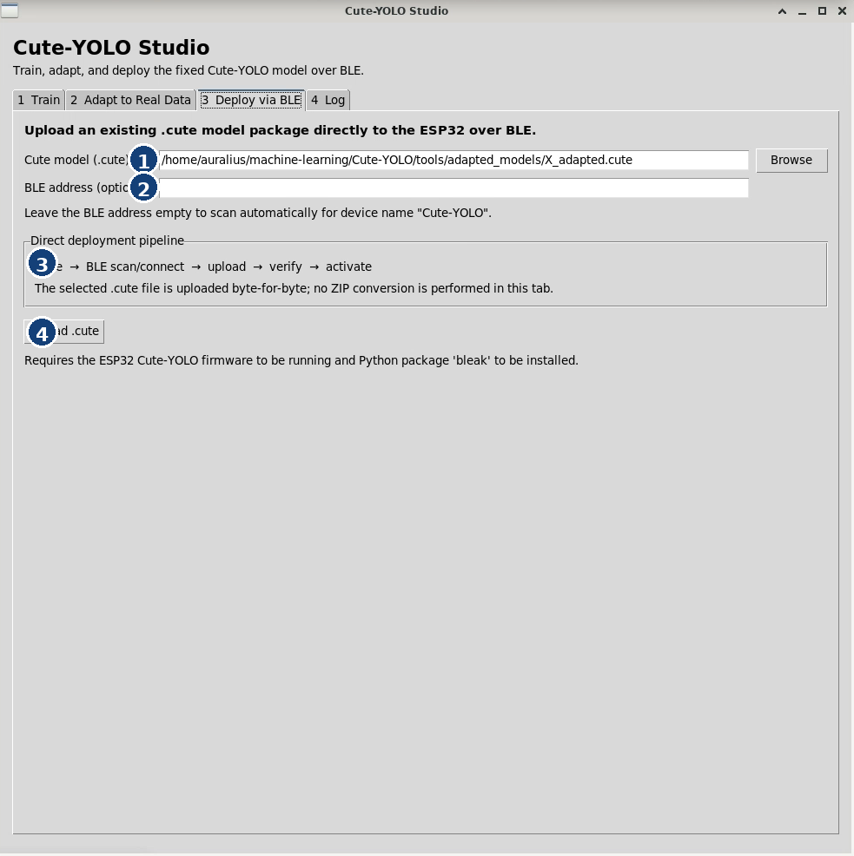
Figure 3. Deploy via BLE tab.
1 | Choose the .cute package to deploy. This can be a base or adapted package.
2 | BLE address is optional. Leave it empty to scan automatically for a device named "Cute-YOLO". Enter an address only when you need to target a known device explicitly.
3 | The direct deployment pipeline is: .cute -> BLE scan/connect -> upload -> verify -> activate.
4 | Press Upload .cute. The ESP32 firmware must already be running and the Python package bleak must be installed.

9. Tab 4 - Log
The Log tab is the authoritative place to check training, adaptation, conversion, packaging, and BLE deployment progress. It is also the easiest place to copy experiment records for a paper or lab notebook.
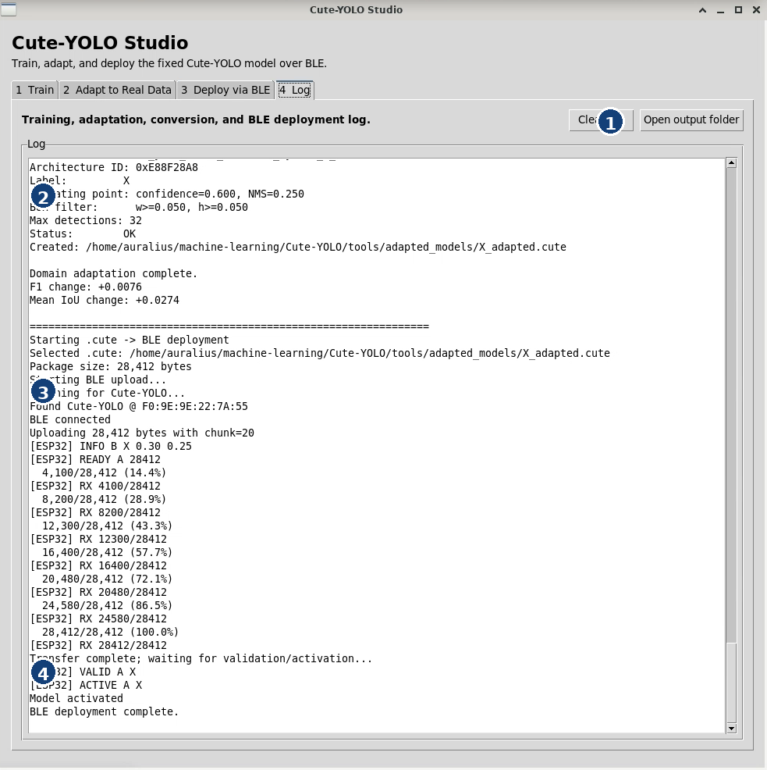
Figure 4. Log tab showing successful package creation and BLE activation.
1 | Utility buttons. Clear log removes the current text. Open output folder jumps to the active output directory.
2 | Package summary. Check the architecture ID, label, confidence/NMS operating point, box filter, maximum detections, status, and output path.
3 | BLE transfer progress. The log reports device discovery, connection, byte counts, and percentage transferred.
4 | Validation and activation. A successful deployment ends with messages such as VALID A, ACTIVE A, Model activated, and BLE deployment complete.

10. Recommended End-to-End Workflows

A. Complex / distinctive objects
- Examples: faces, vehicles, animals, or other visually rich single-class targets.
- Use Complex / distinctive preset.
- Keep hard-negative mining ON.
- Keep footprint/halo and crowd-aware weighting OFF unless a specific experiment shows they help.
- Use a practical minimum size (8 px at 128 x 128 is a useful starting point for face-like targets).
- Enable mild horizontal-flip, brightness, contrast, and shuffle augmentation when appropriate.
- Train base model, then inspect FP32 and INT8 validation metrics.
- Collect real ESP32-domain images and adapt if the physical camera domain differs.
- Deploy the INT8-selected .cute package without manually overriding its threshold unless testing an ablation.

B. Primitive / repetitive objects
- Examples: circles, blobs, simple geometric shapes, or repeated nearby objects.
- Use Primitive / repetitive preset.
- Hard-negative mining remains useful.
- Enable box-footprint + halo negatives to suppress objectness inside and immediately around confusing object geometry.
- Enable crowd-aware weighting when neighboring repeated objects form geometric pseudo-objects.
- Choose minimum object size according to the synthetic generator and physical camera target.
- Use the same quantize -> INT8 sweep -> .cute -> BLE deployment path.
Paper / experiment logging: For reproducible experiments, record the selected preset, overlap loss, augmentation switches, minimum object size, source/real mixing ratio, real-validation split, and the final INT8 confidence/NMS operating point.

11. Troubleshooting
Symptom | What to check
Model trains but misses physical objects | Check the real camera domain, minimum-size filtering, augmentation, and the INT8-selected operating point. If needed, collect verified real data and use domain adaptation.
Many false positives | Confirm the task preset. Complex targets benefit from HNM; repeated primitives may need footprint/halo and crowd-aware weighting.
Two nearby objects become one target | The 16 x 16 head can represent one object center per cell. If two centers land in the same cell, a grid-cell collision occurs.
Tiny faces disappear from training | Boxes below the minimum object size are intentionally dropped after crop/resize to 128 x 128.
BLE scan finds no device | Make sure the ESP32 Cute-YOLO firmware is running, BLE is available on the host, and the device advertises as Cute-YOLO. Optionally enter the BLE address.
Upload reaches 100% but model is not active | Read the Log tab for validation/activation messages. Successful transfer alone is not enough; look for VALID and ACTIVE.
INT8 metric differs from FP32 | Use the INT8 deployment sweep. Small output changes after quantization can change the optimal confidence or NMS threshold even when localization quality is preserved.

12. Quick Reference
Item | Cute-YOLO Studio behavior
Input | 128 x 128 grayscale
Head | 16 x 16 x 5
Object classes | Single class per model package
Base training | All layers trainable
Specialized adaptation | Stem + head frozen; Hybrid A/B trainable
Quantization | Strict INT8
Deployment calibration | Confidence + NMS selected on INT8 validation outputs
Package | .cute
Deployment | BLE upload -> verify -> activate
Runtime max detections | 32
Example data | dataset_examples/: source/base-training ZIPs and real-domain adaptation ZIPs
TFT display | ST7735 128 x 160 SPI, landscape 160 x 128
TFT SPI pins | SCLK=GPIO39, MOSI=GPIO40, CS=GPIO38, DC=GPIO41, RST=GPIO42, MISO unused
BOOT button | GPIO0 on the current ESP32-S3 DevKitC-1 fixed 8+24 firmware
Detection capacity: A 16 x 16 head has 256 possible object-center cells, but the runtime output is capped at 32 detections. The practical crowded-scene limit is often same-cell center collision rather than the raw 256-cell representation.

End of manual - see dataset_examples/ for ready-to-use workflow examples, Section 3 for the tools/ directory, and Section 4 for ESP32-S3 TFT wiring.

