NoodleAI Mode 2
Continuous Gesture Recognition on Sipeed M0Sense
Technical Documentation & User Guide

SYSTEM STATEMENT
Train in the browser. Quantize and calibrate locally. Deploy over BLE. Execute continuously on-device using Noodle INT8 operators.

MCU  BL702 | IMU  QMI8658 | SAMPLING  50 Hz | RUNTIME  Noodle INT8 | FORMAT  NAI4

Documented software release
Firmware v0.4.5 · Web Studio v0.7.1 · August 2026
Browser-trained · BLE-deployed · Noodle-executed

1. System overview
What Mode 2 does and how the complete pipeline fits together.
NoodleAI Mode 2 is a continuous gesture-learning workflow for the Sipeed M0Sense (BL702). The device streams six-axis QMI8658 motion data to a browser over BLE. The browser records labeled motion, builds fixed sliding windows, trains an MLP locally, performs post-training INT8 quantization, sweeps a confidence threshold on validation data, packages the result as NAI4, and deploys it back to the device. In inference mode, the M0Sense runs the model continuously using Noodle operators.

End-to-end workflow
01 | QMI8658 streams raw acceleration + gyroscope data over BLE at 50 Hz.
02 | The browser records continuous examples and slices them into fixed windows.
03 | The selected input representation is generated and filtered consistently.
04 | A compact MLP is trained in TensorFlow.js inside the browser.
05 | Post-training INT8 quantization calibrates the deployed network.
06 | Confidence threshold is swept from 0.30 to 0.90 in 0.01 increments.
07 | The NAI4 package is deployed over BLE and CRC-verified in flash.
08 | Noodle executes the INT8 MLP continuously on the rolling device window.

Current platform
Component | Configuration | Role
MCU | Bouffalo Lab BL702, 512 KiB flash | BLE, sensor acquisition, flash model store, inference
Sensor | QMI8658 6-axis IMU | Acceleration + angular-rate input
Sampling | 50 Hz application stream | Gesture window timing
Web | Chrome/Web Bluetooth + TensorFlow.js | Capture, train, quantize, deploy, visualize
Runtime | Noodle INT8 | On-device MLP execution
Model package | NAI4 | Network + scaler + quantization + threshold + filter metadata

DESIGN PRINCIPLE
Mode 2 intentionally keeps the device architecture simple: one application state machine, one persistent model slot, continuous sensor acquisition, and no gesture-start button.

Operating modes
Mode | Behavior
Training / streaming | Continuously notifies raw six-axis IMU packets to the browser; no device-side prediction required.
Deployment | Temporarily disables mode switching while flash is erased, files are written, CRC-verified, and the slot is committed.
Inference | Maintains the rolling IMU window and runs the committed NAI4 model continuously every configured stride.

BLE GATT interface
Characteristic | UUID suffix | Direction / purpose
IMU | 0002 | Notify: 5 packed six-axis samples per packet
CONTROL | 0003 | Write: training / inference / deployment control opcodes
MODEL | 0004 | Write: raw model-file chunks during deployment
STATUS | 0005 | Read + Notify: model state, deployment status, predictions, diagnostics

2. Firmware build and flashing
Known-good commands for the BL702 M0Sense application.

Build
cd ~/works/M0sense_BL702_example
rm -rf bl_mcu_sdk/build
./build.sh m0sense_apps/nai_m0sense
stat -c '%s bytes' \
bl_mcu_sdk/out/m0sense_apps/nai_m0sense/nai_m0sense_bl702.bin

Firmware v0.4.5 builds to 299,732 bytes. The firmware must remain at or below 319,488 bytes so it does not overlap the raw model region beginning at physical flash address 0x50000.
FIRMWARE  299,732 B | LIMIT  319,488 B | HEADROOM  19,756 B | MODEL REGION  192 KiB

Flash
Enter the BL702 downloader mode by connecting Boot_Strap to 3.3 V, resetting or power-cycling the board, and then run:
source ~/zephyrproject/.venv/bin/activate
bflb-mcu-tool-uart \
--chipname=bl702 \
--port=/dev/ttyACM0 \
--baudrate=2000000 \
--firmware=bl_mcu_sdk/out/m0sense_apps/nai_m0sense/nai_m0sense_bl702.bin

After flashing, remove the Boot_Strap connection and reset/power-cycle again for normal execution.

Flash layout
Physical range | Size | Purpose
0x00000–0x01FFF | 8 KiB | Boot/platform area
0x02000–0x4FFFF | 312 KiB reserved | Application firmware
0x50000–0x50FFF | 4 KiB | Single-slot model header
0x51000–0x7FFFF | 188 KiB | NAI4 model payload

IMPORTANT
There is no FFat partition in the current Mode 2 design. Model files are stored in one raw single-slot flash region with a compact committed header and per-file CRC verification.

3. Connect the browser to M0Sense
Web Bluetooth pairing and live telemetry.
Open the NoodleAI Web Studio in Chrome and press Connect. The browser shows the Web Bluetooth pairing dialog; select the NoodleAI device and press Pair.
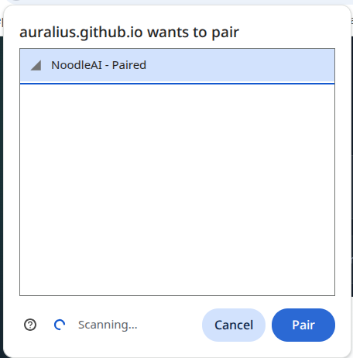 | 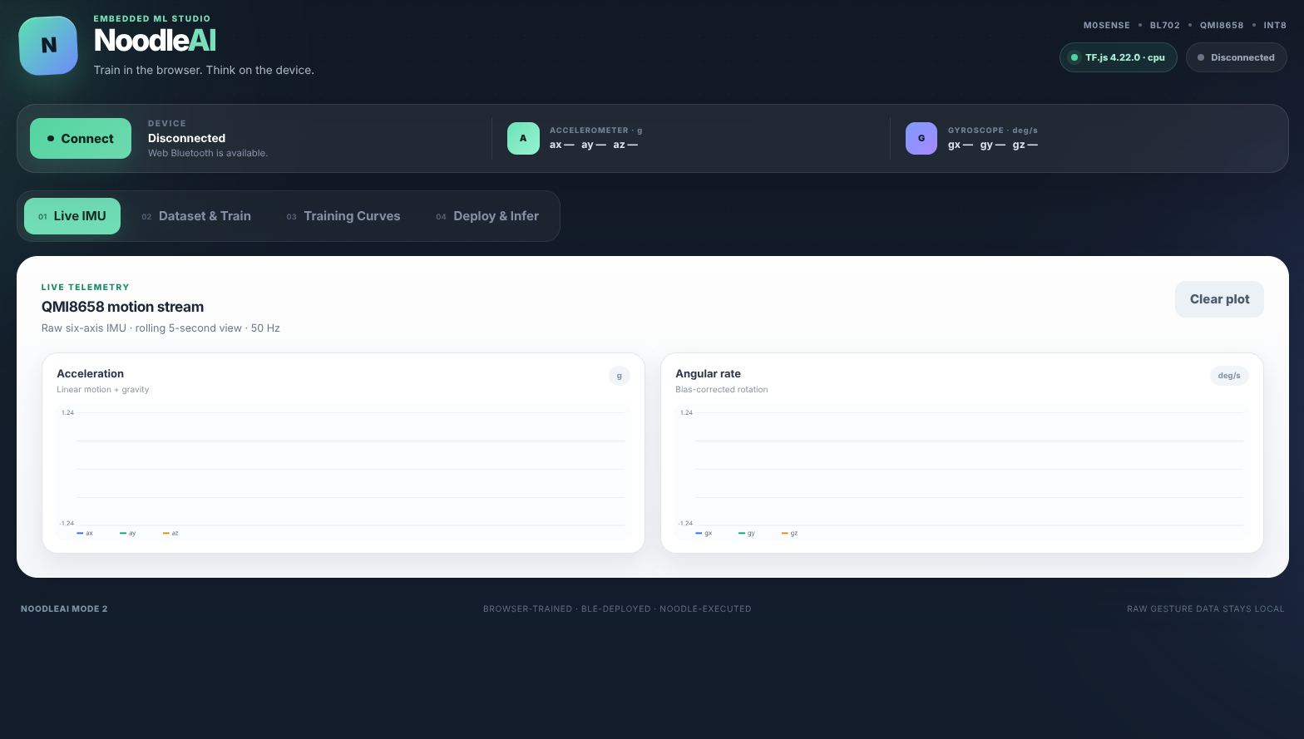
Web Bluetooth pairing (left) and the redesigned NoodleAI Studio live-telemetry view (right).

Connected-state indicators
- The top-right status badges show TensorFlow.js availability and BLE connection state.
- The device strip shows the current Mode 2 state plus live accelerometer and gyroscope values.
- The Live IMU tab plots approximately the latest five seconds of six-axis motion.
- The firmware performs a startup gyro zero-rate calibration; keep the board still for roughly 1–2 seconds immediately after reset.
EXPECTED STATIONARY BEHAVIOR
At rest, the accelerometer should measure a gravity vector with magnitude near 1 g, while all three gyroscope axes should remain near 0 deg/s apart from small zero-centered noise.

4. Record a Mode 2 dataset
Continuous examples are labeled in the browser and converted into overlapping fixed windows.
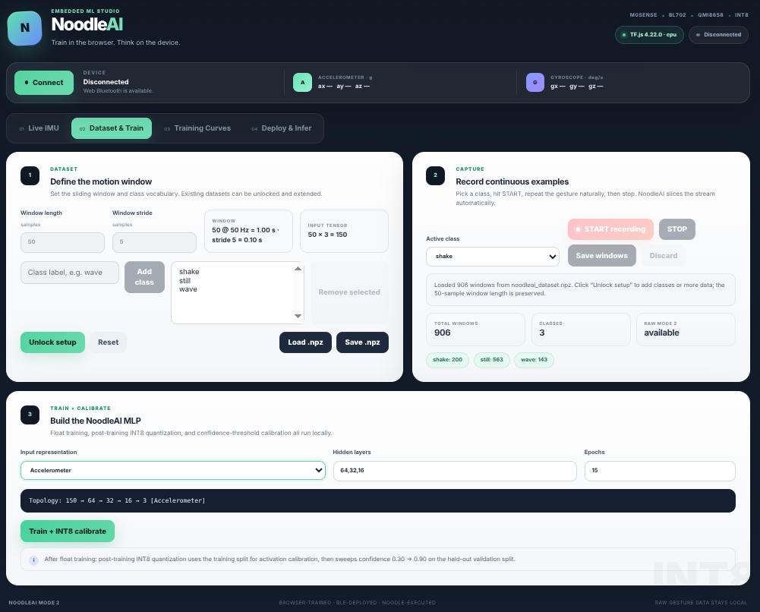
Dataset & Train screen: define window geometry, classes, continuous capture, and MLP topology.

Capture procedure
- Choose the window length and stride before collecting data. Example: 50 samples at 50 Hz = 1.0 s per window; stride 5 samples = a new window every 0.10 s.
- Add class labels such as shake, still, and wave.
- Select a class and press START recording. Perform the gesture repeatedly and naturally.
- Press STOP, review the capture, and Save windows. The browser slices the continuous segment automatically.
- Record an explicit still class; it gives the classifier a useful background state for continuous operation.
Datasets can be saved as .npz and loaded again. When an existing dataset is unlocked, new classes and new recordings can be added while preserving the original window length so the input dimensionality remains consistent.

Validation caution for overlapping windows
PAPER-QUALITY VALIDATION
Adjacent Mode 2 windows can share most of their samples. For rigorous evaluation, separate recording sessions should be held out for validation rather than randomly splitting heavily overlapping windows from the same recording.

5. Input representations and signal filtering
The same preprocessing definition is used during browser training and device inference.
ID | Representation | Channels | Preprocessing before model
1 | Accelerometer | 3 | High-pass 0.10 Hz + low-pass 8 Hz
2 | Gyroscope | 3 | High-pass 0.10 Hz + low-pass 8 Hz
3 | Accel + Gyro | 6 | High-pass 0.10 Hz + low-pass 8 Hz
4 | Relative Quaternion | 4 | Low-pass 8 Hz → Madgwick orientation
5 | Estimated Velocity | 3 | Low-pass 8 Hz → Madgwick → gravity removal → integration
6 | Velocity + Quaternion | 7 | Low-pass 8 Hz → Madgwick → velocity + quaternion

Representations 1–3 use a lightweight first-order band-pass behavior: the high-pass stage suppresses constant/slow sensor offset while the low-pass stage suppresses high-frequency jitter. Representations 4–6 intentionally do not high-pass the sensor inputs before Madgwick, because orientation estimation needs the gravity vector from the accelerometer and genuine slow angular motion from the gyroscope.

Estimated velocity pipeline
A | Low-pass raw accelerometer and bias-corrected gyroscope.
B | Estimate relative orientation using Madgwick.
C | Rotate acceleration into the world frame.
D | Remove 1 g gravity and convert to m/s².
E | Integrate with trapezoidal integration.
F | Apply endpoint linear-drift correction so v(0) and v(end) return to zero.

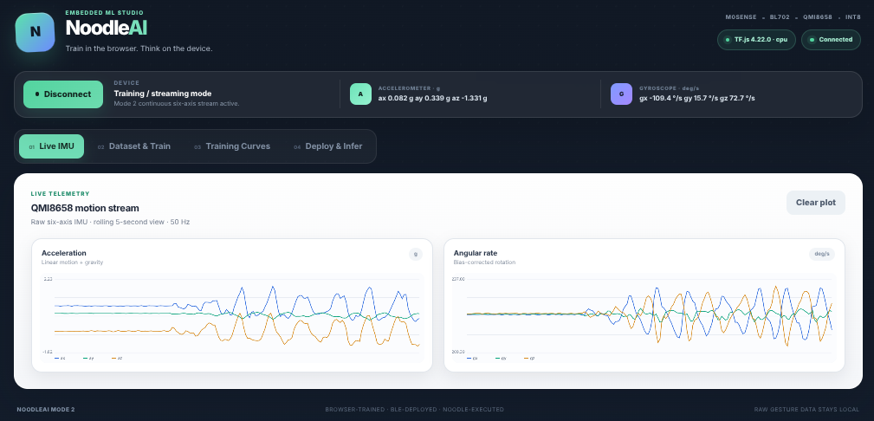
Live QMI8658 telemetry during deliberate motion. The gyro returns near zero when motion stops; transient motion remains clearly visible.

6. Train, quantize, and calibrate
Float training is followed immediately by INT8 calibration and confidence-threshold selection.
The browser trains a dense MLP using TensorFlow.js. A typical Mode 2 topology is specified as a comma-separated list of hidden sizes, for example 64,32,16. The input dimension is determined automatically from window length × representation channels.

Post-training pipeline
01 | Train the float32 MLP.
02 | Use the training split to calibrate INT8 activation/weight ranges.
03 | Evaluate the quantized network on the held-out validation split.
04 | Sweep confidence threshold T = 0.30, 0.31, …, 0.90.
05 | Measure accepted accuracy and coverage for every T.
06 | Select a validation-derived threshold and store it inside cfg.bin.

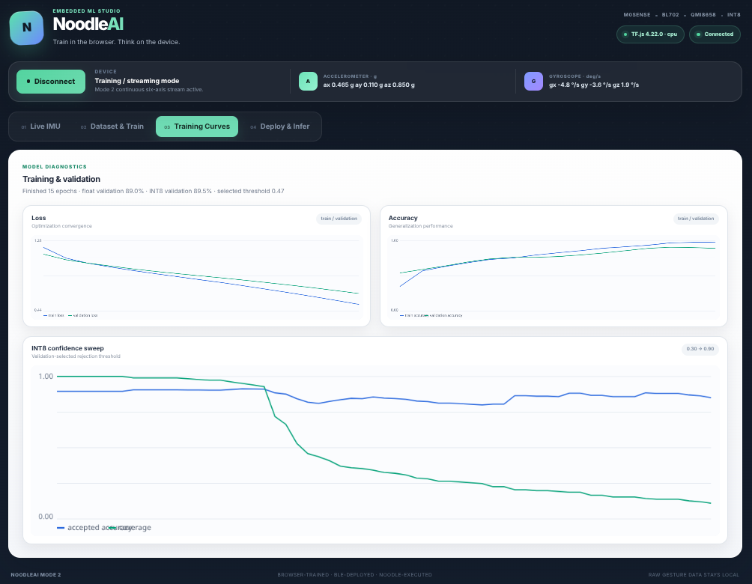
Training curves and INT8 confidence sweep. Blue: accepted accuracy; green: coverage.
For a binary sigmoid classifier, the mathematical class boundary remains 0.5. The swept threshold is a separate acceptance threshold applied to prediction confidence. If confidence is below the deployed threshold, the device reports UNKNOWN rather than forcing a class decision.
WHY SWEEP AFTER QUANTIZATION?
INT8 quantization can slightly shift logits and probabilities. Threshold calibration therefore evaluates the actual quantized model that will run on the M0Sense, rather than calibrating the float model and hoping the same threshold remains optimal.

7. NAI4 deployable model package
One package carries the network and the preprocessing information required to reproduce browser-side inference on the device.

Typical INT8 package contents
Files | Data type / purpose
cfg.bin | NAI4 geometry, classes, representation, stride, confidence threshold, quantization metadata, FLT1 filter metadata
mean.bin / scale.bin | float32 StandardScaler parameters
w00.bin … | INT8 dense-layer weights
b00.bin … | INT32 layer biases
m00.bin / s00.bin … | INT32 requantization multiplier/shift data

Model-owned runtime settings
Setting | Stored with model? | Example
Window length | Yes | 50 or 100 samples
Input representation | Yes | Accelerometer, velocity, etc.
Stride | Yes | 5 or 10 samples
Confidence threshold | Yes | 0.47, 0.67, …
Filter flags / cutoffs | Yes | HP 0.10 Hz, LP 8 Hz
Network dimensions | Yes | 150 → 64 → 32 → 16 → 3
Class labels | Yes | shake / still / wave

KEY ARCHITECTURAL BENEFIT
The firmware does not need a separate build for every gesture model. NAI4 tells the runtime how many channels to generate, which preprocessing path to execute, how often to infer, how to quantize activations, and what confidence is required to accept a prediction.

Storage efficiency
INT8 dramatically reduces the deployed parameter footprint. A representative 600 → 64 → 32 → 16 → 1 float model occupied roughly 165 KiB of raw model files; the INT8 package dropped to roughly 46 KiB while retaining float32 scaler parameters. This comfortably fits the 188 KiB usable model payload region.

8. Deploy and run continuous inference
The model is uploaded once, committed to flash, and can be reused after power cycling.
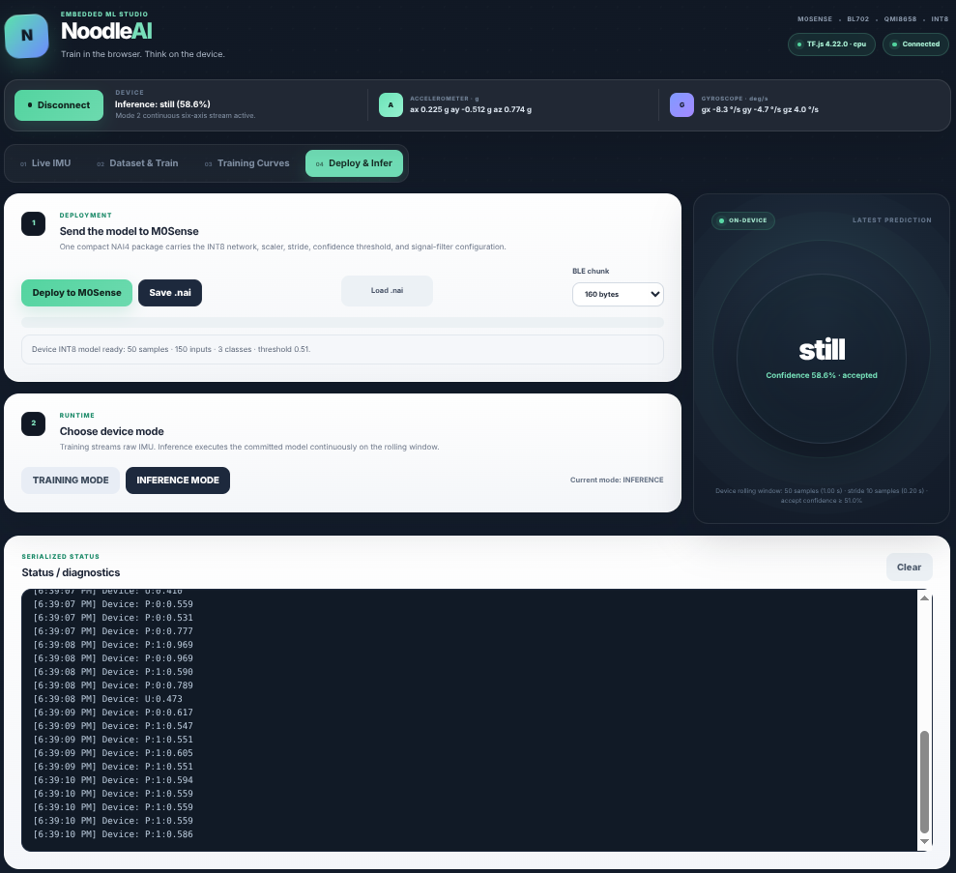
Deploy & Infer screen during live on-device inference. The example prediction is still with 58.6% confidence.

Deployment sequence
- Press Deploy to M0Sense. The firmware erases the raw model region incrementally so BLE remains responsive.
- Each file is announced, written in small BLE chunks, CRC-checked, and read back from flash.
- After all files verify, a compact single-slot header is programmed and committed.
- MODEL_STORED means transport, storage, CRC, and header commit succeeded.
- The runtime then reloads the committed model and reports MODEL:READY with the model geometry and threshold.

Inference behavior
Press INFERENCE MODE to switch from streaming/training behavior to continuous local inference. The firmware fills a rolling raw IMU window, generates the representation requested by cfg.bin, applies the same filters and scaler used during training, quantizes the model input, and executes the Noodle INT8 MLP every configured stride.
QMI8658 @ 50 Hz
↓
rolling raw 6-axis window
↓
NAI4 representation + FLT1 preprocessing
↓
StandardScaler
↓
INT8 quantization
↓
Noodle FCN layers
↓
sigmoid / softmax
↓
confidence ≥ threshold ? class : UNKNOWN
↓
BLE status → browser

PERSISTENT USE
Deployment is only needed when replacing the model. A committed model remains in flash; after a normal power cycle the device can reload it and enter inference mode without retraining or redeploying.

9. Device-side Noodle execution
Neural-network inference is performed using Noodle operators; application code handles only acquisition, preprocessing, storage, and BLE.
The on-device network does not bypass Noodle with a custom dense-layer loop. The runtime prepares quantized tensors and dispatches the dense layers through Noodle. In the INT8 build, the generic FCN call resolves to Noodle’s INT8 implementation with INT32 accumulation and requantization.
input[i] = noodle_quantize_float(...);
for (each layer) {
noodle_fcn(current, next, layer);
}
// Binary classifier
noodle_sigmoid(current);
// Multiclass classifier
noodle_soft_max(current);

What is Noodle vs. application plumbing?
Noodle runtime | Application / platform code
INT8 tensor preparation and quant/dequant helpers | QMI8658 acquisition
INT8 FCN operators | Rolling-window management
INT32 accumulation + requantization | Representation generation and signal filters
Sigmoid / softmax | Raw flash storage and CRC commit
File-backed parameter access | BLE GATT transport and web status messages

SUMMARY
The deployed MLP is executed using Noodle INT8 inference operators, with model parameters stored in onboard flash and model-defined preprocessing reproduced on the BL702 before inference.

10. IMU behavior and practical notes
Zero-rate calibration, filtering, and common troubleshooting observations.

Gyroscope zero-rate calibration
The QMI8658 can exhibit a substantial stationary zero-rate offset. The current firmware estimates this offset during startup: it allows the sensor to settle, discards initial samples, averages a stationary gyro interval, and subtracts that three-axis bias from subsequent readings. Keep the board motionless during this short startup calibration.
A stationary gyroscope should read approximately 0 deg/s on all axes regardless of gravity. Gravity affects the accelerometer, not the gyroscope. Small zero-centered jitter is normal and is additionally attenuated by the model-defined low-pass stage.

Temperature
Gyroscope bias can drift with temperature as the board warms. The current startup calibration is sufficient for the demonstrated gesture workflow, but a future refinement could slowly adapt the bias only while the device is confidently stationary. Temperature compensation is an optimization, not a blocker for the current Mode 2 pipeline.

Quick troubleshooting
Symptom | Likely cause / action
Browser shows stale service/characteristics | Forget the paired device in Bluetooth settings and pair again; GATT caching can survive reflashes.
Deploy reaches MODEL_STORED but model will not load | Check model loader diagnostics and confirm cfg.bin geometry matches supported NAI4 representation.
Inference button disabled | Wait for deployment to finish. Mode changes are intentionally blocked while flash is being erased/written.
Gyro sits far from zero while still | Reset with the board motionless so startup zero-rate calibration is valid.
Velocity inference differs from training | Ensure the dataset was recorded after gyro calibration and that the package includes the same FLT1 preprocessing settings.
Firmware is too large | Binary must stay ≤319,488 bytes; otherwise it would overlap the model region at 0x50000.

11. Reproducible workflow checklist
A compact sequence for demonstrations, experiments, and paper figures.
Step | Action | Expected result
1 | Flash the current Mode 2 firmware. | Normal boot; BLE advertising; gyro calibrates while still.
2 | Open NoodleAI Web Studio and pair. | Connected badge; live six-axis telemetry.
3 | Choose window/stride and define classes. | Input dimension updates automatically.
4 | Record multiple continuous sessions per class. | Raw Mode 2 windows saved in browser / .npz.
5 | Choose representation and train. | Float32 learning curves complete.
6 | Run INT8 calibration + threshold sweep. | INT8 validation, selected threshold, coverage plot.
7 | Save/deploy NAI4 package. | All files CRC-verified; MODEL_STORED; MODEL:READY.
8 | Press INFERENCE MODE. | Continuous accepted class or UNKNOWN every stride.
9 | Power-cycle and reconnect. | Committed model remains available without redeployment.

System contributions captured by this implementation
- Continuous, buttonless gesture capture and rolling-window inference on a small BLE MCU.
- Browser-local training with on-the-fly post-training INT8 quantization.
- Validation-driven confidence threshold calibration with explicit coverage measurement.
- NAI4 packages that carry model geometry, scaler, quantization, stride, class labels, and signal-filter metadata.
- Single-slot BLE deployment with flash read-back CRC verification and persistent on-device storage.
- Six motion representations, including quaternion- and velocity-derived features, reproduced consistently between browser and device.
- On-device neural execution using Noodle INT8 operators on the BL702.
ONE-LINE SYSTEM DESCRIPTION
NoodleAI Mode 2 is a browser-trained, BLE-deployed, continuously executing TinyML gesture-recognition pipeline in which a compact NAI4 package defines both the INT8 neural network and the signal-processing contract used by the embedded Noodle runtime.

— End of Mode 2 technical documentation —

