Project Proposal: Deployment of a Scalable Smart Parking & Vehicle Management System

Name 1 (Leader): Sameer Shahzad — Registration #BSSE23025
Name 2: Hannan Shahzad — Registration #BSSE23055

Repository: https://github.com/Student-ITU/BSSE23025-Smart_Parking_and_Vehicle_Management_System

EXECUTIVE SUMMARY
The Smart Parking & Vehicle Management System (SPVMS) is a full-stack application designed to manage parking operations, real-time vehicle allocation, and secure user access. The system addresses the limitations of traditional parking management systems, which often fail during peak traffic hours, cannot efficiently manage parking space utilization, and lack real-time updates for vehicle tracking.
The proposed solution deploys the SPVMS on a highly available and auto-scaling AWS Cloud architecture. This includes an Application Load Balancer (ALB) to distribute traffic, AWS ECS for containerized backend services, AWS RDS / DynamoDB for storing parking and user data, and AWS ElastiCache (Redis) to ensure real-time state synchronization across multiple backend instances. This implementation guarantees secure, scalable, and resilient operations, handling peak demand while maintaining accurate real-time updates of parking availability.

1. Introduction / Background
Urban areas and commercial facilities face frequent challenges with parking management. Drivers waste time searching for available spots, and administrators lack real-time visibility of parking occupancy. The Smart Parking & Vehicle Management System provides a solution that automates parking allocation, tracks vehicle entry and exit, and provides real-time availability updates to users.
The system is built on a modern stack:
- Frontend (React): A user-friendly interface for customers to search and reserve parking, and for admins to manage spaces.
- Backend (Python / Django): Modular, scalable services built with the Django framework to handle parking allocation, reservations, and notifications.
- Database (PostgreSQL / DynamoDB): Tracks parking spots, user accounts, and reservation history.
- Real-Time (Django Channels / Redis): Ensures instantaneous updates of parking availability across multiple users using WebSockets managed by Django Channels, with Redis serving as the channel layer for synchronization.
- Security (Django Rest Framework & JWT / AWS Cognito): Role-based access for admin and user accounts managed using Django Rest Framework and JSON Web Tokens (JWT).

2. Problem Statement
The central problem is inefficiency and unreliability in conventional parking systems:
- Limited Capacity Management: No real-time tracking of parking space usage.
- Inefficient User Experience: Users cannot know available spaces in advance, leading to wasted time and congestion.
- Scalability Issues: Single-server deployments fail under high demand, e.g., during peak hours or events.
- Data Integrity & Security Risks: Manual systems or poorly secured digital systems risk incorrect allocation and unauthorized access.
Justification & Relevance:
A cloud-native, auto-scaling solution ensures the system can handle large user loads, provide real-time updates, optimize parking usage, and maintain security and operational integrity.

3. Aim & Objectives
Aim: Design and deploy a secure, highly available, and scalable Smart Parking & Vehicle Management System using AWS services.
Precise, Measurable Objectives:
- High Availability: Deploy backend services and database using multi-AZ RDS/PostgreSQL and multiple ECS instances to eliminate single points of failure.
- Scalability: Implement an ECS Auto Scaling Group behind an Application Load Balancer to handle variable parking demand.
- Real-Time Updates: Use ElastiCache (Redis) to synchronize Django Channels communication across multiple backend instances for accurate parking availability.

- Security & Compliance: Protect sensitive data (user credentials, payment info) with AWS Secrets Manager and enforce least privilege IAM roles.
- Performance: Serve the frontend via Amazon S3 + CloudFront for fast, secure, and globally distributed access.
- User Notifications: Integrate AWS SNS/SES to alert users about reservation confirmations, upcoming expirations, or available parking spots.

4. Scope of the Project
The project will cover the architecture, implementation, and configuration of SPVMS on AWS:
Frontend Hosting (S3 + CloudFront):
- Host compiled React/Angular assets on Amazon S3.
- Use CloudFront for caching, global distribution, and HTTPS security.
Backend Deployment (ECS / Lambda + API Gateway):
- Containerize backend microservices using Docker.
- Deploy on AWS ECS with auto-scaling for load handling.
- Use API Gateway to route requests to the correct service.
Database Layer (RDS / DynamoDB):
- Store user, parking spot, and reservation data.
- Enable multi-AZ deployment for high availability.
- Real-Time Layer (Django Channels + ElastiCache Redis): Synchronize parking availability updates across backend instances. Prevent double-booking of spots.
Security & IAM:
- Use AWS Secrets Manager for credentials.
- Enforce role-based access via IAM roles and Cognito/Passport.js.
Monitoring & Logging:
- Use CloudWatch for logging and monitoring system health.
- Set alarms for high load, errors, or latency issues.
Notifications & Alerts:
- Use SNS/SES for sending reservation and availability alerts to users.
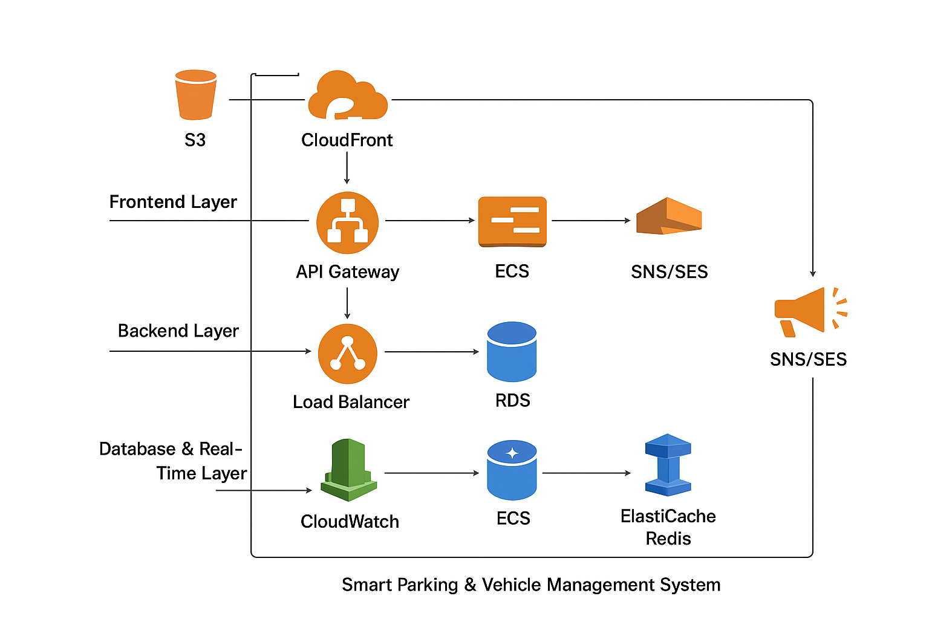
5. Diagram

