Software Architecture and Design Specification (SAD)
Project: Student Record System (SRM)
Version: 1.0
Authors: Sanjana Aravamudhan, Sufiya Khanam, Siddu Shirasagi
Date: 28-09-2026
Status: Draft for submission

Revision History
Version | Date | Author | Change Summary | Approval
1.0 | 28-09-2026 | Team | First version of SAD with diagrams

Approvals
Role | Name | Signature / Email | Date
Course Instructor | Vadiraja A
Team Lead | Sanjana Aravamudhan | Sanjana Aravamudhan | 28-09-2026

1. Introduction

1.1 Purpose
This document specifies the architecture and design of the Student Record System (SRM), following the IEEE 42010 approach (stakeholders, concerns, views).

1.2 Scope
Covers the user services: authentication, student record management, grades and report cards, attendance, user administration, backup/restore and audit logging.

1.3 Audience
Developers, QA engineers, security reviewers, instructors and maintenance staff.

1.4 Definitions
SRM, SRS, STP, RBAC, ADR (Architecture Decision Record), STRIDE (threat model), UML, SHA-256.

2. Document Overview

2.1 How to use this document
Section 3 gives the architecture (goals, component diagram, pattern, traceability, security). Section 4 gives the detailed design (sequence diagrams, interfaces, data design, error handling). Section 5 contains appendices.

2.2 Related documents
SRM SRS v1.0 (requirements), SRM STP v1.0 (test plan and RTM).

3. Architecture

3.1 Goals & Constraints
Goals: secure (RBAC, hashed passwords, audit), reliable (no data loss on crash), simple to build and maintain, responsive with 10,000 students.
Constraints: implementation in C/C++ (C++17); local files for storage; portable between Windows and Linux; no external database or network.

3.2 Stakeholders & Concerns
Stakeholder | Concerns
Administrator | Easy data entry, reliable backup, control of users
Teachers | Fast entry of marks and attendance
Students | Privacy of own data, correct results
Developers | Modularity, testability, portability
Instructors / Evaluators | Traceability to requirements, quality of design
Security reviewers | Access control, password protection, audit trail

3.3 Component (UML) Diagram
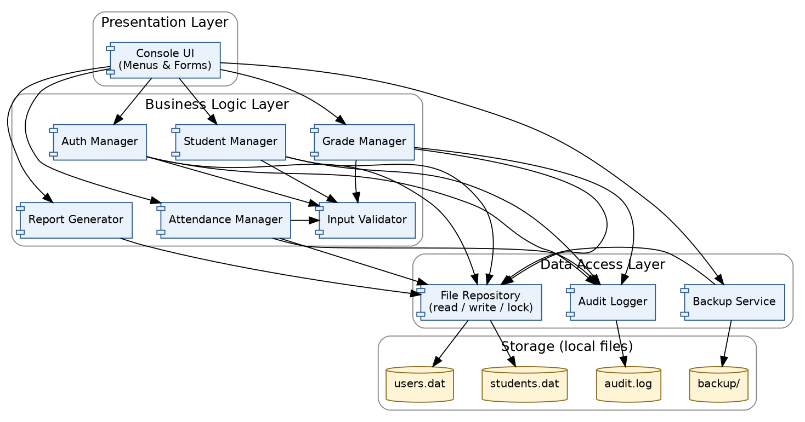
Figure 1: Component diagram - Student Record System

3.4 Component Descriptions
Component | Layer | Responsibility
Console UI | Presentation | Shows role-based menus, reads input (masks password), displays results and error messages
Auth Manager | Business logic | Login, lockout, session timeout, password change, user account operations, role checks
Student Manager | Business logic | Add, update, delete, search and list student records
Grade Manager | Business logic | Enter and update marks per student, subject and semester
Attendance Manager | Business logic | Mark attendance, compute percentages, flag below 75%
Report Generator | Business logic | Builds report card (percentage, letter grade, GPA) and attendance report; export to text file
Input Validator | Business logic | Validates type, length and range of all input
File Repository | Data access | Reads and writes data files; atomic save (write to temp file then rename); in-memory index for fast search
Audit Logger | Data access | Appends security and data-change events to audit.log
Backup Service | Data access | Creates timestamped backups and restores from them
Data files | Storage | students.dat, users.dat, grades/attendance data, audit.log, backup/ folder

3.5 Chosen Architecture Pattern and Rationale
Pattern: Layered architecture with three layers - Presentation, Business Logic and Data Access - on top of local file storage. Each layer talks only to the layer directly below it.
Rationale: clear separation of concerns; business rules and security checks live in one place (business layer) and are unit-testable without the console; storage can later be replaced (e.g. by SQLite) by changing only the data access layer; simple enough for a C++ mini-project.
Alternatives rejected: Client-server with database server - too heavy for a single-machine system; Microservices - unnecessary complexity; MVC web application - the course requires a C/C++ console program.

Architecture Decision Records (ADR)
ADR | Decision | Reason
ADR-1 | Use layered architecture | Separation of concerns, testability, replaceable storage
ADR-2 | Store data in local files with atomic save (temp file + rename) | No external dependency; satisfies SRM-NF-003 (no corruption on crash)
ADR-3 | Salted SHA-256 for passwords | Satisfies SRM-SR-001 without third-party libraries
ADR-4 | Use std::string and bounded input (no raw char arrays) | Prevents buffer overflow (SRM-SR-004)

3.6 Technology Stack & Data Stores
Item | Choice
Language / standard | C++17
Compilers | g++ 11+ (Linux), MSVC 2019+ or MinGW (Windows)
Build | CMake or Makefile
Storage | Local files: binary or CSV data files, plain-text audit log
Hashing | SHA-256 with per-user random salt (portable implementation)
Testing | Catch2 / GoogleTest, gcov, cppcheck, AddressSanitizer
Version control | Git

3.7 Risks & Mitigations
Risk | Mitigation
Data file corruption on power loss | Atomic save; automatic backup before restore; Backup Service
Slow search with 10,000 records | Load into in-memory sorted structure / hash map at start-up
Memory errors in C++ code | Use STL containers and std::string; sanitizers; code review
Unauthorised file access | OS file permissions on data directory (SRM-SR-006)

3.8 Traceability to Requirements
Req ID | Requirement (short) | Component(s)
SRM-F-001 | User login | AuthManager
SRM-F-002 | Account lockout | AuthManager
SRM-F-003 | Session timeout | AuthManager
SRM-F-004 | Change password | AuthManager
SRM-F-010 | Add student | StudentManager
SRM-F-011 | Reject duplicate roll no. | StudentManager
SRM-F-012 | Update student | StudentManager
SRM-F-013 | Delete student | StudentManager
SRM-F-014 | Search student | StudentManager
SRM-F-015 | List students | StudentManager
SRM-F-020 | Enter marks | GradeManager
SRM-F-021 | Update marks | GradeManager
SRM-F-022 | Compute result | ReportGenerator
SRM-F-023 | View own report card | ReportGenerator
SRM-F-024 | Export report | ReportGenerator
SRM-F-030 | Mark attendance | AttendanceManager
SRM-F-031 | Attendance percentage | AttendanceManager
SRM-F-032 | Low-attendance flag | AttendanceManager
SRM-F-033 | View attendance report | ReportGenerator
SRM-F-040 | Manage user accounts | AuthManager
SRM-F-041 | Backup data | BackupService
SRM-F-042 | Restore data | BackupService
SRM-F-043 | Persistent storage | FileRepository
SRM-F-044 | Audit logging | AuditLogger
SRM-NF-001 | Search response time | FileRepository
SRM-NF-002 | Start-up time | FileRepository
SRM-NF-003 | Crash-safe saving | FileRepository
SRM-NF-004 | Ease of use | Console UI
SRM-NF-005 | OS portability | All
SRM-NF-006 | Code maintainability | All
SRM-NF-007 | Data capacity | FileRepository
SRM-NF-008 | Audit log retention | AuditLogger
SRM-SR-001 | Salted password hashing | AuthManager
SRM-SR-002 | Role-based access control | All managers
SRM-SR-003 | Admin-only unlock | AuthManager
SRM-SR-004 | Input validation | Input Validator
SRM-SR-005 | Security event logging | AuditLogger
SRM-SR-006 | Data directory permissions | FileRepository
SRM-SR-007 | Password masking / no logging | Console UI

3.9 Security Architecture
Threat modeling (STRIDE):
Threat | Example in SRM | Mitigation
Spoofing | Guessing another user's password | Salted hashed passwords, lockout after 3 failures, password rules
Tampering | Editing data files or changing grades without permission | RBAC in business layer, OS file permissions, validation, audit log
Repudiation | Teacher denies changing a grade | Audit log with timestamp and user for every change (append-only)
Information disclosure | Student reading another student's report; reading password file | RBAC (own-data rule), hashed passwords, masked input, no passwords in logs
Denial of service | Corrupt file or crash from oversized input | Input validation, atomic save, backup/restore
Elevation of privilege | Student trying Admin functions | Role check on every operation; menus built from role; refused attempts logged
Security controls: authentication (AuthManager), authorisation (role check at the start of every manager method), input validation (Input Validator), accountability (Audit Logger), recoverability (Backup Service).

4. Design

4.1 Design Overview
SRM is designed as a set of small C++ classes, one per component. The UI calls manager classes; managers call the Input Validator, File Repository and Audit Logger. Every manager method first checks the session role (SRM-SR-002), then validates input, then acts and logs.

4.2 UML Sequence Diagrams
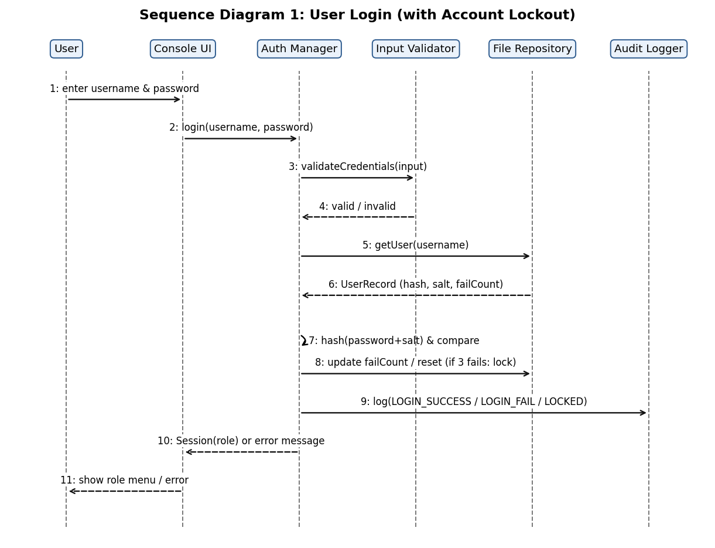
Figure 2: Sequence diagram - User login with account lockout (SRM-F-001, F-002, SR-001, SR-003)
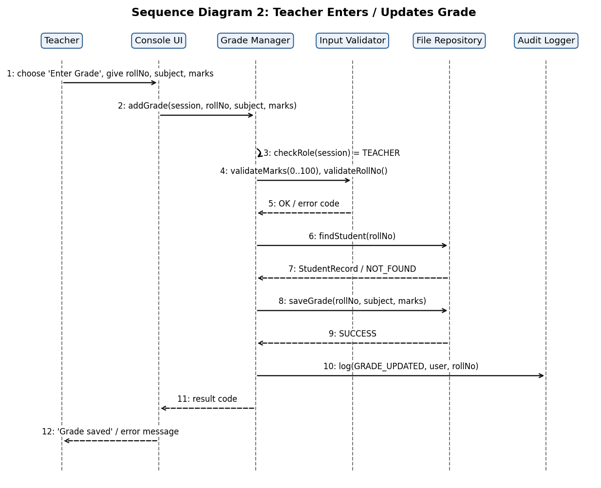
Figure 3: Sequence diagram - Teacher enters or updates a grade (SRM-F-020, F-021, SR-002, SR-004, F-044)
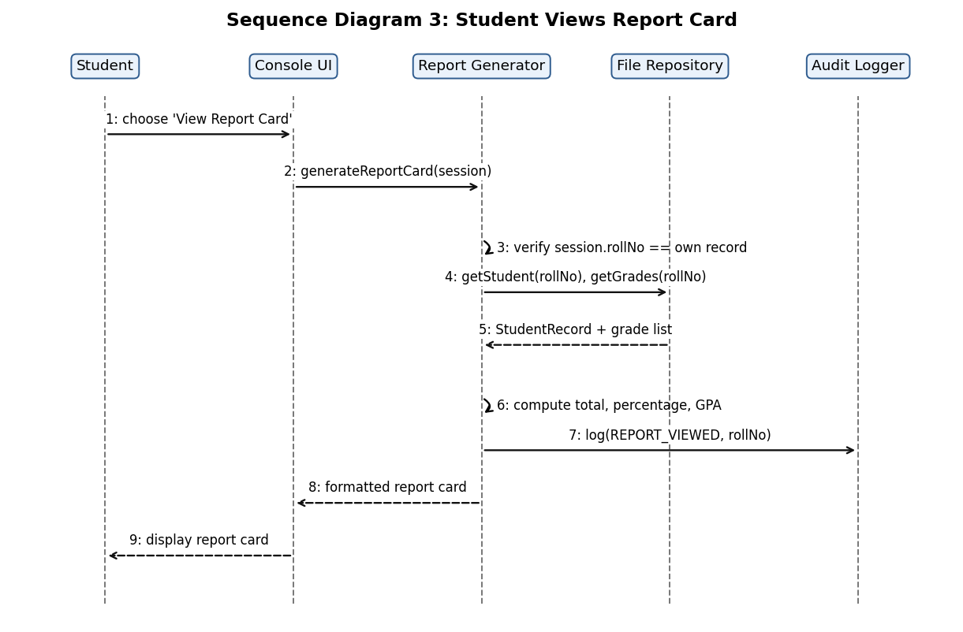
Figure 4: Sequence diagram - Student views report card (SRM-F-022, F-023)

4.3 API Design
SRM has no network API. The interfaces are the public C++ methods of the components below. Every method returns a status code (see 4.4).

Interface 1: AuthManager
Method | Input | Output | Error codes
login | username, password | Session {userId, role} and status | E_INVALID_INPUT, E_BAD_CREDENTIALS, E_LOCKED, E_INACTIVE
logout | Session | status | E_NO_SESSION
changePassword | Session, oldPassword, newPassword | status | E_BAD_CREDENTIALS, E_WEAK_PASSWORD
unlockUser | Session (Admin), username | status | E_ACCESS_DENIED, E_NOT_FOUND

Interface 2: GradeManager
Method | Input | Output | Error codes
addGrade | Session (Teacher), rollNo, subject, semester, marks (0-100) | status | E_ACCESS_DENIED, E_INVALID_INPUT, E_OUT_OF_RANGE, E_NOT_FOUND, E_IO_ERROR
updateGrade | Session (Teacher), rollNo, subject, semester, newMarks | status | same as addGrade
getGrades | Session, rollNo | List of {subject, semester, marks} | E_ACCESS_DENIED (Student asking for another roll no.), E_NOT_FOUND

Interface 3: StudentManager (summary)
Method | Input | Output | Error codes
addStudent | Session (Admin), Student{rollNo, name, dob, dept, year, contact} | status | E_ACCESS_DENIED, E_INVALID_INPUT, E_DUPLICATE
searchStudents | Session (Admin/Teacher), rollNo or name part | List of students | E_ACCESS_DENIED, E_NOT_FOUND
deleteStudent | Session (Admin), rollNo, confirmed | status | E_ACCESS_DENIED, E_NOT_FOUND, E_NOT_CONFIRMED

Data design (record layouts)
Record | Fields
Student | rollNo (unique), name, dob, department, year, contact
User | username, passwordHash, salt, role, failCount, locked, active
Grade | rollNo, subject, semester, marks (0-100)
Attendance | rollNo, subject, date, status (P/A)
AuditEntry | timestamp, username, action, target, result

4.4 Error Handling, Logging & Monitoring
- Error codes: all methods return a status enum (OK, E_INVALID_INPUT, E_OUT_OF_RANGE, E_ACCESS_DENIED, E_BAD_CREDENTIALS, E_LOCKED, E_DUPLICATE, E_NOT_FOUND, E_IO_ERROR); the UI translates each into a message with cause and corrective action.
- File errors: failed saves are detected (temp-file write / rename); the old data file is kept and the user sees "Could not save. Data unchanged."
- Exceptions: C++ exceptions are caught at the UI boundary; the program never exits on bad input.
- Logging: audit log records timestamp, user, action, target and result; passwords and other secrets are never logged.
- Monitoring: Administrator reviews audit log for failed logins and access-denied events; backup age is displayed at Admin login.

4.5 UX Design
- Numbered role-based menus; option 0 always goes back
- Prompts show format and example (e.g. "Date of birth (DD-MM-YYYY):")
- Password entry masked; confirmation before delete and restore
- Clear, plain-language error messages
- Report cards and attendance tables aligned in columns

4.6 Open Issues & Next Steps
- Replace files with SQLite for larger data
- Add graphical user interface or web front-end
- Add email/SMS alerts for low attendance
- Add multi-user (concurrent) access with file locking

5. Appendices
5.1 Glossary: SRM, RBAC, ADR, STRIDE, SHA-256, GPA, UML.
5.2 References: IEEE 42010, IEEE 830 / 29148, OWASP ASVS, NIST SP 800-160.
5.3 Tools: Graphviz / PlantUML / draw.io (diagrams), Catch2 or GoogleTest, cppcheck, Git.

