Software Architecture and Design Specification
Student Record Management System (SRMS)
Project | Student Record Management System (SRMS)
Version | 1.0
Authors | Sanjana Aravamudhan, Sufiya Khanam, Siddu Shirasagi
Date | 28-09-2026
Status | Draft for submission (Mini-Project Part-1)

Revision History
Version | Date | Author | Change Summary
1.0 | 28-09-2026 | Team | First complete architecture and design

Approvals
Role | Name | Signature / Date
Course Coordinator | Vadiraja A
Team Lead | Sanjana Aravamudhan | 28-09-2026

1. Introduction

1.1 Purpose
This document specifies the architecture and design of the Student Record Management System (SRMS), a C/C++ application for managing student records, attendance and grades.

1.2 Scope
Covers the user services defined in the SRS: authentication and user management, student and course management, attendance, grades, reports, data persistence/backup and audit logging.

1.3 Audience
Developers, QA engineers, security reviewers, instructors and maintenance teams.

1.4 Definitions
SRMS, SRS, RBAC, ADR (Architecture Decision Record), STRIDE (threat model: Spoofing, Tampering, Repudiation, Information disclosure, Denial of service, Elevation of privilege), CSV.

2. Document Overview

2.1 How to use this document
Section 3 describes the architecture (structure, pattern, technology, security). Section 4 describes the detailed design (sequence diagrams, module interfaces, error handling, UX). Requirements are referenced by their SRS IDs.

2.2 Related documents
SRMS Software Requirements Specification v1.0 (SRS); SRMS Software Test Plan v1.0 (STP); Requirements Traceability Matrix (SRS Section 8).

3. Architecture

3.1 Goals & Constraints
Goals: secure handling of student data; reliable storage that survives crashes; fast search on 10,000 students; easy to extend and test; portable across Windows and Linux.
Constraints: implementation in C/C++ (C++17); local file storage, no database server; console user interface; single-machine deployment; student project timeline.

3.2 Stakeholders & Concerns
Stakeholder | Concerns
Administrators | Correct records, easy backup/restore, control of users
Faculty | Fast data entry, clear errors, correct grade computation
Students | Privacy of own data, accurate results
Institution / auditors | Accountability, audit trail, data protection
Developers / QA | Modularity, testability, maintainability, memory safety

3.3 Component (UML) Diagram
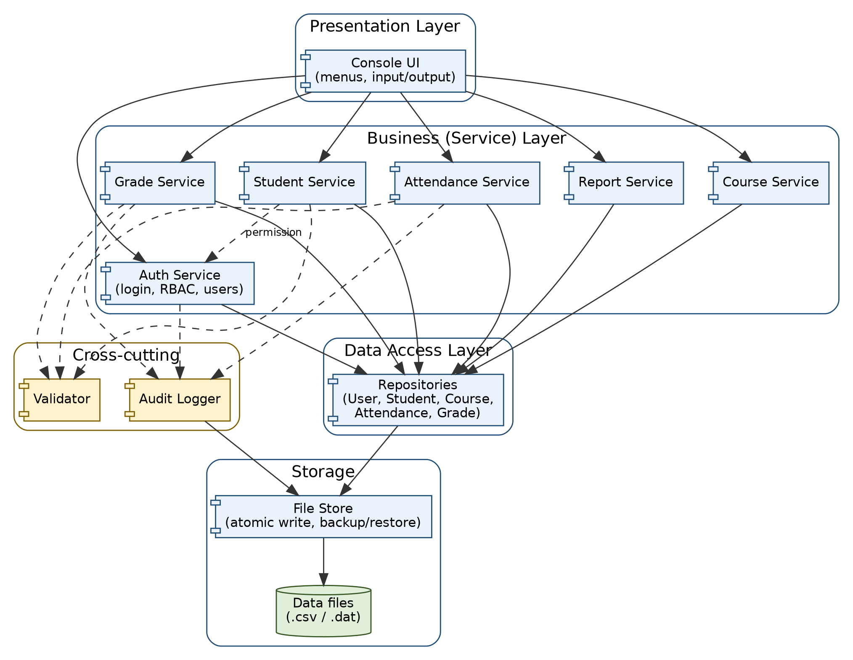
Figure 1 - SRMS component diagram (layered architecture). Solid arrows: calls; dashed arrows: uses.

3.4 Component Descriptions
Component | Layer | Responsibility
Console UI | Presentation | Displays menus, reads and echoes user input (password not echoed), shows results and error messages; contains no business rules.
Auth Service | Business | Login, account lockout, password change, user management, session and idle timeout, role-based permission checks (checkPermission).
Student Service | Business | Add, update, deactivate, search and list students.
Course Service | Business | Create/edit courses and enrol students.
Attendance Service | Business | Mark and correct attendance; compute attendance % and shortage list.
Grade Service | Business | Enter/update marks; compute grade, grade points and CGPA.
Report Service | Business | Build report cards and attendance reports; export to CSV/text.
Validator | Cross-cutting | Central input validation (type, length, range, format) used by all services.
Audit Logger | Cross-cutting | Append-only, hash-chained audit log of security and data-changing events.
Repositories | Data access | User, Student, Course, Attendance and Grade repositories; in-memory indexes (hash maps by roll number) loaded from files.
File Store | Storage | Reads/writes data files; atomic write (temp file then rename); timestamped backup and restore; sets file permissions.

3.5 Chosen Architecture Pattern and Rationale
Layered architecture (Presentation -> Business services -> Data access -> Storage), with a small set of cross-cutting components (Validator, Audit Logger). Each layer only calls the layer directly beneath it.
Why: clear separation of concerns; business rules and security checks live in one place (services) so they cannot be bypassed by the UI; each service can be unit-tested with a fake repository; storage can later be replaced (e.g. by SQLite) without changing the services.
Rejected alternatives: Microservices / client-server (overkill for a single-machine console application, adds network attack surface); a single monolithic main() (untestable and hard to secure).

3.6 Technology Stack & Data Stores
Item | Choice
Language / standard | C++17 (C-style code only where required); std::string, std::vector, std::unordered_map, <filesystem>
Build | CMake or Makefile; g++ 11+ / MinGW-w64; flags -Wall -Wextra
Password hashing | Salted hash via OpenSSL or libsodium (PBKDF2 / Argon2 preferred; SHA-256 with salt minimum)
Data store | Structured text/CSV data files: users, students, courses, enrolments, attendance, grades, audit log; loaded into memory at start-up
Testing / quality | Catch2 or GoogleTest, Valgrind / AddressSanitizer, cppcheck, gcov

3.7 Risks & Mitigations
Risk | Mitigation
Data file corrupted by crash during write | Atomic write (write temp file, flush, rename); backup before restore; NF-004 test.
Buffer overflow / memory errors from C-style code | Use std::string and containers; bounded input; no gets/strcpy/sprintf; run ASan/Valgrind (NF-008).
Slow search with 10,000+ records | In-memory hash-map indexes by roll number; sorted vector for name search.
Data loss from disk failure | Backup/restore feature (F-051); recommend copying backups off-machine.
Team unfamiliar with cryptography | Use a well-known library; never implement own hashing.

3.8 Traceability to Requirements
Requirement(s) | Component
SRMS-F-001..005, SRMS-SR-001, 002, 004, 007 | Auth Service (+ Audit Logger)
SRMS-F-010..015, SRMS-SR-003 | Student Service, Validator
SRMS-F-016 | Course Service
SRMS-F-020..024 | Attendance Service, Audit Logger
SRMS-F-030..033 | Grade Service, Validator, Audit Logger
SRMS-F-040..043 | Report Service, Auth Service (own-data check)
SRMS-F-050, F-051, SRMS-SR-006, SRMS-NF-004 | Repositories, File Store
SRMS-F-052, SRMS-SR-005 | Audit Logger
SRMS-NF-001..003 | Repositories (indexes), Report Service
SRMS-NF-005 | Console UI
SRMS-NF-006..008 | Whole code base (build, layering, tooling)

3.9 Security Architecture
Threat modelling with STRIDE:
Threat | Example in SRMS | Mitigation (component)
Spoofing | Guessing another user's password | Salted password hashes, password policy, lockout after 3 failures, generic error message (Auth Service) - SR-001, F-002, SR-007
Tampering | Editing grades or data files by hand; altering the audit log | Role checks before every change (SR-002); OS file permissions (SR-006); hash-chained audit log (SR-005); atomic writes
Repudiation | Faculty denies changing marks | Audit log with user, time, old/new value (Audit Logger) - F-052, F-033
Information disclosure | Student reading others' marks; plaintext passwords in files | RBAC and own-data check (SR-002, F-043); hashed passwords; restricted file permissions; no sensitive data in logs
Denial of service | Malformed or huge input crashing the program | Central input validation, bounded buffers, length limits (SR-003); backup/restore (F-051)
Elevation of privilege | Student invoking a Faculty function | checkPermission() in every service method, independent of the UI (SR-002)
Security design rules: (1) all input passes through Validator; (2) every service method calls AuthService::checkPermission first; (3) passwords and full personal data are never written to the log; (4) sessions expire after 10 minutes of inactivity; (5) files are created with owner-only permissions.

4. Design

4.1 Design Overview
SRMS is built from small classes grouped in the layers of Figure 1. The Console UI passes a Session object (user ID, role, last-activity time) to each service call. Services return a Result object (success flag, error code, message, optional data) instead of throwing across layer boundaries, so the UI can show a consistent message. Data is kept in memory in repositories and written through to files on every committed change.

4.2 UML Sequence Diagrams
Two flows specific to SRMS are shown: user login with lockout handling, and entering marks.
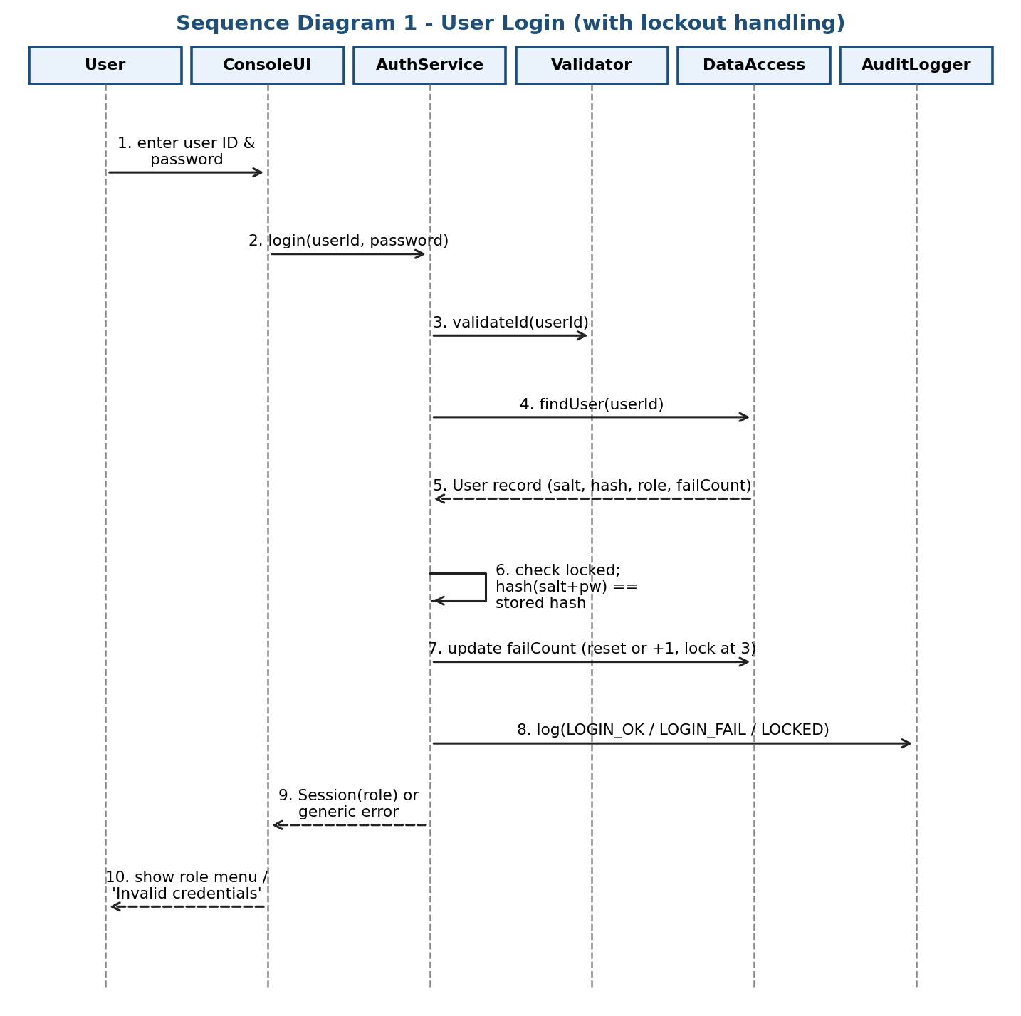
Figure 2 - Sequence diagram: user login
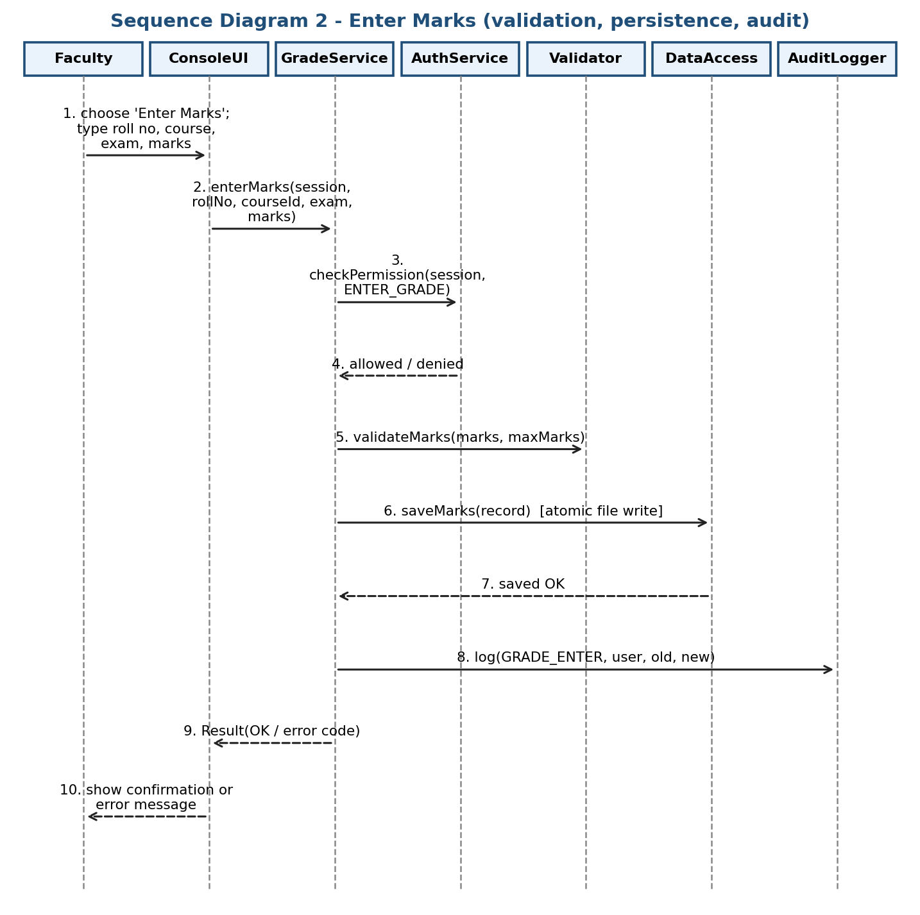
Figure 3 - Sequence diagram: enter marks

4.3 API Design (module interfaces)
SRMS is a stand-alone application, so its "API" is the set of C++ interfaces between components. Two are defined here in detail: AuthService and GradeService. All methods return a Result (success flag, ErrorCode, message).

4.3.1 AuthService
struct Session { std::string userId; Role role; time_t lastActivity; };
enum class Role { Admin, Faculty, Student };

Result<Session> login(const std::string& userId, const std::string& password);
Result<void> logout(Session& s);
Result<void> changePassword(const Session& s, const std::string& oldPw, const std::string& newPw);
Result<void> checkPermission(const Session& s, Permission p); // also enforces idle timeout
Result<void> unlockUser(const Session& admin, const std::string& userId);

Method | Inputs | Success output | Errors
login | userId (≤ 20 chars), password (8-64 chars) | Session with role | E_AUTH_FAILED (generic; unknown user or wrong password), E_ACCOUNT_LOCKED, E_INVALID_INPUT
changePassword | session, old password, new password | OK | E_AUTH_FAILED (old wrong), E_WEAK_PASSWORD, E_SESSION_EXPIRED
checkPermission | session, permission | OK | E_ACCESS_DENIED, E_SESSION_EXPIRED
unlockUser | admin session, userId | OK | E_ACCESS_DENIED, E_NOT_FOUND

4.3.2 GradeService
Result<void> enterMarks(const Session& s, const std::string& rollNo, const std::string& courseId,
Assessment a, double marks);
Result<void> updateMarks(const Session& s, const std::string& rollNo, const std::string& courseId,
Assessment a, double newMarks);
Result<CourseGrade> computeGrade(const std::string& rollNo, const std::string& courseId);
Result<double> computeCGPA(const std::string& rollNo);

Method | Inputs | Success output | Errors
enterMarks | session, roll no, course ID, assessment, marks (0..max) | OK (record saved, audit entry written) | E_ACCESS_DENIED, E_NOT_FOUND (student/course), E_NOT_ENROLLED, E_OUT_OF_RANGE, E_DUPLICATE, E_IO_FAILURE
updateMarks | session, roll no, course ID, assessment, new marks | OK (old and new value audited) | E_ACCESS_DENIED, E_NOT_FOUND, E_OUT_OF_RANGE, E_IO_FAILURE
computeGrade | roll no, course ID | total, %, letter grade, grade points | E_NOT_FOUND, E_INCOMPLETE_MARKS
computeCGPA | roll no | CGPA (credit-weighted, 2 decimals) | E_NOT_FOUND, E_INCOMPLETE_MARKS
The same pattern (session first, Result returned, permission check inside) applies to StudentService, CourseService, AttendanceService and ReportService.

4.4 Error Handling, Logging & Monitoring
Errors are represented by an ErrorCode enumeration and returned in Result objects; the Console UI maps each code to a standard message that states the cause and how to fix it.
Error code | Standard message (example) | Cause
E_INVALID_INPUT | Invalid <field>: <rule>. Please re-enter. | Validator rejected input
E_OUT_OF_RANGE | Marks must be between 0 and <max>. | Marks or numeric value outside allowed range
E_AUTH_FAILED | Invalid user ID or password. | Failed login (same text for both causes)
E_ACCOUNT_LOCKED | Account locked. Contact the Administrator. | 3 failed attempts
E_ACCESS_DENIED | You are not allowed to do this. | Role lacks permission
E_SESSION_EXPIRED | Session timed out. Please log in again. | 10 minutes idle
E_NOT_FOUND / E_DUPLICATE | No such record. / Record already exists. | Missing or duplicate key
E_IO_FAILURE | Could not save data. No changes were made. | File write failed; previous file kept intact

- Logging: the Audit Logger records logins, failures, lockouts, and create/update/deactivate, attendance-correction and grade-change events with timestamp, user ID, action and old/new values. Passwords, hashes and personal data such as phone numbers are never logged.
- Diagnostics: a separate application log (levels INFO/WARN/ERROR) is written for troubleshooting.
- Monitoring: on start-up the application verifies data-file integrity and the audit-log hash chain and warns the Administrator if a problem is found; the Administrator report shows counts of failed logins and I/O failures.
- C/C++ safety: exceptions are caught at the layer boundary; RAII (smart pointers, std::string, std::vector) is used to prevent leaks; all input buffers are bounded.

4.5 UX Design
- Numbered menus limited to 8 options per screen, with 0 = Back/Exit on every screen.
- Header on every screen shows user ID and role.
- Confirmation prompt before deactivating a student or restoring a backup.
- Passwords entered without echo; sensitive screens cleared on logout.
- Clear, short messages (Section 4.4); tabular output aligned in columns; page-wise lists (20 rows).
- Faculty attendance entry: default Present, press A/L to mark Absent/On-Leave, to make entry for a full class fast (NF-005).

4.6 Open Issues & Next Steps
- Decide the final data-file format (CSV vs a simple binary format) and hashing library.
- Confirm the grading scale and attendance threshold with the instructor.
- Future enhancements: SQLite storage, encrypted data files, GUI front-end, parent/guardian view, email notifications.
- Next: implement modules in the order Auth -> Storage -> Student -> Course -> Attendance -> Grade -> Report.

5. Appendices

5.1 Glossary
SRMS, RBAC, STRIDE, CGPA, CSV, RAII (Resource Acquisition Is Initialisation), ADR, ASan (AddressSanitizer).

5.2 References
IEEE 42010 (architecture description), OWASP ASVS, NIST SP 800-160, C++ Core Guidelines.

5.3 Tools
draw.io / PlantUML (diagrams), CMake, Catch2 or GoogleTest, Valgrind, AddressSanitizer, cppcheck, gcov.

