Software Requirements Specification (SRS)
Project: Student Record System (SRM)
Version: 1.0
Authors: Sanjana Aravamudhan, Sufiya Khanam,
Date: 28-09-2026
Status: Draft for submission

Revision History
Version | Date | Author | Change Summary | Approval
1.0 | 28-09-2026 | Team | First version of SRS with diagrams

Approvals
Role | Name | Signature / Email | Date
Course Instructor | Vadiraja A
Team Lead | Sanjana Aravamudhan | Sanjana Aravamudhan | 28-09-2026

Table of Contents
1. Introduction
2. Overall description
3. External interface requirements
4. System features (detailed)
5. Non-functional requirements (detailed)
5.1 Security (objectives and requirements)
6. Quality attributes & acceptance tests
7. System models and diagrams (UML use cases)
8. Requirements Traceability Matrix (RTM)

1. Introduction

1.1 Purpose
This document is the Software Requirements Specification (SRS) for the Student Record System (SRM), written following the IEEE 830 / ISO/IEC/IEEE 29148 structure. It defines the functional, non-functional and security requirements, external interfaces and verification criteria of the system. It is the reference for design, coding and testing.

1.2 Scope
The Student Record System is a C++ console application that keeps student details, grades and attendance in local data files. It lets an Administrator manage students and users, lets Teachers enter grades and attendance, and lets Students view their own report card and attendance. It also provides backup/restore and an audit log.
Out of scope: online or mobile access, fee management, timetable scheduling, payroll, and integration with any external college ERP.

1.3 Audience
Developers, QA engineers, course instructors and evaluators, and the Administrator who will operate the system.

1.4 Definitions, acronyms and abbreviations
Term | Meaning
SRM | Student Record System (this product)
SRS | Software Requirements Specification
FR / NFR | Functional / Non-Functional Requirement
RBAC | Role-Based Access Control
GPA | Grade Point Average (10-point scale)
UML | Unified Modeling Language
Roll number | Unique identifier of a student
Audit log | Append-only file recording who did what and when
SHA-256 | Cryptographic hash function used for storing passwords with a salt

1.5 References
- IEEE Std 830-1998 / ISO/IEC/IEEE 29148: Software requirements specifications
- Course problem statement: Mini-Project #12, Student Record System (C / C++)
- Companion documents: Software Test Plan (STP) and Software Architecture and Design Specification (SAD)
- OWASP Application Security Verification Standard (for security requirements)

1.6 Document overview
Section 2 describes the product in general terms. Section 3 lists interfaces. Section 4 lists functional requirements, Section 5 lists non-functional and security requirements, Section 6 gives acceptance criteria, Section 7 contains UML use case diagrams and Section 8 traces each requirement to design modules and test cases.

2. Overall description

2.1 Product perspective
SRM is a stand-alone desktop console program. It has no dependency on a database server or network. Data is stored in local files (students, users, grades, attendance) managed by the program itself. It replaces paper registers and spreadsheets used to keep student records.

2.2 Major product functions
- User authentication with roles, lockout and session timeout
- Student record management (add, update, delete, search, list)
- Grade entry, GPA calculation and report cards
- Attendance marking, percentage calculation and low-attendance flagging
- User account management (create, deactivate, unlock, reset)
- Backup and restore of all data
- Audit logging of important actions

2.3 User roles and characteristics
Role | Characteristics | Allowed operations
Administrator | Office staff, basic computer skills, full responsibility for data | Add / update / delete / search / list students; manage user accounts; backup and restore; view audit log; change own password
Teacher | Faculty, occasional user, wants fast entry of marks and attendance | Search students; enter and update marks; mark attendance; view attendance reports; change own password
Student | Casual user, read-only interest in own data | View own report card and attendance report; export them; change own password

2.4 Operating environment
Windows 10 or later, or Ubuntu 22.04; standard C++17 compiler (g++ 11+ or MSVC 2019+); at least 4 GB RAM and 100 MB free disk space; keyboard and text console.

2.5 Design and implementation constraints
- Must be implemented in C / C++ (course requirement).
- Data is stored in local files; no external database.
- Only the C++ standard library and portable code may be used (see SRM-NF-005).
- Personal data must be protected as described in Section 5.1.

2.6 Assumptions and dependencies
- The computer is used in a trusted office or lab and the operating system account of the program is protected.
- A single instance of the program runs at a time (no simultaneous multi-user access).
- Grading scale (marks to letter grade and GPA points) is fixed as in the grade table below.
Percentage | Letter grade | Grade points
90 - 100 | O | 10
80 - 89 | A+ | 9
70 - 79 | A | 8
60 - 69 | B | 7
50 - 59 | C | 6
40 - 49 | D | 5
Below 40 | F | 0

3. External interface requirements

3.1 User interfaces
Text-based console menus. After login the user sees only the menu for their role. Each screen shows numbered options, a short prompt and the option 0 to go back. Password entry is masked. Error messages state the cause and what to do next.

3.2 Hardware interfaces
Standard keyboard and display. No special hardware. Optional printer through the operating system when exported text reports are printed.

3.3 Software interfaces
- Operating system file system: read and write data files, audit log and backup folders.
- C++ standard library only (no third-party runtime dependency).
- Optional: a unit-testing framework (Catch2 or GoogleTest) used only during development.

3.4 Communications interfaces
None. The system does not use a network. Consequently no data leaves the machine except through explicit export or backup by the Administrator.

4. System features (detailed)
Every requirement is written to be clear, unambiguous, concise, measurable and testable. Each has a unique ID (SRM-F-###), a priority (High / Medium / Low), and acceptance criteria with a reference test case.

4.1 Authentication & Access Control
Description: Verify who the user is and what role they have (Administrator, Teacher, Student).
Req ID | Requirement (the system shall...) | Priority | Source | Acceptance criteria | Test case
SRM-F-001 | The system shall authenticate every user with a username and password and grant access according to the user role (Administrator, Teacher, Student). | High | College / Security | Valid credentials open the menu for that role; invalid credentials show an error and no menu. | TC-Auth-01
SRM-F-002 | The system shall lock a user account after 3 consecutive failed login attempts and record an audit event. | High | Security | 4th attempt is refused with "Account locked" even if the password is correct. | TC-Auth-02
SRM-F-003 | The system shall automatically log a user out after 5 minutes of inactivity. | Medium | Security | After 5 min idle, the next action returns to the login screen. | TC-Auth-03
SRM-F-004 | The system shall allow any user to change their own password; the new password shall have at least 8 characters with at least one letter and one digit. | Medium | Security | Weak passwords are rejected with a reason; a valid new password works at next login. | TC-Auth-04

4.2 Student Record Management
Description: Create, change, find and remove student details.
Req ID | Requirement (the system shall...) | Priority | Source | Acceptance criteria | Test case
SRM-F-010 | The system shall allow an Administrator to add a student record containing roll number, name, date of birth, department, year and contact number. | High | Administration | Record is saved and appears in Search with all fields as entered. | TC-Stu-01
SRM-F-011 | The system shall reject a new student record whose roll number already exists. | High | Administration | Second record with same roll number is refused; the first is unchanged. | TC-Stu-01
SRM-F-012 | The system shall allow an Administrator to update any field of a student record except the roll number. | Medium | Administration | Changed value is shown on next search; roll number field is not editable. | TC-Stu-02
SRM-F-013 | The system shall allow an Administrator to delete a student record only after explicit confirmation, and shall delete that student's grades and attendance with it. | Medium | Administration | Answering "N" keeps the record; answering "Y" removes the record, grades and attendance. | TC-Stu-03
SRM-F-014 | The system shall allow Administrators and Teachers to search students by exact roll number or by partial, case-insensitive name. | High | Teachers / Admin | Searching "ram" returns all names containing "ram" in any case. | TC-Stu-02
SRM-F-015 | The system shall list all students sorted by roll number in ascending order. | Low | Administration | Listing shows every record in ascending roll number order. | TC-Stu-02

4.3 Grades & Report Cards
Description: Record marks and produce results.
Req ID | Requirement (the system shall...) | Priority | Source | Acceptance criteria | Test case
SRM-F-020 | The system shall allow a Teacher to enter marks (integer 0 to 100) for a student for a given subject and semester, and shall reject values outside this range. | High | Teachers | Marks 0 and 100 are accepted; -1, 101 and non-numeric input are rejected. | TC-Grd-01
SRM-F-021 | The system shall allow a Teacher to update marks that were entered earlier. | Medium | Teachers | Updated marks replace the old value and appear in the report card. | TC-Grd-01
SRM-F-022 | The system shall compute percentage, letter grade and GPA (10-point scale) for a student from the stored marks. | High | Students / Teachers | For marks 80, 70, 90 the percentage is 80.0% and matches the documented grade table. | TC-Grd-02
SRM-F-023 | The system shall allow a Student to view only his or her own report card. | High | Students / Security | Student sees own report card; attempt to open another roll number is refused. | TC-Grd-02  TC-Sec-01
SRM-F-024 | The system shall allow a report card or attendance report to be exported to a text file. | Low | Students / Teachers | Exported file exists and its contents equal the on-screen report. | TC-Grd-02

4.4 Attendance
Description: Record and analyse attendance.
Req ID | Requirement (the system shall...) | Priority | Source | Acceptance criteria | Test case
SRM-F-030 | The system shall allow a Teacher to mark a student Present or Absent for a given subject and date, and shall reject future dates. | High | Teachers | Entry is stored for that date; a date after today is rejected. | TC-Att-01
SRM-F-031 | The system shall calculate attendance percentage per student per subject as (days present / days held) x 100. | High | Teachers / Students | 8 present out of 10 days held shows 80.0%. | TC-Att-02
SRM-F-032 | The system shall flag every student whose attendance in a subject is below 75%. | Medium | Administration | Student at 74.9% is flagged; student at 75.0% is not. | TC-Att-02
SRM-F-033 | The system shall allow Teachers to view the attendance report of any student and Students to view only their own. | Medium | Teachers / Students | Teacher can open any roll number; Student can open only own. | TC-Att-02  TC-Sec-01

4.5 Administration & Data Management
Description: User accounts, storage, backup and audit.
Req ID | Requirement (the system shall...) | Priority | Source | Acceptance criteria | Test case
SRM-F-040 | The system shall allow an Administrator to create, deactivate, unlock and reset the password of user accounts. | High | Administration | A created user can log in; a deactivated user cannot; an unlocked user can log in again. | TC-Adm-01
SRM-F-041 | The system shall allow an Administrator to create a timestamped backup of all data files. | Medium | Administration | A backup folder named with date and time is created containing all data files. | TC-Adm-02
SRM-F-042 | The system shall allow an Administrator to restore all data from a selected backup after explicit confirmation. | Medium | Administration | After restore, records equal the state at backup time. | TC-Adm-02
SRM-F-043 | The system shall save all records to data files after every change and reload them at start-up. | High | Administration | Records added in one run are present after closing and reopening the program. | TC-Stu-01  TC-Rel-01
SRM-F-044 | The system shall write an audit log entry (timestamp, user, action, target) for every login, create, update, delete, backup and restore action. | High | Security | Each listed action adds exactly one correct entry to the audit log. | TC-Adm-03

5. Non-functional requirements (detailed)
NFRs are measurable and tied to test cases. IDs follow SRM-NF-###.
Req ID | Category | Requirement | Priority | Acceptance criteria / measurement | Test case
SRM-NF-001 | Performance | Search by roll number or name shall complete within 2 seconds with 10,000 student records loaded. | High | Average of 20 searches <= 2 s on the reference machine. | TC-Perf-01
SRM-NF-002 | Performance | Application start-up, including loading all data files, shall complete within 5 seconds with 10,000 student records. | Medium | Measured start-up time <= 5 s. | TC-Perf-01
SRM-NF-003 | Reliability | A crash or power loss while saving shall not corrupt the data files; at most the last unsaved operation may be lost. | High | After forced termination during save, program starts and all earlier records are intact. | TC-Rel-01
SRM-NF-004 | Usability | A new user shall complete a common task (add a student, or view a report card) within 3 minutes using only on-screen menus; every error message shall state the cause and the corrective action. | Medium | 5 of 5 test users finish within 3 min; all error messages reviewed against the rule. | TC-Use-01
SRM-NF-005 | Portability | The system shall build and run on Windows 10 (or later) and Ubuntu 22.04 using standard C++17 with no operating-system-specific libraries. | Medium | Clean build and full test run succeed on both operating systems. | TC-Port-01
SRM-NF-006 | Maintainability | The source code shall be modular (one class per module), each function shall be at most 50 lines, and unit tests shall cover at least 70% of business-logic code. | Medium | Code review checklist passed; coverage report >= 70%. | TC-Maint-01
SRM-NF-007 | Capacity / Scalability | The system shall support at least 10,000 students, 50 user accounts and 100,000 grade and attendance entries without exceeding the limits in SRM-NF-001. | Medium | Load test with the stated volumes meets NF-001. | TC-Perf-01
SRM-NF-008 | Audit / Retention | Audit logs shall be kept for at least 1 year and shall not be modifiable or deletable through the application. | Medium | No menu option edits or deletes the log; log file retains entries older than 1 year. | TC-Adm-03

5.1 Security

5.1.1 Security Objectives
The system protects personal and academic data of students. The following objectives guide the security requirements.
Objective | Description
SO-1 Confidentiality | Only authenticated and authorised users can see student data; a Student can see only his or her own data.
SO-2 Integrity | Grades, attendance and user accounts can be changed only by authorised roles, inputs are validated, and every change is traceable to a user.
SO-3 Availability & Accountability | Data can be recovered after failure or mistakes (backup/restore), and security-relevant actions are recorded so that misuse can be investigated.

5.1.2 Security Requirements
Req ID | Requirement (the system shall...) | Priority | Objective | Acceptance criteria | Test case
SRM-SR-001 | User passwords shall be stored only as salted cryptographic hashes (SHA-256 or stronger, unique salt per user); plain-text passwords shall never be stored. | High | SO-1 | Inspecting users.dat shows no readable passwords; two users with the same password have different hashes. | TC-Sec-02
SRM-SR-002 | The system shall enforce role-based access control on every operation: Administrator, Teacher and Student can perform only the operations listed for their role in Section 2.3. | High | SO-1, SO-2 | Every forbidden operation for each role is refused and logged. | TC-Sec-01
SRM-SR-003 | Only an Administrator shall be able to unlock a locked account, and the locked state shall persist after the program is restarted. | High | SO-1 | Locked account stays locked after restart until an Administrator unlocks it. | TC-Auth-02
SRM-SR-004 | All user input shall be validated for type, length and range before use; input longer than the field limit shall be rejected without crashing (no buffer overflow). | High | SO-2 | Fuzz inputs (very long strings, special characters, format specifiers) are rejected safely. | TC-Sec-03
SRM-SR-005 | Security-relevant events (login success/failure, lockout, role violation, data change, backup, restore) shall be appended to the audit log with timestamp and user; existing entries shall not be altered. | High | SO-3 | Each event type produces an entry; older entries remain unchanged. | TC-Adm-03
SRM-SR-006 | Data files and backups shall be stored in a directory accessible only to the application's operating-system user (OS file permissions). | Medium | SO-1, SO-3 | A different OS user cannot read or write the data directory. | TC-Sec-04
SRM-SR-007 | Passwords shall not be displayed on screen while typed and shall never be written to any log or export file. | High | SO-1 | Typed characters are masked; searching logs for a test password finds nothing. | TC-Auth-04

6. Quality attributes & acceptance tests
- Exit criteria for acceptance: all High-priority functional and security requirements are implemented and verified, no critical NFR test fails, and the RTM shows all mapped test cases as passed.
- Acceptance test suites: Authentication, Student Management, Grades, Attendance, Administration, Performance, Reliability, Usability, Portability and Security (see the Software Test Plan, Section 13).
- Quality priorities: security and data integrity first, then reliability, then usability.

7. System models and diagrams

7.1 UML Use-Case diagrams
Figure 1 shows the overall use cases for the three actors. Figure 2 details the academic-records use cases, showing the shared behaviour with include and extend relationships.
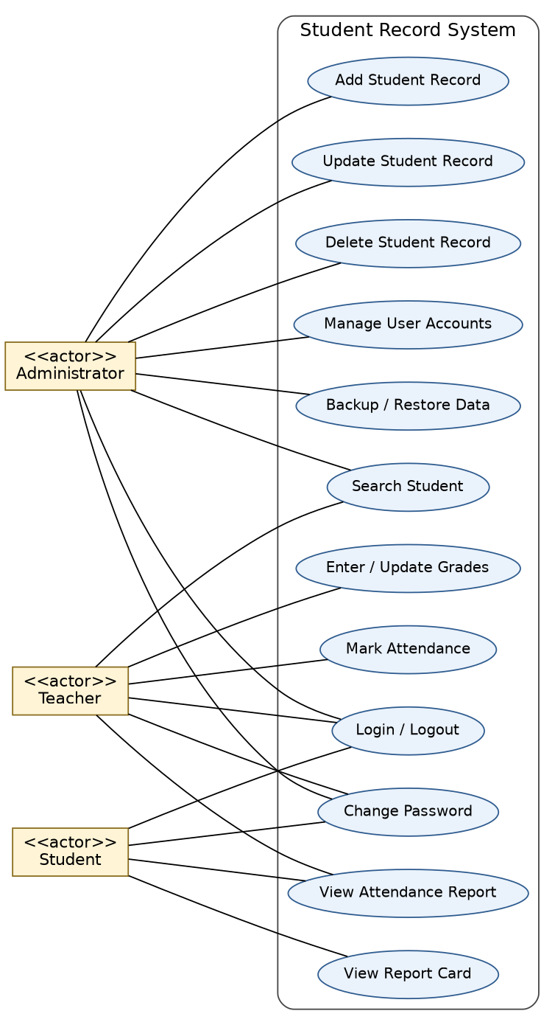
Figure 1: Use case diagram - Student Record System (overall)
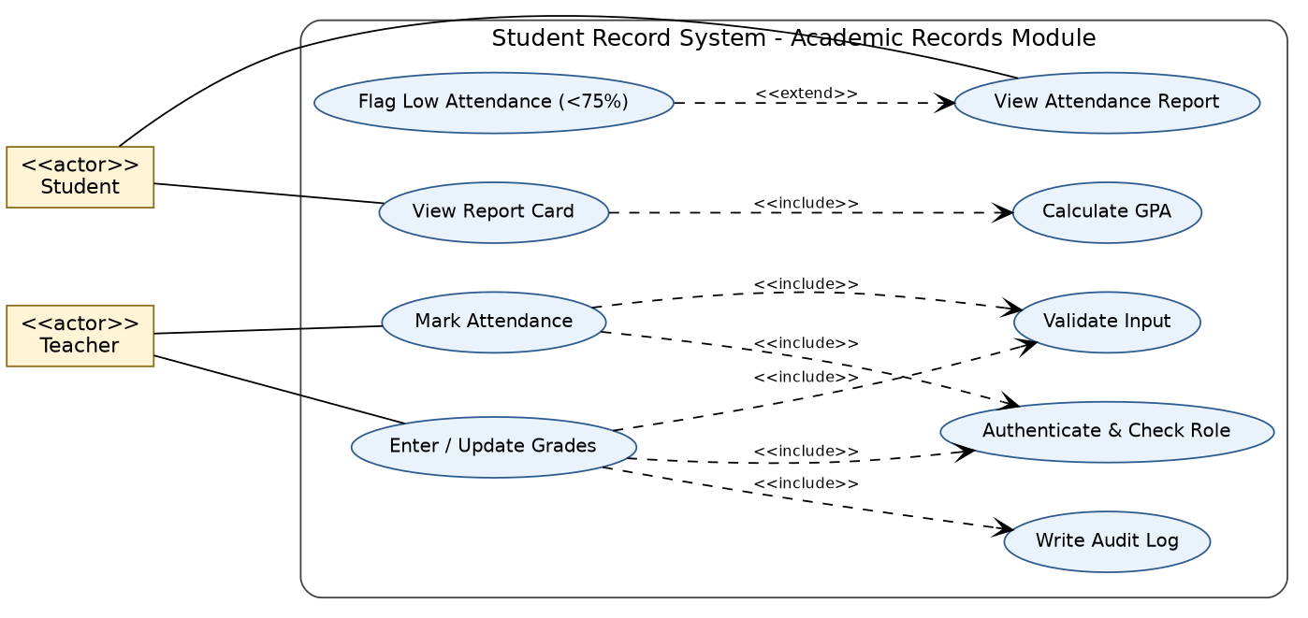
Figure 2: Use case diagram - Academic Records (grades and attendance) with include / extend

7.2 Use case description (example)
Item | Description
Use case | UC-03 Enter / Update Grades
Actor | Teacher (primary)
Precondition | Teacher is logged in; the student record exists
Main flow | 1. Teacher selects "Enter Grades".  2. Teacher gives roll number, subject, semester and marks.  3. System validates the input.  4. System saves the marks and writes an audit entry.  5. System confirms "Grade saved".
Alternate flows | 3a. Marks outside 0-100 or non-numeric: system shows an error and asks again.  2a. Roll number not found: system shows "Student not found".
Postcondition | Marks are stored in the data file and visible in the student's report card
Related requirements | SRM-F-020, SRM-F-021, SRM-SR-002, SRM-SR-004, SRM-F-044

8. Requirements Traceability Matrix (RTM)
Status: N = Not started, P = In progress, A = Accepted (tests passed).
Req ID | Requirement (short) | SRS section | Module | Test case(s) | Status
SRM-F-001 | User login | 4.1 | AuthManager | TC-Auth-01 | N
SRM-F-002 | Account lockout | 4.1 | AuthManager | TC-Auth-02 | N
SRM-F-003 | Session timeout | 4.1 | AuthManager | TC-Auth-03 | N
SRM-F-004 | Change password | 4.1 | AuthManager | TC-Auth-04 | N
SRM-F-010 | Add student | 4.2 | StudentManager | TC-Stu-01 | N
SRM-F-011 | Reject duplicate roll no. | 4.2 | StudentManager | TC-Stu-01 | N
SRM-F-012 | Update student | 4.2 | StudentManager | TC-Stu-02 | N
SRM-F-013 | Delete student | 4.2 | StudentManager | TC-Stu-03 | N
SRM-F-014 | Search student | 4.2 | StudentManager | TC-Stu-02 | N
SRM-F-015 | List students | 4.2 | StudentManager | TC-Stu-02 | N
SRM-F-020 | Enter marks | 4.3 | GradeManager | TC-Grd-01 | N
SRM-F-021 | Update marks | 4.3 | GradeManager | TC-Grd-01 | N
SRM-F-022 | Compute result | 4.3 | ReportGenerator | TC-Grd-02 | N
SRM-F-023 | View own report card | 4.3 | ReportGenerator | TC-Grd-02, TC-Sec-01 | N
SRM-F-024 | Export report | 4.3 | ReportGenerator | TC-Grd-02 | N
SRM-F-030 | Mark attendance | 4.4 | AttendanceManager | TC-Att-01 | N
SRM-F-031 | Attendance percentage | 4.4 | AttendanceManager | TC-Att-02 | N
SRM-F-032 | Low-attendance flag | 4.4 | AttendanceManager | TC-Att-02 | N
SRM-F-033 | View attendance report | 4.4 | ReportGenerator | TC-Att-02, TC-Sec-01 | N
SRM-F-040 | Manage user accounts | 4.5 | AuthManager | TC-Adm-01 | N
SRM-F-041 | Backup data | 4.5 | BackupService | TC-Adm-02 | N
SRM-F-042 | Restore data | 4.5 | BackupService | TC-Adm-02 | N
SRM-F-043 | Persistent storage | 4.5 | FileRepository | TC-Stu-01, TC-Rel-01 | N
SRM-F-044 | Audit logging | 4.5 | AuditLogger | TC-Adm-03 | N
SRM-NF-001 | Search response time | 5 | FileRepository | TC-Perf-01 | N
SRM-NF-002 | Start-up time | 5 | FileRepository | TC-Perf-01 | N
SRM-NF-003 | Crash-safe saving | 5 | FileRepository | TC-Rel-01 | N
SRM-NF-004 | Ease of use | 5 | Console UI | TC-Use-01 | N
SRM-NF-005 | OS portability | 5 | All | TC-Port-01 | N
SRM-NF-006 | Code maintainability | 5 | All | TC-Maint-01 | N
SRM-NF-007 | Data capacity | 5 | FileRepository | TC-Perf-01 | N
SRM-NF-008 | Audit log retention | 5 | AuditLogger | TC-Adm-03 | N
SRM-SR-001 | Salted password hashing | 5.1.2 | AuthManager | TC-Sec-02 | N
SRM-SR-002 | Role-based access control | 5.1.2 | All managers | TC-Sec-01 | N
SRM-SR-003 | Admin-only unlock | 5.1.2 | AuthManager | TC-Auth-02 | N
SRM-SR-004 | Input validation | 5.1.2 | Input Validator | TC-Sec-03 | N
SRM-SR-005 | Security event logging | 5.1.2 | AuditLogger | TC-Adm-03 | N
SRM-SR-006 | Data directory permissions | 5.1.2 | FileRepository | TC-Sec-04 | N
SRM-SR-007 | Password masking / no logging | 5.1.2 | Console UI | TC-Auth-04 | N

