Software Architecture and Design Specification
Project: Student Record System
Group: 6
Version: 1.0
Authors:
PES2UG24CS252 — M B DIVYADHARSHINI
PES2UG24CS253 — M S NIKHIL CHOWDHARY
PES2UG24CS268 — MARAPAREDDY DEEKSHITHA
PES2UG24CS296 — NAIJA ARUN HODIGERE
Date: 01-10-20256
Status: Draft
Project Guide / Mentor: Professor Niveditha Reddy

1. Introduction
1.1 Purpose
This document specifies the software architecture and detailed design of the Student Record System. It describes the system's components, their interactions, the chosen architecture pattern, the technology stack, and the design-level artifacts (sequence diagrams, interface definitions, error handling, and UX flow) needed to implement the functional and non-functional requirements defined in the SRS (v1.0).
1.2 Scope
Covers Authentication, Student Profile Management, Course & Enrollment, Attendance, Grades & Transcripts, Fee Management, Reporting & Analytics, and Administration & Access Control. It also defines how these modules are structured, how they communicate, and how key workflows (enrollment, attendance recording, grade publication, fee payment) are executed end to end.
1.3 Audience
Developers, QA engineers, security auditors, instructors, and maintenance teams.
1.4 Definitions
Term | Meaning
SRS | Software Requirements Specification
SAD | Software Architecture and Design (this document)
SRN | Student Registration Number
RBAC | Role-Based Access Control
GPA / CGPA | Grade Point Average / Cumulative GPA
UML | Unified Modeling Language
API | Application Programming Interface (here: module-level interfaces, not REST, given the C/C++ implementation)

2. Document Overview
2.1 How to use this document
This document should be read alongside the SRS (which defines what the system must do) and the Software Test Plan (which defines how it will be verified). Section 3 (Architecture) establishes the system's components and their relationships; Section 4 (Design) breaks those components down into concrete interfaces, interaction sequences, and error-handling behaviour that developers can implement directly against.
2.2 Related Documents
- Software Requirements Specification (SRS), v1.0 — Student Record System, Group 6
- Software Test Plan (STP) — Student Record System, Group 6
- Requirements Traceability Matrix (RTM) — Section 8 of the SRS

3. Architecture
3.1 Goals & Constraints
Goals
- Ensure secure, role-based access to student records.
- Provide a modular and maintainable system for academic and administrative functions.
- Support scalability and reliability during peak academic periods.
- Maintain data integrity and auditability of academic and administrative records.
- Provide responsive and accessible web-based access.

Constraints
- The system must be cloud-hosted and accessible through modern web browsers.
- Structured records must use a relational database, while uploaded documents use object storage.
- External Payment Gateway and Notification Service availability may affect system operations.
- Communication must use TLS 1.2 or higher.
- The system must comply with institutional data-protection and privacy requirements.
3.2 Stakeholders & Concerns
- Students: Secure access to profiles, courses, attendance, grades, transcripts, and fee information
- Faculty: Efficient access to course rosters, attendance recording, marks entry, and academic reports.
- Administrator / Registrar: Management of student and course data, result approval, fees, reports, user roles, and audit logs.
- Institution / Academic Administration: Data integrity, security, availability, and compliance with institutional policies.
- Developers / QA Engineers: Modularity, maintainability, testability, and reliable system behaviour.
- External Services: Secure and reliable interaction with the Payment Gateway and Notification Service.

3.3 Component (UML) Diagram
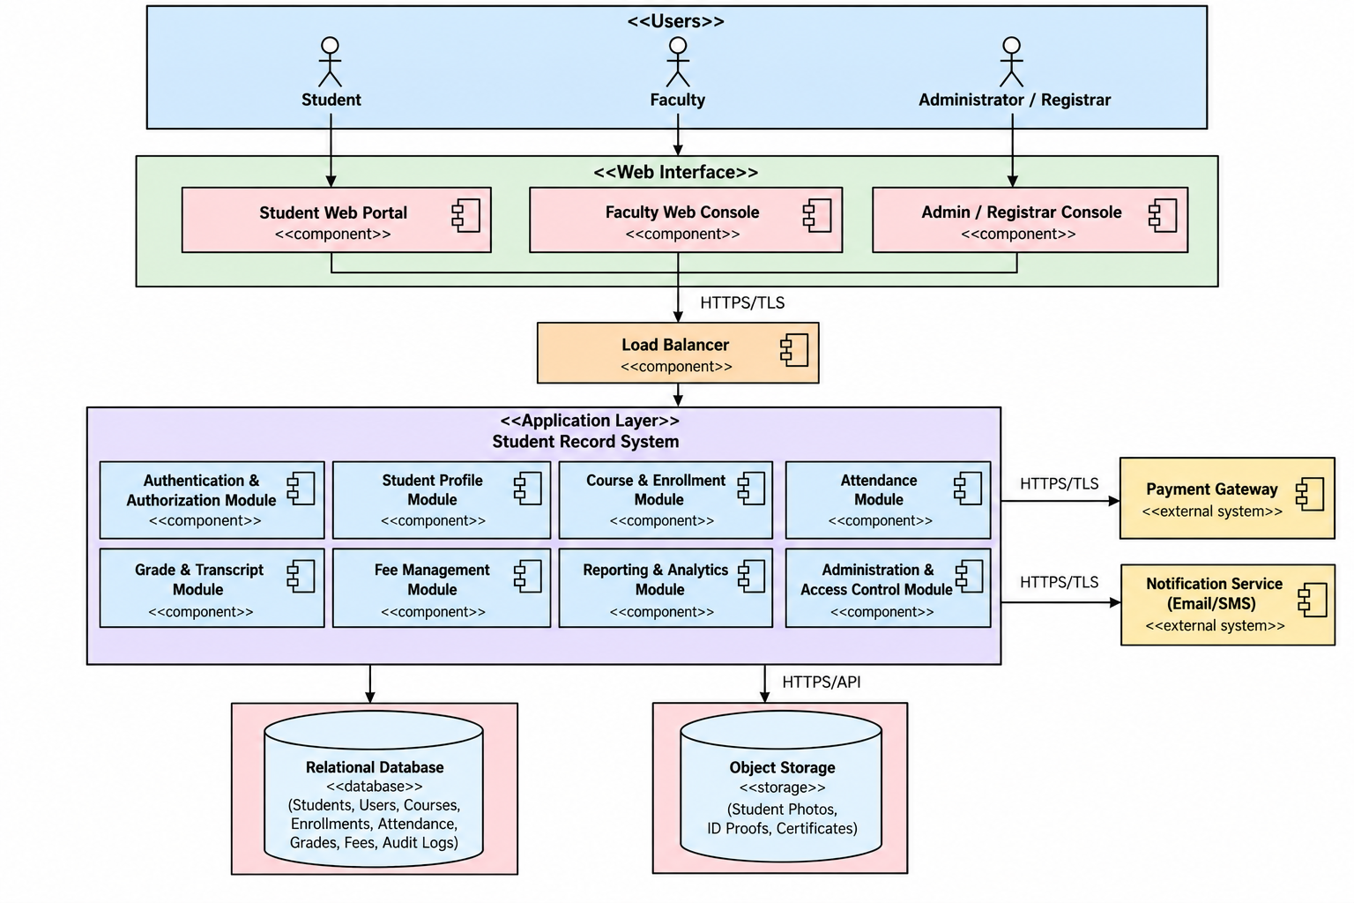

3.4 Component Descriptions
- Web Interface: Provides role-specific interfaces for Students, Faculty, and Administrators/Registrars.
- Authentication & Authorization Module: Handles authentication, password reset, account lockout, and role-based access control.
- Student Profile Module: Manages student profiles, permitted updates, documents, and profile history.
- Course & Enrollment Module: Manages courses, prerequisites, enrollment, credit limits, and course rosters.
- Attendance Module: Records attendance and calculates attendance percentages.
- Grade & Transcript Module: Manages marks, result approval/publication, GPA/CGPA, and transcripts.
- Fee Management Module: Manages fee invoices, payments, fee status, reminders, and dues.
- Reporting & Analytics Module: Generates academic, attendance, enrollment, and fee reports.
- Administration & Access Control Module: Manages users, roles, permissions, record archival, and audit logs.
- Relational Database: Stores structured student and academic records, including audit-log data.
- Object Storage: Stores student photographs, ID proofs, and scanned certificates.
- Payment Gateway: Processes online fee payments and payment-confirmation callbacks.
- Notification Service: Delivers credentials, OTPs, fee reminders, attendance alerts, and result notifications.

3.5 Chosen Architecture Pattern and Rationale
- The system uses a layered architecture separating the web interface, application modules, data storage, and external services.
- This provides separation of responsibilities between different parts of the system.
- The modular structure supports maintainability and independent testing of authentication, profiles, attendance, grades, fees, and reporting modules.
- The architecture supports the SRS requirement for a cloud-hosted, scalable system behind a load balancer.
- The architecture also allows secure integration with the Payment Gateway and Notification Service.

3.6 Technology Stack & Data Stores
Technology Stack
- Frontend: React.js
- Backend: Python with Flask
- Database: MySQL
- Authentication: Flask-based authentication with bcrypt password hashing
- API Communication: REST APIs over HTTPS
- File Storage: Local file storage initially, with support for cloud object storage if required
- Deployment: Docker-based cloud deployment
Data Stores
- MySQL: Stores student profiles, courses, enrollments, attendance, grades, fees, user accounts, and audit logs.
- File/Object Storage: Stores student photos, ID proofs, and scanned certificates.

3.7 Risks & Mitigations
- Unauthorized access to student records - Implement role-based access control, secure authentication, and password hashing.
- Data loss or corruption - Use regular database backups and maintain the required recovery procedures.
- External service failure - Use retry and backoff mechanisms for transient failures when communicating with the Payment Gateway and Notification Service.
- Performance issues during peak periods - Use a scalable cloud-hosted deployment and load balancing to support concurrent users.
- Incorrect or unauthorized academic record changes - Maintain audit logs and restrict modification of published grades and attendance to authorized, logged corrections.
- Privacy and security risks - Use TLS 1.2+ for communication and follow institutional data-protection requirements.

3.8 Traceability to Requirements
- Authentication & RBAC → Supports secure login, role-based access, password reset, and account management.
- Student Profile Module → Supports student profile creation, updates, documents, and profile history.
- Course & Enrollment Module → Supports course management, prerequisites, enrollment, and credit limits.
- Attendance Module → Supports attendance recording and attendance percentage calculation.
- Grade & Transcript Module → Supports marks, result approval/publication, GPA/CGPA calculation, and transcripts.
- Fee Management Module → Supports fee invoices, payments, fee status, reminders, and dues.
- Reporting & Analytics Module → Supports academic, attendance, enrollment, and fee reports.
- Administration & Access Control Module → Supports user/role management, permissions, archival, and audit logging.

3.9 Security Architecture
- Authentication: Users must authenticate before accessing the system.
- Role-Based Access Control (RBAC): Access to functions and records is controlled according to the user's role.
- Password Security: Passwords are protected using salted adaptive hashing such as bcrypt or Argon2.
- Secure Communication: Client-server and service-to-service communication uses TLS 1.2+.
- Data Protection: Student and academic information is protected according to institutional data-protection and privacy requirements.
- Academic Record Integrity: Published grades and attendance cannot be modified except through an authorized and logged correction process.
- Audit Logging: Administrative and record modifications are recorded in tamper-evident audit logs for accountability.

4. Design

4.1 Design Overview
The system is designed as a set of independently testable modules, each corresponding to one functional area of the SRS: AuthModule, ProfileModule, EnrollmentModule, AttendanceModule, GradeModule, FeeModule, ReportModule, and AdminModule. Each module is implemented as a separate .c/.cpp file pair (source + header) exposing a small set of functions as its interface. Modules communicate through well-defined function calls and shared data structures (defined in a common header) rather than direct access to each other's internals — this keeps each module testable and replaceable in isolation, consistent with the Maintainability quality attribute in the SRS.

4.2 UML Sequence Diagrams

Flow 1: Student Course Enrollment (STU-F-021, STU-F-023)
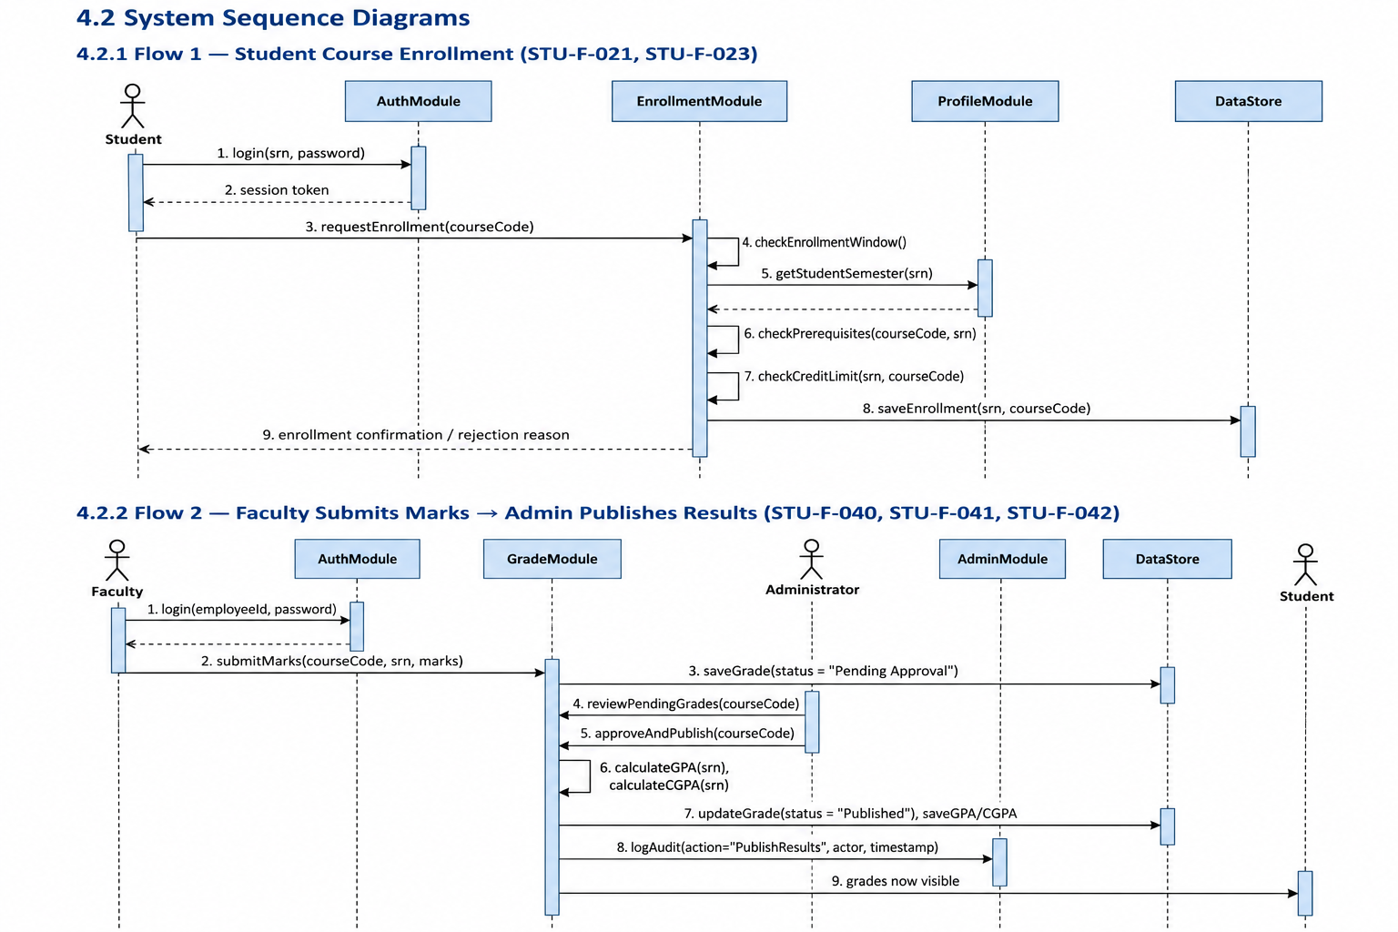

Flow 2: Faculty Submits Marks → Admin Publishes Results (STU-F-040, STU-F-041, STU-F-042)

4.3 API Design
- EnrollmentModule interface (enrollment.h)
typedef enum { ENROLL_OK, ERR_WINDOW_CLOSED, ERR_PREREQ_NOT_MET, ERR_CREDIT_LIMIT } EnrollResult;
EnrollResult enrollStudent(const char *srn, const char *courseCode);
int getEnrolledCourses(const char *srn, Course *outList, int maxCount);
int getTotalCreditLoad(const char *srn);
- GradeModule interface (grade.h)
typedef enum { GRADE_OK, ERR_NOT_ENROLLED, ERR_ALREADY_PUBLISHED } GradeResult;
GradeResult submitMarks(const char *facultyId, const char *courseCode, const char *srn, float marks);
GradeResult approveAndPublish(const char *adminId, const char *courseCode);
double calculateGPA(const char *srn, const char *semester);
double calculateCGPA(const char *srn);
Each function returns a result/error code rather than throwing — consistent with C conventions — and every write-path function logs to AdminModule's audit log internally.

4.4 Error Handling, Logging & Monitoring
- Every module function returns a typed result/error code (see enums above) rather than a raw int, to make failure modes explicit at call sites.
- No sensitive data (passwords, OTPs, raw payment details) is ever written to logs — only actor ID, action, and timestamp (per STU-SR-005).
- All administrative actions, grade modifications, and profile edits are logged through a single shared logAudit() call in AdminModule, so that the audit trail format stays consistent across modules (per STU-F-045, STU-F-073).
- Input validation (e.g. malformed SRN, out-of-range marks, negative credits) is rejected at the module boundary before reaching the data-access layer.
- Monitoring, for this scope, means console/log-file output tracking failed login attempts, enrollment rejections, and grade-publish events — sufficient for a coursework-scale deployment rather than a production monitoring stack.

4.5 UX Design
- On launch, the user logs in (SRN/employee ID + password); the menu presented depends on their role (Student / Faculty / Administrator), reflecting the RBAC model in STU-F-071.
- Student menu: View Profile, Enroll in Courses, View Attendance, View Grades/Transcript, Pay Fees, Raise Grade-Review Request.
- Faculty menu: View Roster, Record Attendance, Enter/Submit Marks, View Reports.
- Administrator menu: Manage Students/Courses, Approve & Publish Results, Manage Fees, Generate Reports, Manage Users/Roles, View Audit Log.
- Validation errors (e.g. enrollment window closed, credit limit exceeded) are shown as clear, specific console messages rather than generic failures — matching the SRS's "Clear validation messages" interface requirement.

4.6 Open Issues & Next Steps
- Decide on persistence: flat files vs. SQLite (affects DataStore interface and Section 3.6 of the architecture).
- Decide whether Payment Gateway / Notification Service are simulated (stubbed functions) or omitted entirely, given the console-based, offline nature of a C/C++ build versus the SRS's original web-hosted assumption.
- Finalize whether multi-user/concurrent access is in scope, or whether the system is single-session per run (affects locking/concurrency design).

5. Appendices
5.1 Glossary:
Term | Meaning
SRS | Software Requirements Specification
SAD | Software Architecture and Design Specification
STP | Software Test Plan
RTM | Requirements Traceability Matrix
SRN | Student Registration Number
UI | User Interface
API | Application Programming Interface (here: module-level function interfaces)
JWT | JSON Web Token
OTP | One-Time Password
TLS | Transport Layer Security
RBAC | Role-Based Access Control
GPA | Grade Point Average
CGPA | Cumulative Grade Point Average
RPO | Recovery Point Objective
RTO | Recovery Time Objective
WCAG | Web Content Accessibility Guidelines
UML | Unified Modeling Language
STRIDE | Threat-modeling framework: Spoofing, Tampering, Repudiation, Information disclosure, Denial of service, Elevation of privilege
ADR | Architecture Decision Record

5.2 References:
- Software Requirements Specification (SRS) — Student Record System, Group 6, v1.0
- Software Test Plan (STP) — Student Record System, Group 6
- IEEE 42010 — Systems and software engineering, Architecture description
- WCAG 2.1 — Web Content Accessibility Guidelines
5.3 Tools:
- Diagramming: PlantUML or draw.io (for use-case, component, and sequence diagrams)
- Version Control: Git / GitHub
- Build: [specify — e.g. Make / CMake]
- Compiler: [specify — e.g. GCC / Clang / MSVC]
- Persistence (if used): SQLite, or flat-file storage (to be finalized per Section 4.6 Open Issues)

