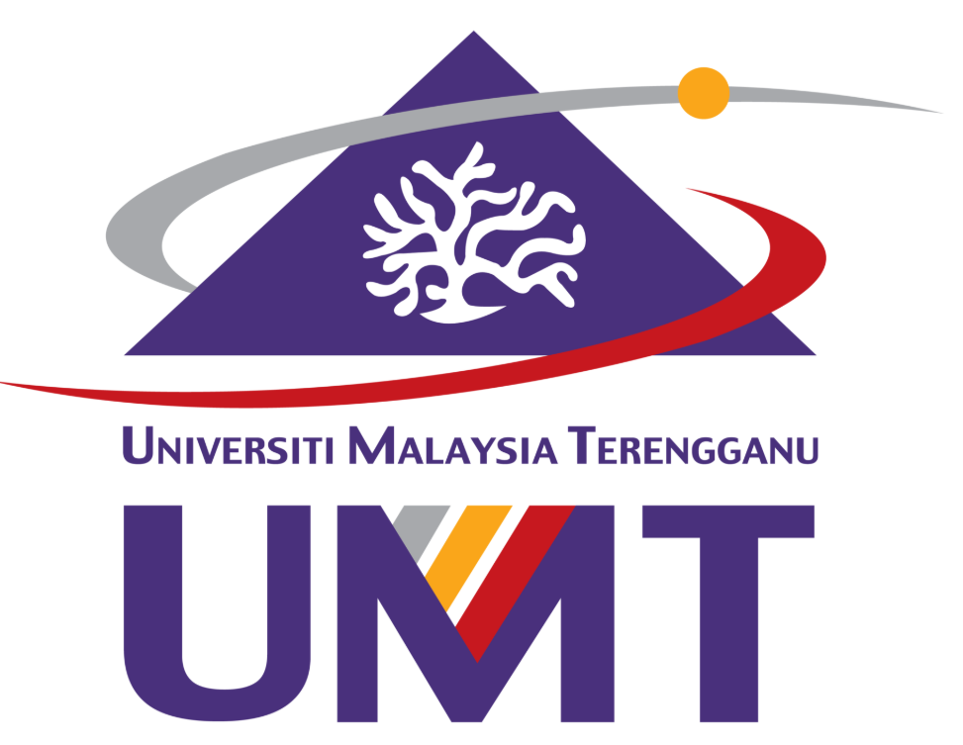
UNIVERSITI MALAYSIA TERENGGANU

CSF3143 - BASIC SOFTWARE ENGINEERING
GROUP PROJECT REPORT: STUDENT ACADEMIC WORKLOAD SYSTEM
LECTURER: Ts. MOHAMMAD AIZAT BASIR
PREPARED BY:

GROUP 13

NAME | MATRIC NUMBER
NUR AUNI BATRISYIA BINTI MOHAMAD NIZAM | S84857
NURINA ATIKAH BINTI CHE ROHAIZI | S88899
SHARRMINI A/P VENGKATESWARA NAIDU | S88359
HEMASRI A/P AMARSAN | S88914

TABLE OF CONTENTS:
1. PROJECT BACKGROUND 3
1.1 Problem Statement Justification 3
1.2 Proposed System Overview 3
2. SYSTEM REQUIREMENTS 4
2.1 Stakeholder Identification & Requirement Gathering 4
2.1 Functional Requirements 4
2.2 Non-Functional Requirements 5
2.3 Quality & Completeness of Requirements 5
3. SYSTEM DESIGN 6
3.1 Use Case Diagram 6

PROJECT BACKGROUND

Problem Statement Justification
University students are required to manage various academic responsibilities, including assignments, quizzes, projects and other coursework. Managing multiple academic tasks with different deadlines can become challenging, especially when students have difficulties organising their schedules and prioritising their work.
Some students rely on manual methods such as notes, planners and to-do lists to keep track of their academic responsibilities. However, these methods may not provide a centralised way to monitor deadlines and overall academic progress.
Therefore, the Student Academic Workload System (SAWS) is proposed to address these challenges by providing a more organised platform for students to manage their academic workload.

Summary from the survey that we have done findings from nine student respondents revealed that 55.6% experienced difficulties due to heavy academic workloads, while 44.4% faced challenges in managing their time. Additionally, 33.3% reported difficulties in remembering assignment deadlines. These findings indicate a need for a system that can help students organise their academic tasks, monitor deadlines and manage their workload more effectively.

1.2 Proposed System Overview

The Student Academic Workload System (SAWS) is a proposed system designed to help university students manage their academic tasks in a more organised and more efficient. The system aims to provide a centralised platform where students can record assignments, monitor deadlines and track their task progress.
SAWS will include features such as assignment and task management, deadline tracking, reminder notifications and a workload overview dashboard. These features are intended to help students organise their academic responsibilities, prioritise tasks and reduce the possibility of missing important deadlines.
The system is proposed based on the feedback collected through the stakeholder questionnaire. The findings indicate that students need a more organised way to manage their academic workload.

SYSTEM REQUIREMENTS

2.1 Stakeholder Identification & Requirement Gathering
The primary stakeholders of the Student Academic Workload System (SAWS) are university students who are responsible for managing their academic tasks and deadlines.
To gather the initial system requirements, a google form was distributed to university students. A total of nine responses were collected from the respondents. The questions focused on identifying students' challenges in managing academic workloads, their current task management methods and the features they expect from the proposed system.
The collected responses were analysed to identify the students' needs and preferences. The findings will be used as a basis for determining the functional and non-functional requirements of SAWS.

Functional Requirements

The functional requirements describe the main functions that the Student Academic Workload System (SAWS) is expected to provide to its users. Based on the questionnaire findings, the following functional requirements have been identified.

FUNCTIONAL REQUIREMENTS | DESCRIPTION
Academic Calander | The system shall display important academic dates and events.
Task Prioritisation | The system shall allow students to assign priority levels to their academic tasks.
Timetable Management | The system shall allow students to record and view their class schedules.
Progress Tracking | The system shall allow students to update and monitor task completion status.
Workload Overview | The system shall display a summary of students' academic tasks and workload.
Reminder Notification | The system shall provide reminders for upcoming task deadlines
Deadline Tracking | The system shall allow students to set and monitor assignment deadlines.
Task Management | The system shall allow students to add, view, edit and delete academic tasks.

2.2 Non-Functional Requirements
Non-functional requirements describe the quality attributes and performance expectations of the Student Academic Workload System (SAWS). These requirements ensure that the system is easy to use, reliable and suitable for students.

REQUIREMENT | DESCRIPTION
Usability | The system shall provide a simple and user-friendly interface.
Perfomance | The system shall maintain accurate task and deadline information.
Reliability | The system shall maintain accurate task and deadline information.
Security | The system shall protect students' academic information from unauthorised access.
Compatibility | The system shall be accessible through commonly used web browsers.
Maintainability | The system shall be designed so that future updates and improvements can be made easily.

2.3 Quality & Completeness of Requirements
The requirements of the Student Academic Workload System (SAWS) were identified based on the feedback collected through the stakeholder questionnaire. The questionnaire helped the project team understand the challenges faced by students and identify the features required in the proposed system.
The identified requirements cover the main needs of students, including task management, deadline tracking, reminders and progress monitoring. Both functional and non-functional requirements have been included to ensure that the proposed system addresses users' needs and provides a user-friendly experience.
The requirements will be reviewed and refined throughout the system development process to ensure their accuracy, clarity and completeness.

SYSTEM DESIGN

3.1 Use Case Diagram

The Use Case Diagram illustrates the interactions between students and the Student Academic Workload System (SAWS). It identifies the main functions available to students when managing their academic workload.

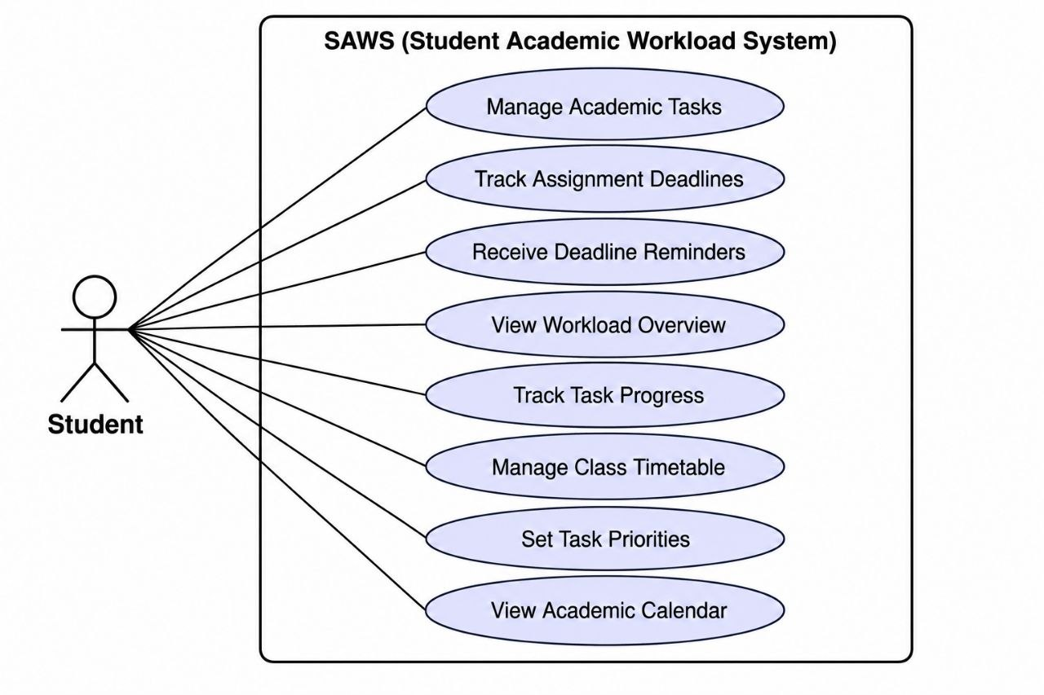

Figure 3.1: Use Case Diagram of Student Academic Workload System (SAWS)

