Jackfruit Phase-2
Project Plan Document
Project: Student Attendance Management System (SAMS)
Subject Code: UE24CS341A — Software Engineering
Version: 1.1
Date: 16-09-2026
Status: Draft — For Submission

Project Team
USN | Name
PES2UG24CS350 | Piyush A Patel
PES2UG24CS310 | Neel Chandrakar
PES2UG24CS331 | Nookala Sai Tushar Krishna
PES2UG24CS364 | Pranav Somashekar

1. Introduction

1.1 Purpose
This document is the Jackfruit Phase-2 Project Plan for the Student Attendance Management System (SAMS), building on the Phase-1 Software Requirements Specification. It defines the development lifecycle, tooling, deliverables, work breakdown structure, team roles, effort estimate, testing strategy, and schedule that will guide the team from design through to the final demo.

1.2 Scope
This plan covers the planning and execution approach for all functional and non-functional requirements defined in the SRS (SAMS-F-001 to SAMS-F-040, SAMS-NF-001 to SAMS-NF-006, and SAMS-SR-001 to SAMS-SR-005). It does not itself specify detailed test case steps — those are covered in the Phase-3 Test Plan — but does establish the testing strategy, test-ID conventions, and testing schedule (Section 8).

1.3 References
- Software Requirements Specification (SRS) — Student Attendance Management System, Version 1.0
- Jackfruit Mini-Project Guidelines, Software Engineering (UE24CS341A), 2026

1.4 Definitions and Acronyms
- SAMS — Student Attendance Management System
- WBS — Work Breakdown Structure
- PM — Person-Month(s)
- UT / IT / ST — Unit Test / Integration Test / System Test
- RTM — Requirements Traceability Matrix

2. Software Development Lifecycle Model
The team will follow the Agile (Scrum) model, structured as seven 2-week sprints across the semester, as mandated by the course guidelines ("Agile methodology only").

Justification
- Requirements for an academic mini-project are refined iteratively as the course syllabus is covered week by week, making a plan-driven model (e.g. Waterfall) impractical.
- A four-person team with clearly separable modules (Authentication, Master Data, Attendance Engine, Analytics/Dashboards — see Section 6) benefits from Scrum's parallel sprint backlogs, letting each member work independently while integrating every sprint.
- Regular sprint reviews align naturally with weekly faculty evaluations and let the team demonstrate incremental working software rather than a single big-bang delivery.
- Short sprints surface integration issues (e.g., between the Attendance Engine and Analytics modules) early, reducing risk before the final demo.

3. Tools & Infrastructure
Category | Tool | Purpose
Planning & Task Tracking | GitHub Projects (Kanban board) | Sprint planning, backlog grooming, user stories
Design / Diagramming | draw.io, Graphviz | ER diagrams, UML use-case diagrams, architecture sketches
Version Control | Git + GitHub | Source control, feature branches, pull-request reviews
Development Environment | VS Code, Python 3.x, Django | Core application implementation
Bug Tracking | GitHub Issues | Logging, triaging, and resolving defects
Testing | Django TestCase / pytest | Unit and integration testing
CI Pipeline | GitHub Actions | Automated test runs on push / pull request
Documentation | Markdown, Google Docs / Word | SRS, README, project plan, test plan

4. Deliverables (Reuse vs. Build)
Deliverables are categorised below as Reuse (leveraging Django/framework-provided capability) or Build (custom logic specific to SAMS), to focus development effort where it adds the most value.
Deliverable | Category | Justification
Django framework & built-in auth | Reuse | Tested, secure session/authentication mechanics; avoids reinventing security-critical code
Django ORM & admin scaffolding | Reuse | Speeds up baseline CRUD scaffolding for master data entities
SQLite database engine | Reuse | Bundled with Django; sufficient for the project's academic scale
CSS styling (Bootstrap or similar) | Reuse | Consistent, professional styling without custom framework development
Shared base HTML template & navigation | Build | Project-specific layout so all four members' pages stay visually consistent
Authentication & RBAC logic | Build | Role-based access rules (Admin/Faculty/Student) are specific to SAMS
Attendance marking & editing engine | Build | Core differentiator; roster selection, present/absent capture, edit-window logic
Attendance calculation engine | Build | Subject-wise/overall percentage logic is a custom business rule
Low-attendance monitoring & alerts | Build | Configurable-threshold logic specific to SAMS' requirements
Reporting module | Build | Role-scoped report views tailored to Admin/Faculty/Student needs
Dashboards | Build | Role-specific summaries unique to SAMS' three user types

5. Work Breakdown Structure (WBS)
The WBS decomposes SAMS into implementation-level tasks, each mapped to the functional requirements defined in the Phase-1 SRS (Section 4) and to the responsible team member.
WBS ID | Task | Sub-tasks | Linked SRS IDs | Owner
1.0 | Project Setup & Environment Configuration | Repo init, Django project scaffold, base template, CI setup | — | All
2.0 | Database Design | ER modelling, Django model classes, migrations | Appendix A | All (Neel lead)
3.0 | Authentication & Security Module | Login/logout, session mgmt, password hashing, CSRF, server-side RBAC | SAMS-F-001–008,  SAMS-SR-001–004 | Tushar
4.0 | Master Data Management | Student/Faculty/Section/Subject CRUD, faculty assignment, admin UI | SAMS-F-009–021 | Neel
5.0 | Attendance Marking Engine | Roster selection UI, mark Present/Absent, duplicate prevention, edit window | SAMS-F-022–027 | Piyush
6.0 | Attendance Calculation & Analytics | Subject-wise/overall % calculation, low-attendance threshold logic | SAMS-F-028–030,  SAMS-F-035–037 | Pranav
7.0 | Reporting Module | Subject/section/student reports, attendance history views | SAMS-F-031–034 | Pranav
8.0 | Dashboards | Admin, Faculty, and Student dashboard views | SAMS-F-038–040 | Pranav
9.0 | Integration & System Testing | Cross-module integration, unit/integration/system test execution | — | All
10.0 | Documentation Finalisation | SRS updates, README, user guide, Phase-3 Test Plan handoff | — | All
11.0 | Final Demo Preparation | Demo script, working build, 15-min presentation | — | All

6. Team Roles & Responsibilities
Each member owns a distinct module end-to-end (design, implementation, unit testing) while contributing to shared activities like integration testing and documentation.

6.1 Roles Overview
Role | Team Member | Primary Responsibility
Lead Developer — Security & Auth | Nookala Sai Tushar Krishna | Authentication/RBAC design & implementation, security unit tests
Lead Developer — Master Data | Neel Chandrakar | Admin CRUD modules, database schema coordination
Lead Developer — Attendance Engine | Piyush A Patel | Attendance marking/editing engine, integration test coordination
Lead Developer — Analytics & Reporting | Pranav Somashekar | Calculation engine, reports, dashboards, final test report consolidation

6.2 Division of Work by Area
Work Area | Primary Owner | Supporting Member(s)
Database design & schema | Neel | All (review)
Authentication & security | Tushar | Piyush (integration into attendance views)
Master data management | Neel | Tushar (RBAC hooks on admin pages)
Attendance marking engine | Piyush | Neel (data model), Pranav (test data seeding)
Analytics, reporting & dashboards | Pranav | Piyush (attendance data source)
Integration & system testing | All | —
Documentation (SRS, README, plans) | All | —

7. Effort Estimation
Effort is estimated in person-months (PM), assuming part-time contribution alongside other coursework over a 15-week semester. Figures are rough estimates for planning purposes and will be refined during sprint planning.
WBS ID | Task | Effort (Person-Months) | Primary Owner
1.0 | Project Setup & Environment Configuration | 0.25 | All
2.0 | Database Design | 0.50 | All
3.0 | Authentication & Security Module | 1.00 | Tushar
4.0 | Master Data Management | 1.50 | Neel
5.0 | Attendance Marking Engine | 1.25 | Piyush
6.0 | Attendance Calculation & Analytics | 0.75 | Pranav
7.0 | Reporting Module | 0.75 | Pranav
8.0 | Dashboards | 0.50 | Pranav
9.0 | Integration & System Testing | 0.50 | All
10.0 | Documentation Finalisation | 0.25 | All
11.0 | Final Demo Preparation | 0.25 | All
 | Total | 7.50 PM

8. Testing Strategy Preview & Schedule
This section previews the testing approach that will be fully detailed in the Phase-3 Test Plan: the levels of testing, the test-ID convention that keeps this plan consistent with the SRS, and the schedule for executing tests alongside development.

8.1 Test Levels
- Unit Testing (UT) — verifies individual functions/validation rules within a single module (e.g. duplicate-USN rejection, percentage-calculation formula), written by each module's owner as it is built.
- Integration Testing (IT) — verifies connected components work together (e.g. a marked attendance record correctly feeding the calculation engine).
- System Testing (ST) — verifies complete end-to-end workflows across roles (e.g. Admin sets up a section → Faculty marks attendance → Student views updated percentage).
- Security Testing (SEC) — verifies the security requirements SAMS-SR-001 to SAMS-SR-005 (password hashing, session enforcement, server-side RBAC, CSRF, SQL-injection prevention).

8.2 Sample Test Case Preview
A representative sample of the SRS-to-test-case mapping is shown below to fix the ID convention (TC-<Module>-##) ahead of Phase-3; the full test case specifications (steps, test data, expected results) will be authored in the Phase-3 Test Plan.
SRS Req ID | Test Case ID(s) | Test Level
SAMS-F-001 | TC-Auth-01, TC-Auth-02 | Unit, Integration
SAMS-F-007 | TC-RBAC-03 | Integration
SAMS-F-012 | TC-Stu-04 | Unit
SAMS-F-022 | TC-Att-01 | System
SAMS-F-025 | TC-Att-04 | Integration
SAMS-F-028 | TC-Calc-01 | Unit
SAMS-F-036 | TC-Low-02 | System
SAMS-SR-001 | TC-Sec-01 | Security
SAMS-SR-003 | TC-Sec-03 | Security
SAMS-SR-004 | TC-Sec-04 | Security

8.3 Testing Schedule
Testing Activity | Week(s) | Detail
Unit test design & execution (per module) | W3–W11 | Each developer writes/runs unit tests for their module as it is implemented
Integration testing | W9–W13 | Cross-module checks (e.g. Attendance Engine ↔ Analytics, Auth ↔ all modules)
System testing (end-to-end workflows) | W12–W14 | Full role-based workflows: Admin setup → Faculty marking → Student viewing
Security validation | W12–W13 | Checks against SAMS-SR-001 to SAMS-SR-005
Regression / bug-fix retesting | W13–W14 | Re-run affected tests after fixes
Test reporting & sign-off | W14–W15 | Consolidate results, update RTM, final report

9. Schedule — Gantt Chart
The schedule below maps each WBS task onto a 15-week semester timeline, sequenced so that foundational modules (setup, database, authentication) complete before dependent modules (attendance marking before calculation and reporting) begin, consistent with the Concurrent Testing approach of seeding dummy attendance data early to unblock the Analytics workstream.
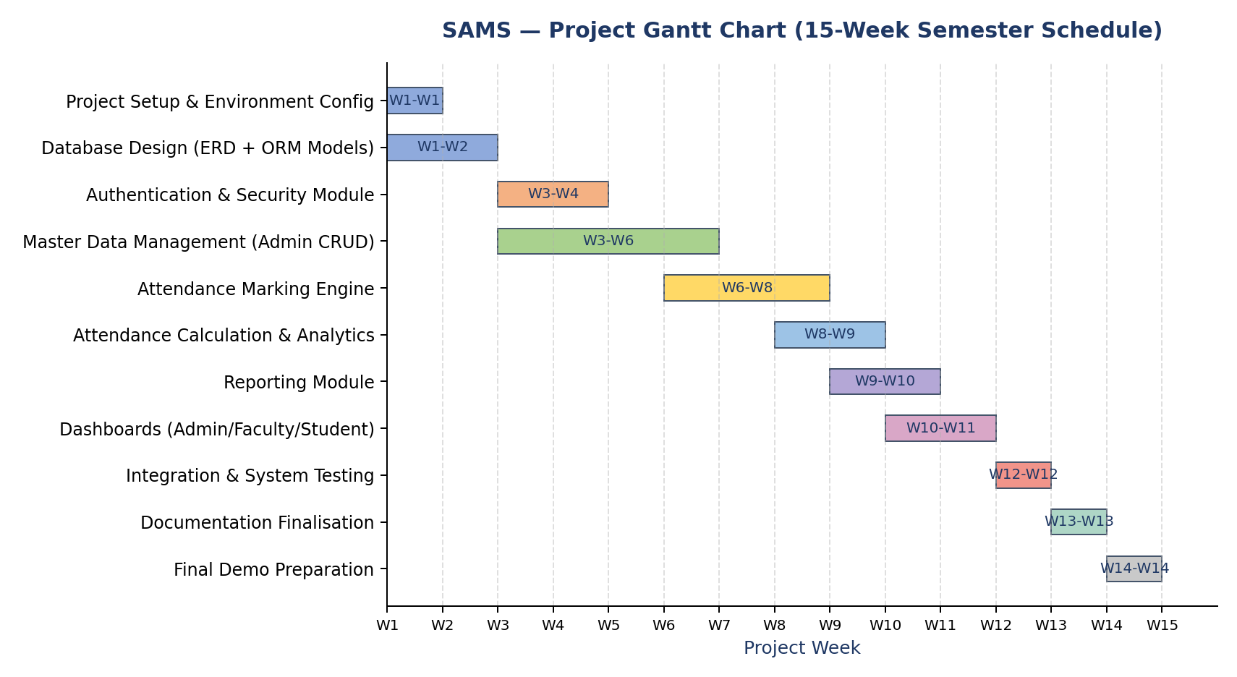

10. Risks and Mitigation
Risk | Impact | Mitigation
Parallel coursework limits available time | Medium | Follow the WBS/schedule and prioritize High-priority FRs first
A dependent module (e.g. Analytics) is blocked waiting on another (e.g. Attendance Engine) | High | Seed dummy attendance data early per the Concurrent Testing approach (Section 9)
Team member unavailability during a sprint | Medium | Responsibilities are documented (Section 6) so another member can step in
Environment/configuration mismatch between members' machines | Medium | Shared requirements.txt and a standardized SQLite dev setup
Scope creep beyond the 40 SRS-defined functional requirements | Low | All work is traced to SAMS-F/NF/SR IDs; RTM (SRS Section 8) tracks coverage

11. Assumptions and Dependencies

11.1 Assumptions
- Implementation will follow the Phase-1 SRS functional and security requirements as written.
- All four team members have access to a consistent local development environment (same Python/Django versions).
- Test data used during development and testing is synthetic and contains no real student information.

11.2 Dependencies
- The database schema (SRS Appendix A) must be finalised before module development begins.
- The Attendance Marking Engine (Piyush) must reach a testable state before the Analytics module (Pranav) can validate calculations — mitigated via seeded dummy data.
- Each module's unit tests must pass before that module is merged into the shared integration branch.

12. Approvals
Role | Name | Signature / Email | Date
Course Coordinator

