Software Requirements Specification (SRS)
Project: Student Attendance Management System
Version: 1.0
Authors: Piyush A Patel; Neel Chandrakar; Nookala Sai Tushar Krishna; Pranav Somashekar
Date: 03-09-2026
Status: Draft — For Submission

Project Team
USN | Name
PES2UG24CS350 | Piyush A Patel
PES2UG24CS310 | Neel Chandrakar
PES2UG24CS331 | Nookala Sai Tushar Krishna
PES2UG24CS364 | Pranav Somashekar

Revision History
Version | Date | Author | Change summary | Approval
1.0 | 03-09-2026 | Piyush A Patel | Initial SRS draft for SAMS, aligned to course SRS template

Approvals
Role | Name | Signature / Email | Date
Course Coordinator

Table of Contents
1. Introduction
2. Overall Description
3. External Interface Requirements
4. System Features (Detailed)
5. Non-Functional Requirements (Detailed)
6. Quality Attributes & Acceptance Tests
7. System Models and Diagrams
8. Requirements Traceability Matrix (RTM)

1. Introduction

1.1 Purpose
This document is a Software Requirements Specification (SRS) for the Student Attendance Management System (SAMS). It defines functional and non-functional requirements, interfaces, and verification criteria intended for the project guide, evaluators, and the student development team to use as a reference during design and implementation.

1.2 Scope
Covers user interactions at the web application for three roles — Administrator, Faculty, and Student — including master-data management, attendance marking, automatic percentage calculation, and reporting. Excludes external ERP integration, biometric/facial-recognition capture, mobile applications, and cloud deployment, none of which are part of the current project requirements.

1.3 Audience
Project guide/evaluator, student developers (project team), and any future contributor who extends or maintains the system after the initial submission.

1.4 Definitions
List of acronyms: SRS, SAMS, Admin, CRUD, DB, UI, ORM, FR, NFR, RTM.
Term | Description
SAMS | Student Attendance Management System (this project)
Admin | Administrator — the user role with full system access
Section | A subdivision of a class/batch, e.g. "CSE-3A"
Attendance % | Ratio of classes attended to classes held, expressed as a percentage
Low Attendance | Attendance percentage below the configured minimum threshold (default 75%)
ORM | Object-Relational Mapping (used by Django to interact with SQLite)
RTM | Requirements Traceability Matrix

2. Overall Description

2.1 Product Perspective
SAMS is a new, standalone web application, not a modification of an existing system. It is a self-contained Django project with a single relational database (SQLite) and a server-rendered frontend (Django Templates, HTML, CSS, JavaScript), following a three-tier structure: presentation (templates/static assets), application logic (views, forms), and data (Django ORM models over SQLite).

2.2 Major Product Functions (Detailed)
- Authenticate user and enforce role-based access
- Manage students, faculty, sections, and subjects (Administrator)
- Assign faculty to subject-section combinations
- Mark and edit attendance for assigned subjects (Faculty)
- Automatic subject-wise and overall attendance percentage calculation
- Low-attendance identification against a configurable threshold
- Attendance reports and attendance history (all roles, scoped by permission)
- Role-specific dashboards

2.3 User Roles and Characteristics (Expanded)
- Administrator: single or small set of privileged users (e.g. HOD/office staff); comfortable with basic web forms; requires full CRUD access to master data and system-wide reports.
- Faculty: teaching staff with limited technical background; needs a fast interface for marking attendance per class period, and read access to reports for their own subjects.
- Student: largest user group; requires only read-only access to personal attendance data; interface must require no training.

2.4 Operating Environment
- Backend: Python 3.x with the Django web framework.
- Database: SQLite (file-based, bundled with Django by default).
- Frontend: Django Template Language rendering HTML5, styled with CSS and vanilla JavaScript.
- Server: Django development server for evaluation; optionally served via WSGI on a local network for demonstration.
- Client: any modern desktop/laptop browser (Chrome, Firefox, Edge) with JavaScript enabled.

2.5 Constraints
- Must be implemented in Python/Django, per course requirements; SQLite is the only database, so no database-specific stored procedures.
- Frontend must use Django Templates rather than a separate SPA framework.
- Development and evaluation are confined to a single academic semester, limiting scope to core attendance-management functionality.
- No biometric, facial-recognition, AI/ML-based, or cloud-hosted components, consistent with the project's academic scope.

3. External Interface Requirements

3.1 User Interfaces
Primary UI: browser-rendered pages with a clear navigation structure common to all roles (login page redirecting to a role-specific dashboard). Usability: plain-language forms and validation messages; consistent layout via a shared base template, navigation bar, and footer.

3.2 Hardware Interfaces
SAMS has no dedicated hardware peripherals. Client-side hardware requirements are limited to a standard desktop, laptop, or mobile device with a keyboard/mouse or touchscreen, capable of running a modern web browser. No card readers, biometric scanners, or specialised input devices are required.

3.3 Software Interfaces
- Django Framework: request/response handling, ORM, authentication, and templating used throughout the system.
- SQLite: accessed exclusively through the Django ORM; no direct SQL queries required for standard operations.
- Web Browser: client-side interface is rendered HTML/CSS/JavaScript, requiring no additional client software.

3.4 Communications
- Standard HTTP/HTTPS between browser and Django server; session-based authentication using signed cookies.
- All state-changing requests (forms) are protected by Django's CSRF token mechanism.
Note: This SRS defines 40 functional requirements, 6 non-functional requirements, 3 security objectives, and 5 security requirements across Sections 4 and 5, exceeding the minimum of 15 FRs, 5 NFRs, 2 security objectives, and 5 security requirements.

4. System Features (Detailed)
Each requirement below includes acceptance criteria and a reference test case. IDs follow SAMS-F-###.

4.1 Authentication
Description: Authenticate registered users (Administrator, Faculty, Student) against stored credentials and maintain a secure session.
Req ID | Requirement (shall...) | Type | Priority | Source/  Stakeholder | Acceptance criteria / Test case ref | Comments/  Dependencies
SAMS-F-001 | The system shall allow a registered user to log in using a username and password. | Functional | High | Admin/Faculty/Student | AC-001: Valid credentials lead to an authenticated session. Test: TC-Auth-01 | Uses Django auth
SAMS-F-002 | The system shall validate credentials and deny access with an error message on failure. | Functional | High | Security | AC-002: Invalid login shows error, no session created. Test: TC-Auth-02
SAMS-F-003 | The system shall maintain a session until logout or expiry. | Functional | High | Security | AC-003: Session persists across pages until logout/timeout. Test: TC-Auth-03 | Django session framework
SAMS-F-004 | The system shall allow a logged-in user to log out, terminating the session. | Functional | High | Admin/Faculty/Student | AC-004: Logout invalidates session; protected pages redirect to login. Test: TC-Auth-04

4.2 Role-Based Access Control
Description: Restrict pages and actions according to the user's assigned role (Administrator, Faculty, Student).
Req ID | Requirement (shall...) | Type | Priority | Source/  Stakeholder | Acceptance criteria / Test case ref | Comments/  Dependencies
SAMS-F-005 | The system shall assign every user account exactly one role. | Functional | High | Admin | AC-005: Each user record has a single non-null role field. Test: TC-RBAC-01
SAMS-F-006 | The system shall restrict Administrator-only pages to Administrator accounts. | Functional | High | Security | AC-006: Direct URL access by non-admin is rejected. Test: TC-RBAC-02 | Server-side check
SAMS-F-007 | The system shall restrict attendance-marking pages to Faculty, and only for assigned subjects/sections. | Functional | High | Security | AC-007: Faculty cannot mark for unassigned sections. Test: TC-RBAC-03
SAMS-F-008 | The system shall restrict Student accounts to read-only views of their own data. | Functional | High | Security | AC-008: Student cannot view another student's records. Test: TC-RBAC-04

4.3 Student Management
Description: Administrator CRUD operations on student master data.
Req ID | Requirement (shall...) | Type | Priority | Source/  Stakeholder | Acceptance criteria / Test case ref | Comments/  Dependencies
SAMS-F-009 | The system shall allow the Administrator to add a student record (name, USN, section, semester, contact). | Functional | High | Admin | AC-009: New record saved and retrievable. Test: TC-Stu-01
SAMS-F-010 | The system shall allow the Administrator to update existing student details. | Functional | High | Admin | AC-010: Edited fields persist. Test: TC-Stu-02
SAMS-F-011 | The system shall allow the Administrator to deactivate or remove a student record. | Functional | Medium | Admin | AC-011: Deactivated student cannot log in. Test: TC-Stu-03
SAMS-F-012 | The system shall prevent duplicate student records with the same USN. | Functional | High | Data Integrity | AC-012: Duplicate USN submission is rejected. Test: TC-Stu-04 | DB unique constraint

4.4 Faculty Management
Description: Administrator CRUD operations on faculty master data and subject-section assignment.
Req ID | Requirement (shall...) | Type | Priority | Source/  Stakeholder | Acceptance criteria / Test case ref | Comments/  Dependencies
SAMS-F-013 | The system shall allow the Administrator to add a faculty record (name, employee ID, department, contact). | Functional | High | Admin | AC-013: New faculty record saved. Test: TC-Fac-01
SAMS-F-014 | The system shall allow the Administrator to update or deactivate a faculty record. | Functional | Medium | Admin | AC-014: Edits/deactivation persist. Test: TC-Fac-02
SAMS-F-015 | The system shall allow the Administrator to assign one or more subject-section combinations to a faculty member. | Functional | High | Admin | AC-015: Assignment appears on faculty dashboard. Test: TC-Fac-03

4.5 Class and Section Management
Req ID | Requirement (shall...) | Type | Priority | Source/  Stakeholder | Acceptance criteria / Test case ref | Comments/  Dependencies
SAMS-F-016 | The system shall allow the Administrator to create a section (name, semester, academic year). | Functional | High | Admin | AC-016: New section available for student assignment. Test: TC-Cls-01
SAMS-F-017 | The system shall allow the Administrator to update or delete a section, provided no attendance records would be orphaned. | Functional | Medium | Admin | AC-017: Delete blocked if dependent records exist. Test: TC-Cls-02
SAMS-F-018 | The system shall allow students to be assigned to exactly one section per academic term. | Functional | High | Data Integrity | AC-018: Student record references exactly one section_id. Test: TC-Cls-03

4.6 Subject Management
Req ID | Requirement (shall...) | Type | Priority | Source/  Stakeholder | Acceptance criteria / Test case ref | Comments/  Dependencies
SAMS-F-019 | The system shall allow the Administrator to create a subject (name, subject code, semester). | Functional | High | Admin | AC-019: New subject saved. Test: TC-Sub-01
SAMS-F-020 | The system shall allow the Administrator to map a subject to one or more sections. | Functional | High | Admin | AC-020: Mapping visible in subject list. Test: TC-Sub-02
SAMS-F-021 | The system shall allow the Administrator to update or remove a subject record. | Functional | Medium | Admin | AC-021: Edits/removal persist. Test: TC-Sub-03

4.7 Attendance Management
Description: Faculty marking and editing of attendance for assigned subject-section combinations.
Req ID | Requirement (shall...) | Type | Priority | Source/  Stakeholder | Acceptance criteria / Test case ref | Comments/  Dependencies
SAMS-F-022 | The system shall allow Faculty to select an assigned subject-section and a date to mark attendance. | Functional | High | Faculty | AC-022: Marking page loads correct student roster. Test: TC-Att-01
SAMS-F-023 | The system shall display enrolled students for marking as Present or Absent. | Functional | High | Faculty | AC-023: All section students listed with two-state control. Test: TC-Att-02
SAMS-F-024 | The system shall save one attendance record per student, per subject, per date, linked to the marking faculty. | Functional | High | Data Integrity | AC-024: Record count = roster size after submission. Test: TC-Att-03
SAMS-F-025 | The system shall prevent duplicate marking for the same subject/section/date and instead allow editing. | Functional | High | Data Integrity | AC-025: Re-submission updates, not duplicates, records. Test: TC-Att-04 | DB unique constraint
SAMS-F-026 | The system shall allow Faculty to edit attendance already marked, within an authorized correction window. | Functional | Medium | Faculty | AC-026: Edit permitted within window, blocked after. Test: TC-Att-05 | Configurable window
SAMS-F-027 | The system shall reject marking for dates outside the current term or for unassigned subjects/sections. | Functional | High | Security | AC-027: Out-of-term/unassigned submission returns error. Test: TC-Att-06

4.8 Attendance Calculation
Req ID | Requirement (shall...) | Type | Priority | Source/  Stakeholder | Acceptance criteria / Test case ref | Comments/  Dependencies
SAMS-F-028 | The system shall calculate subject-wise attendance % as (attended ÷ held) × 100. | Functional | High | Business Rule | AC-028: Percentage matches manual calculation on sample data. Test: TC-Calc-01
SAMS-F-029 | The system shall calculate overall attendance % across all subjects for the current term. | Functional | High | Business Rule | AC-029: Overall % matches aggregate of subject-wise values. Test: TC-Calc-02
SAMS-F-030 | The system shall recalculate percentages automatically whenever attendance data changes. | Functional | High | Business Rule | AC-030: Percentage updates immediately after edit. Test: TC-Calc-03

4.9 Attendance Reports
Req ID | Requirement (shall...) | Type | Priority | Source/  Stakeholder | Acceptance criteria / Test case ref | Comments/  Dependencies
SAMS-F-031 | The system shall allow Faculty to generate a subject-wise report per section, listing each student's %. | Functional | High | Faculty | AC-031: Report lists all section students with correct %. Test: TC-Rep-01
SAMS-F-032 | The system shall allow the Administrator to generate section-wise and subject-wise reports institution-wide. | Functional | High | Admin | AC-032: Report aggregates across sections. Test: TC-Rep-02
SAMS-F-033 | The system shall allow a Student to view their own subject-wise and overall report only. | Functional | High | Security | AC-033: Student report scoped to own student_id. Test: TC-Rep-03
SAMS-F-034 | The system shall display date-wise attendance history for a selected student and subject. | Functional | High | Admin/Faculty/Student | AC-034: History lists Present/Absent per date. Test: TC-Rep-04

4.10 Low-Attendance Monitoring
Req ID | Requirement (shall...) | Type | Priority | Source/  Stakeholder | Acceptance criteria / Test case ref | Comments/  Dependencies
SAMS-F-035 | The system shall allow the Administrator to configure a minimum attendance threshold (default 75%). | Functional | Medium | Admin | AC-035: Threshold value editable and persisted. Test: TC-Low-01
SAMS-F-036 | The system shall identify students whose % falls below the configured threshold. | Functional | High | Business Rule | AC-036: List matches students below threshold on sample data. Test: TC-Low-02
SAMS-F-037 | The system shall allow Faculty and Administrator to view the low-attendance list for their respective scope. | Functional | High | Faculty/Admin | AC-037: Faculty sees own sections; Admin sees all. Test: TC-Low-03

4.11 Dashboard
Req ID | Requirement (shall...) | Type | Priority | Source/  Stakeholder | Acceptance criteria / Test case ref | Comments/  Dependencies
SAMS-F-038 | The system shall present an Administrator dashboard summarising totals and low-attendance count. | Functional | Medium | Admin | AC-038: Dashboard counts match underlying data. Test: TC-Dash-01
SAMS-F-039 | The system shall present a Faculty dashboard summarising assigned subjects and today's marking status. | Functional | Medium | Faculty | AC-039: Status reflects whether today's attendance is marked. Test: TC-Dash-02
SAMS-F-040 | The system shall present a Student dashboard summarising overall % and subjects below threshold. | Functional | Medium | Student | AC-040: Dashboard values match report data. Test: TC-Dash-03

5. Non-Functional Requirements (Detailed)
NFRs below are measurable and tied to test plans. IDs follow SAMS-NF-###.
Req ID | Requirement | Category | Priority | Acceptance criteria / Measurement
SAMS-NF-001 | Standard pages (dashboard, attendance list, report) shall load within 3 seconds under normal load for a database of up to a few thousand attendance records. | Performance | High | Page load timed at ≤3s in local test. Test: TC-Perf-01
SAMS-NF-002 | Once saved, attendance records shall persist correctly and be retrievable in reports without data loss. | Reliability | High | Sample records verified present after restart. Test: TC-Rel-01
SAMS-NF-003 | The user interface shall use consistent navigation, labelling, and layout across all pages for a given role. | Usability | Medium | UI review checklist pass. Test: TC-UX-01
SAMS-NF-004 | The codebase shall follow Django's standard project structure with reusable model methods for calculations. | Maintainability | Medium | Code review confirms no duplicated calculation logic. Test: TC-Maint-01
SAMS-NF-005 | The data model shall be normalized so migration to a larger database engine would not require a schema redesign. | Scalability | Low | Schema review against 3NF checklist. Test: TC-Scal-01
SAMS-NF-006 | The system shall validate all form inputs and reject invalid data with a clear, field-level error message. | Reliability | High | Invalid input (e.g., future-dated attendance) is rejected with message. Test: TC-Rel-02

5.1 Security

5.1.1 Security Objectives
- Protect the confidentiality of user credentials at rest and in transit.
- Enforce role-based authorization on the server side for every protected action, not only in the UI.
- Preserve the integrity and accountability of attendance records once marked.

5.1.2 Security Requirements
Req ID | Requirement (shall...) | Type | Priority | Acceptance criteria / Test case ref
SAMS-SR-001 | User passwords shall be stored using Django's built-in password hashing; plain-text passwords shall never be stored. | Security | High | AC-SR-001: DB inspection shows hashed values only. Test: TC-Sec-01
SAMS-SR-002 | All pages that display or modify data shall require an authenticated session. | Security | High | AC-SR-002: Unauthenticated request redirects to login. Test: TC-Sec-02
SAMS-SR-003 | Role-based checks shall be enforced server-side in Django views, not only hidden in the frontend. | Security | High | AC-SR-003: Direct URL request by wrong role is rejected. Test: TC-Sec-03
SAMS-SR-004 | All state-changing forms shall be protected against Cross-Site Request Forgery using Django's CSRF tokens. | Security | High | AC-SR-004: Form submission without valid CSRF token is rejected. Test: TC-Sec-04
SAMS-SR-005 | All database queries shall go through the Django ORM to prevent SQL injection. | Security | High | AC-SR-005: No raw string-concatenated SQL in codebase (code review). Test: TC-Sec-05

6. Quality Attributes & Acceptance Tests
Exit criteria for acceptance: all High-priority functional requirements implemented and verified, no critical NFR failures, and the RTM (Section 8) shows all listed test cases passed.
Acceptance test suites: Authentication & Access Control, Student/Faculty/Subject/Section Management, Attendance Marking & Editing, Attendance Calculation & Reports, Low-Attendance Monitoring, Security.

7. System Models and Diagrams

7.1 UML Use-Case Diagram
Two use-case diagrams are provided below: one for the Administrator, and one covering Faculty and Student, reflecting the three actors of the system.
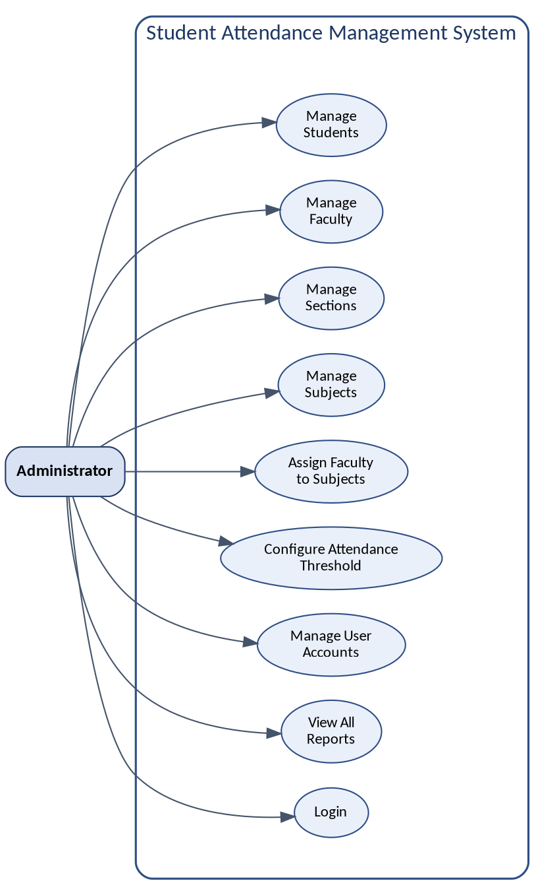
Figure 7.1 — Administrator Use-Case Diagram

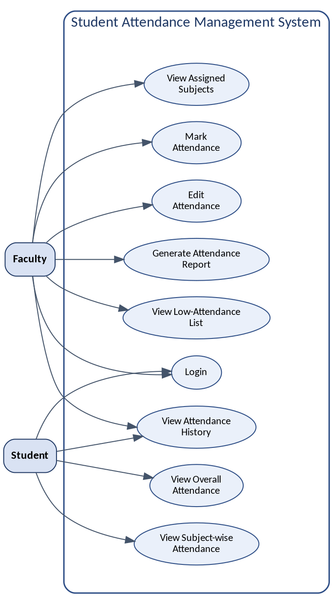
Figure 7.2 — Faculty and Student Use-Case Diagram

8. Requirements Traceability Matrix (RTM)
Req ID | Requirement short | Section ref / Design Spec | Module | Test case(s) | Status  (N/P/A) | Comments
SAMS-F-001 | Login authentication | 4.1 / DS-Auth-01 | AuthModule | TC-Auth-01 | N
SAMS-F-007 | Restrict marking to assigned faculty | 4.2 / DS-RBAC-01 | AuthModule | TC-RBAC-03 | N
SAMS-F-012 | Prevent duplicate USN | 4.3 / DS-Stu-01 | StudentModule | TC-Stu-04 | N
SAMS-F-022 | Mark attendance for section | 4.7 / DS-Att-01 | AttendanceModule | TC-Att-01 | N
SAMS-F-025 | Prevent duplicate attendance | 4.7 / DS-Att-02 | AttendanceModule | TC-Att-04 | N
SAMS-F-028 | Subject-wise % calculation | 4.8 / DS-Calc-01 | ReportModule | TC-Calc-01 | N
SAMS-F-036 | Low-attendance identification | 4.10 / DS-Low-01 | ReportModule | TC-Low-02 | N
SAMS-NF-001 | Page load performance | 5 / DS-Perf-01 | WebUI | TC-Perf-01 | N
SAMS-NF-006 | Form input validation | 5 / DS-Rel-02 | Forms | TC-Rel-02 | N
SAMS-SR-001 | Password hashing | 5.1.2 / DS-Sec-01 | AuthModule | TC-Sec-01 | N
SAMS-SR-003 | Server-side role enforcement | 5.1.2 / DS-Sec-03 | AuthModule | TC-Sec-03 | N
SAMS-SR-004 | CSRF protection | 5.1.2 / DS-Sec-04 | Forms | TC-Sec-04 | N
Status legend: N = Not yet tested, P = Passed, A = Failed/Action needed. To be updated during the testing phase.

Appendices (Supplementary)
The following appendices are not part of the 8 core sections required by the course SRS template. They are included as additional supporting material relevant to the DBMS/Software Engineering scope of this project.

Appendix A — Database Schema Reference
Entity | Key Attributes
User | user_id (PK), username, password (hashed), role, email
Student | student_id (PK), user_id (FK), USN, name, section_id (FK), semester, contact_no
Faculty | faculty_id (PK), user_id (FK), employee_id, name, department, contact_no
Section | section_id (PK), section_name, semester, academic_year
Subject | subject_id (PK), subject_code, subject_name, semester
Subject_Section | id (PK), subject_id (FK), section_id (FK)
Faculty_Assignment | id (PK), faculty_id (FK), subject_id (FK), section_id (FK)
Attendance | attendance_id (PK), student_id (FK), subject_id (FK), faculty_id (FK), date, status, marked_at, modified_at
Attendance_Config | id (PK), threshold_percentage
- User (1)—(1) Student/Faculty; Section (1)—(M) Student.
- Subject (M)—(M) Section via Subject_Section; Faculty (M)—(M) Subject/Section via Faculty_Assignment.
- Student (1)—(M), Subject (1)—(M), Faculty (1)—(M) Attendance.

Appendix B — Additional System Models

B.1 Data Flow Diagram Description
At Level 0, the system exchanges data with three external entities — Administrator, Faculty, Student. At Level 1: (1) Master Data Management, (2) Authentication and Access Control, (3) Attendance Recording, (4) Report and Percentage Generation.

B.2 Entity Relationship Description
Core entities — User, Student, Faculty, Section, Subject, Attendance — relate as summarised in Appendix A.

B.3 Activity Diagram Description
- Faculty logs in and is directed to their dashboard.
- Faculty selects subject, section, and date.
- System checks whether attendance already exists for that combination.
- Faculty marks each student Present/Absent and submits.
- System validates, saves records, and recalculates percentages.
- System displays confirmation and returns to dashboard.

Appendix C — Future Scope
- Email/SMS notifications for low attendance.
- Export of reports to PDF/Excel.
- Responsive/mobile-friendly interface.
- Migration from SQLite to PostgreSQL for larger deployments.
- QR-code-based attendance marking as a faster manual alternative.

