|| Jai Sri Gurudev |

Sri AdichunchanagiriShikshana Trust (R)

SJB INSTITUTE OF TECHNOLOGY



Study Material

Subject Name: Artificial Intelligence and Machine Learning

Subject Code: 23CST601

By

Faculty Name: Mrs. Laxmi Shabadi

Designation: Assistant Professor

Semester: VI



Department of Computer Science & Engineering
Aca. Year: Even Sem /2025-26

Module 2

Chapter 1: Introduction

1.1 Need for Machine Learning

Introduction
Business organizations handle massive amounts of data in their daily activities. Earlier, the full potential of this data remained untapped due to two main reasons:
- Scattered Data Sources: Data was distributed across different archival systems, making it difficult for organizations to integrate and utilize effectively.
- Lack of Awareness of Tools: Organizations were unaware of software tools capable of extracting valuable information from the data.
This situation has changed with the adoption of machine learning, which allows businesses to utilize this data effectively.

Reasons for the Popularity of Machine Learning
Machine learning has gained immense popularity among business organizations for three key reasons:
- High Volume of Available Data:
  - Companies like Facebook, Twitter, and YouTube generate massive amounts of data daily.
  - Data volume is estimated to double approximately every year.
- Reduced Cost of Storage:
  - The cost of storage and hardware has dropped significantly.
  - It is now easier to capture, process, store, distribute, and transmit digital information.
- Availability of Complex Algorithms:
  - The advent of deep learning has provided numerous algorithms for machine learning.
Due to these factors, machine learning has become a dominant technology trend in business organizations.

Knowledge Pyramid (Figure 1.1)
Before exploring machine learning further, it is essential to understand the following terms: data, information, knowledge, intelligence, and wisdom.
- Data:
  - All facts are considered data.
  - Data can be numbers or text processed by computers.
  - Organizations accumulate data from various sources like flat files, databases, and data warehouses in diverse storage formats.
- Information:
  - Processed data is called information.
  - It includes patterns, associations, or relationships among data.
  - Example: Sales data analyzed to determine the fastest-selling product.
- Knowledge:
  - Condensed information is termed knowledge.
  - Example: Historical patterns and future trends derived from sales data.
  - Knowledge is useful only when applied effectively.
- Intelligence:
  - Knowledge in actionable form is called intelligence.
  - Intelligence refers to applying knowledge for decision-making or actions.
  - Computer systems have excelled in achieving intelligence.
- Wisdom:
  - Wisdom represents the maturity of mind and is exhibited solely by humans.

The Need for Machine Learning
The goal of machine learning is to process archival data to help organizations:
- Make better decisions.
- Design new products.
- Improve business processes.
- Develop effective decision-support systems.
Machine learning bridges the gap between data and wisdom, enabling businesses to thrive in a data-driven environment.

1.2Machine Learning Explained
Definition: Machine Learning (ML) is a subfield of Artificial Intelligence (AI) that focuses on developing systems capable of learning from experience without being explicitly programmed. Arthur Samuel defined it as "the field of study that gives computers the ability to learn without being explicitly programmed." The essence of this definition is that systems should autonomously learn without direct programming.
Traditional Programming vs. Machine Learning:
- Traditional Programming: Involves understanding a problem, designing a detailed algorithm or flowchart, and implementing it using a programming language. This method can be challenging for complex real-world problems like puzzles, games, or image recognition.
- Expert Systems: Early AI approaches attempted to tackle such problems by manually developing general-purpose rules based on expert knowledge. These rules were formulated into logic and implemented in programs to create intelligent systems. An example is the expert system MYCIN, designed for medical diagnosis by incorporating the expertise of many doctors. The name "MYCIN" is derived from the suffix commonly found in antibiotic names. However, this approach was limited because programs still relied heavily on human expertise and didn't exhibit true intelligence.
Shift to Data-Driven Systems: The focus of AI shifted to machine learning through data-driven systems. In this approach, data is used as input to develop intelligent models capable of predicting new inputs. The goal of machine learning is to automatically learn a model or set of rules from a given dataset, enabling accurate predictions on unknown data.
As humans take decisions based on an experience, computers make models based on extracted patterns in the input data and then use these data-filled models for prediction and to take decisions. For computers, the learnt model is equivalent to human experience. This is shown in Figure 1.2

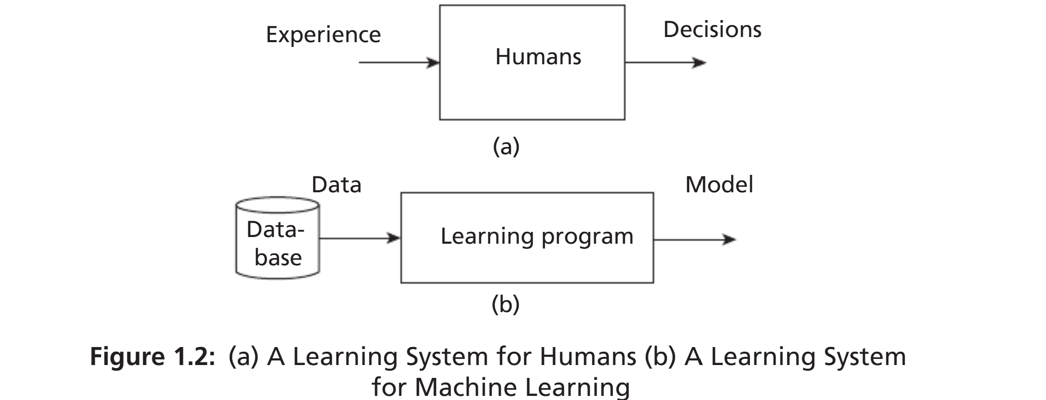
Function Representation: Machine learning models are represented as functions in the form y=f(x)y = f(x)y=f(x), where:
- xxx: Input data
- yyy: Output
- fff: Learning function mapping input xxx to output yyy
Learning the function fff is crucial in forming a model in statistical learning, often referred to as mapping input to output.
Model Definition: A model is an explicit description of patterns within the data, which can be represented as:
- Mathematical equations
- Relational diagrams like trees or graphs
- Logical if/else rules
- Groupings called clusters
The key components of this definition are:
- Experience EEE
- Task TTT
- Performance measure PPP
Example:
- Task TTT: Detecting an object in an image
- Experience EEE: Training dataset of thousands of images
- Performance Measure PPP: Metrics like precision and recall
The machine uses experience EEE to improve its performance on task TTT, as measured by PPP. Based on the performance measures, course corrections can be made to enhance the system's performance.
Human Experience vs. Machine Learning: Human experience is based on data gathered through various means, such as rote learning, observation, instruction, and trial and error. When encountering new problems, humans search for similar past situations, formulate heuristics, and use them for prediction.
In machine learning systems, experience is gathered through the following steps:
- Collection of Data: Gathering relevant data.
- Abstraction: Forming abstract concepts from the data, similar to how humans conceptualize objects (e.g., recognizing an elephant).
- Generalization: Converting abstractions into actionable intelligence by ordering all possible concepts, ranking them, inferring from them, and forming heuristics—educated guesses for tasks.
- Evaluation: Assessing the thoroughness of the models and making course corrections if necessary to generate better formulations.
Heuristics generally work but may occasionally fail. This is not the fault of heuristics, as they are just 'rules of thumb.' Evaluation helps in refining these heuristics to improve system performance.
1.3 MACHINE LEARNING IN RELATION TO OTHER FIELDS
Machine learning uses the concepts of Artificial Intelligence, Data Science, and Statistics primarily. It is the resultant of combined ideas of diverse fields
1.3.1 Machine Learning and Artificial Intelligence
Machine learning is an important branch of AI, which is a much broader subject. The aim of AI is to develop intelligent agents. An agent can be a robot, humans, or any autonomous systems. Initially, the idea of AI was ambitious, that is, to develop intelligent systems like human beings. The focus was on logic and logical inferences. It had seen many ups and downs. These down periods were called AI winters.
The resurgence in AI happened due to development of data driven systems. The aim is to find relations and regularities present in the data. Machine learning is the subbranch of AI, whose aim is to extract the patterns for prediction. It is a broad field that includes learning from examples and other areas like reinforcement learning. The relationship of AI and machine learning is shown in Figure 1.3. The model can take an unknown instance and generate results.
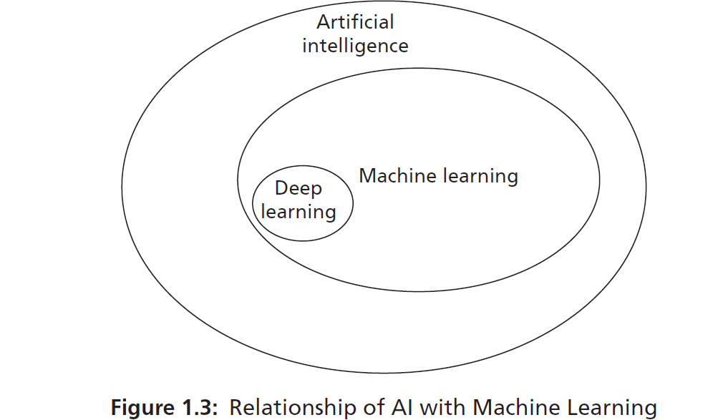

Deep learning is a subbranch of machine learning. In deep learning, the models are constructed using neural network technology. Neural networks are based on the human neuron models. Many neurons form a network connected with the activation functions that trigger further neurons to perform tasks.

1.3.2 Machine Learning, Data Science, Data Mining, and Data Analytics
Data Science and Machine Learning: Data science is an umbrella term encompassing various fields, with machine learning being a branch of data science. Data science focuses on gathering data for analysis and includes areas such as:
- Big Data: This field deals with data characterized by:
  - Volume: Large amounts of data generated by companies like Facebook, Twitter, and YouTube.
  - Variety: Data available in various forms, including images and videos, and in different formats.
  - Velocity: The speed at which data is generated and processed.
Big data is utilized by many machine learning algorithms for applications such as language translation and image recognition. It also influences the growth of subjects like deep learning, a branch of machine learning that constructs models using neural networks.
- Data Mining: Originating in business, data mining involves extracting hidden patterns from data. While often considered synonymous with machine learning, data mining focuses on uncovering hidden patterns, whereas machine learning aims to use these patterns for prediction.
- Data Analytics: This branch aims to extract useful knowledge from raw data. Predictive data analytics is used for making predictions and shares many algorithms with machine learning.
- Pattern Recognition: An engineering field that uses machine learning algorithms to extract features for pattern analysis and classification. It can be viewed as a specific application of machine learning.
These relationships are summarized in Figure 1.4:
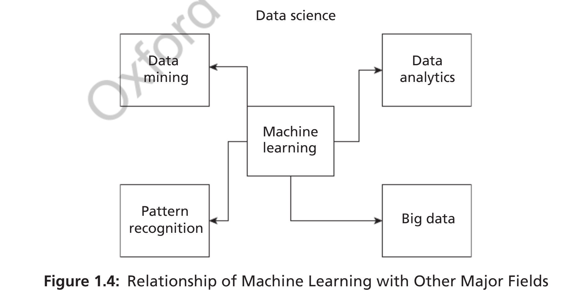
Machine Learning and Statistics: Statistics is a branch of mathematics with a solid theoretical foundation in statistical learning. Like machine learning, it learns from data. However, statistical methods look for regularities in data, called patterns. Initially, statistics sets a hypothesis and performs experiments to verify and validate it to find relationships among variables. It requires knowledge of statistical procedures and the guidance of a good statistician. Statistical methods are mathematics-intensive, often involving complicated equations and many assumptions, and are developed in relation to the data being analyzed. They are coherent and rigorous, with strong theoretical foundations and interpretations requiring strong statistical knowledge.
In contrast, machine learning has fewer assumptions and requires less statistical knowledge but often requires interaction with various tools to automate the learning process. Some consider machine learning as the latest version of 'old statistics,' highlighting the close relationship between the two fields.
1.3.3 Machine Learning and Statistics
statistics is a branch of mathematics with a solid theoretical foundation in statistical learning. Like machine learning (ML), it learns from data. However, statistical methods focus on identifying regularities in data, known as patterns. Typically, statistics begins by formulating a hypothesis and then conducting experiments to verify and validate this hypothesis to uncover relationships within the data.
Statistical analysis requires a thorough understanding of statistical procedures and often the expertise of a skilled statistician. It is mathematics-intensive, with models frequently comprising complex equations and numerous assumptions. These methods are developed in direct relation to the data being analyzed. Moreover, statistical approaches are coherent and rigorous, possessing strong theoretical foundations and interpretations that necessitate substantial statistical knowledge.
In contrast, machine learning operates with fewer assumptions and demands less statistical expertise. However, it often involves the use of various tools to automate the learning process. Some consider machine learning as a modern evolution of traditional statistics, highlighting the close relationship between the two fields.
1.4 TYPES OF MACHINE LEARNING
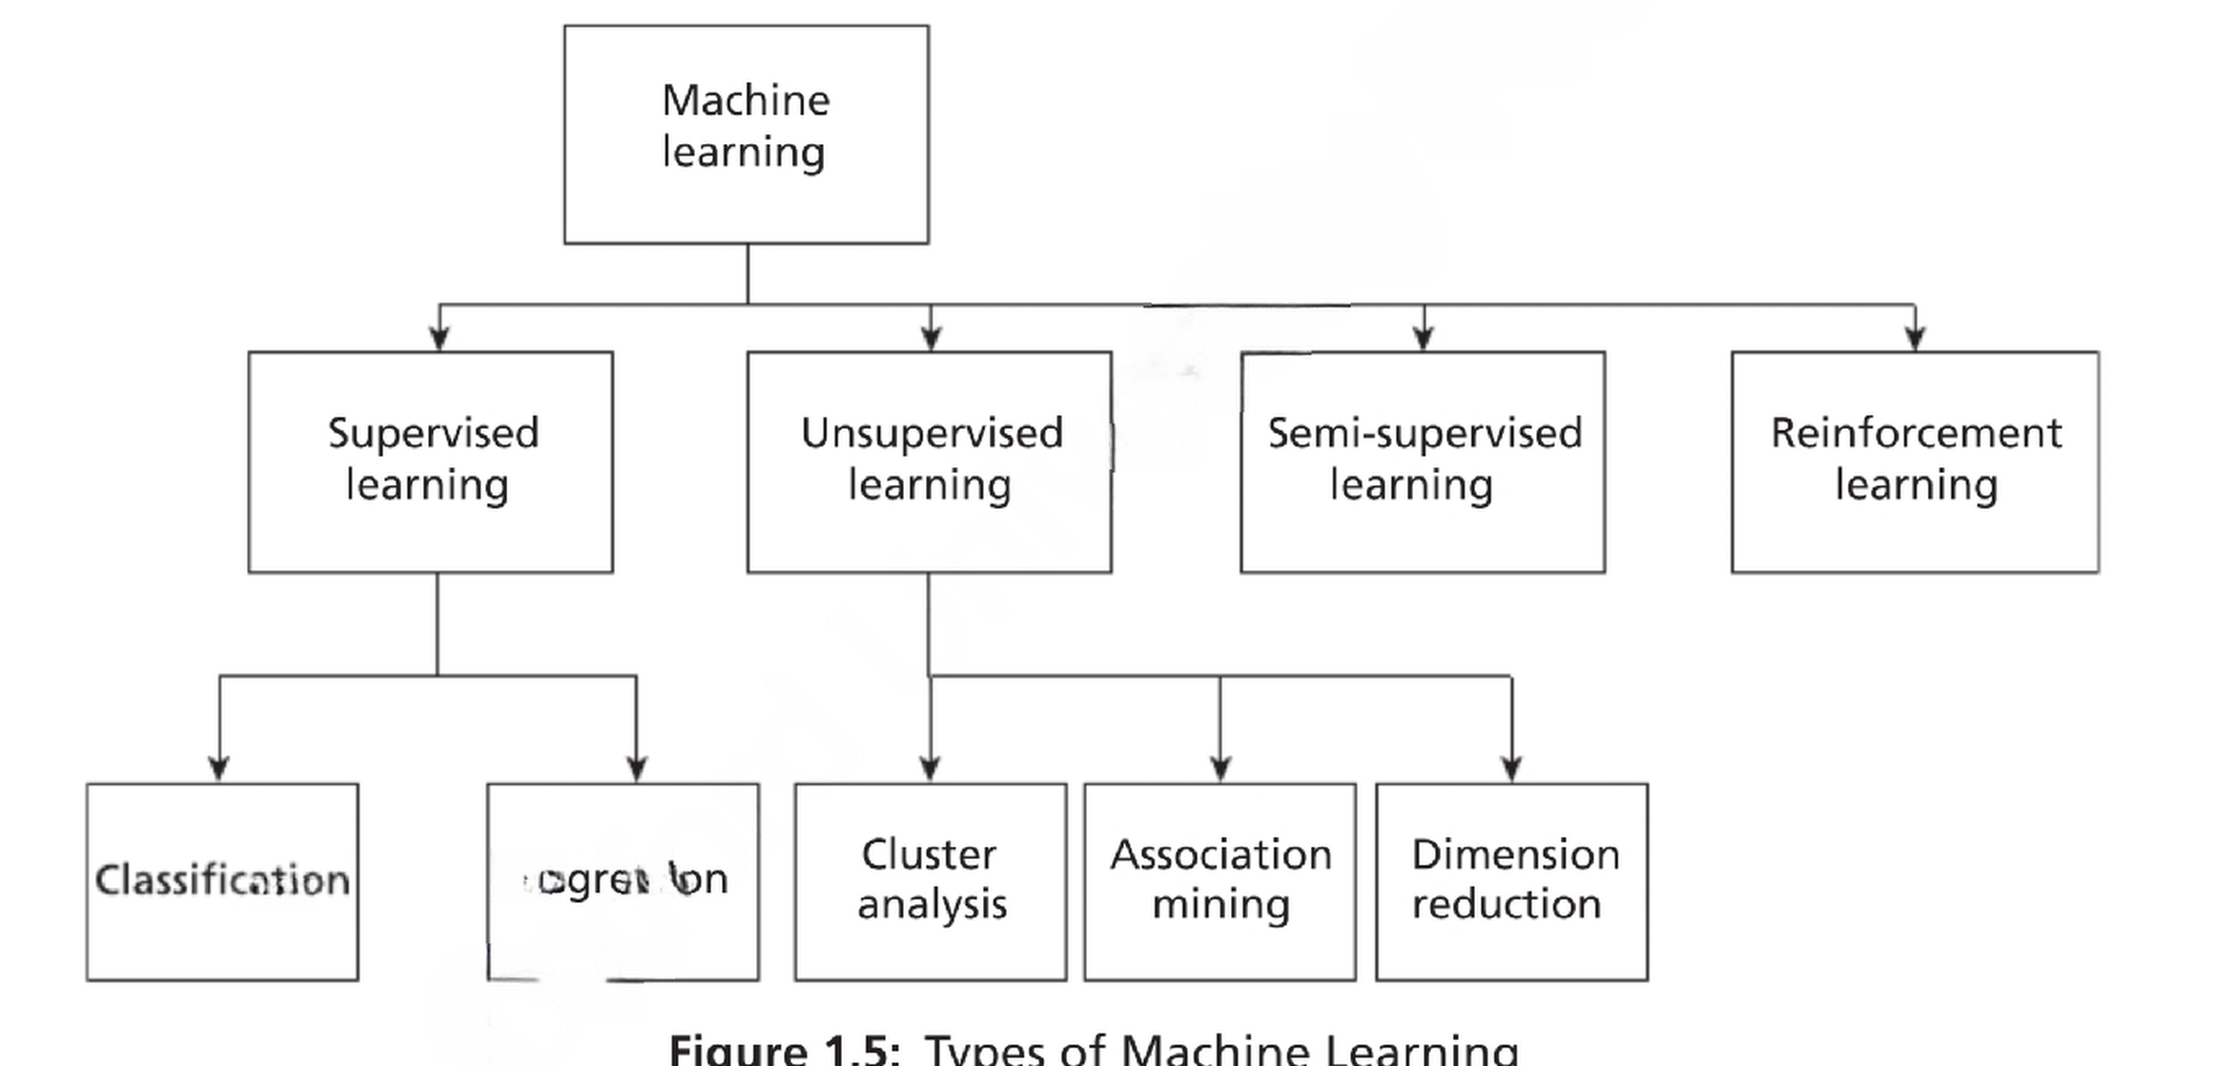

Chapter 2: Understanding Data
Labelled and Unlabelled Data Data is a raw fact. Normally, data is represented in the form

All Facts Are Data
- Definition: Facts are represented as data, encoded in computer systems as bits (0s and 1s).
- Types of Data:
  - Human-interpretable data: Numbers, text.
  - Diffused data: Images, videos (interpretable by computers).
- Data Growth:
  - Modern organizations accumulate data in large volumes: gigabytes (GB), terabytes (TB), exabytes (EB).
  - Units of Data Storage:
    - 1 Byte = 8 bits.
    - 1 KB = 1024 bytes.
    - 1 MB = ~1000 KB.
    - 1 GB = ~1,000,000 KB.
    - 1 TB = 1000 GB.
    - 1 EB = 1,000,000 TB.

Data Sources
- Flat files: Simple storage structures.
- Databases: Organized data storage.
- Data warehouses: Consolidated data repositories.

Types of Data
- Operational Data: Used in daily business processes (e.g., daily sales data).
- Non-operational Data: Used for decision-making processes.

From Data to Information
- Data is meaningless until processed.
- Example: Raw sales data becomes meaningful information when patterns, associations, or relationships are identified (e.g., identifying best-selling products).

Elements of Big Data

Small Data vs. Big Data
- Small Data:
  - Small volume.
  - Processed and stored by small-scale computers.
  - Integrated from multiple sources.
- Big Data:
  - Large volume, beyond traditional data capacities.
  - Measured in petabytes (PB) and exabytes (EB).

Characteristics of Big Data (6 Vs)
- Volume:
  - Growth in storage capacity leads to tremendous data volume.
  - Traditional data: Measured in GB, TB.
  - Big Data: Measured in PB, EB.
- Velocity:
  - Speed of data arrival and volume increase.
  - Enabled by IoT devices and the internet.
  - Represents data accessibility by users, systems, and applications.
- Variety:
  - Forms: Text, graph, audio, video, maps, composite data (e.g., video with audio).
  - Functions: Sources like human conversations, transaction records, archived data.
  - Sources:
    - Open/Public data.
    - Social media data.
    - Multimodal data (e.g., data combining multiple formats).
- Veracity:
  - Conformity to facts, truthfulness, and believability.
  - Errors may arise from technical, typographical, or human sources.
- Validity:
  - Accuracy of data for decision-making or specific goals.
- Value:
  - Indicates the usefulness and influence of extracted information on decision-making.

Data Quality Factors
- Precision:
  - Closeness of repeated measurements.
  - Often measured using standard deviation.
- Bias:
  - Systematic errors due to faulty assumptions in algorithms or procedures.
- Accuracy:
  - Closeness of measurements to the true value.
  - Dependent on the significant digits used for storage and computation.

2.1.1 Types of Data
In Big Data, there are three main types of data:

1. Structured Data
Structured data is organized and stored in a defined format, such as a database, typically represented in the form of a table. It can be retrieved using tools like SQL.
- Characteristics:
  - Organized into rows and columns.
  - Easily searchable and retrievable.
- Types of Structured Data:
  - Record Data:
    - A dataset is a collection of measurements taken from a process.
    - Each dataset consists of objects (also called entities, cases, or records).
    - Measurements (attributes, features, or fields) are arranged in matrix form:
      - Rows: Represent objects.
      - Columns: Represent attributes.
    - Labels describe individual observations.
  - Data Matrix:
    - A variation of record data where all attributes are numeric.
    - Standard matrix operations can be applied.
    - Data points are represented as vectors in a multidimensional space, with each dimension corresponding to an attribute.
  - Graph Data:
    - Represents relationships among objects.
    - Example: Web pages and hyperlinks.
      - Nodes: Web pages.
      - Edges: Hyperlinks connecting the nodes.
  - Ordered Data:
    - Attributes have an implicit order among them.
    - Example: Time-series data.

2. Unstructured Data
Unstructured data is not organized in a predefined manner. Examples include:
- Video.
- Images.
- Audio.
- Textual documents (e.g., blog data, programs).
Key Insight: It is estimated that 80% of all data is unstructured.

3. Semi-Structured Data
Semi-structured data combines aspects of both structured and unstructured data. Examples include:
- XML/JSON data.
- RSS feeds.
- Hierarchical data.

Subcategories of Data:
- Temporal Data:
  - Data with attributes associated with time.
  - Example: Customer purchasing patterns during festivals.
  - Special Type: Time-series data, which consists of measurements over time.
- Sequence Data:
  - Similar to temporal data but lacks time stamps.
  - Example: DNA sequences (ATGC).
- Spatial Data:
  - Attributes relate to positions or areas.
  - Example: Maps, where points are related by location.

2.1.2 Data Storage and Representation
Once the dataset is assembled, it must be stored in a structure suitable for data analysis. The goal of data storage management is to make data available for analysis. Various approaches to organizing and managing data include:

1. Flat Files
- Simplest and most commonly available data source.
- Cheapest way of organizing data.
- Data is stored in plain ASCII or EBCDIC format.
- Limitations: Minor changes in data can affect the results of data mining algorithms. Suitable for small datasets but not for large ones.
Popular Spreadsheet Formats:
- CSV Files:
  - Stands for comma-separated value files.
  - Values are separated by commas.
  - First row often contains attributes; subsequent rows represent data.
- TSV Files:
  - Stands for tab-separated value files.
  - Values are separated by tabs.
Tools: Google Sheets and Microsoft Excel can process both CSV and TSV files.

2. Database System
- Consists of database files and a Database Management System (DBMS).
- Database Files: Contain original data and metadata.
- DBMS: Manages data and improves operator performance with tools like database administrator, query processing, and transaction manager.
Relational Database:
- Organized into tables with rows and columns.
- Columns: Represent attributes.
- Rows: Represent tuples (objects or relationships).
- Access and manipulation via SQL.
Types of Databases:
- Transactional Database:
  - Collection of transactional records.
  - Each record is a transaction with a timestamp, identifier, and set of items.
  - Used for associational analysis to identify correlations among items.
- Time-Series Database:
  - Stores time-related information like log files.
  - Represents data sequences over time (e.g., hourly, weekly, yearly).
  - Example: Continuous observation of product sales.
- Spatial Database:
  - Stores spatial information in raster or vector format.
  - Raster Format: Bitmaps or pixel maps (e.g., images).
  - Vector Format: Geometric primitives like points, lines, and polygons (e.g., maps).

3. World Wide Web (WWW)
- Provides a diverse, worldwide online information source.
- Objective of data mining algorithms: Extract interesting patterns of information.

4. XML (eXtensible Markup Language)
- Human and machine interpretable data format.
- Used to represent data shared across platforms.

5. Data Stream
- Dynamic data flowing in and out of the observing environment.
- Characteristics:
  - Huge volume of data.
  - Dynamic and fixed order movement.
  - Real-time constraints.

6. RSS (Really Simple Syndication)
- Format for sharing instant feeds across services.

7. JSON (JavaScript Object Notation)
- A data interchange format widely used in machine learning algorithms.

2.2 Big Data Analytics and Types of Analytics
The primary aim of data analysis is to assist business organizations in decision-making. For example, a business may want to identify its fastest-selling product to optimize marketing activities. Data analysis involves transforming raw data into useful information and insights to support organizations.

Difference Between Data Analysis and Data Analytics
- Data Analysis:
  - Focuses solely on analyzing historical data.
  - A part of data analytics.
  - Aims to extract meaningful insights from past data.
- Data Analytics:
  - A broader term encompassing data collection, preprocessing, and analysis.
  - Involves the entire data management cycle.
  - Focuses on future predictions and helps with forecasting and decision-making.

Types of Data Analytics
There are four main types of data analytics:

1. Descriptive Analytics
- Describes the main features of the data.
- Deals with collected data and quantifies it.
- Often associated with statistics.
  - Two Aspects of Statistics: Descriptive and Inference.
  - Descriptive analytics focuses only on the description of data and not inference.
Example: Summarizing sales figures over the last year to identify trends.

2. Diagnostic Analytics
- Answers the question: ‘Why?’
- Also known as causal analysis.
- Aims to find the cause-and-effect relationships of events.
Example: Analyzing why a particular product is not selling well by exploring potential causes and their effects.

3. Predictive Analytics
- Answers the question: ‘What will happen in the future given this data?’
- Focuses on identifying patterns and applying algorithms to predict future outcomes.
- Forms the core of machine learning.
Example: Using past sales data to forecast future demand for a product.

4. Prescriptive Analytics
- Focuses on identifying the best course of action for organizations.
- Goes beyond prediction to provide actionable recommendations for decision-making.
- Helps organizations plan for the future and mitigate risks.
Example: Suggesting optimal inventory levels to avoid overstocking or stockouts.

