**ICT 709 INDUSTRY PROJECT**

**Description**

To bring the students and corporates together, we aim to develop a website with the help of sponsorship from the corporate world. The single most important objective of this website would be to allow the corporate to post about the various opportunities for students on a temporary basis. At the same time, the students would be able to view these opportunities and express their interest in working on the requirements as listed by the corporates. These aspects would provide a direct interface between the corporates and the students. To ensure that only applicable candidates are able to view and apply for the opportunities, the access to the website shall be restricted to university campus.

**Architecture View:**

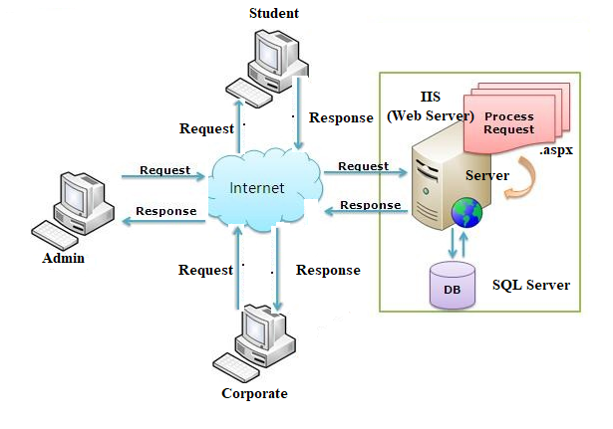

Figure 1.1

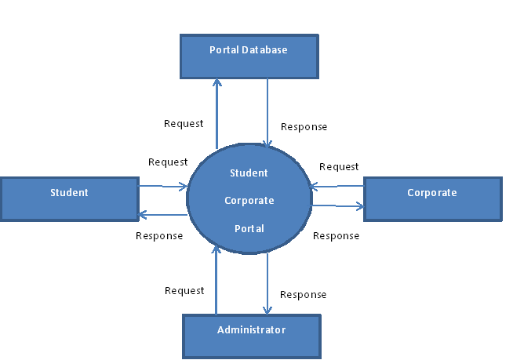

Figure 1.2

**Entity Relationship Diagram(ERD):**

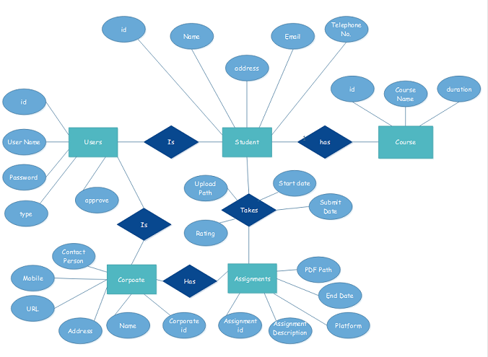

Figure 1.3

**Database Design:**

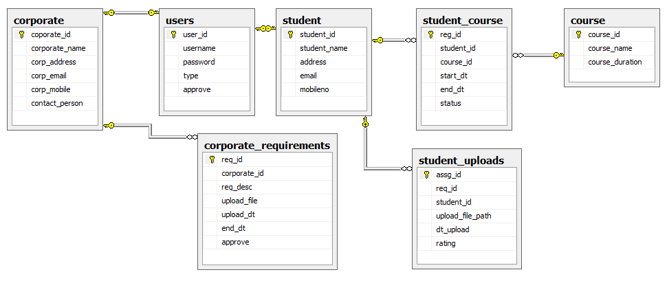

Figure 1.4

**Home Page:**

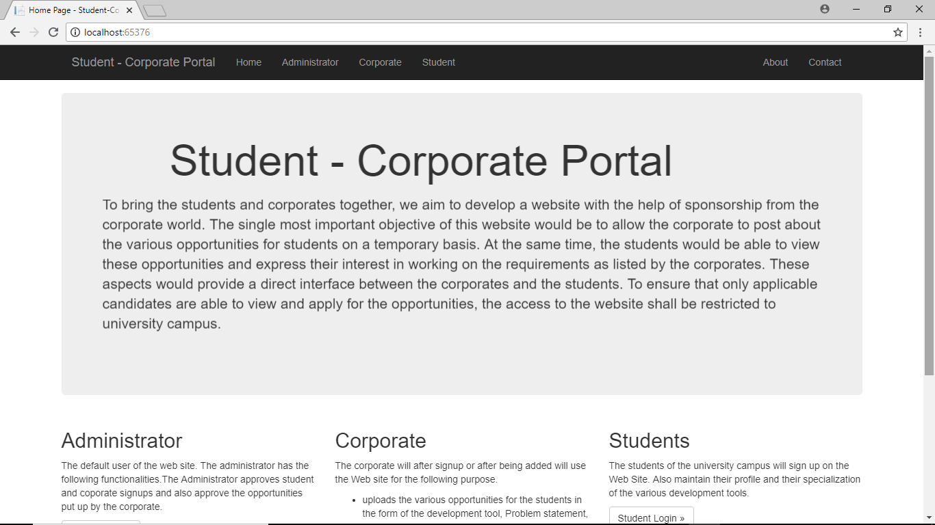

Figure 1.5

**Login:**

A Single login form is designed and user trying to login is passed as a Querystring to identify the user. The administrator is the default user, hence no new sign up for admin. It only displays the new Sign up message for corporate and the student users .This is achieved with the following code.

protected void Page_Load(object sender, EventArgs e)

{

if (Request.QueryString["user"].ToString().Equals("Admin"))

{

RegisterHyperLink.Visible = false;

}

else if (Request.QueryString["user"].ToString().Equals("Corporate"))

{

lblMsg.Text = "New Corporates Sign Up Here";

}

else if (Request.QueryString["user"].ToString().Equals("Student"))

{

lblMsg.Text = "New Students Sign Up Here";

} }

**Student Login:**

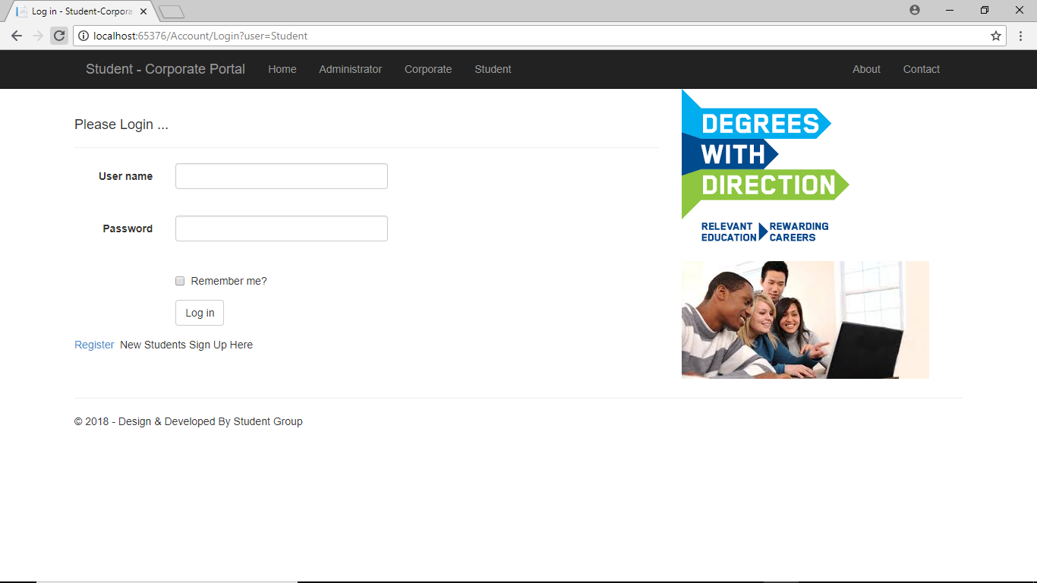

Figure 1.6

**Administrator Login:**

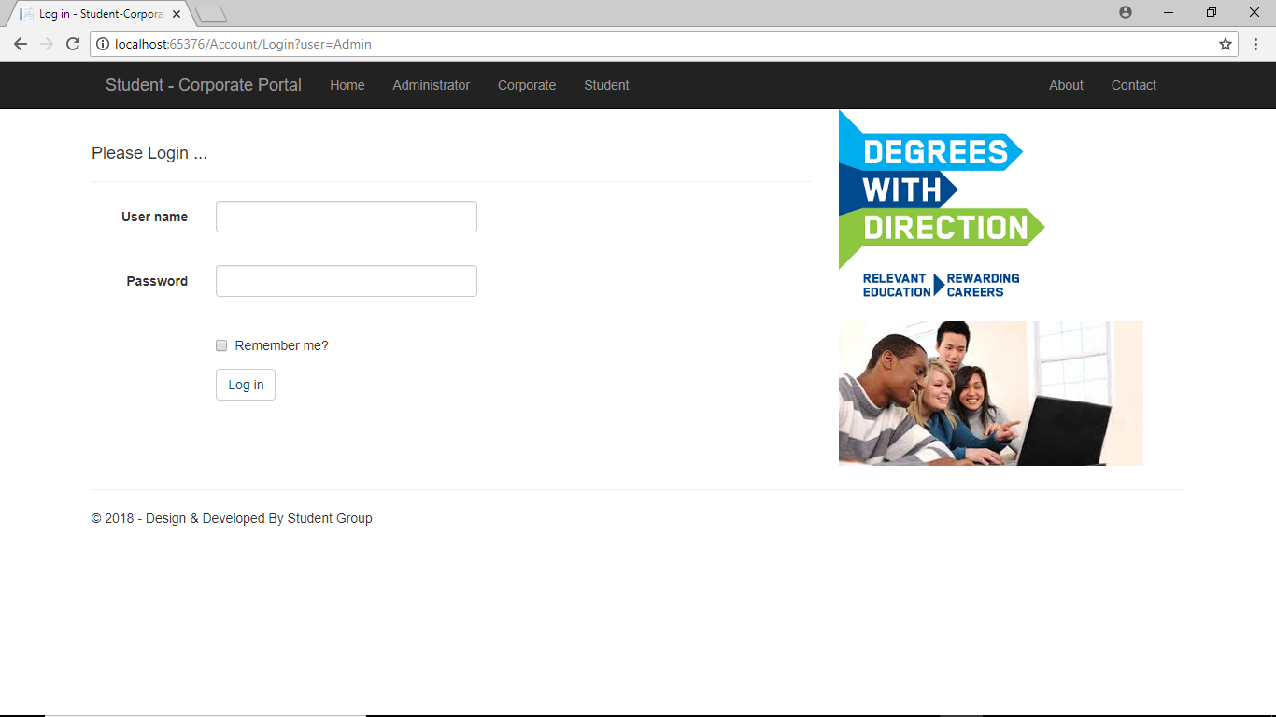

Figure 1.7

**Corporate Login:**

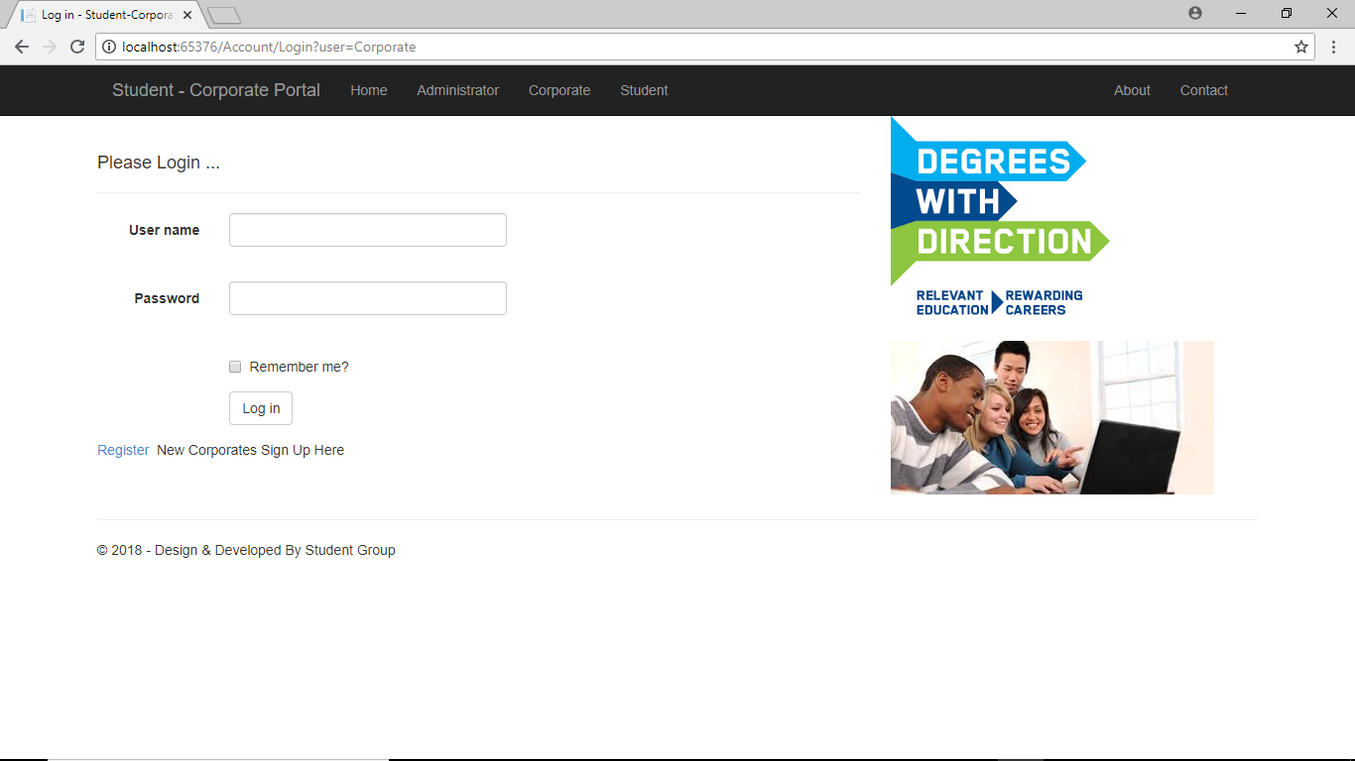

Figure 1.8

**Validation on Login:**

When the user try to directly the login without giving username and password, validation control will display the error message. Following screen demonstrate this.

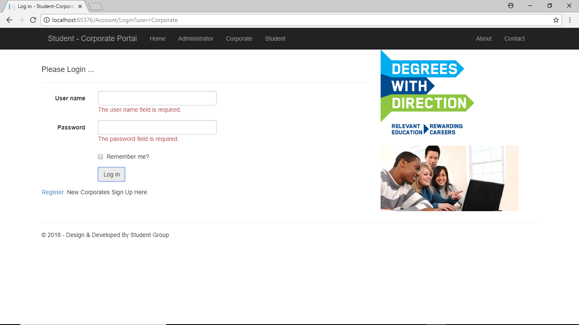

Figure 1.9

**Responsive Site:**

The Application is being developed as a Responsive site as can be seen from screen shots below.

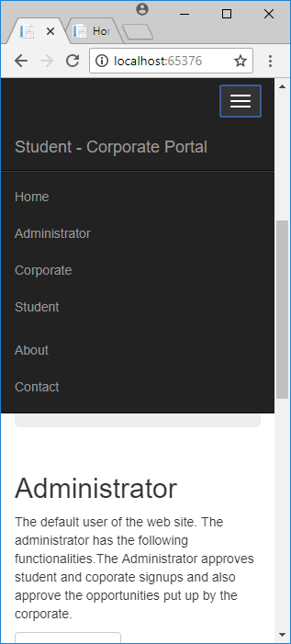

Figure 1.10

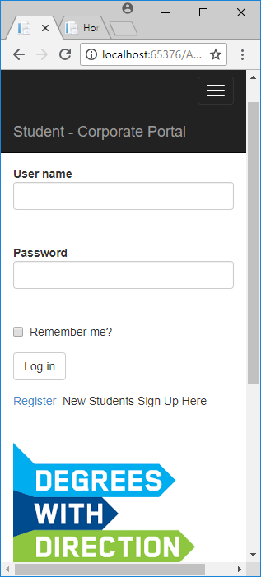

Figure 1.11

**Instructions To run:**

1. Extract the .rar or .zip file.
2. Double Click on ICT70
3. Double Click Visual Studio Solution file name ICT709 Or Right click and select open with Visual studio.net 2017
4. Once the project is opened , run it by pressing F5
5. Click on various Links.

**Web Site Development**

The Website or the Web Portal is designed and development using the following development tools.

**Front End Tool:** C#.net

**Back End Tool:** SQL Server

**Web Technology:** ASP.Net

The Web site develop will have the following users.

1. **Administrator:**   
   The default user of the web site. The administrator has the following functionalities:  
   i) Takes backup of the database as well as restore it in case of failures.  
   ii) Approves or disapprove student Sign ups.  
   ii) Approves Corporate Sign up. It means that the collaborating company or corporate will sign up on the portal. The Administrator will then approve their sign ups. Or the administrator will add the corporate and provide username and password to them.  
   iii) The Administrator will also approve the opportunities put up by the corporate.
2. **Corporate:** The corporate will after signup or after being added will use the Web site for the following purpose:  
   i) uploads the various opportunities for the students in the form of the development tool, Problem statement, deadline , requirements for the various projects undertaken by the corporate.

ii) The corporate will see the student request for the requirements and shall decide to consider it or not. They will update the status.  
ii) Evaluate the student‘s work uploaded on the Web site and provide experts comment to improve their performance.

1. **Students:** The students of the university campus will sign up on the Web Site. Also maintain their profile and their specialization of the various development tools.

i) After Approval by the administrator, the student can login and see the requirements and opportunities put up by the company.

ii) Apply for the opportunities as per their area of specialization. (this will be ensured that the student will be able to apply to jobs of his/her area of specialization only).

iii) Will check the status of interest shown in the opportunities put up by the corporate?

iv) The student will attempt it as per their knowledge and the guidelines provided in the problem statement.

v) Will be able to see performance report of their submitted work.

The Web Portal in general will also maintain the student’s performances in the various opportunities. The negative feedback can be used for the improvement of the student as well as restructuring course design so as to fulfill the requirements of the corporate. The objective is making the student eligible for the corporate world.

**Schedule:**

1. Analysis Of the Project
2. Design Of the project using UML diagrams as follows:
3. Use Case
4. Data flow diagram
5. Entity Relationship Diagram
6. Database Creation in SQL Server as well as creating various required queries and stored procedures.
7. Web Development using Visual Studio.Net 2017, Home Page, and Login for all the three users, sign up for Students and Corporate, Approval Management.
8. Finally all the functionalities will be developed required for the students, corporates and the administrator.
9. Testing and Deployment.