**TP-16**

**A Project Report on**

**jjmmedicines.com**

**Prepared By**

**2143135 Rajan N. Rana**

**2143022 Hardi T. Kadakia**

**2143229 Meet P. Shah**

**Semester 5th of Third Year M.Sc. (CA & IT)**

**(2016-2017)**

**Guided By**

**Pravin L. Umarania**

**Submitted to**



**K.S. School of Business Management**

**Gujarat University, Navrangpura, Ahmedabad-380009**

* Acknowledgement
* The success and final outcome of this project required a lot of guidance and assistance from many people and we are extremely fortunate to have got this all along the completion of our project work. Whatever we have done is only due to such guidance and assistance and we would not forget to thank them.
* We respect and thankful to K.S.S.B.M., for giving us an opportunity to do the project work and providing us all support and guidance which made us completes the project on time.
* We would like to express our gratitude towards Course coordinator Department, **Dr. Kalyani Patel** and Director, **Dr. M.N. Patel**for their kind co-operation and encouragement, which help us in this project.
* List of Figures

Figure 1 Use Case Diagram(User) 21

Figure 2 Use Case Diagram(Admin) 22

Figure 3 Sequence Diagram (User) 23

Figure 4 Sequence Diagram (Admin) 24

Figure 5 Collaboration Diagram(User) 25

Figure 6 Collaboration Diagram(Admin) 26

Figure 7 Activity Diagram(User) 27

Figure 8 Activity Diagram(Admin) 28

Figure 9 Class Diagram 29

Figure 10 State Diagram(User) 30

Figure 11 State Diagram(Admin) 31

Figure 12 Deployment Diagram 32

Figure 13 System Flow Diagram(User) 33

Figure 14 System Flow Diagram(Admin) 34

Figure 15 System Navigation 84

* List of Tables

Table 1 User Table 36

Table 2 Company Table 37

Table 3 Product Table 38

Table 4 Blog Table 39

Table 5 Order Table 40

Table 6 Prescription Table 41

Table 7 Favourite Table 42

Table 8 Feedback Table 43

**Index**

|  |  |  |
| --- | --- | --- |
| Sr. No | Title | Page Number |
| 1. | Introduction | 7 |
|  | 1.1Organization Profile | 7 |
|  | 1.2Project Details | 8 |
|  | 1.2.1Current System | 8 |
|  | 1.2.2Proposed System | 8 |
|  | 1.3Scope | 9 |
|  | 1.4Objective | 9 |
| 2. | Requirement Gathering | 10 |
|  | 2.1Stakeholder | 10 |
|  | 2.2Requirement Gathering Technique Used | 11-13 |
|  | 2.3Consolidated List Of Requirement | 13-14 |
|  | 2.4Project Definition | 14 |
| 3. | Project Management & Planning | 15 |
|  | 3.1Feasibility Study | 15 |
|  | 3.1.1Technical | 15 |
|  | 3.1.2Economical | 16 |
|  | 3.1.3Operational | 16 |
|  | 3.2Hardware Software Requirement | 17 |
|  | 3.3.1Work Breakdown Structure | 18 |
|  | 3.3.2Gantt Chart | 19 |
|  | 3.4Project Model | 20-21 |
| 4. | Analysis & Design | 22 |
|  | 4.1UML Diagrams | 22-33 |
|  | 4.2System Flow Structure | 34 |
|  | 4.3Data Dictionary | 36-43 |
|  | 4.4 User Interface | 44-84 |
|  | 4.5 System Navigation | 85 |
| 5. | Summary | 86 |
|  | 5.1Assumption | 86 |
|  | 5.2Limitation | 86 |
|  | 5.3Conclusion | 86 |
|  | 5.4Future Scope | 87 |

|  |
| --- |
| Chapter-1 |

* 1. Organization Profile



Name of Organization :-JAY JALARAM MEDICINES

11-A, JalaramPlaza, JawaharChowk, Maninagar, Ahmedabad-380 008

About Organization:-

This medical store has been providing the medicines and various other related products to the customer since last 15 years, which is located at the maninagar area. The owner of the store**Mr. Pravinbhai** is self manages the medical records in the file. And they get the medicines and other products from many other company like Abbot India ltd, Aimmaxpharma, etc. It also contain all the type of medicines for the riddhi hospital which is above their store. And all the medicines are sells in reasonable rate so anyone can purchase the medicines from their store.

* 1. Project Details

This project is used mainly for medical store to maintain the detail of medical store and inventory management system of medical shop. Users of this project can also buy medicine online. In which users of project can upload the prescription about the medicines. And the admin can manage the various type of products and admin can add the blog of health care for the users of system.

(1.2.1) Current System

There is no current system available for this organization and currently owner of the organization manages all the inventory and orders through manually process. It involves handling of managing Paper work and files, so this is increasing cost of organization and more effort to manage all files.

(1.2.2) Proposed System

* We are providing a platform on which the users can buy the medicine online and place the order on web application as well as on mobile application platform.

* This will automatic order processing system unlike manual process. Order works more effortless using proposed system and it will reduce cost of managing manual process.
* The software is provided with all the entries to enter any new product, or supplier, or customer can manage its order.
  1. Scope

Scope of the project is limited to managing order processing and stock processing using online system. This system allows organization to manage their customer through online process. Because of online processing now organization have customers without limitation of any region. This system is basically updating the stock details and admin have rights to manages all the things of the system.organization can manage their records in efficient and organized form.

* 1. Objective
* Medical store management software is very needy for medical store. This software helps them maintain day to day transaction in computer.
* This system gives the facility to search medicines.
* Software have feature to upload prescription of medicines which they not found in the system.

|  |
| --- |
| Chapter-2 |

2. Requirement Gathering

In this phase we gathering requirements for the system from different methods.

There are different methods for it and which are as follows:

(2.1) Stakeholder of System:-

There are mainly two types of stakeholder for this system.

1. **Owner of organization**

The owner of organization can manages whole system. He can easily manage the various products. And he have all rights to access system.

1. **Customers**

Customers can buy the various product from our system. She/he can easily add the product to the cart which they want and purchase it.

(2.2)Requirement gathering technique used:-

1) Interview:-

This is the most common technique for gathering requirements. And it’s generally done through face to face.Developers have to sit down with the clients and ask them what they need. The discussion should be planned out ahead of time based on the type of requirements you're looking for. In our system we asked to owner of the organization questions that are as follows:

Q-1) What type of system they looking for?

Q-2) What they plan for their system?

Q-3) What they need in their system?Etc.

### 2) Questionnaires:-

### Questionnaires are much more informal, and they are good tools to gather requirements from stakeholders in remote locations. In this we create the form of questions and give it to the owner of the organization to complete it. So that we easily get the requirements for the system. The Questionnaires are as follows::

1. How many public health medical stores and facilities (including hospitals) does this medical store supply?

a. Medical stores __________

b. Health facilities _________

c. Hospitals ____________

d.Other ________________

### 

1. How many staff are employed full time at the store? ___________
2. How many products are currently in the inventory? _________
3. Does the medical store track information for any of the following? If so, indicate if manual or computerized.
4. Tracking orders Manual Computerized None
5. Tracking deliveries Manual Computerized None
6. Accounting/financial Manual Computerized None
7. Inventory control Manual Computerized None

1. How does the store receive payment for orders from public health facilities?

a. Cheque

b. Cash

c. Bank transfer

d. Other: __________________________________

e. Does not apply

1. How does the medical store communicate with customer?

a. Telephone

b. Computer

c. Cell phone

d. Other

1. Is there any web based system for your organization?
2. Yes
3. No
4. Do you have another branch of your organization?
5. Yes(if yes than give address and detail)

Address______________________________________________________

_______________________________________________________

1. No
2. Does the store use its own transportation to get supplies the medicines to the customer?
3. Yes
4. No
5. How do you manage the stock details?
6. In files
7. In computer

2.3)Consolidated list of requirement:-

1. In this the owner of the organization is looking for the system like netmeds,medcart,etc.
2. The owner of the organization is plan for give us the work to develop the website as well as mobile application for their organization.
3. The owner of the organization is need their system to handles the stock details and medicines should be sale out online.
4. There are no staff for the medical store, owner of the store is himself manages the store.
5. They are selling so many products in there store.
6. Owner of store is tracking the order, delivery, accounting and inventory control manually.
7. Owner of the organization is receiving the payment of an order in the cash.
8. Owner of organization is communicating to the customers through telephone and cell phone.
9. There is no web based system for the organization.
10. There is no other branch of the organization.
11. No they don’t use the transportation to supply the medicines to the customer now!
12. Owner of organization is manages the stock details in the files.

**(2.4) Project Definition:-**

This project will use mainly for medical store to maintain the details of medicine and other medical products. We will develop a project that will enable all the customers to buy the medical products online. In this system of admin is manages many functionality to handles the various features. Admin can manage the product details. The users of the system update their profile and also they can upload prescription about medicines to get medicines early.The system is fully automated.

|  |
| --- |
| **Chapter-3** |

1. **Project management and Planning**

**3.1) Feasibility Study**

## There are 3 major Ares that determine the feasibility of the project . These all areas combine defines whether the project is feasible or not .

**3.1.1) Technical Feasibility:-**

It is considered in terms of technical requirements and their availability in the markets. It determines whether the current level of technology supports the proposed system or not. The technical possibility of proposed system is possible or not. The technical possibility of proposed system is as follows

* The units does process the hardware as well as related software for the projects.
* The proposed system does not require much technical details.
* The current manual working is not so much sufficient.
* It just requires window operating system.
* The Organization has already purchase all the enough devises for latest technology.

Hence, the proposed system is technically feasible.

**3.1.2) Economical Feasibility:-**

The economical feasibility is considered in terms of price.The Organization measure the cost effectiveness of the project. The economical feasibility of the proposed system is asunder:

* The organization is ready to invest in proposed system for latest technology and best result.
* As the personnel and the owner of organization know the computer operating, the organization need not have to appoint any computer operator.

**3.1.3) Operational Feasibility:-**

As the ultimate feasibility, consideration of the proposed system will fulfill the organization’s requirements. It decides whether the proposed system covers all the operational feasibility is as under :

* The proposed system will fulfill the organization’s requirements.
* The proposed system covers all the aspects of current manual system .
* The owner of organization is honestly enthusiastic for the new system.
* It is operate very easily so that the admin can easily use it.

**3.2) Hardware & Software Requirements:-**

* **Software Requirements**

1. Language: - PHP, Android
2. Platform :- PHP 7.0 , Android
3. Frontend:- Notepad++,Visual Studio Code, Android Studio
4. Backend :- MySql , Node.js
5. Web Service:- JSON
6. Technology :- Angular 2.0 , IONIC, Jquery,Bootstrap,HTML 5, CSS6

* **Hardware Requirements**

1. Processor:- Intel Dual Core Processor
2. RAM :- 512 mb and above
3. Hard Disk :- 1 gb and above

3.3) Project Planning

3.3.1)Work Breakdown Structure

3.3.2) Gantt Chart

|  |  |  |  |  |  |  |
| --- | --- | --- | --- | --- | --- | --- |
| **Activities** | **June** | **Aug** | **Sep** | **Oct** | **Nov** |  |
| Project Scope |  |  |  |  |  |  |
| Research |  |  |  |  |  |  |
| ––––Requirement Gathering |  |  |  |  |  |  |
| Analysis |  |  |  |  |  |  |
| Designing |  |  |  |  |  |  |

3.4) Process Model:-

**Reasons to Use Waterfall Model as Process Model:=**

* This model is simple and easy to understand and use.
* Each phase has specific deliverable and a review process.
* In this model phases are processed and completed one at a time.
* Phases do not overlap.
* Waterfall model works well for our project.
* This model is well worked where requirements are well known and well understand.
* Easy to arrange the tasks.

**1) Communication:-**

In this phase we had communicate with the owner of the organization for the system of their organization. We also discuss about the various fact for their system. We are also asked many questions like “Was he gives us the right to develop their organization system?”

**2) Planning:-**

In this phase we will plan for how the system will develop, how the system will meets organization needs, when the system will deliver.

**3) Modeling:-**

In this phase we will go to do paper work for the system design. In this we will draw a system design on the paper. So that we will easily get the flow of the System.

**4) Construction:-**

In this phase we will go to develop the system and add features of the system and we will test our system and get what will the output of the system on the basis of construction of the system.

**5) Deployment:-**

In this phase we will deliver the system to the owner of organization and receive feedback from the owner of the organization.

|  |
| --- |
| Chapter-4 |

4) Analysis and Design

4.1) UML Design

1) Use Case Diagram(User)



Figure 1 Use Case Diagram(User)

1.1) Use Case Diagram(Admin)



Figure 2Use Case Diagram(Admin)

2) Sequence Diagram(User)



Figure 3 Sequence Diagram (User)

2.1) Sequence Diagram(Admin)



Figure 4 Sequence Diagram (Admin)

3) Collaboration Diagram(User)



Figure 5 Collaboration Diagram(User)

3.1) Collaboration Diagram(Admin)



Figure 6 Collaboration Diagram(Admin)

4) Activity Diagram(User)

Figure 7 Activity Diagram(User)

4.1) Activity Diagram(Admin)

Figure 8 Activity Diagram(Admin)

5) Class Diagram



Figure 9 Class Diagram

6) State Diagram(User)

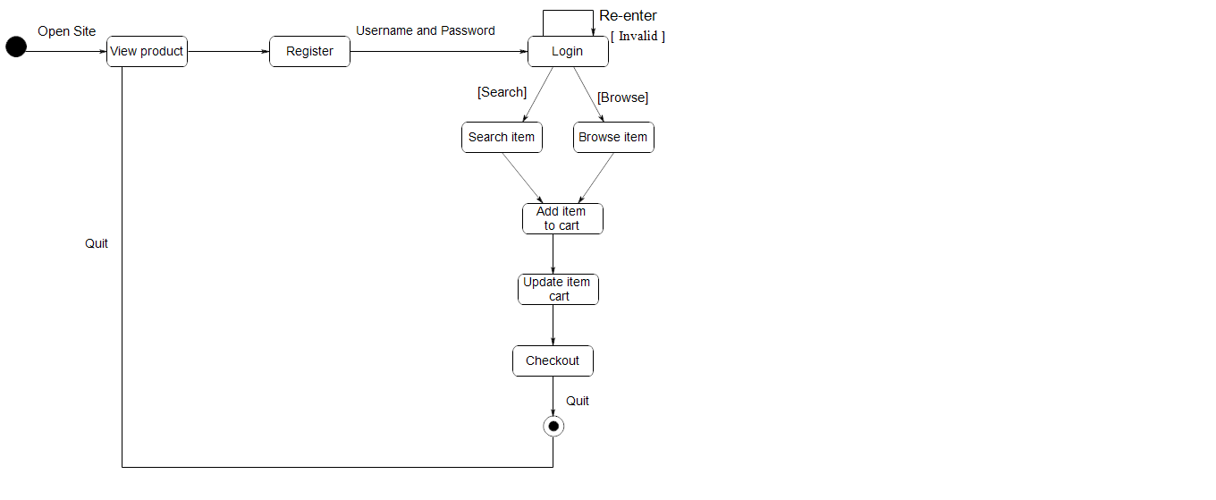

Figure 10 State Diagram(User)

6) State Diagram(Admin)



Figure 11 State Diagram(Admin)

7) Deployment Diagram

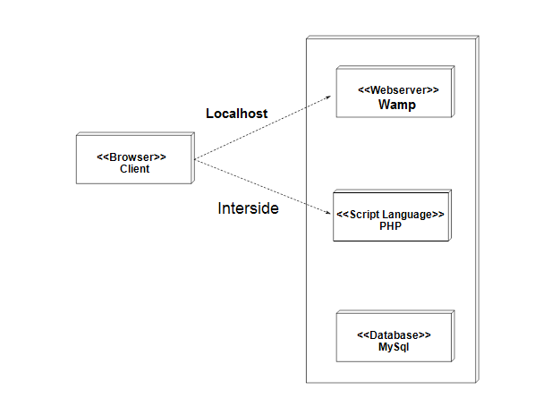

Figure 12 Deployment Diagram

4.2) System Flow Diagram(User)



Figure 13 System Flow Diagram(User)

4.2.1) System Flow Diagram(Admin)



Figure 14System Flow Diagram(Admin)

**4.3) Data Dictionary:-**

**Table Name: - User_Table**

**Description: - Information about the user.**

**Primary key: - user_id**

Table 1 User Table

|  |  |  |  |  |
| --- | --- | --- | --- | --- |
| **Field Name** | **Data Type** | **Size** | **Constraint** | **Description** |
| **Email_Id** | Varchar | 30 | Primary key | Email id |
| **User Name** | Varchar | 30 | Not Null | Name of user |
| **Password** | Varchar | 30 | Not Null | Password of user |
| **Address** | Varchar | 100 | Not Null | Address of user |
| **Area** | Varchar | 30 | Not Null | Area of address |
| **ZipCode** | Int | 6 | Not Null | Zip Code of area |
| **Mobile_No** | Int | 10 | Not Null | Mobile number of User |
| **Gender** | Varchar | 5 | Not Null | Gender of user |
| **Type** | Varchar | 30 | Not Null | Type of user |

**Table Name: - Company_Table**

**Description: - Information about the company.**

**Primary key: - Company_id**

Table 2 Company Table

|  |  |  |  |  |
| --- | --- | --- | --- | --- |
| **Field Name** | **Data Type** | **Size** | **Constraint** | **Description** |
| **Company_Id** | Int | 10 | Primary key | Email id |
| **Company Name** | Varchar | 50 | Not Null | Name of company |
| **Address** | Varchar | 100 | Not Null | Address of company |
| **Contact Number** | Int | 10 | Not Null | Contact number of company |

**Table Name:- Product_Table**

**Description: - Information about the products.**

**Primary key: -Product_id**

Table 3 Product Table

|  |  |  |  |  |
| --- | --- | --- | --- | --- |
| **Field Name** | **Data Type** | **Size** | **Constraint** | **Description** |
| **Product_Id** | Int | 10 | Primary key | Product id |
| **Product_name** | Varchar | 50 | Not Null | Name of product |
| **Product_image** | Varchar | 30 | Not Null | Image of product |
| **Product_price** | Int | 20 | Not Null | Price of Product |
| **Stockonhand** | Int | 20 | Not Null | Stock of product |
| **Company_id** | Int | 10 | Foreign key | Refers to the company detail |

**Table Name:- Blog_Table**

**Description :- Information about the Blog.**

**Primary key: - Blog_Id**

Table 4 Blog Table

|  |  |  |  |  |
| --- | --- | --- | --- | --- |
| **Field Name** | **Data Type** | **Size** | **Constraint** | **Description** |
| **Blog_Id** | Int | 10 | Primary key | Blog id |
| **Blog_Que** | Varchar | 100 | Not Null | Blog question |
| **Blog_status** | Varchar | 10 | Not Null | Status of blog |
| **Answer** | Varchar | 100 | Not Null | Answer of blog question |
| **Email_id** | Varchar | 30 | Foreign key | Refers to the users detail |

**Table Name:-Order_Table**

**Description: - Information about the Order.**

**Primary key: - Order_Id**

Table 5 Order Table

|  |  |  |  |  |
| --- | --- | --- | --- | --- |
| **Field Name** | **Data Type** | **Size** | **Constraint** | **Description** |
| **Order_Id** | Int | 30 | Primary key | Bill id |
| **Order_date** | Varchar | 20 | Not Null | Date of order |
| **Quantity** | Int | 10 | Not Null | Quantity of product |
| **Product_id** | Int | 10 | Foreign key | Refers to the product detail |
| **Email_id** | Int | 30 | Foreign key | Refers to the email detail |
| **Product_price** | Int | 20 | Foreign key | Refers to the product price details |
| **Status** | Varchar | 10 | Not Null | Status of order |

**Table Name:- Prescription_Table**

**Description :- Information about the prescription.**

**Primary key :- Prescription_id**

Table 6 Prescription Table

|  |  |  |  |  |
| --- | --- | --- | --- | --- |
| **Field Name** | **Data Type** | **Size** | **Constraint** | **Description** |
| **Prescription_Id** | Int | 10 | Primary key | Prescription id |
| **Prescription_photo** | Varchar | 100 | Not Null | Photo of prescription |
| **Email_id** | Varchar | 30 | Foreign key | Refers to the email detail |

**Table Name:- Favourite_Table**

**Description :- Information about the Bill.**

**Primary key :- Favourite_id**

Table 7 Favourite Table

|  |  |  |  |  |
| --- | --- | --- | --- | --- |
| **Field Name** | **Data Type** | **Size** | **Constraint** | **Description** |
| **Product_Id** | Int | 10 | Foreign key | Refers to the product detail |
| **Product_name** | Varchar | 50 | Foreign key | Refers to the product detail |
| **Product_price** | Int | 20 | Foreign key | Refers to the product price detail |

**Table Name: - Feedback_Table**

**Description: - Information about the Bill.**

Table 8 Feedback Table

|  |  |  |  |  |
| --- | --- | --- | --- | --- |
| **Field Name** | **Data Type** | **Size** | **Constraint** | **Description** |
| **Email_id** | Varchar | 30 | Foreign key | Refers to the users detail |
| **Description** | Varchar | 100 | Not Null | Contact description |

**4.4) User Interface:-**

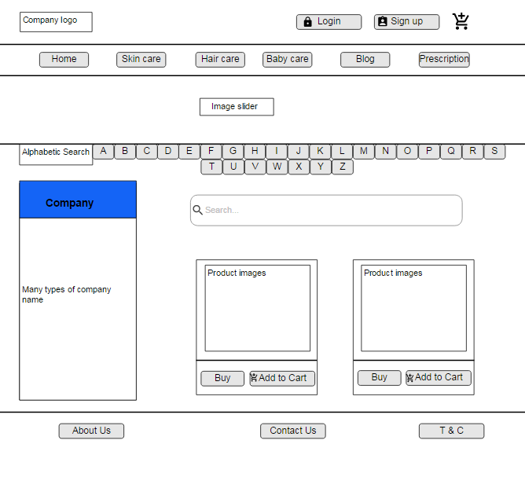

Home page of website

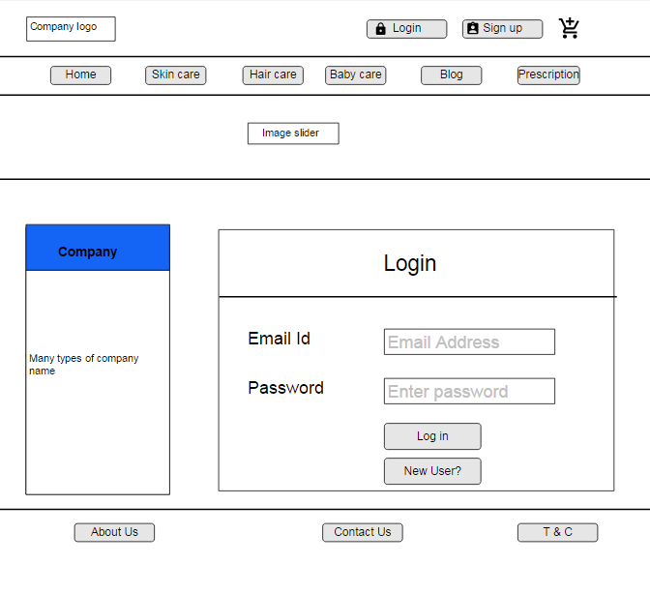

Login Page of website

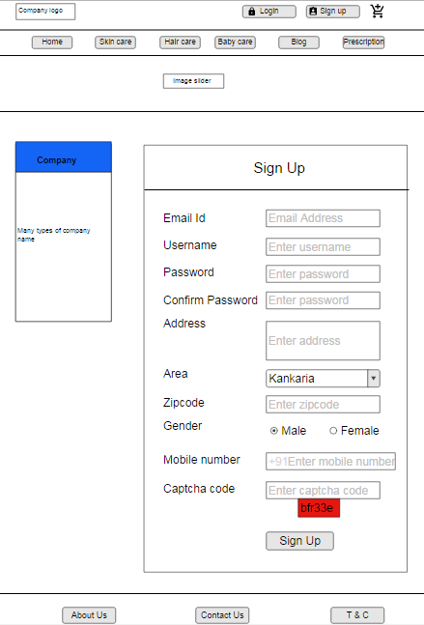

Sign up form of website

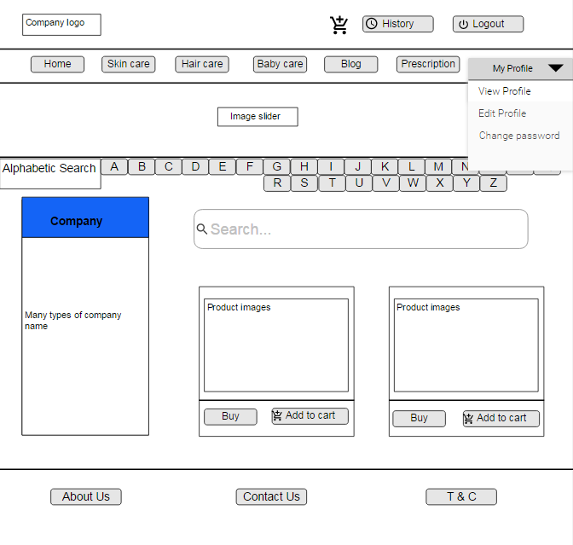

User site of website

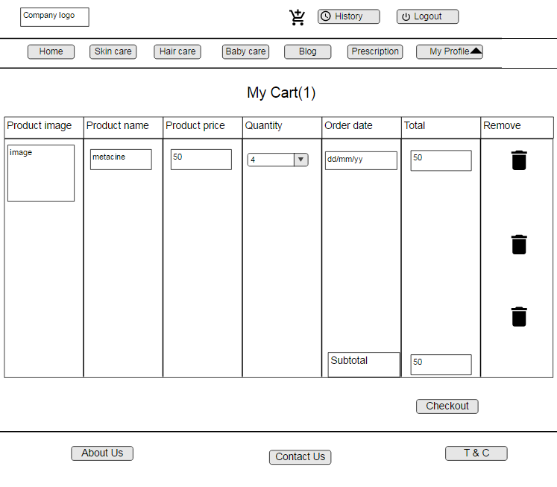

If user clicks on add to cart

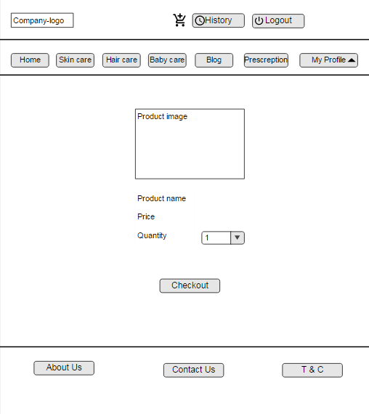

If user clicks on buy button

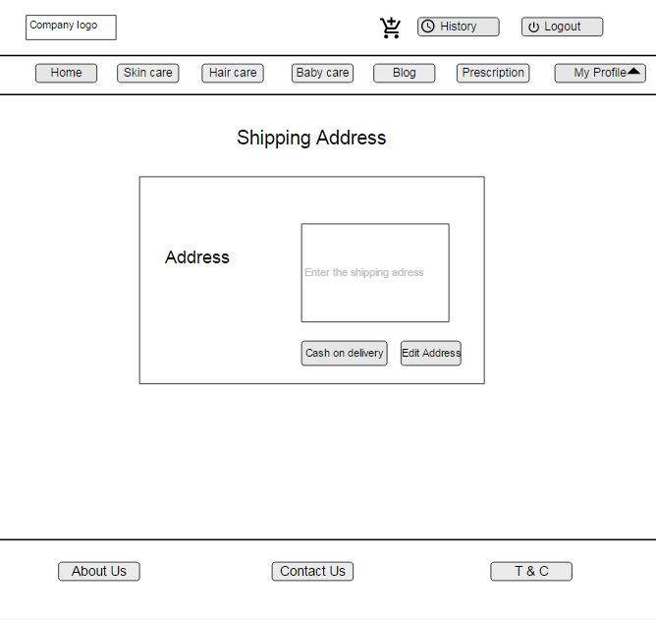

If user clicks on checkout than shipping address Form

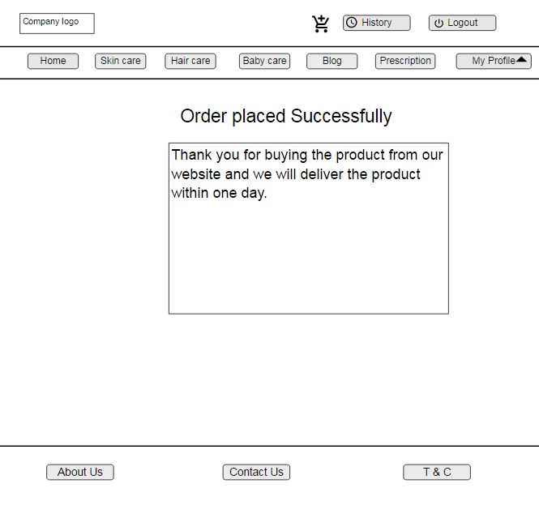

If user clicks on cash on delivery than Order placed successfully Form

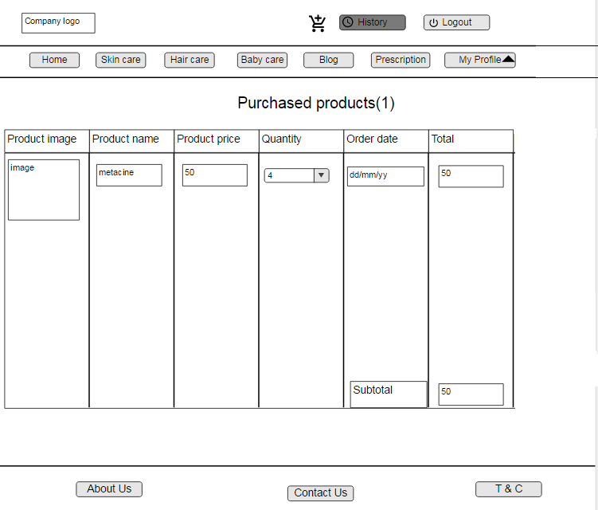

If user clicks on history



If user clicks on the my profile on website

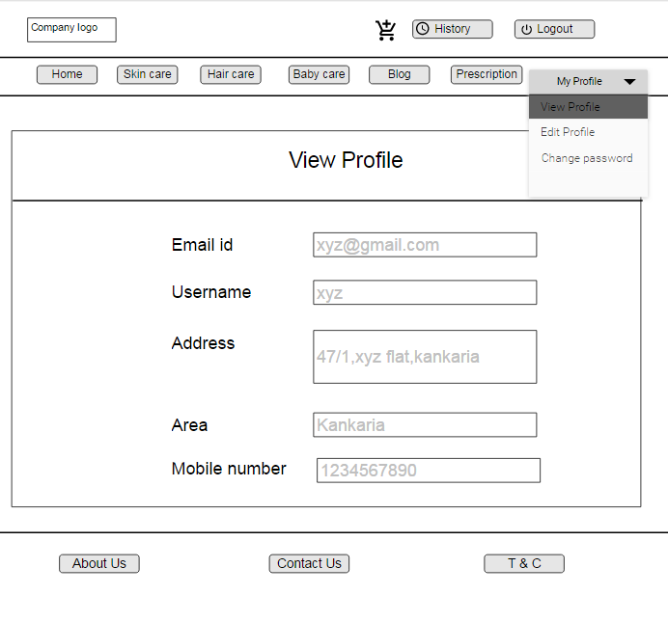

If user clicks on the view profile

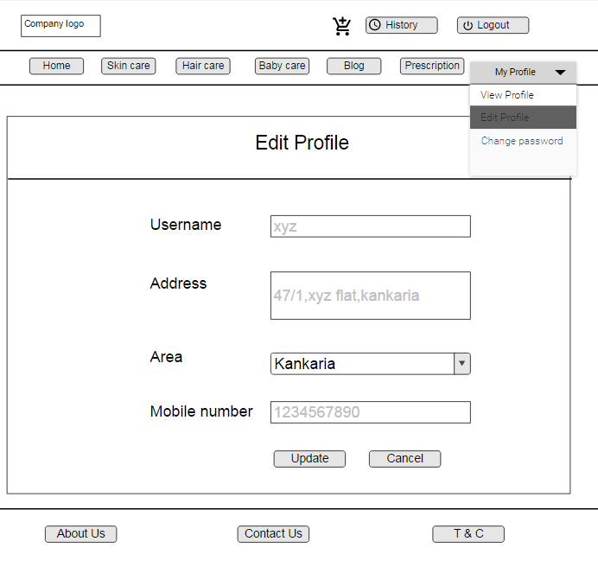

If user clicks on edit profile

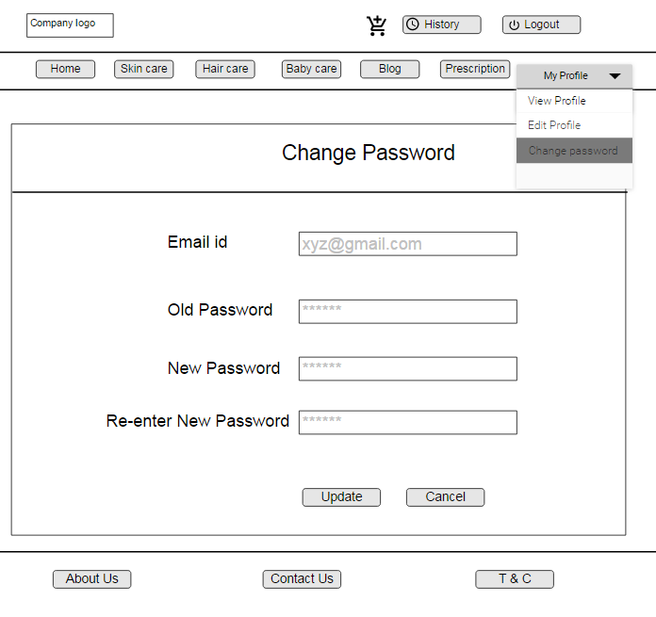

If user clicks on the change password

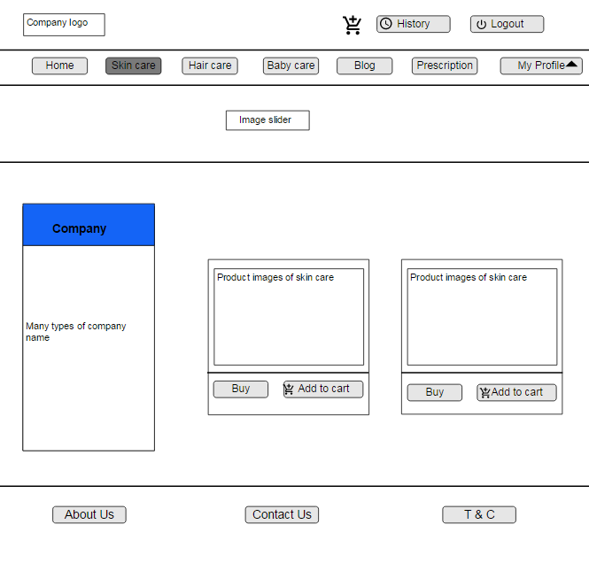

If user clicks on skin care

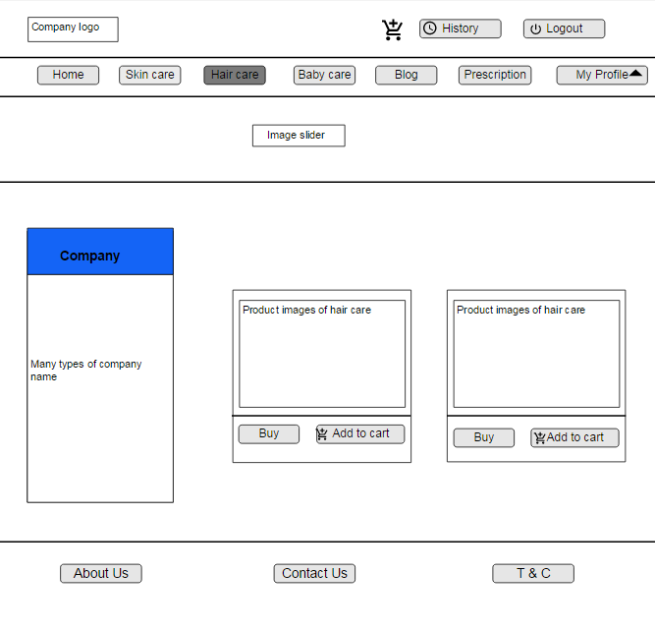

If user clicks on hair care

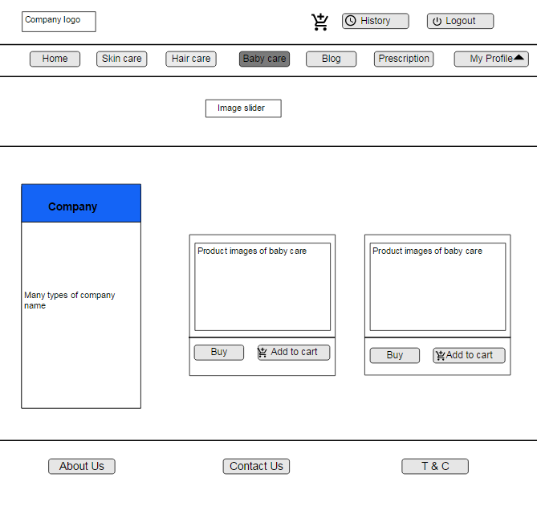

If user clicks on baby care

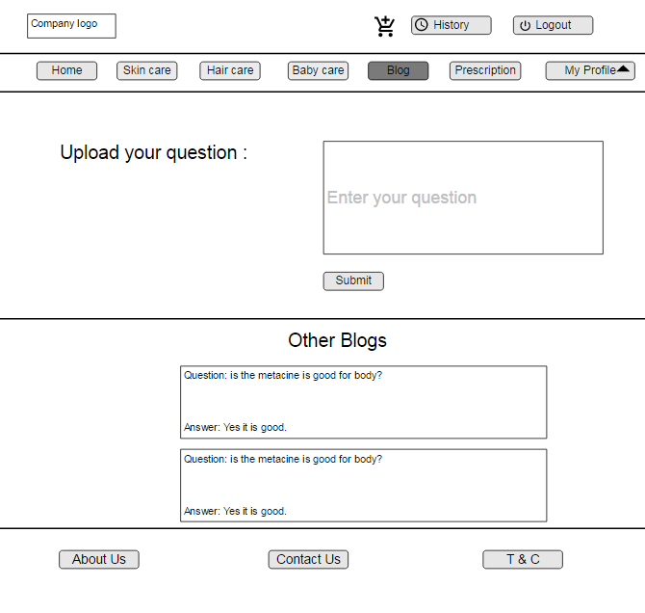

If user clicks on blog

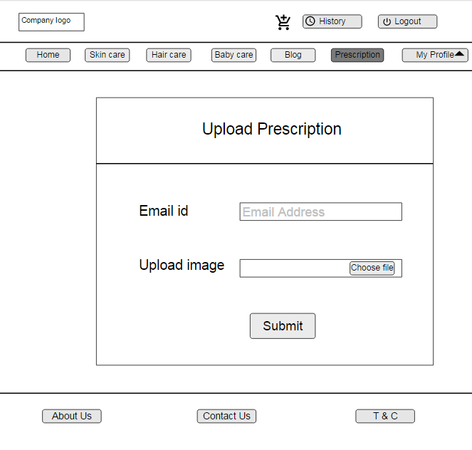

If user clicks on prescription

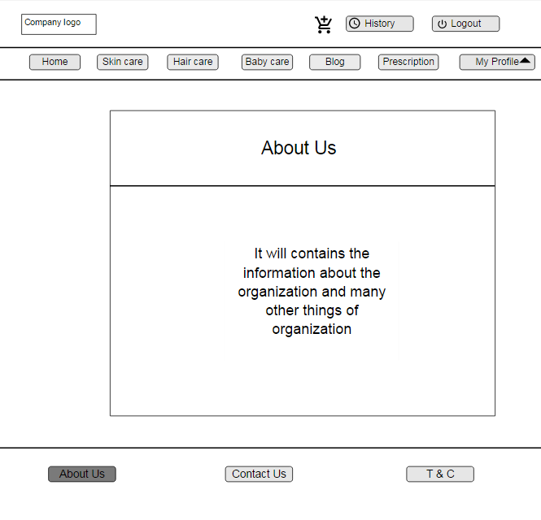

If user clicks on about us

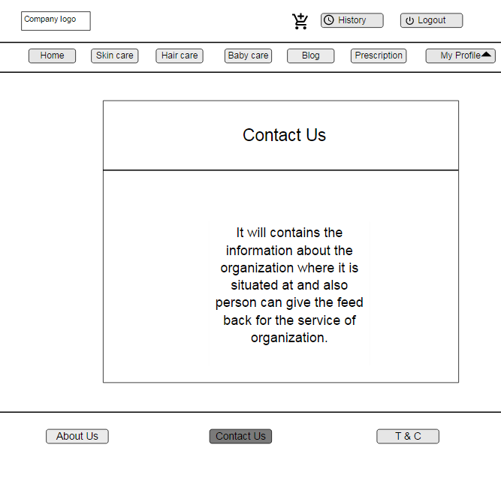

If user clicks on contact us

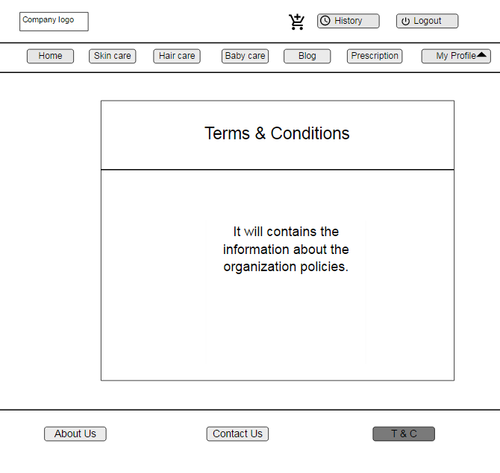

If user clicks on terms and condition

* Application Interface

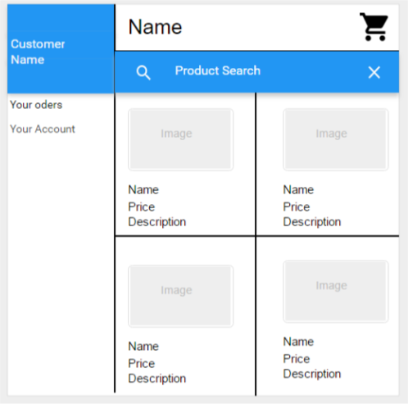

Home page of application

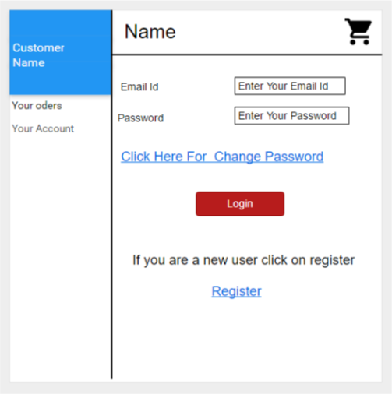

Login application

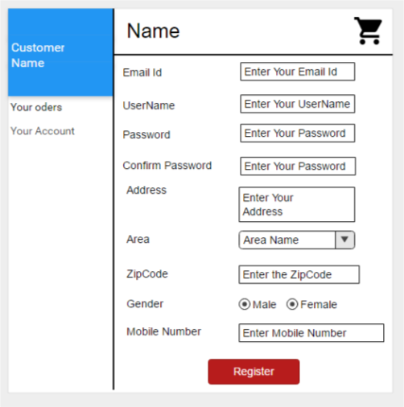

Register of application



Redirect to user site

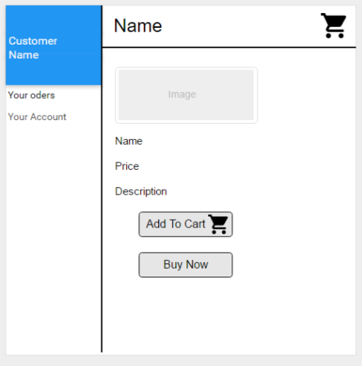

If user click on particular product

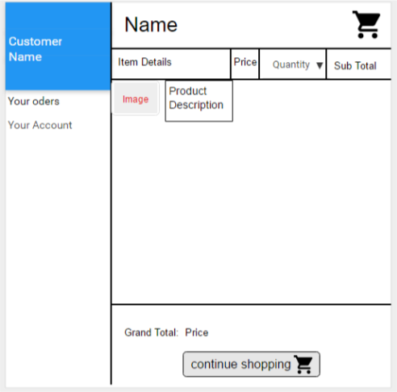

Cart of the user

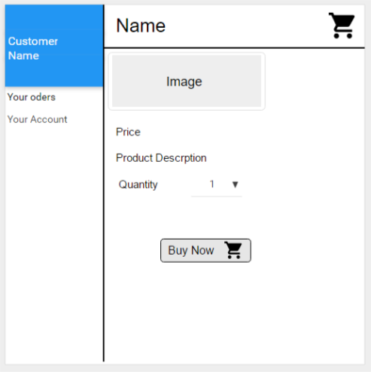

If user clicks on buy button

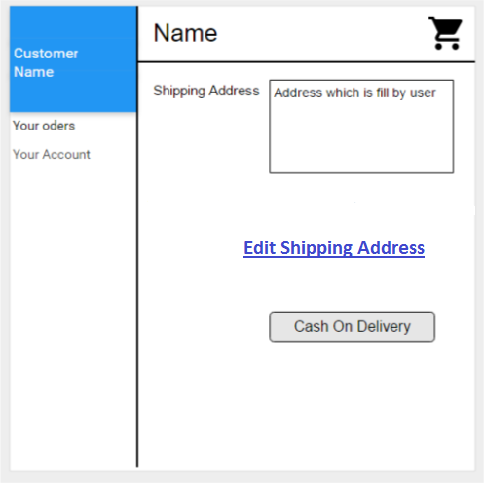

To fill up shipping details

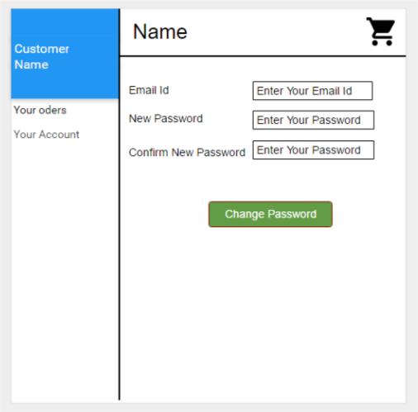

If user want to change the password

* Admin Interface

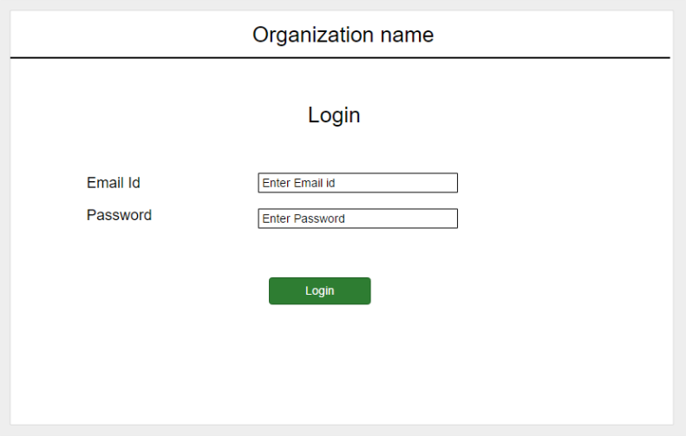

Login page

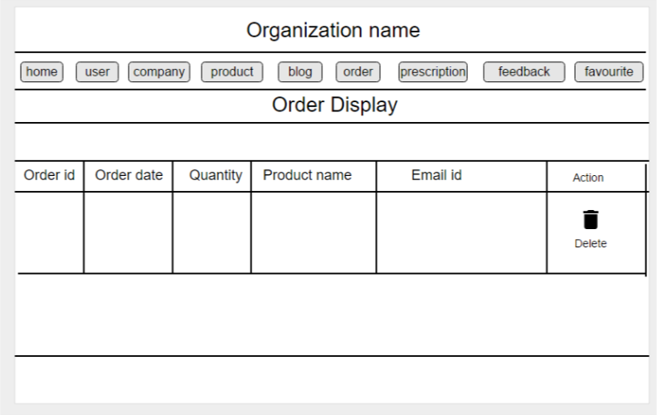

Admin site

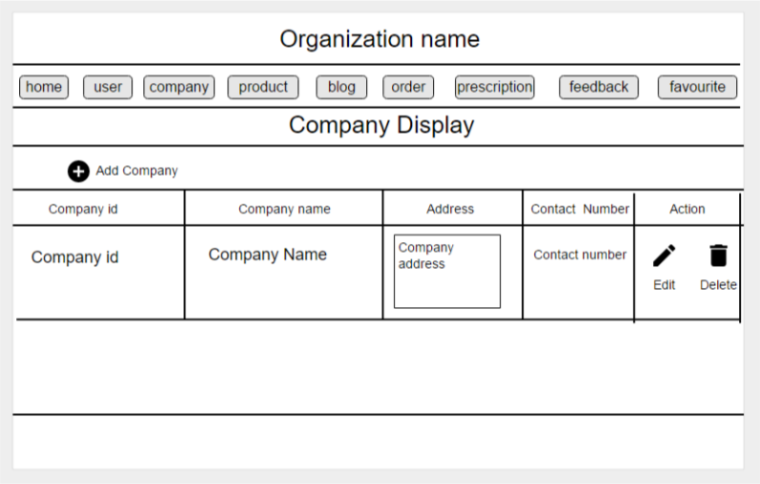

If Admin clicks on company

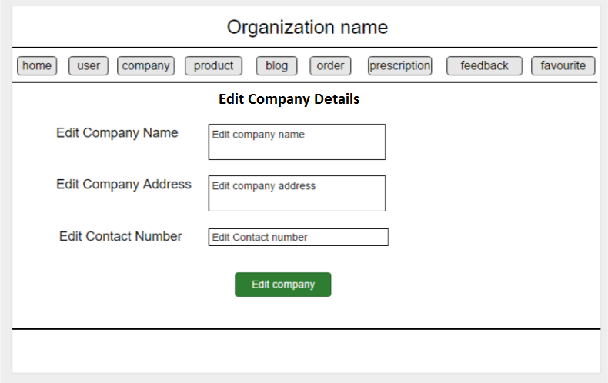

If admin want to edit the company

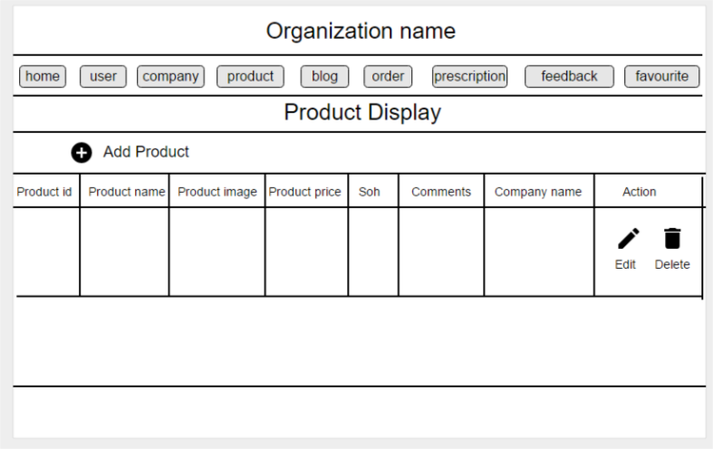

If admin clicks on Product

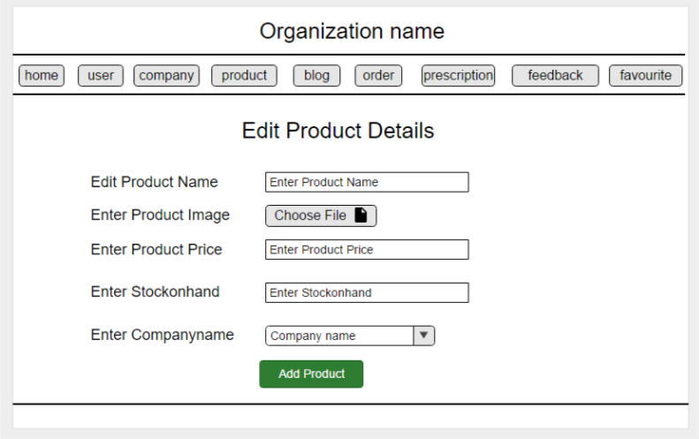

If admin clicks on Edit Product

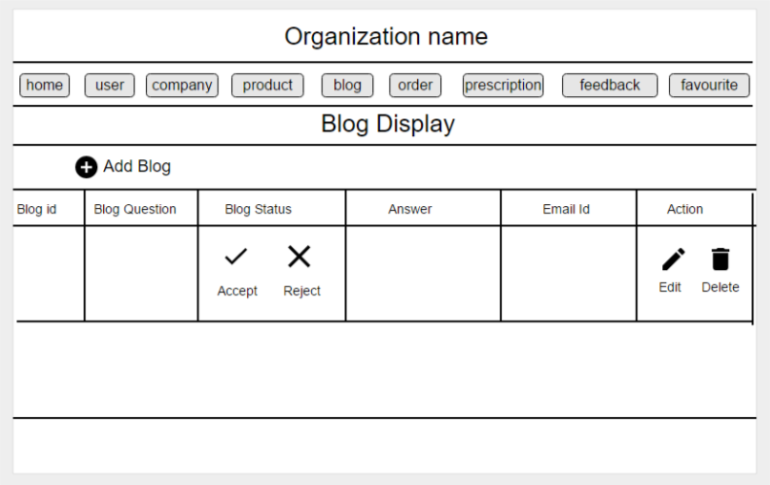

if admin click on Blog

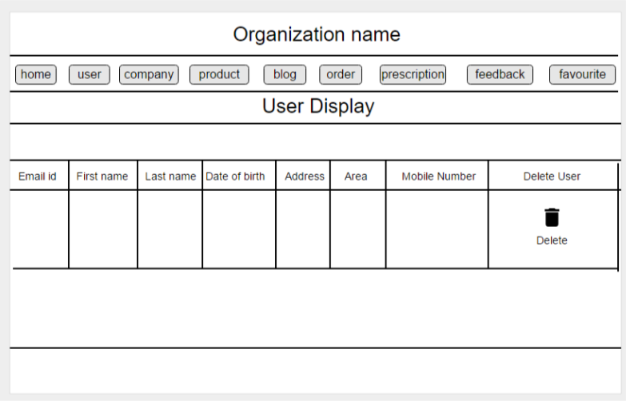

If admin click on User Display

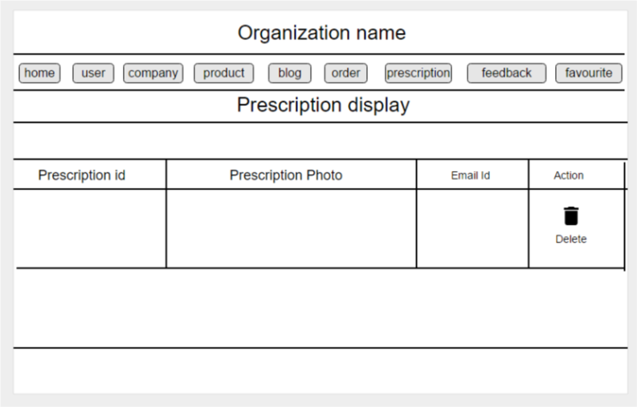

if admin prescription display

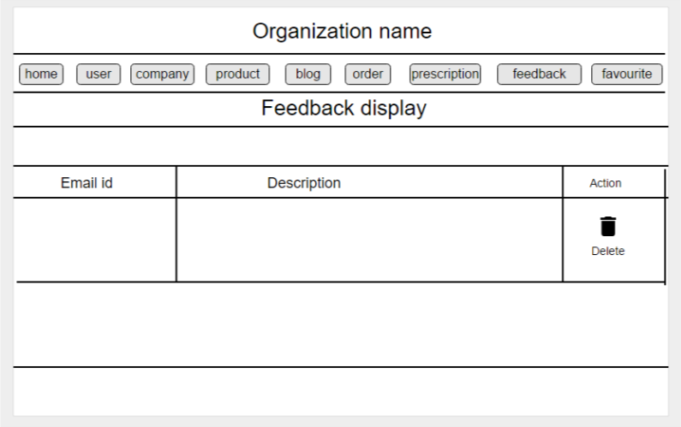

If admin click on feedback

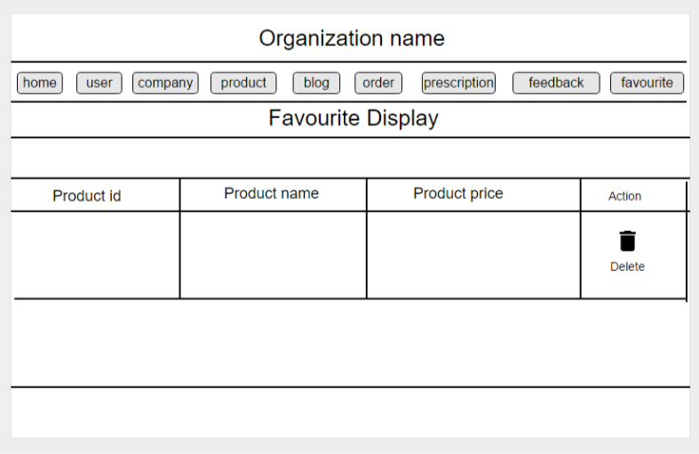

If admin click on favourite

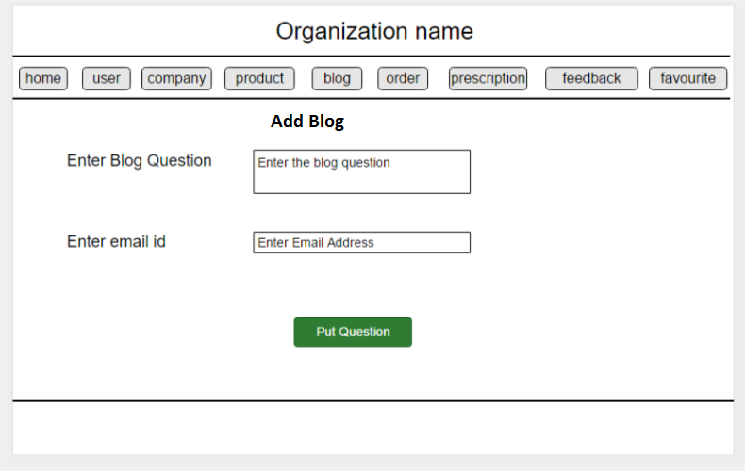

If admin click on add blog page

4.5) System Navigation:-



Figure System Navigation

|  |
| --- |
| Chapter-5 |

5) Summary

5.1) Assumptions:-

* + We assume that the system which will prepare by us is easy to use for all end users.
  + We assume that the owner of the organization will able to maintain the system very easily.
  + We assume that all the features of the system will be work properly in future.
  + We will implements cash on delivery when user give order.

5.2) Limitations:-

* The system will not be requiring internet because it will be host locally.
* Without internet we will not able to login from other ways like login with google, login with facebook, etc.

5.3) Conclusion:-

* This system is only useful to the owner of the organization because other organization can not contain the same information as this organization.
* End users will able to put their order very easily and also they can easy to use system without any confusion.

5.4) Future Scope:-

* In future we will able to host the system online.
* We will also add the various features like login with google, login with facebook, etc.
* We will implement the payment gate ways for ease of pay.

Bibliography

Books:-

1. HTML DHTML JavaScript

By Ivan Bayross

1. Analysis & Design of Information

By James A Senn

1. SOFTWARE ENGINEERING A practitioners’s Approach

By Roger S. Pressman

Web Sites:-

1. [www.google.com](http://www.google.com)
2. [www.w3schools.com](http://www.w3schools.com)
3. [www.medkart.in](http://www.medkart.in)
4. [www.**apollopharmacy**.in](http://www.apollopharmacy.in)
5. [www.netmeds.com](http://www.netmeds.com)