**TAKING AIM AT STUDENT LEARNING:**

**Assessment in the Division of Student Life**

**WHAT ARE LEARNING OUTCOMES?**

Goals that describe “the knowledge, skills, attitudes, and habits of mind that students take with them from a learning experience” (Suskie, 2009, p. 75).

**HOW DO I WRITE LEARNING OUTCOMES?**

Follow the SWiBAT formula: **S**tudents (who __________) **wi**ll **b**e **a**ble **t**o __________. Below are some examples from the Division of Student Services:

*Students will be able to successfully discuss accommodation needs with their instructors.*

*Students who work as intramural officials will be able to demonstrate appropriate conflict resolution skills in an emotional environment.*

*Students who participate in The Path will be able to identify at least two academic support resources on campus.*

You can also indicate your assessment method in the learning outcome, as shown below:

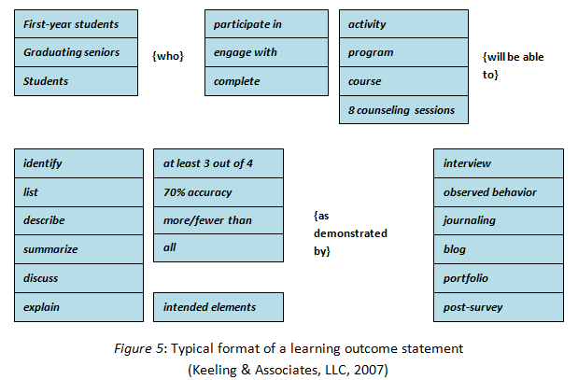

**WHAT ARE THE CHARACTERISTICS OF GOOD LEARNING OUTCOMES?**

Learning outcomes should:

* Align with department, division, and institution goals
* Describe a behavior that is:
  + Meaningful
  + Specific
  + Measureable
  + Attainable
* Describe a single behavior
* Describe knowledge, skills, attitudes, and habits of mind (i.e., learning, not something else)



**KEY POINTS ABOUT ASSESSMENT:**

It all starts with goals – What are you trying to accomplish with the program, course or service? How will you know if you’ve met your goals?

Assessment takes time – but surely it doesn’t take any more time than working aimlessly without a clear direction of where you want to end up.

Focus on what’s important. Assess things that you care about and that you are in a position to change.

Remember, help is available.