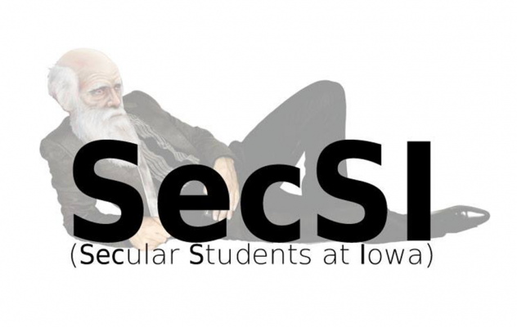

**Author Sean Faircloth to Speak on Social Justice Benefits of Church-State Separation**

IOWA CITY, IA – Noted author Sean Faircloth will speak September 17 at the Iowa Memorial Union on the opportunity for American voters to restore essential liberties to which all citizens are entitled based on the principle of separation of church and state envisioned by the nation’s founders.

Faircloth’s program, entitled *The Pursuit of Social Justice through Secular Government,* reveals how religious bias negatively affects religious and non-religious Americans in a wide range of legal areas including marriage rights, medical research, end-of-life choices, and many others, and proposes a specific, practical plan to return America to its secular roots.

Bill Nye the Science Guy said Faircloth’s 2012 book, *Attack of the Theocrats: How the Religious Right Harms Us All – And What We Can Do About It,* “makes a compelling case for people everywhere to steadily reestablish Thomas Jefferson’s fundamental idea and keep religions out of politics.”

Faircloth, an attorney, served in the Maine legislature for ten years, where he spearheaded over thirty laws, many pertaining to children’s and women’s rights. He served on the Judiciary and Appropriations Committees, and was elected Majority Whip in his last term.

Doors open at 7 p.m. to the IMU Main Lounge, 125 N. Madison St., Iowa City. Admission is free. The event is hosted by Secular Students at Iowa, a student organization at the University of Iowa, and cosponsored by the Unitarian Universalist Society of Iowa City.

**About the Organizers**

Secular Students at Iowa (SecSI) is a recognized student organization at the University of Iowa. The group’s core principles are advocacy, community, education, and service. <http://secularstudents.org.uiowa.edu/>

The Unitarian Universalist Society of Iowa City was founded in 1841. It is a diverse spiritual community that draws inspiration from a wide variety of faiths as well as reason and personal experience, and that emphasizes social action. <http://uusic.org/>