# General Paired Coordinate Graphs & Time Series User Manual

## File Requirements

Please have the data in the CSV file sorted by class number. Also Make sure the file is correctly formatted first, for example open it first to see if it needs to get reformatted, as files moving around different machines may be formatted differently.

## Loading a File

Once the program has been opened, a file must be loaded. In the upper left hand corner, open the File menu and select Open. From the file selection dialog, select a .csv file. Once a file has been opened, the program will default to the Seperated CPC view. Other views can be accessed via the side panel.

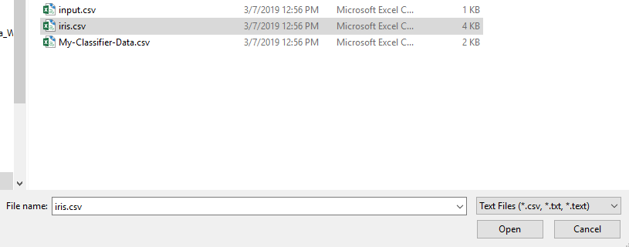

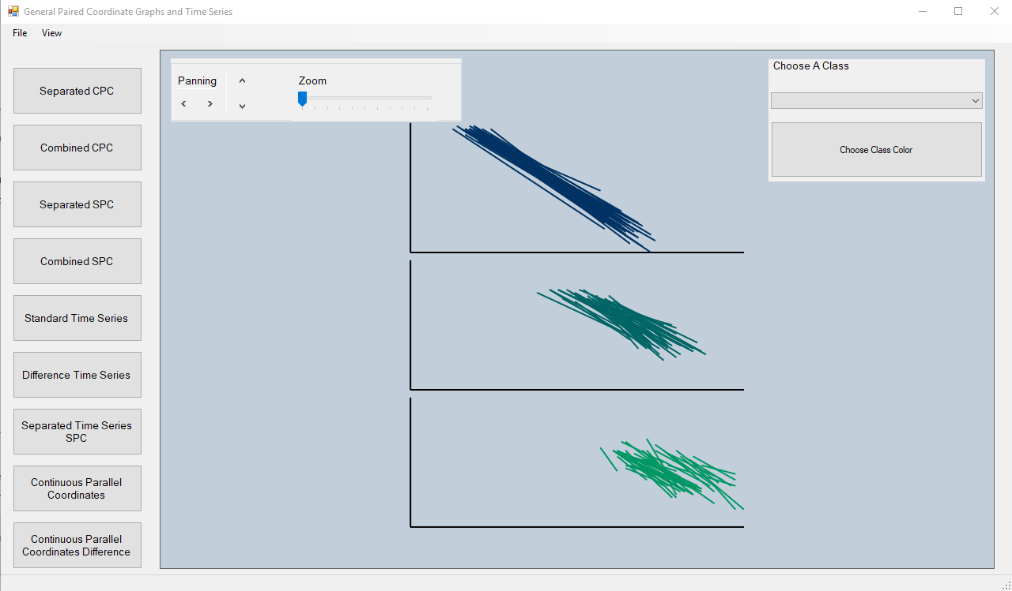

## Pan & Zoom

On any graph, the view can be adjusted via the panel on the top left of the viewport. The view slider allows you to adjust the scale of the graph in the viewport, while the panning buttons allow you to scroll around the entirety of the graph.

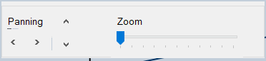

## Changing Colors

In the top right of the viewport there is the option to change the color of each class in the data set. Select the class you wish to modify via the drop-down menu, then push the button. In the pop-up window you can select from one of the predefined Windows colors or click on one of the swatches in the custom color palette and press “Define Custom Colors” to replace it with your own.

