Summary

The purpose of this document is to communicate how to correctly setup up a FeatureCAM document to mimic what is found on the CAE computers.

***NOTE: Do this before you start making your part!***

Network Mapping

You must map the Student Shop CAD/CAM network drive (you will only have to do this one time). Follow the steps below in order to map the drive.

1. Click your ***RIGHT*** mouse button over the Windows logo in the lower left corner of your screen and click your ***LEFT*** mouse button on Open Windows Explorer. This will bring up Windows Explorer (not to be confused with Internet Explorer which is your web browser).  
   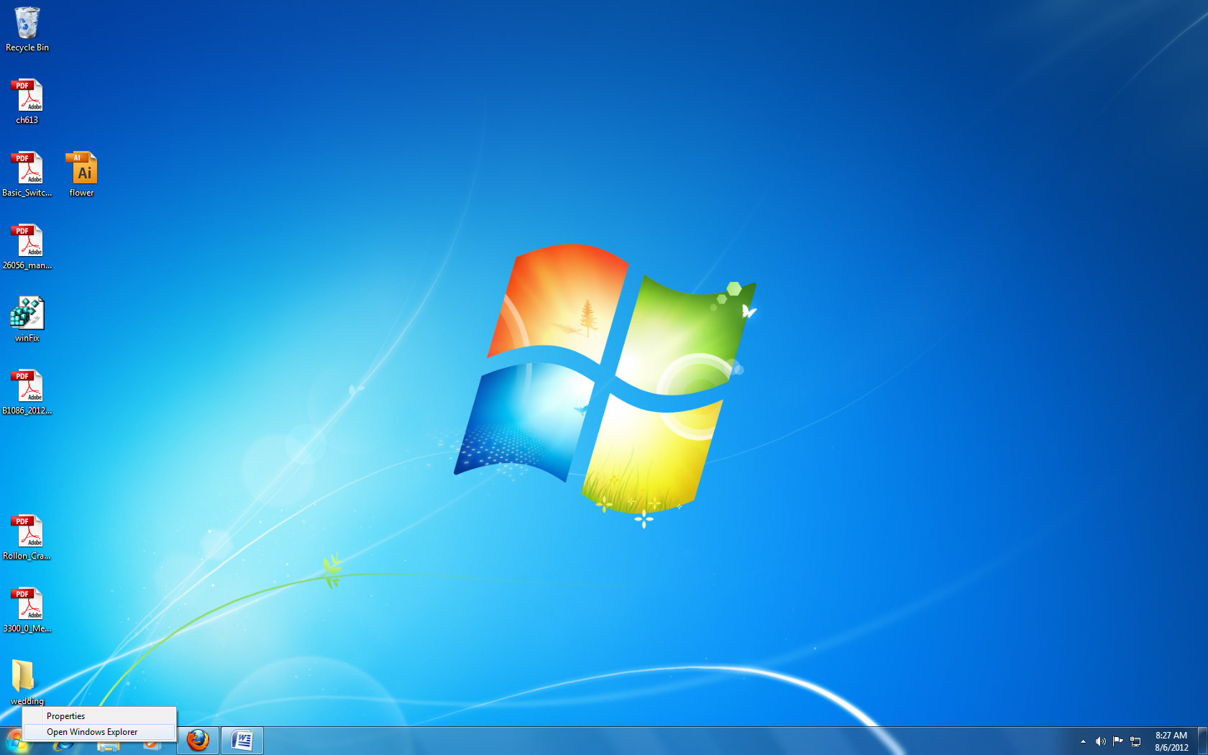
2. Click your ***RIGHT*** mouse button over the word Network in the left pane of the window of Windows Explorer and click your ***LEFT*** mouse button on the word Map network drive… This will bring up the Map Network Drive dialog box.  
   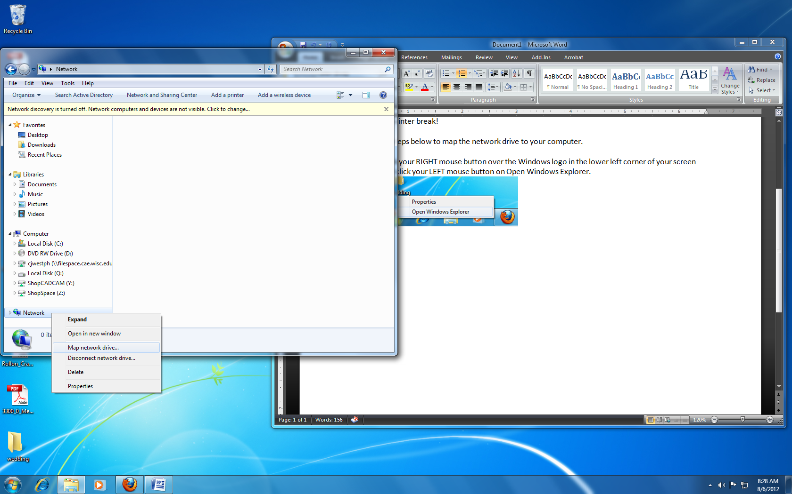
3. The default drive letter will probably be ‘Z:’ if you have no other drives maps, otherwise it will probably be ‘Y:’. It is my recommendation to choose the letter that is closest to the end of the alphabet. On the screen shot below, it says X: because there are network drives already mapped to Z: and Y:. In the folder text box, type in the following:  
   \\filespace.cae.wisc.edu\groups\dept\shopcadcam  
   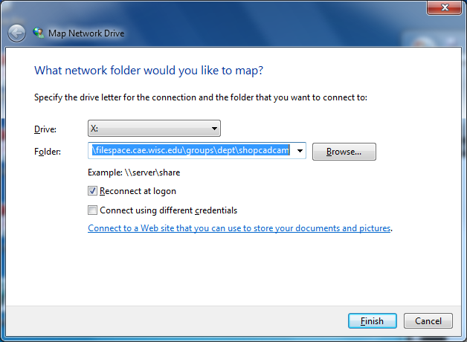
4. Click the Finish button and a Windows Explorer window will show up with the contents of the ShopCADCAM drive displayed.

Setting the Post

FeatureCAM will default to a post within in the programs directory. You’ll want to use the post that was setup by the Student Shop so you’ll have to navigate to the location of the correct post. Follow the steps below to navigate to the correct post.

1. Go to Manufacturing 🡪 Post Process…
2. This will open up the Post Options window in which you will want to click on the Browse button.
3. This will open up a browsing dialog box in which you will want to navigate to the following path: Z:\shopcadcam\FeatureCAM2012\Posts\Mill\ and choose between either PTRAKMX3 for 2D machining on the Eisen mill and DPMS3 & S5 for 3D machining on the DPM.
   1. To get to the Mill Post folder, first click on the Computer icon on the left side of the window
   2. Scroll down and under Network Location open the shopcadcam drive
   3. Open the FeatureCAM2012 folder
   4. Open the Posts folder
   5. Open the Mill folder
   6. Click on one of the post files and click the Open button.
4. Press OK which will close the Post Options window.

Setting the Machine Configuration

FeatureCAM will also default to a general machine configuration file that sets some default values that the Student Shop has changed. You must use the machine configuration files that are provided by the Student Shop. These files are located in the same network directory. The steps below outline how to change the machine configuration.

1. Go to Manufacturing 🡪 Machining Configurations…
2. This will open the Machining Configurations dialog box. At the bottom of the box, the initial configuration for new documents should be set to COE_StudentShop. If it is, you are all set! If it is not, please continue with these steps.
3. Click the Import button.
4. This will open a browsing dialog box where you will want to navigate to the Machine_Configs folder. The path for that is: : Z:\shopcadcam\FeatureCAM2012\Machine_Configs.
5. Select the COE_StudentShop file and click open.
6. A message dialog box will open stating that it has successfully done what you told it to do. Press OK.
7. If the ‘Initial configuration for new documents’ is not set to the COE_StudentShop, set it by click on the drop down menu and selecting it.
8. Select the COE_StudentShop configuration file and press OK to close the Machining Configuration dialog box.