New Bugs 3/22:

When we are adding a new video, the home page featured videos are distorted.

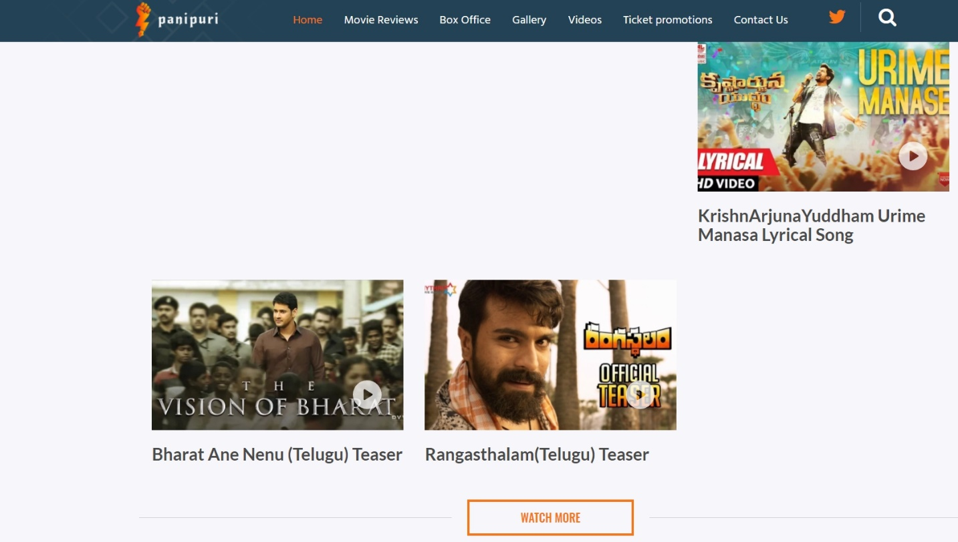

2. When I select movie Review language as Telugu in Wordpress. It is not reflected in Website. It is shown as English

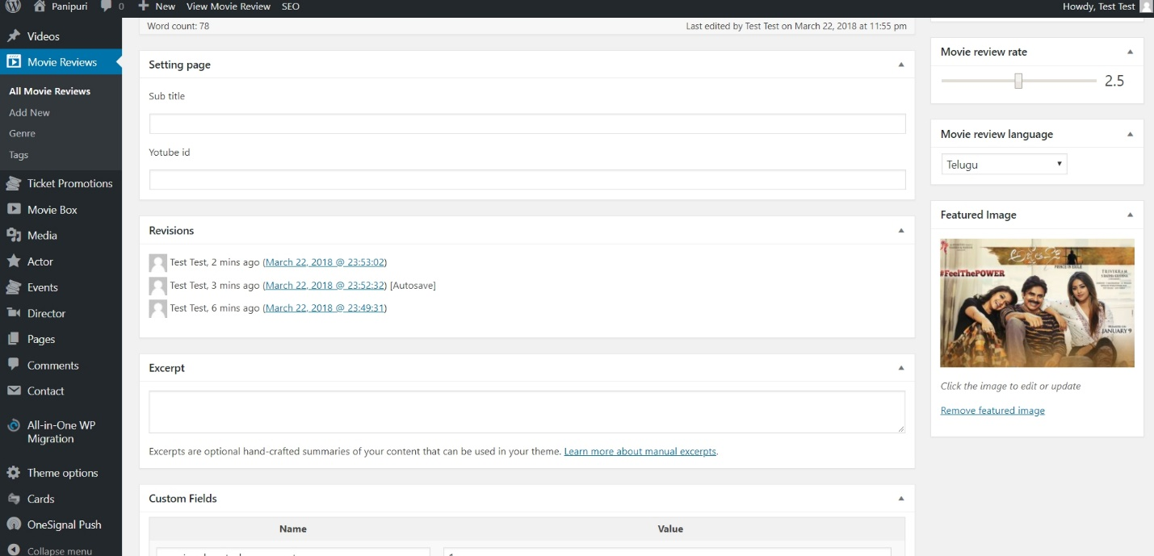

I Kept this movie review Language-Telugu and Rating 2.5, But it’s showing like this on website

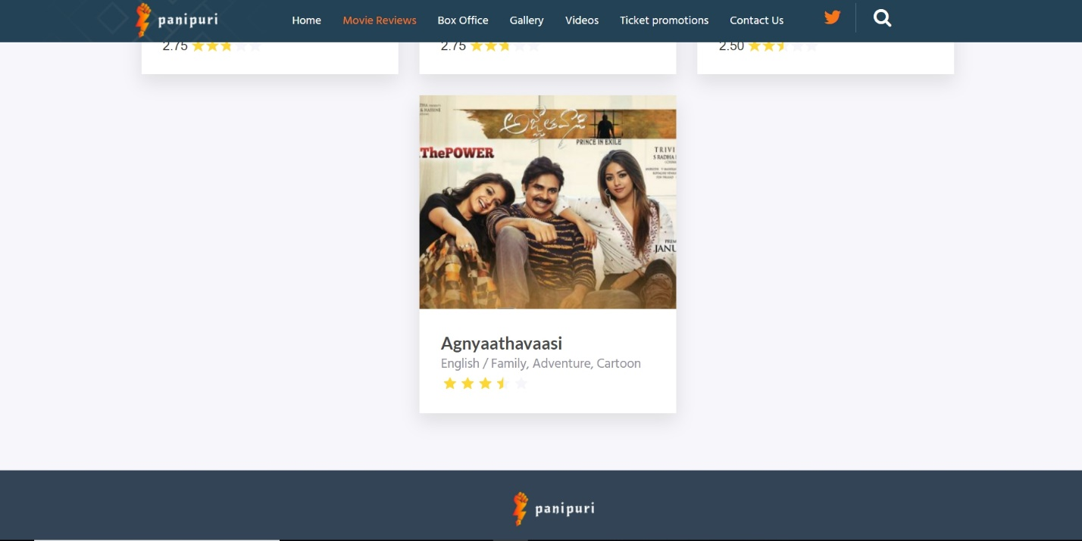

If you see this page, Click is not working, Language is different and rating is different.