1. Upcoming Releases is not sorted by the date. It should automatically sort by the recent date first.

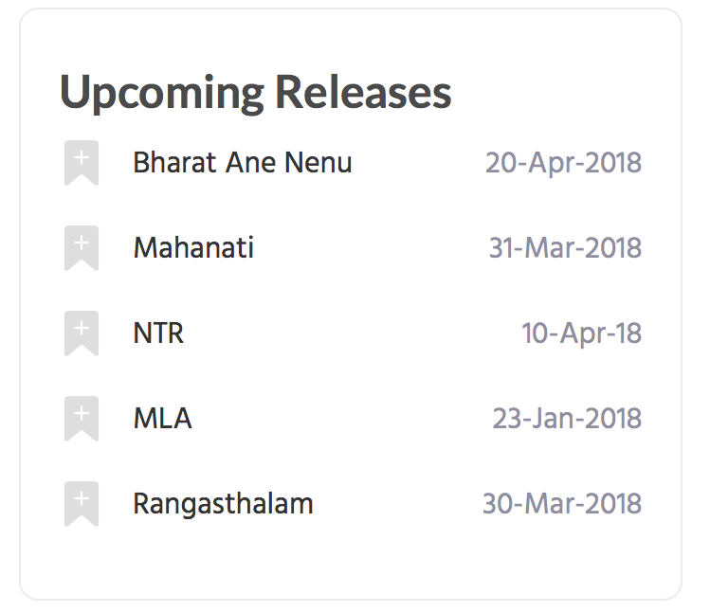

**2. Boxoffice**:

The way it should work is..if we only fill information for one table..**only that table should be displayed**. Currently, both the tables are displayed with one table having information and other table having blank information.

Issue 1: Table with blank information shouldn’t be displayed.

Also, we may need one more table named. “**Hero Gross Collections**” with below columns. This should also work likewise, only if this table has information it should pop up. If not only the table that has information should be displayed.

New Table - Third Table:

Name of Table: Hero Gross Collections

**Movie Name, Gross, Premieres Gross, Locs**

This table should also behave like I mentioned before. Only the tables that have data should be displayed and at point in time only one table will have information.

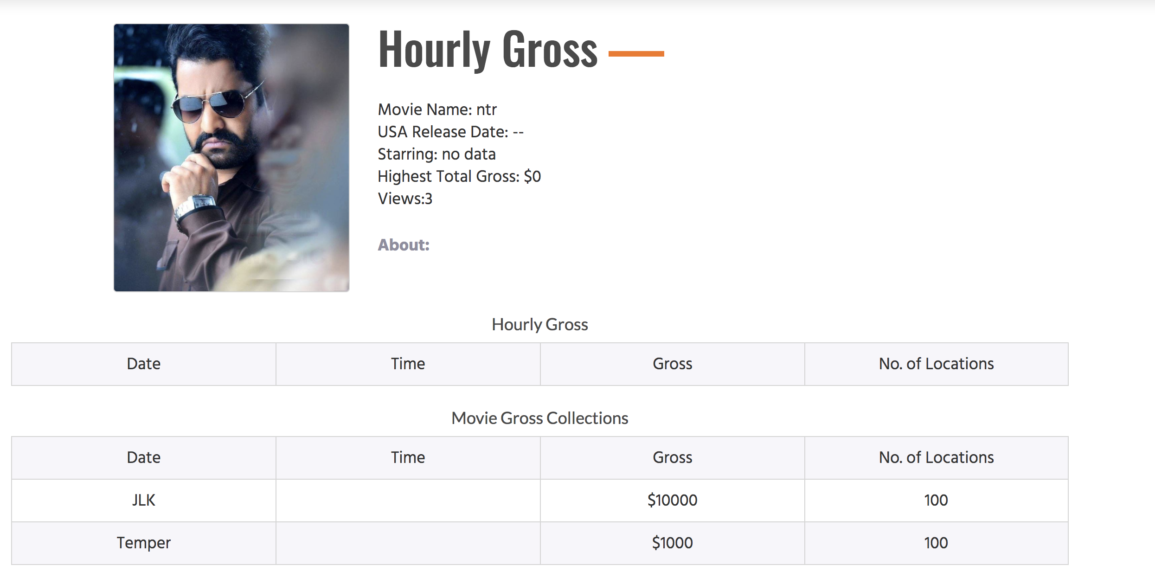

3 How to add a site icon when we enter in the browser? Like below Yahoo Icon



**4** How can we enter the description that should be displayed in the tab of a browser when we enter the website?

We want: Panipuri | Fastest Growing News Portal

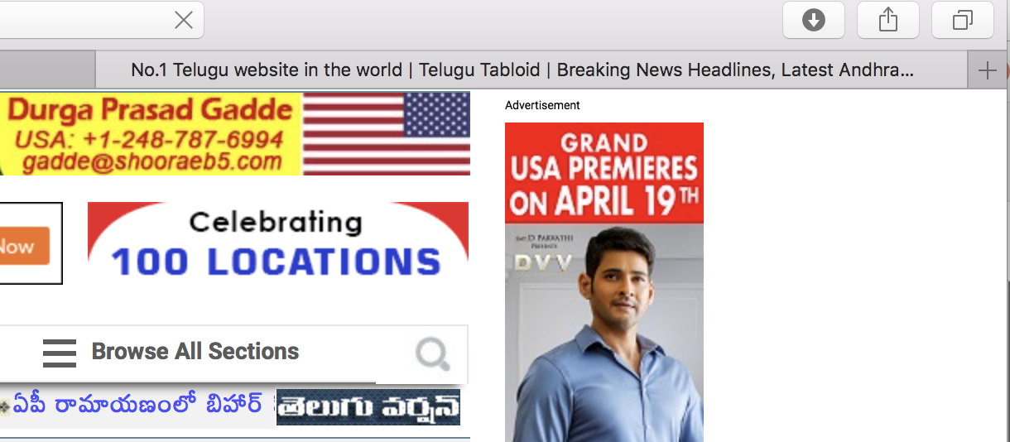

5. For the notifications, can we have our logo instead generic logo?

. 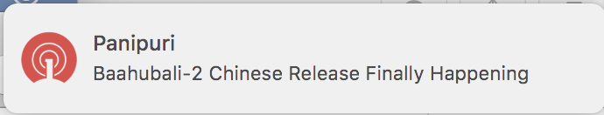

6. Clicking on the Box Office movies in the Homepage should take to their box office version page. But, instead it is taking to some random page. (Upcoming Releases is working fine)

Click on the below movie:

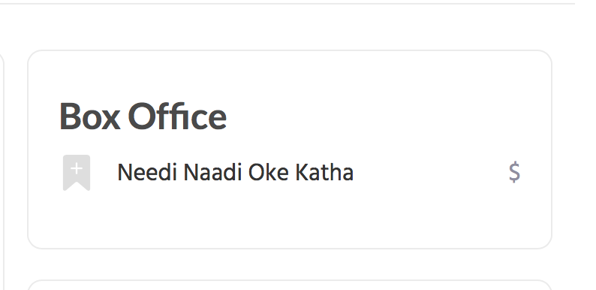

It it taking to below page, which is not expected.

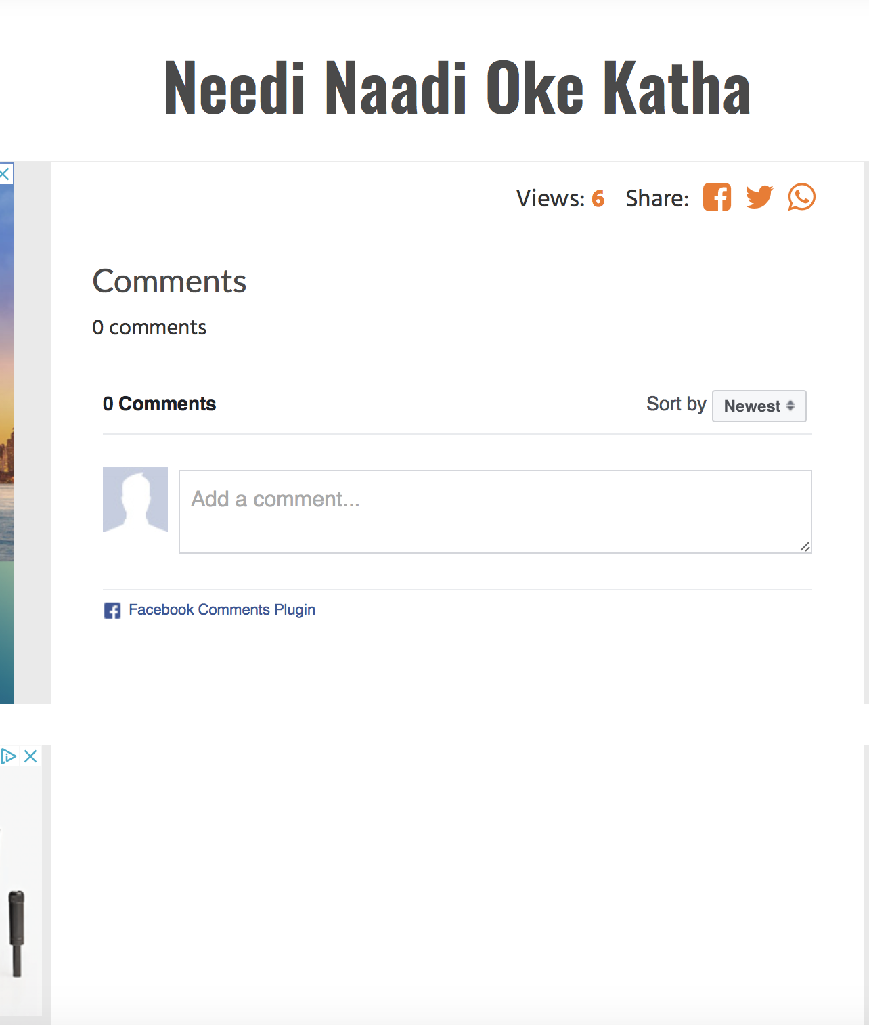

It should take to below page.

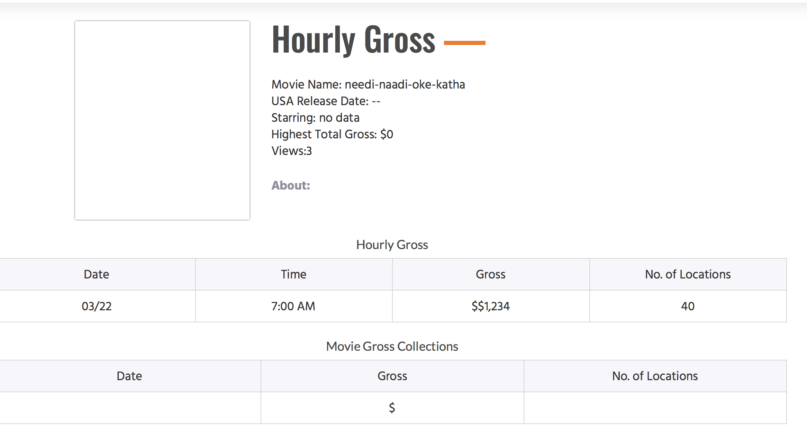

7. Hyphens are being added in the movie name.

Movie name: Needi Naadi Oke Katha is changed to needi-naadi-oke-kadha



8. How can I add different Author Names in the future? Currently, the place holders are Test and Developer. How do I change these?

9. Please do Search Engine Optimization for Google and Bing. Here are some of the keywords our users enter usually:

**SEO Search keywords:**

Latest Telugu Movies

Panipuri Review

Telugu Movies

Telugu News

Telugu Movie News

Telugu Box Office Collections

Telugu Movie Reviews

US Box Office Collections

US Showtimes

US Movie Schedules

Upcoming Telugu Movies

Telugu Trailers

Premiere Collections

Telugu Premieres

Movie Premieres

10. When sharing our website via Whatsapp or any messaging platform, the image is not displayed in the card.

Copy pasted in Whatsapp. This article has a nice image and would like the image to be displayed.

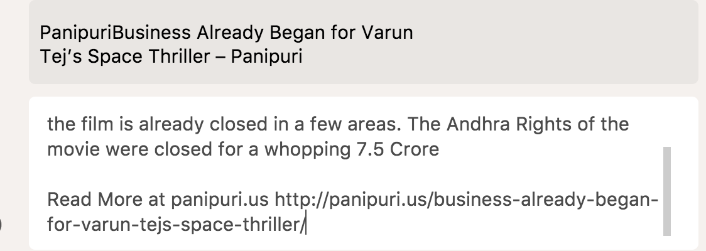

For example:

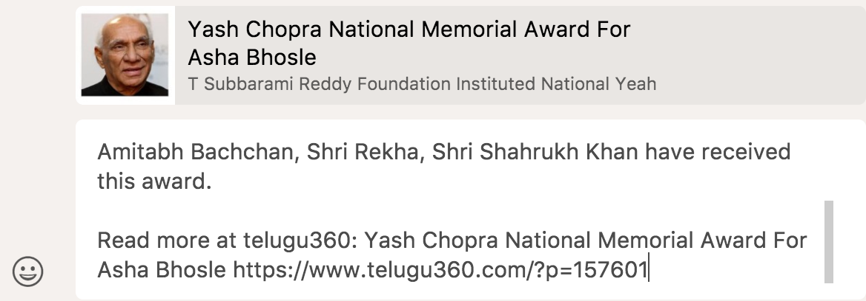

11. Also, we don’t need Panipuri two times. Just one time is enough (at the end). So the below one should read

Business Already Began for Varun Tej’s Space Thriller – Panipuri



12. Is there any plugin that will allow us to run the poll in website. That plugin should avoid duplicate votes through some browser cookie mechanism or facebook plugin.