BSplineTransformInitializer

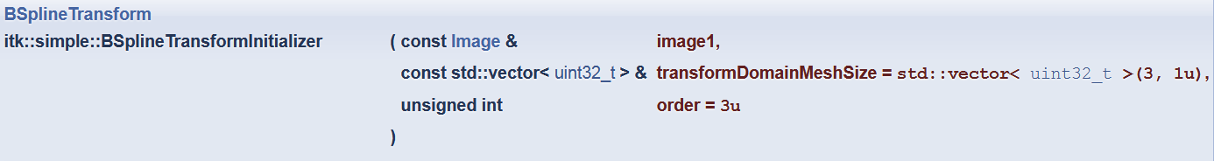

SetShrinkFactorsPerLevel

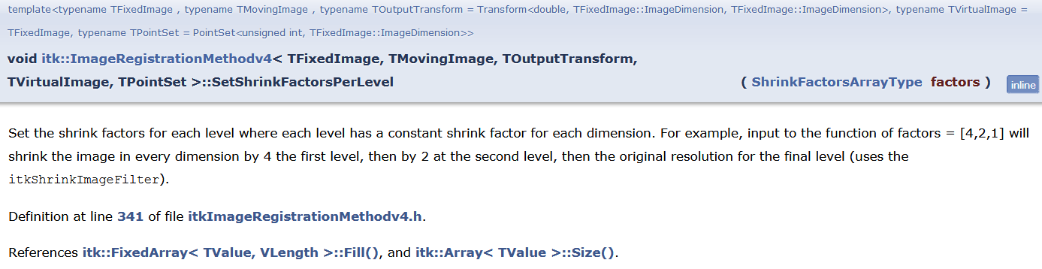

SetSmoothingSigmasPerLevel

