**Fundamental**

1. **SUMMARY**



Src: <https://www.geeksforgeeks.org/sql-tutorial/?ref=shm>

**Table of contents:**

|  |  |
| --- | --- |
| 1 | SQL Basics |
| 2 | Database in SQL |
| 3 | Table in SQL |
| 4 | ONE to ONE, ONE to MANY, MANY TO MANY |
| 5 | Practice |

1. **CHAPTER**
2. **SQL Basics**
   1. **What is Database?**

A database is a collection of data that is organized, which is also called structured data. It can be accessed or stored in a computer system. It can be managed through a [Database Management System](https://www.geeksforgeeks.org/introduction-of-dbms-database-management-system-set-1/)(DBMS), a software used to manage data. Database refers to related data in a structured form.

1. **Database in SQL**
   1. **Create Database**

The syntax to use the CREATE DATABASE command in SQL is:

CREATE DATABASE database_name;

* 1. **List Database**

List database in SQL

SHOW DATABASES;

* 1. **Use Database**

The syntax to use a database in SQL is:

USE database_name;

* 1. **Delete Database**

The DROP DATABASE command can be used to delete the database and all its contents:

DROP DATABASE database_name;

1. **Tables in SQL**
   1. **Create Table**

To create a table in SQL, use this CREATE TABLE syntax:

CREATE table table_name  
(  
Column1 datatype (size),  
column2 datatype (size),  
.  
.  
columnN datatype(size)  
);

**Where:**

**table_name:** The name you assign to the new table.

**column1, column2, … :** The names of the columns in the table.

**datatype (size):** Defines the data type and size of each column.

**Example**

**CREATE TABLE** Customer(

CustomerID INT PRIMARY KEY,

CustomerName VARCHAR(50),

LastName VARCHAR(50),

Country VARCHAR(50),

Age INT CHECK (Age >= 0 AND Age <= 99),

Phone int(10)

);

**Output**

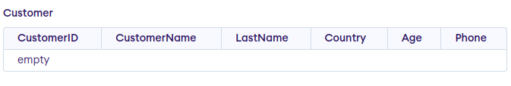

* 1. **Insert data into Table**

To add data to the table, we use [INSERT INTO](https://www.geeksforgeeks.org/sql-insert-statement" \t "https://www.geeksforgeeks.org/sql-create-table/_blank) command, the syntax is as shown below:

**INSERT INTO** table_name (column1, column2, …) **VALUES** (value1, value2, …);

**Example:**

**INSERT INTO** Customer (CustomerID, CustomerName, LastName, Country, Age, Phone)

**VALUES** (1, 'Shubham', 'Thakur', 'India','23','xxxxxxxxxx'),

(2, 'Aman ', 'Chopra', 'Australia','21','xxxxxxxxxx'),

(3, 'Naveen', 'Tulasi', 'Sri lanka','24','xxxxxxxxxx'),

(4, 'Aditya', 'Arpan', 'Austria','21','xxxxxxxxxx'),

(5, 'Nishant. Salchichas S.A.', 'Jain', 'Spain','22','xxxxxxxxxx');

**Output:**

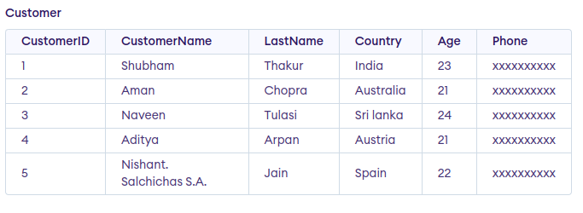

* 1. **Create table from another table**

**Syntax:**

**CREATE TABLE** new_table_name AS  
    **SELECT** column1, column2,…  
    **FROM** existing_table_name  
    **WHERE** ….;

**Query:**

**CREATE TABLE** SubTable **AS**

**SELECT** CustomerID, CustomerName

**FROM** customer;

**Output:**

